**NATIONAL LIBRARY OF BULGARIA "ST. ST. CYRIL AND METHODIUS"**

**Changes in the Library Caused by Covid-19 in 2020**

**Report**

**Introduction**

Back in the history of our humanity, it looks like libraries in their 5000 year existence have never been closed or prevented of fulfilling their duties. Year 2020 will be memorable for us all with the lockdowns around the globe, with Covid-19 consequences, with the impact on the libraries and our work as librarians.

Bulgarian national library "St. St. Cyril and Methodius" is 142 years old and for the first time it has been closed twice in 2020 because of the severe pandemic situation in the country. The first closure was in March-April for two weeks and the second one started on November 30, 2020 and is still in power. Even Christmas seems unreal to be celebrated in this new online reality.

While being closed for the first time the national library of Bulgaria has strengthen the competences and focused on personnel's skills to come out with decisions and services in favor of our customers, security of our book heritage and employee's security and health.

We published our observations in a book "Libraries and Covid-19: Guidlines for Staff Safety and Disinfection of Library Documents".

Thus with the second closure in December the National library of Bulgaria is well prepared and is following the guidelines and developing new online and e-services to our customers.

We know it is hard to believe that libraries are closed but the final report for the NL of Bulgaria points out that the number of customers and visitors in 2020 has been increased thanks to our new e-services and digital documents.

Our contribution to the efforts of all CENL members are our guidelines, which we share as the focal part of our report:

**LIBRARIES AND COVID-19: GUIDELINES FOR STAFF SAFETY AND DISINFECTION OF LIBRARY DOCUMENTS**

**These guidelines have been consulted with Vasil Vassilev - an expert in occupational medicine**

**GENERAL OBSERVATIONS**

**Public use of the library**

№ 41. Readers are obliged to protect the books taken for reading from any damage, not to write in the margins of the books, not to fold the sheets and not to turn them with a wet finger, not to lean on the books and when making notes not to put the notepaper on top of the book.

№ 43. If a contagious disease appears in the home of someone who has taken a reading book, he is obliged to report it to the library and immediately return the borrowed book for disinfection.

Regulations for the National Libraries in Sofia and Plovdivaccepted on 18.06.1898.

This document is designed to assist librarians in their efforts to preserve collections and aims to develop and systemize recommendations on the application of various methods for disinfection and surface cleaning of documents and collection items in a library environment. The proposed methods are based on current research on the spread and specifics of SARS-CoV-2[1] provided by the medical and scientific communities. As the understanding of the disease evolves, it is only natural for these recommendations to change as well.

Following the general recommendations for mitigating the risk of disease spread the easiest solution to protect the library staff and visitors from this relatively new and unknown disease would be to limit access to the reading rooms and library premises for a certain period. This would also be the safest method to preserve the collections from the action of the highly aggressive disinfectants. This statement is based on the available scientific research and is supported by many experts in the field of cultural heritage preservation, e.g. Fletcher Durant, Preservation Librarian at George A. SmathersLibraries - University of Floridapoints out that *“…isolation for at least 72 hours - and preferably for 14 days - is the best disinfectant. Otherwise, such places become risky for the spread of the disease, which will affect not only health but also public confidence in the library as such.”*

The spread of infectious pathogens, including spores, can lead to thebiodegradationof collections and collection itemsand could pose risk to the health of the people handling these items. Among the main factors for the occurrence of microbial contamination of library collections, is the violation of environmental conditions on one hand, and on the other –the inclusion ofnew itemsin the collections without them undergoing preliminary disinfection process. Creating a strategy or at least a sensible guideline is crucial forlimiting the consequences of these threats on documents, books, and personnel. Implementing a unified approach in the institutions working with library materials is desirable especially for smaller institutions that lack personnel trained in preventive conservation (simple methods such as control and management of environmental conditions do not require special training and/or knowledge).

An effort has been made to systemize and illustrate basic solutions and methods for conducting an effective and safe(both concerning collection items, but to personnel and users as well) disinfection protocol. In addition to libraries, these guidelines can be useful for other public and administrative institutions that are responsible for the preservation of documents and other archives.

**CHAPTER ONE**

**CHARACTERISTICS AND DISTRIBUTION OF INFECTIOUS PATHOGENS IN THE LIBRARY ENVIRONMENT**

The most common agents leading to the destruction of various library collections are cellulose-destroying bacteria, molds, and fungus, insects, and rodents[2]. In addition to being damaging to the collections, some of the listed groups can be infectious pathogens that are harmful to the human health (e.g. molds, fungus, and bacteria could cause many local and general inflammations, which could develop into allergies or could lead to the development of various diseases). Infectious pathogens include viruses as well, whichalthough not deemed as directly harmful to collections, could pose a risk to human health through their spread in the library environment. Pathogens spread mainly through the air. Through ventilation along with the fresh air from outside, dust, water vapors, and small airborne particles enter the repositories andsettle on various surfaces, including books and other collection items.

1. **Bacteria**

The main types of bacteria found in the library environment are cellulose-destroying bacteria, which include actinomycetes or actinobacteria, also called radiant fungi. Cellulose-destroying bacteria are unicellular organisms, ranging in size from 0.1 µ to 15 µ. Depending on whether their development takes place in oxygen or oxygen-free environment, they are aerobic and anaerobic. The following species are described as the most common aerobic cellulose-destroying bacteria:

- of the genus Cellvibrio - Cellvibrioochracae, Cellvibrioflavescens, Cellvibriovidiris, Cellvibrio mucosa, Cellvibriofusca, Cellvibrio vulgaris;

- of the genus Pseudomonas - Pseudomonas erytha, Pseudomonas ephemerocyanea, Pseudomonas lasia;

- of the genus Cellulomonas - Cellulomonasbiazotae, Cellulomonasgalba;

- of the genus Bacillus - Bacillus soli, Bacillus vaguos;

- of the genus Bacterium - Bacterium infirme;

- of the genus Cytophaga - Cytophagarubra, Cytophagaaurautica, Cytophagatenissima;

- of the genus Streptomyces - Streptomyces melanocyclus, Streptomyces cellrlosae, Streptomyces flavochromogenes, Streptomyces violaccus, Streptomyces glabus, and others.

**2. Molds**

Another large group of pathogens that are detrimentalto both library holdings and human health are the molds – aerobic microorganisms with an extremely large diversity of sub-species. Mold spores are ubiquitous and could either be in anactive or dormant state. The most common representatives are:

- Penicillium;

- Aspergillus;

- Chaetomium;

- Mucor;

- Tusarium;

- Stemphylium;

- Cladosporium;

- Stachybotrys;

- Alternaria;

- Sporotrichum;

- Trichoderma;

- Torula etc.

The development of mold and fungi is subject to various interrelated factors. Temperature, stagnant air, and storage space are some of the main factors that are directly related to mold growth when not monitored, but undoubtedly relative humidity is the most important factor. High temperatures in combination with high relative humidity increase the growth rate of spores. Stagnant air allows them to layer on the surface of library materials. The combination of both a lack of air circulation and increased relative humidity provides the spores with a suitable environment for development. If favorable conditions are not present, the spores remain inactive until changes in the environment occur. That is, they do not contaminate the collection itemswhile the relative humidity is stable. In general, the higher the relative humidity (RH), the faster and easier development occurs. The correlation between the different factors at a constant temperature of 21° C is explained in Table 1:

|  |  |  |
| --- | --- | --- |
| RH | Temperature | Development time |
| 75% | 21°С | 1 month |
| 80% | 21°С | 2 weeks |
| 90% | 21°С | 4 days |

Table 1: Mold growth at different relative humidity values and constant temperature.

The humidification of paper and books, in general, is a slow process that starts from the points of contact of the surface with the air. It is there that the initial growth of individual spores takes place, which subsequently leads to the emergence of colonies. The initial stage of mold growth is characterized by the appearance of cotton-like stains on the bindings’ surface, due to the easily digestible nutrients present in the various types of adhesives such as starch, gelatin, and others used in bookbinding. The next stage during which there are active growth and reproduction of fungi is the gradual penetration of mold into the book body.A byproduct of the mold and fungi development are the digestive enzymes that weaken the cellulose and lead to destruction and discolorations of the paper (a common sign of high relative humidity is the sticking of pages into one solid block).

1. **Viruses**

The last considered group of infectious pathogens that can be found and transmitted in the library environment are viruses (poison, lat.). They have a variety of shapes and very small sizes ranging from 15 to 350 nm. There are two types of viruses - coated and non-coated. Unlike bacteria and molds, they are not independent organisms. Viruses can only reproduce by subordinating and controlling other cells, as they do not have their cellular apparatus for self-reproduction. Due to their size, viruses are very easily transmitted and in a library environment, their spread can occur directly (from person to person by airborne droplets) or indirectly (from contact with contaminated surfaces).

**CHAPTER TWO**

**METHODOLOGY OF DISINFECTION ACTIVITIES IN LIBRARIES IN THE CONDITIONS OF A VIRAL PANDEMIC - PRACTICAL GUIDELINES**

1. **General information**

The proposed methodology is consistent with the guidelines developed by experts from the National Center for Infectious and Parasitic Diseases (NCIPD) and their laboratory "Disinfection, Sterilization, and Bioindicators".It aims to provide accessible information to library employees on the requirements and steps for implementation of the necessary disinfection measures in connection with the spread of COVID-19. The main pointsthat need to be taken into account when developing and implementing a strategy are:

1. Selection of disinfectant.

2. Determining the most visited indoor spaces and the frequency of disinfection treatments.

3. Methods of application of disinfectants.

4. Additional requirements for the treatment of sanitary facilities.

5. Disinfection with UVC light/bactericidal lamps.

6. Safety of library staff and visitors.

1. Selection of disinfectant

1.1. Cleaning products used in routine sanitation activities are replaced by disinfectants.

1.2. The new coronavirus, which causes the infectious disease COVID-19, belongs to the group of enveloped RNA viruses that are known to be sensitive to chlorine, aldehydes, oxidants, alcohols, iodine, quaternary ammonium compounds.

1.3. The choice of disinfectant should be consistent withthe products authorized for use by the Ministry of Health of the Republic of Bulgaria.[3]

1.4. Depending on the sites and surfaces to be treated, disinfectants must be approved for Product Type 2 "Disinfectants and algaecides not intended for direct use on humans or animals".

1.5. The choice of disinfectant should be consistent with its effectiveness against the virus. At present, the products available on the market do not specify that they are effective against SARS-CoV-2 on their labels. For the time being it has been accepted as sufficient for the disinfectant to have a virucidal action or a partial virucidal action (enveloped viruses).

1.6. It is advisable to choose a disinfectant with shorter exposure time (up to 15 minutes).

2. Determining the most visited indoor spaces (critical points) and the frequency of disinfection treatments.

2.1. For each organization (library) the critical points that are subject to disinfection are to be determined. Critical points are defined as all surfaces and indoor spaces related to the movement of people, as well as frequently touched surfaces (floors, desks, door handles, window latches, lighting switches, elevator buttons, railings, fixed telephones and appliances, toilet bowls, sinks, taps and other surfaces often touched by hand, depending on the specifics of each workplace).

2.2. Critical points are subject to daily disinfection.

2.3. In the presence of confirmed cases of COVID-19 in the locality, the frequency of disinfection measures should be increased, and it can vary from 4 times a day to disinfection every hour.

3. Methods of application of disinfectants

Disinfectants can be ready-to-use solutions that are applied directly to surfaces or in the form of a concentrate that must be diluted with water before use.

Important: Alcohol-based disinfectants must not be used on large surfaces (over 2 m2) due to their flammability. For the same reason, they must not be used near ignition sources and the electrical panels or appliances connected to the main electrical system.

3.1. Small surfaces (handles, buttons, keyboards, desks, etc.)

3.1.1. It is recommended to use pre-pared alcohol-based disinfectant solutions (containing ethanol, propanol, isopropanol, or a combination) in the form of a spray.

3.1.2. Surfaces are sprayed directly or wiped with a clean cloth pre-soaked in disinfectant.

3.1.3. The entire surface must be completely covered in disinfectant.

3.1.4. The treated surface must be allowed to dry.

3.1.5. Smaller surfaces could also be wiped with disinfectant wet wipes (which need to be collected and disposed of safely afterward).

3.2. Large surfaces (walls, floors, worktops, and others.)

3.2.1. Disinfectants intended for large surfaces are most often in the form of a concentrate, which must be diluted with water before use. The manufacturer instructions must be followed to achieve a virucidal action (minimal count of enveloped viruses) of the solution. The solutions are prepared with lukewarm water unless a specific temperature is explicitly stated on the label.

3.2.2. The treatment is performed by wiping with a clean mop or cloth soaked in the solution of the disinfectant; alternately spraying the solution is accepted, as well as using it with foaming machines.

3.2.3. The disinfection rate and exposure time indicated on the label must be strictly observed.

3.2.4. It is important to observe the specific requirements for ventilation, following the disinfection of surfaces.

3.3. Techniques for applying disinfectants when treating large surfaces

Surfaces can be treated in different ways, depending on the selected disinfectant and the type of surfaces themselves.

3.3.1. Disinfection by mop/cloth wiping

3.3.1.1. It is recommended to use a system of mops pre-soaked in a disinfectant solution. With this method of treatment, the floor of a room is treated with a mop and the small surfaces in a room - with a cloth. Each separate space/surface should be treated with a clean mop/cloth.

3.3.1.2. In the absence of numerous mops, it is recommended to use two containers (two buckets) containing a disinfectant solution in the same concentration. A surface up to 10 m2 is rubbed with a mop and up to 2 m2 with a towel. This should be followed by cleaning the mop/cloth in both containers and before using them on another surface.

3.3.1.3. Used cloths and mops must be decontaminated after disinfection by soaking them in a working solution of disinfectant in the highest concentration indicated on the label for the relevant exposure time, then rinsing them and allowing them to dry.

3.3.1.4. When working with chlorine disinfectants in sanitary facilities, surfaces that will come into contact with the skin, such as toilet seats, chairs, benches, etc., must be wiped with a clean dry or damp cloth or rinsed thoroughly with water. after the exposure time of the disinfectant has passed.

3.3.2. Spray disinfection

3.3.2.1. It can be carried out by hand, back sprayers, motor sprayers, or automatic dry mist systems.

3.3.2.2. Extensive treatments with back and motor sprayers and automated systems can be performed only by registered personnel under Ordinance № 1 from 5 January 2018 under the terms and conditions for disinfection, disinsection, and pest control.

4. Additional requirements for the treatment of sanitary facilities

4.1. For all toilets in the libraries, it is necessary to monitor the consumption and timely provision of hygiene products, such as liquid soaps, disinfectants, disposable wipes for drying hands.

4.2. Regular waste disposal must be ensured.

4.3. The staff responsible for and maintaining the sanitary and hygienic conditions of the library must be equipped with and use personal protective equipment.

4.4. Personal protective equipment should be removedwith attention.

4.5. Non-disposable personal protective equipment, such as goggles, helmets, gloves, should be disinfected by soaking or wiping.

4.6. Disposable personal protective equipment should be disposed of safely.

4.7. After removing personal protective equipment (masks, gloves, apron, etc.), hands must be washed with soap and water or disinfected with an alcohol product.

5. Disinfection by UVC light/bactericidal lamps

5.1. Closed type bactericidal lamps

5.1.1. They are used for air disinfection and can work without interruption in the presence of people.

5.1.2. To achieve efficiency, the number of air UVC systems must be correctly adjusted to the volume of the space, according to the manufacturer's recommendations.

5.1.3. It is recommended that the lamps used by the systems do not produce ozone (ozone-free).

5.1.4. It is extremely important to replace the lamps according to the manufacturer's recommendations and/or to monitor the UVC intensity annually with a measuring device (UVC meter).

5.2. Bactericidal lamps with direct UVC radiation

5.2.1. They are used for the disinfection of air and surfaces.

5.2.2. Do not allow access/presence of people on the premises in the operating mode of the direct transmitters.

5.2.3. The use of ozone-free lamps is recommended.

5.2.4. Disinfection is achieved by switching on the lamps for 20-30 minutes and a minimum of 6 µW/cm2 UVC intensity throughout the room should be achieved.

5.2.5. To achieve efficiency, the number of direct bactericidal lamps must be correctly adjusted to the size of the space and the place of their installation, to maintain a minimum of 6 µW/cm2 UVC intensity in the entire volume of the room.

5.2.6. It is extremely important to monitor the UVC intensity of the lamps annually with a measuring device (UVC-meter).

5.2.7. If direct germicidal lamps have been used daily for one year or irregularly, but for more than 3 years, and their lamps have not been replaced or controlled, likely, they do not emit effective doses of UVC light, although they have ablue-violet glow. In the absence of a meter, such lamps must be replaced, otherwise, disinfection cannot be guaranteed.

5.2.8. In terms of surface decontamination, direct germicidal lamps only support disinfection with chemicals (disinfectants) but do not replace it.

6. Safety of library staff and visitors

6.1. Workrooms, reading rooms, and common areas

6.1.1. Ensure a distance of at least 1.5 m between workplaces (World Health Organization guidelines).

6.1.2. In the reading rooms ensure a distance between the workplaces not less than 2 m.

6.1.3. Regular ventilation of workrooms, reading rooms, and common areas must be ensured.

6.1.4. Disinfection of workrooms, reading rooms, and common areas (every 4 hours).

6.2. Hand hygiene (applies to all library staff and visitors)

6.2.1. It is recommended to place disinfectants in visible places in libraries and workplaces.

6.2.2. Touching the face with the hands should be avoided, especially in the area of ​​the nose, eyes, and mouth.

6.2.3. Wash your hands regularly with soap and water for 20 seconds, following proper rubbing techniques (paying special attention to the thumbs, between the fingers, fingertips, back of the palms).

6.2.4. When using an alcohol disinfectant, it should be rubbed into the skin of dry hands for a minimum of 30 seconds following proper hand rubbing techniques.

6.2.5. After the required contact time has elapsed, the hands should be allowed to dry. The required skin treatment time is indicated on the disinfectant label.

6.3. Safety equipment for libraries

The health safety in libraries is of paramount importance both for the people who work in them and for the visitors. The current pandemic situation and the way we need to deal with it is unprecedented, according to preservation specialists. There is no evidence that special care has been taken for library collections in previous epidemics and/or pandemics.

6.3.1. Visitors:

- are allowed on the territory of the library only with a protective mask or helmet;

- during the stay in the library it is always mandatory to wear a mask or helmet ;

- the conditions for their stay in the library are regulated by the director.

6.3.2. Employees:

- librarians and staff who are in direct contact with users and external visitors must wear protective masks or helmets, gloves, and appropriate protective clothing;

- when moving books or other collection items, remove the gloves immediately so that they do not touch other surfaces;

- after removing the gloves, wash your hands for 20 seconds, following the instructions of the World Health Organization.

6.4. Quarantine of books, documents and other collection items in circulation

6.4.1. А special quarantine space should be designated for books and documents that were used by readers.

6.4.2. The quarantine period of used books/documents is considered to be a minimum of 72 hours, or 3 days unless otherwise specified. For each day the documents are marked with the respective date of the beginning of the quarantine.

6.4.3. If it is not possible to specify a quarantine space, the used documents may be placed in plastic/paper bags until the end of the quarantine period of at least 72 hours.

II. Sources used to determine quarantine parameters

A study published in the Journal of Hospital Infection clearly states that the coronavirus can survive on inanimate surfaces (metal, glass, and plastic) for up to nine days. As for paper, scientists believe that SARS-CoV-2 survives on it for 4-5 days. NEDCC recommends a minimum 72-hour quarantine for books and documents from other collections as the safest and most effective way to disinfect after use. A study published in the New England Journal of Medicine on March 17, 2020, shows that the coronavirus remains on cardboard surfaces for 72 hours. Based on this study, a suitable quarantine period for paper or plain cardboard is a minimum of 72 hours, as well as for plastic-based materials such as CDs and DVDs. A minimum of 72 hours of quarantine is recommended for any other collection item.

**CHAPTER THREE**

**DISINFECTION AND SURFACE CLEANING OF LIBRARY COLLECTION ITEMS**

Disinfection and surface cleaning are two separate processes that are interlinked and that complement each other. Their goal is to reduce the risk of spreading infections by interrupting the mechanism of transmission of pathogenic microorganisms (bacteria, fungi, viruses) to the environment. When performing both processes, the following personal protective equipment must be used:

- masks/respirators (it is recommended that they are class FFP2 or FFP3)

- goggles or face helmet

- apron (if possible, for single use)

- gloves (disposable if possible)

After work, wash hands with soap and warm water for at least 20 seconds.

1. **Resistance of viruses on various surfaces**

Although typically enveloped viruses are less stable than non-enveloped viruses because they react to all disinfectants, it is not appropriate to generalize and assume the same data is relevant to all viruses. Conclusions should be based on research for each specific virus. For example, studies have been performed by German scientists for lipoprotein-coated coronaviruses. As a result,the lifespan of the virus on various surfaces (metal, wood, paper, plastic, etc.) has been established.[4]

|  |  |
| --- | --- |
| *Surface* | *Lifespan* |
| *Paper* | *4-5 days* |
| *Metal* | *5 days* |
| *Wood* | *4 days* |
| *Plastic* | *6-9 days* |

Table 2: Coronavirus lifespan on various surfaces.

Paper undoubtedly occupies the largest share of materials found in library collections. However, metal, wood, and plastic can be added to it, as materials used for individual elements that are part of the bookbinding and are just as common. According to the National Center for Preservation Technology and Training, the recommended quarantine period for paper documents is between 6 and 9 days[5]. Data from another study, published in the New England Journal of Medicine[6], showed that the coronavirus retained its resistance on cardboard surfaces for 24 hours and on plastic surfaces for up to 72 hours. In connection with the presented data from the research, it can be concluded that the safest and most effective way to reduce the indirect spread of the virus after the use of library documents by employees or readers is to quarantine them, with a minimum period of 24 hours and the maximum - 9 days.

NEDCC, which specializes in the preservation, restoration, and preservation of paper-based materials, also recommends a 24-hour quarantine for paper or plain cardboard library materials and a 72-hour quarantine for plastic-based materials (such as music records, CDs and DVDs), as well as a 72-hour quarantine for books whose bindings are covered with a layer of polyester or other plastic.[7]

1. **Disinfection of library collection items**

Disinfection is a process of selective reduction by irreversible inactivation of pathogens to safe levels. However, it is not a process that guarantees the complete eradication of pathogens. Disinfection is carried out utilizing physical and chemical methods and should always be performed under a conservator’s guidance or instructions. The application of a chosen method for disinfection must be chosen with care and concerning the specific collection item and its materials.

* 1. **Disinfection by chemical means**

Undoubtedly, the main disinfection method that has been widely used in library practices in the past is the chemical disinfection. It uses disinfectants and chemicals with various compositions - alcohols, aldehydes, alkaloids, chlorine and phenol, and many others. Each of them has a different mechanism and spectrum of action (bactericidal, fungicidal, virucidal, sporicidal). The guiding principle for the method of application (gassing, spraying, or direct application of solutions) of disinfectants is the volume of library material that needs to be processed.

For decades, chemicals such as formaldehyde, thymol, ethylene oxide, etc., have been widely used to disinfect library collections[8]. Although they have a proven disinfectant effect, their main drawback is the pronounced toxicity, which is harmful to human health. For this reason, their application in library practice is not currently applied.

* 1. **Disinfection with natural products**

Following the global trend for the introduction of environmentally friendly products, in recent years the use of natural products with proven antibacterial and antifungal properties as a disinfectant in the library environment is increasing. An important condition for the application of these methods is that the natural materials and reagents are harmless both for various components of the library materials (paper, ink) and for humans. Biological and empirical studies have been performed and antibacterial and antifungal properties were found among various essential oils at concentrations of 0.5% alcohol solutions.[9] The disinfecting action of different essential oilsis presented in the following diagram.

Diagram 1: Disinfective action of essential oils on library collections.

It is clear from the diagram that the tea tree essential oil gives the best results. Studies show that its mechanism of action consists of disruption of membrane integrity, accompanied by the release of intracellular material and inhibition of cellular respiration, leading to an inability to maintain cell hemostasis.

Disinfection with tea tree essential oil solution in alcohol

The methodology includes the following stages:

1. **Preparation of a solution.**

5 ml of essential oil is added to 1 l of ethyl alcohol

**2. Application of solution.**

Place the document/book/collection item on a flat surface and brush it with a disinfectant solution with a concentration of 0.5%. It is necessary to wait until the alcohol evaporates from the surface of the paper after applying the solution. Then filter paper is inserted between the pages as well as on the outside of the book. Processed in this way, the document is placed in a closed volume (desiccator or polypropylene bag) for 4-5 days.

Essential oils could be used for the prevention of respiratory diseases. Placed on the worktable in a small container in the form of a 0.05% solution oftea tree oil in rose water.

* 1. **Anoxic treatment**

Another harmless method for both library materials and people is the Anoxictreatment[10]. The method is based on removing oxygen in an enclosed space to levels below 0.5% and introducing an inert gas (nitrogen, argon, carbon dioxide), i.e. an anaerobic environment is created to achieve inactivation of all stages of spores, fungi, mold, insects,etc., present in library collections. The modification of the atmosphere can be achieved in three ways - dynamic, static, or combined (dynamic-static) methods. During the treatment process, the temperature and relative humidity levels are controlled,and it is recommended to maintain certain parameters (20–23º C and RH 50%).

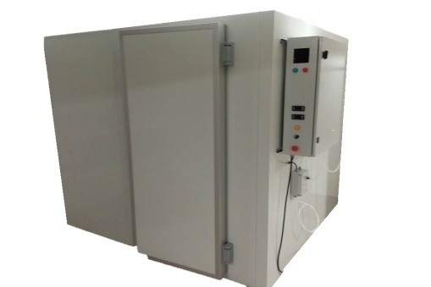

Figure 1: Anoxic chamber

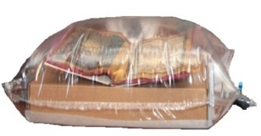

Figure 2: Anoxic "balloon"

This treatment is very convenient for mass disinsection and disinfection. The collection items are placed in a hermetically sealed space that can be in the form of a chamber or made fromnylon.

* 1. **Disinfection with ultraviolet radiation**

The electromagnetic spectrum of ultraviolet radiation is divided into several areas according to the wavelength. Shortwaves, which cover the middle ultraviolet range (UVC), have a proven disinfectant effect. Their maximum decontaminating effect occurs at a wavelength of 253.7 nm, although it can vary between 240 and 280 nm.

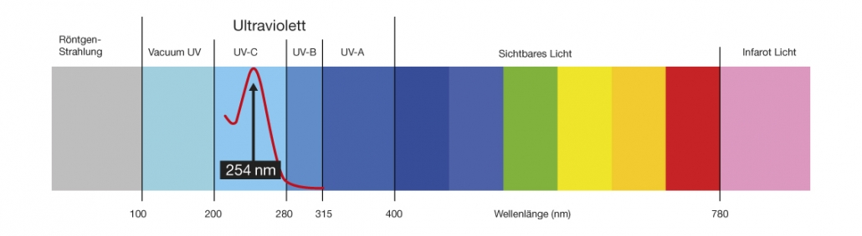

Figure 3: Disinfection with UVC light.

This method uses artificial sources of ultraviolet radiation, capable of destroying both vegetative forms and spores of pathogenic microorganisms present both in the air and on top of surfaces. The mechanism of action is the destruction of the DNA of pathogenic microorganisms and the disruption of their cellular respiration and synthesis. This leads to the impossibility of reproduction and death of the cell. The variety of artificial sources of UV is great - bactericidal lamps/irradiators; quartz lamps, germicidal lamps, etc. Often these names act as synonyms but can also show various specific features in material and technical terms such as wavelength, UVC intensity, operating time, safety, and more. Documents in the library are often contaminated due to their frequent use by different readers. Dust and bacteria stick to books after handling.

In general, according to the method of processing the surrounding space and the type of its construction, artificial sources of UVC radiation are divided into two groups: open and closed. Open sources of UVC radiation propagate a stream of ultraviolet radiation throughout the perimeter of the room, disinfecting the air and the surface of any object located within their radius. Places that fall into the shade are not exposed to radiation;i.e. pathogenic microorganisms do not die at these specific spots. To achieve maximum efficiency, the number of devices must be adjusted to the size of the room and the place of installation[11], to maintain a minimum of 6 µW/cm2 UVC intensity throughout the room. They can be static (mounted on a wall, ceiling, or other surfaces) or mobile. During operation, direct emitters come into contact with oxygen in the air and cause the formation of ozone, which is a highly toxic gas[12]. They must work in the complete absence and lack of access to people in the premises in which they are placed. The minimum exposure to radiation is 2 hours[13], after which the room must be ventilated to remove the characteristic odor of ozone.

Closed sources of UVC radiation propagate a stream of ultraviolet radiation in anenclosed volume. Disinfection is performed as a result of the passage of air through the device, sucked in by special fans. Such devices can operate in a constant mode and have a low intensity, which allows them not to be turned off for 7 days. Closed sources of UVC radiation have a high efficiency of air purification, but at the same time, no disinfection of objects and surfaces is performed. Disinfection using this method decontaminatesbased on convection, i.e. flow of air. The degree of disinfection depends on the power of the source and the duration of irradiation. In open sources, the efficiency of disinfection varies from 90% to 99%, while in closed sources it is 90%. The optimal parameters for the operation of both types of irradiators are a temperature of 18–25 ° C and relative humidity no more than 60–65%. If the humidity is above 80%, the efficiency of the procedure decreases by 30%.

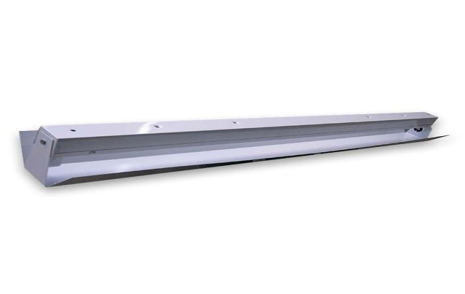

Figure 4: Static lamp

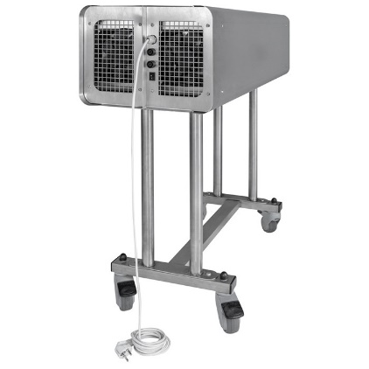

Figure 5: Mobile lamp.

Although the method of ultraviolet disinfection is highly effective, it may be partially applicable in library settings. Closed devices will effectively destroy infectious pathogens in the air and this, in turn, is a prerequisite for limiting their sedimentation on surfaces and library materials. It is important to keep in mind that radiation cannot replace sanitary and anti-epidemic measures. It can only complement them as an intermediate or final stage in the disinfection protocol. Prolonged exposure with UV light damages the paper and its effect is cumulative, which making it unacceptable as a sole measure for book and paper disinfection. If there is a separate quarantine space in which collection items are stored for a certain period, a method of disinfection of the environment and surfaces can be applied before and after placing the items (books, etc.) under quarantine. Exceptions to the general rule of limiting exposure to UV rays could be made for specially designed devices for combined disinfection and cleaning of books. In them, dedusting is carried out with high air pressure, and ultraviolet radiation is short (30 seconds). Various manufacturers of this technique offer models for processing one or more books.

Book Sterilizer is a device that is used for quick and efficient disinfection of low-value books, but it is not advisable to be used on precious documents and/or special collections. Its effect is based on ultraviolet rays and a high-performance filter to disinfect the book body completely - from the bookbinding to the book body. The machine is designed for disinfection in the library and is approved by the national certification (SGS) with an efficiency of up to 99.9% against pathogenic bacteria, influenza of new type A virus (H1N1), other viruses and bacteria. It is a convenient option for processing books used in reading and lending services.



Figure 6: Book Sterilizer

As noted, the selection of disinfection protocol must consider current scientific research on the specific pathogens, as well as the specifics of each collection item. Summarized information on effective disinfectants, their concentration, and the length of time required to eradicate the new coronavirus are presented in Table 3.

|  |  |  |
| --- | --- | --- |
| Disinfectant | Concentration | Length of time |
| Ethanol | 95% | 30 s |
| Ethanol | 70% | 600 s |
| 2-propanol  (isopropyl alcohol) | 95% | 30 s |
| 2-propanol  (isopropyl alcohol) | 70% | 30 s |
| Sodium hypochlorite  (Bleach) | 0,21% | 30 s |
| Sodium hypochlorite  (Bleach) (Белина) | 0,1% | 60 s |
| Hydrogen peroxide | 0,5% | 60 s |

Although effective and relatively fast, the use of liquid disinfectants is detrimental to paper-based library materials and can cause irreversible damage.[14] The recommended approach for the disinfection of library collections is to quarantine them for a period based on the data already described. The books/documents could also be placed in a polypropylene bag with a zipper or a box made of foamed polymeric material. However, it is important that the relative humidity is stable and around 50% because a harmful microclimate could be created in the envelope/box, which is a prerequisite for the development of mold. Labeling with quarantine date information will be convenient to track the duration of the quarantine.

1. **Surface cleaning of books**

Surface cleaning is a process in which dirt, including layered pathogens, is removed. It does not kill the micro-organisms, but eliminates some of them, reducing their number. The cleaning of documents can be done in two main ways: manually or mechanically (using specialized equipment).

* 1. Manual cleaning

When performing manual cleaning, it is important to avoid two-way movement as well as rotating movements, because there is a risk ofinserting dirt and infectious pathogens deeper into the book body.

1. Cleaning should always start from the top edge (head). The recommended direction is from the spine towards the edge.

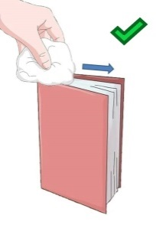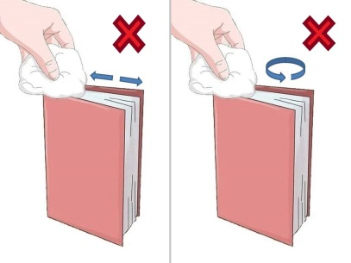

1. Similarly, clean the fore edge.

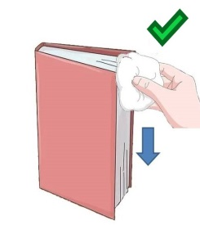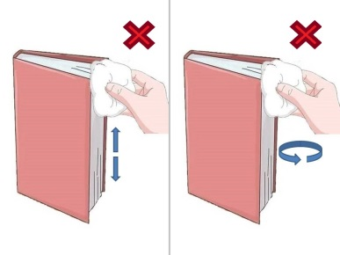

1. Clean the bottom edge from the spine towards the edge.

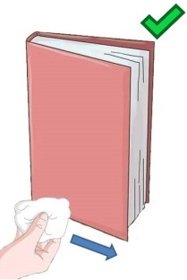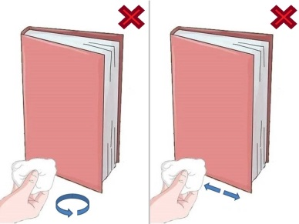

1. Clean the spine from top to bottom.

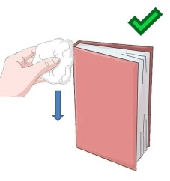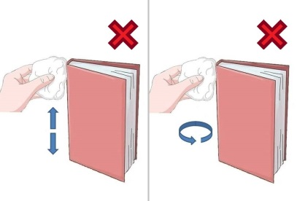

1. Clean the covers from top to bottom - right cover.

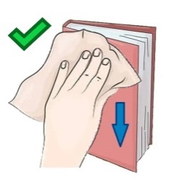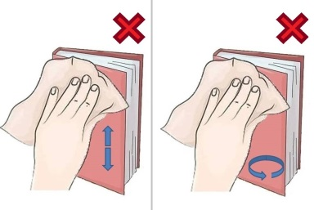

1. Cleaning the covers in the direction from top to bottom - left cover.

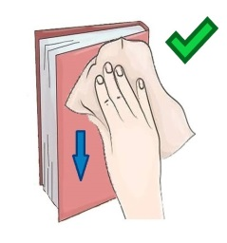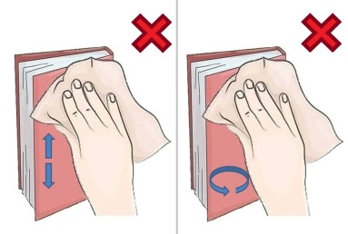

3.2. **Mechanized cleaning**

Vacuum cleaners and specialized machines canbe used to facilitate the surface cleaning of large volumes of books. Vacuum cleaners needto have a HEPA filter and soft bristles/brushes. An important condition for their effectiveness is the power of the vacuum to be adjustable. When using thistechnique for surface cleaning, the same sequence is followed, and the direction described for manual cleaning of books is followed.

**Bibliography**

**Alexandrova, K., Tsekova, G.**Naturalrawmaterials, notanalternative, but a futureinpreservingtheculturalheritage - In: BulletinoftheHistoricalMuseumofShumen, vol. 16. CulturalHeritageandCulturalTourism: MuseumPerspectives: Proceedingsofthe International ScientificConference, Shumen, June 25-27, 2014 - Shumen, 2014, pp.74-83.

**Dobreva, R., Tsekova, G.** Essential oils and protection of book collections: a practical guide, Shumen, 2015.

**Saikova, G.** Basic methods for conservation and restoration of paper. Sofia, 1990.

# AerosolandSurfaceStabilityof SARS-CoV-2 asComparedwith SARS-CoV-1. – In: [New England Journal of Medicine](https://www.nejm.org/doi/full/10.1056/NEJMc2004973?query=featured_home), 2020, 16.04: *https://www.nejm.org/doi/full/10.1056/NEJMc2004973?query=featured_home*

**Kampf****, G., Todt****, D.,Pfaender****, S., Steinmann, E.**Persistenceofcoronavirusesoninanimatesurfacesandtheirinactivationwithbiocidalagents.In: [JournalofHospitalInfection](https://www.sciencedirect.com/science/journal/01956701), [Volume 104, Issue 3](https://www.sciencedirect.com/science/journal/01956701/104/3), March 2020, P.246-251:

*https://www.journalofhospitalinfection.com/article/S0195-6701(20)30046-3/fulltext*

**Selwitz, C., Maekawa, S.**InertGasesintheControlofMuseumInsectPests. LosAngeles: TheGettyConservation Institute, 1998:

*https://www.getty.edu/conservation/publications_resources/pdf_publications/pdf/inertgases.pdf*

**International Federationof Library AssociationsandInstitutions (IFLA)/ Международна федерация на библиотечните асоциации**

COVID-19 andtheGlobalLibraryField *– https://www.ifla.org/covid-19-and-libraries#handling*

**American LibraryAssociation (ALA)/ Американска библиотечна асоциация**

PandemicPreparedness – *http://www.ala.org/tools/atoz/pandemic-preparedness*

**BulgarianLibraryandInformationAssociation**

COVID-19 andhealthprotectioninlibraries - https://www.lib.bg/index.php?option=com_content&task=view&id=1388&Itemid=274

Disinfectionofbooksandothercollectionsinlibraries - https: //www.lib.bg/index.php? Option = com_content&task = view&id = 1377 &Itemid = 274

**World Health Organization/ Световна здравна организация**

*https://www.who.int/docs/default-source/coronaviruse/getting-workplace-ready-for-covid-19.pdf?fbclid=IwAR1OQJeFjLyPV7gEbN-JM4l2kbynpjgHt27BbSM7y15s5wWrcpWfWOFV1ao%3C%2027.02.%202020%20%D0%B3.%3E*

**EuropeanCentreforDiseasePreventionandControl(ECDC) / Европейски център за профилактика и контрол върху заболяванията**

Infectionpreventionandcontrolandpreparednessfor COVID-19 inhealthcaresettings - thirdupdate

*https://www.ecdc.europa.eu/en/publications-data/infection-prevention-and-control-and-preparedness-covid-19-healthcare-settings*

**EuropeanAgencyforSafety and Health at Work (EU-OSHA) / Европейска агенция за безопасност и здраве при работа**

Здравословните работни места спират пандемията –

*https://osha.europa.eu/bg/themes/covid-19-resources-workplace*

**National Center for Infectious and Parasitic Diseases**

Algorithm of disinfection measures in public sites in the conditions of disinfection measures in public sites in the conditions of epidemiological spread of COVID-19 -

https://www.ncipd.org/index.php?option=com_k2&view=item&id=563:covid-19-desinfection-08032020&lang=en

**National Center for Preservation Technology and Training**

Covid-19 Basics: DisinfectingCulturalResources – *https://www.ncptt.nps.gov/blog/covid-19-basics-disinfecting-cultural-resources/*

**NortheastDocumentConservationCenter**

3.5 DisinfectingBooksandOtherCollections – *https://www.nedcc.org/free-resources/preservation-leaflets/3.-emergency-management/3.5-disinfecting-books*

1. The full name of the virus, causing the disease called COVID-19 is Severe acute respiratory syndrome coronavirus 2 (SARS-CoV-2). For the purposes of this document, the more popular name *coronavirus*or *COVID-19* will be used.
2. Although insects and rodents are among the most common causes for destruction and damage of library materials, the methods used to control and manage their action are not subject of this document.
3. TheMinistryof Health maintainsonitswebsite a listofbiocidesauthorizedforuse, whichisbeing updatedmonthly.
4. Kampf, G., D. Todt, S. Pfaender, E. Steinmann. Persistenceofcoronavirusesoninanimatesurfacesandtheirinactivationwithbiocidalagents. – JournalofHospitalInfection, Vol. 104, Issue 3, March 2020, 246 – 251. [https://www.sciencedirect.com/science/article/pii/S0195670120300463#%21] (03.06.2020)
5. [https://www.ncptt.nps.gov/blog/covid-19-basics-disinfecting-cultural-resources/] (03.06.2020)
6. AerosolandSurfaceStabilityof SARS-CoV-2 asComparedwith SARS-CoV-1. – New EnglandJournalofMedicine. [https://www. nejm.org/doi/full/10.1056/NEJMc2004973?query=featured_home] (03.06.2020)
7. [https://www.nedcc.org/free-resources/ preservation-leaflets/3.-emergency-management/3.5- disinfecting-books] (03.06.2020)
8. More information on the application of these methods can be found inСъйкова, Г. Основни методи за консервация и реставрация на хартия, 1990, 124–145.
9. Александрова, К. и др. Природните суровини, не алтернатива, а бъдеще при опазване на културното наследство /Красимира Александрова, Галина Цекова. – Известия на историческия музей Шумен, кн. 16. Културно наследство и културен туризъм: Музейни перспективи: Сборник с доклади от Международна научна конференция, Шумен, 25–27 юни 2014 г. Шумен, 2014, с. 74–83.
10. Selwitz, C., Maekawa, S. InertGasesintheControlofMuseumInsectPests. LosAngeles: TheGettyConservation Institute, 1998. [https://www.getty.edu/conservation/publications_resources/pdf_publications/pdf/ inertgases.pdf] (04.06.2020)
11. Theinstallationshould beperformedbyqualifiedexpertsinaccordancetotherequirementsforlaborprotection.
12. Therearedeviceswith lamps that donotproduceozone. However, people must not be present in the space while they are operating.
13. Opensourcesofultravioletradiationincludegermicidalandquartzlamps, bothofwhicharegas-discharge. Thedifferencesbetweenthetwoaretheradiatedwavelengthsandthematerialfromwhichtheglass (respectively UV andquartz) ismade.
14. Concentrationofsodiumhypochloriteas low as 0.1% canleadtoirreversible discoloration.