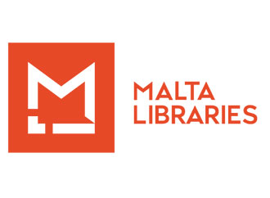
2020 has challenged all of us; we have had to improvise and discover new ways of doing our job but all in all we can say that the challenges have been met with considerable verve and vigour. Our dedicated team has adapted quickly and reached out to make sure that our National Library remains ever more present and available to those who wish to consult its rich collections. We look forward to opening up our doors even more widely in the New Year with renewed hope and refreshed vision; for it is through challenges overcome that we have learnt our best lessons and made our biggest discoveries to date. May 2020 inspire us all to be better and more present!

Malta Libraries are taking the following precautionary procedures with regard to Covid-19:

- Staff given the opportunity for smart-working, especially for vulnerable or those living in households with vulnerable persons or those who shared their working space with more than two persons;

- Researchers accepted by appointment and on alternate days to allow for quarantining of used material;

- Malta Libraries internal and external activities moved online, such as meetings, public lectures, reading sessions, etc.

Then of course, we take the obligatory new measures of hand-sanitising, social distancing and wearing of face masks.

