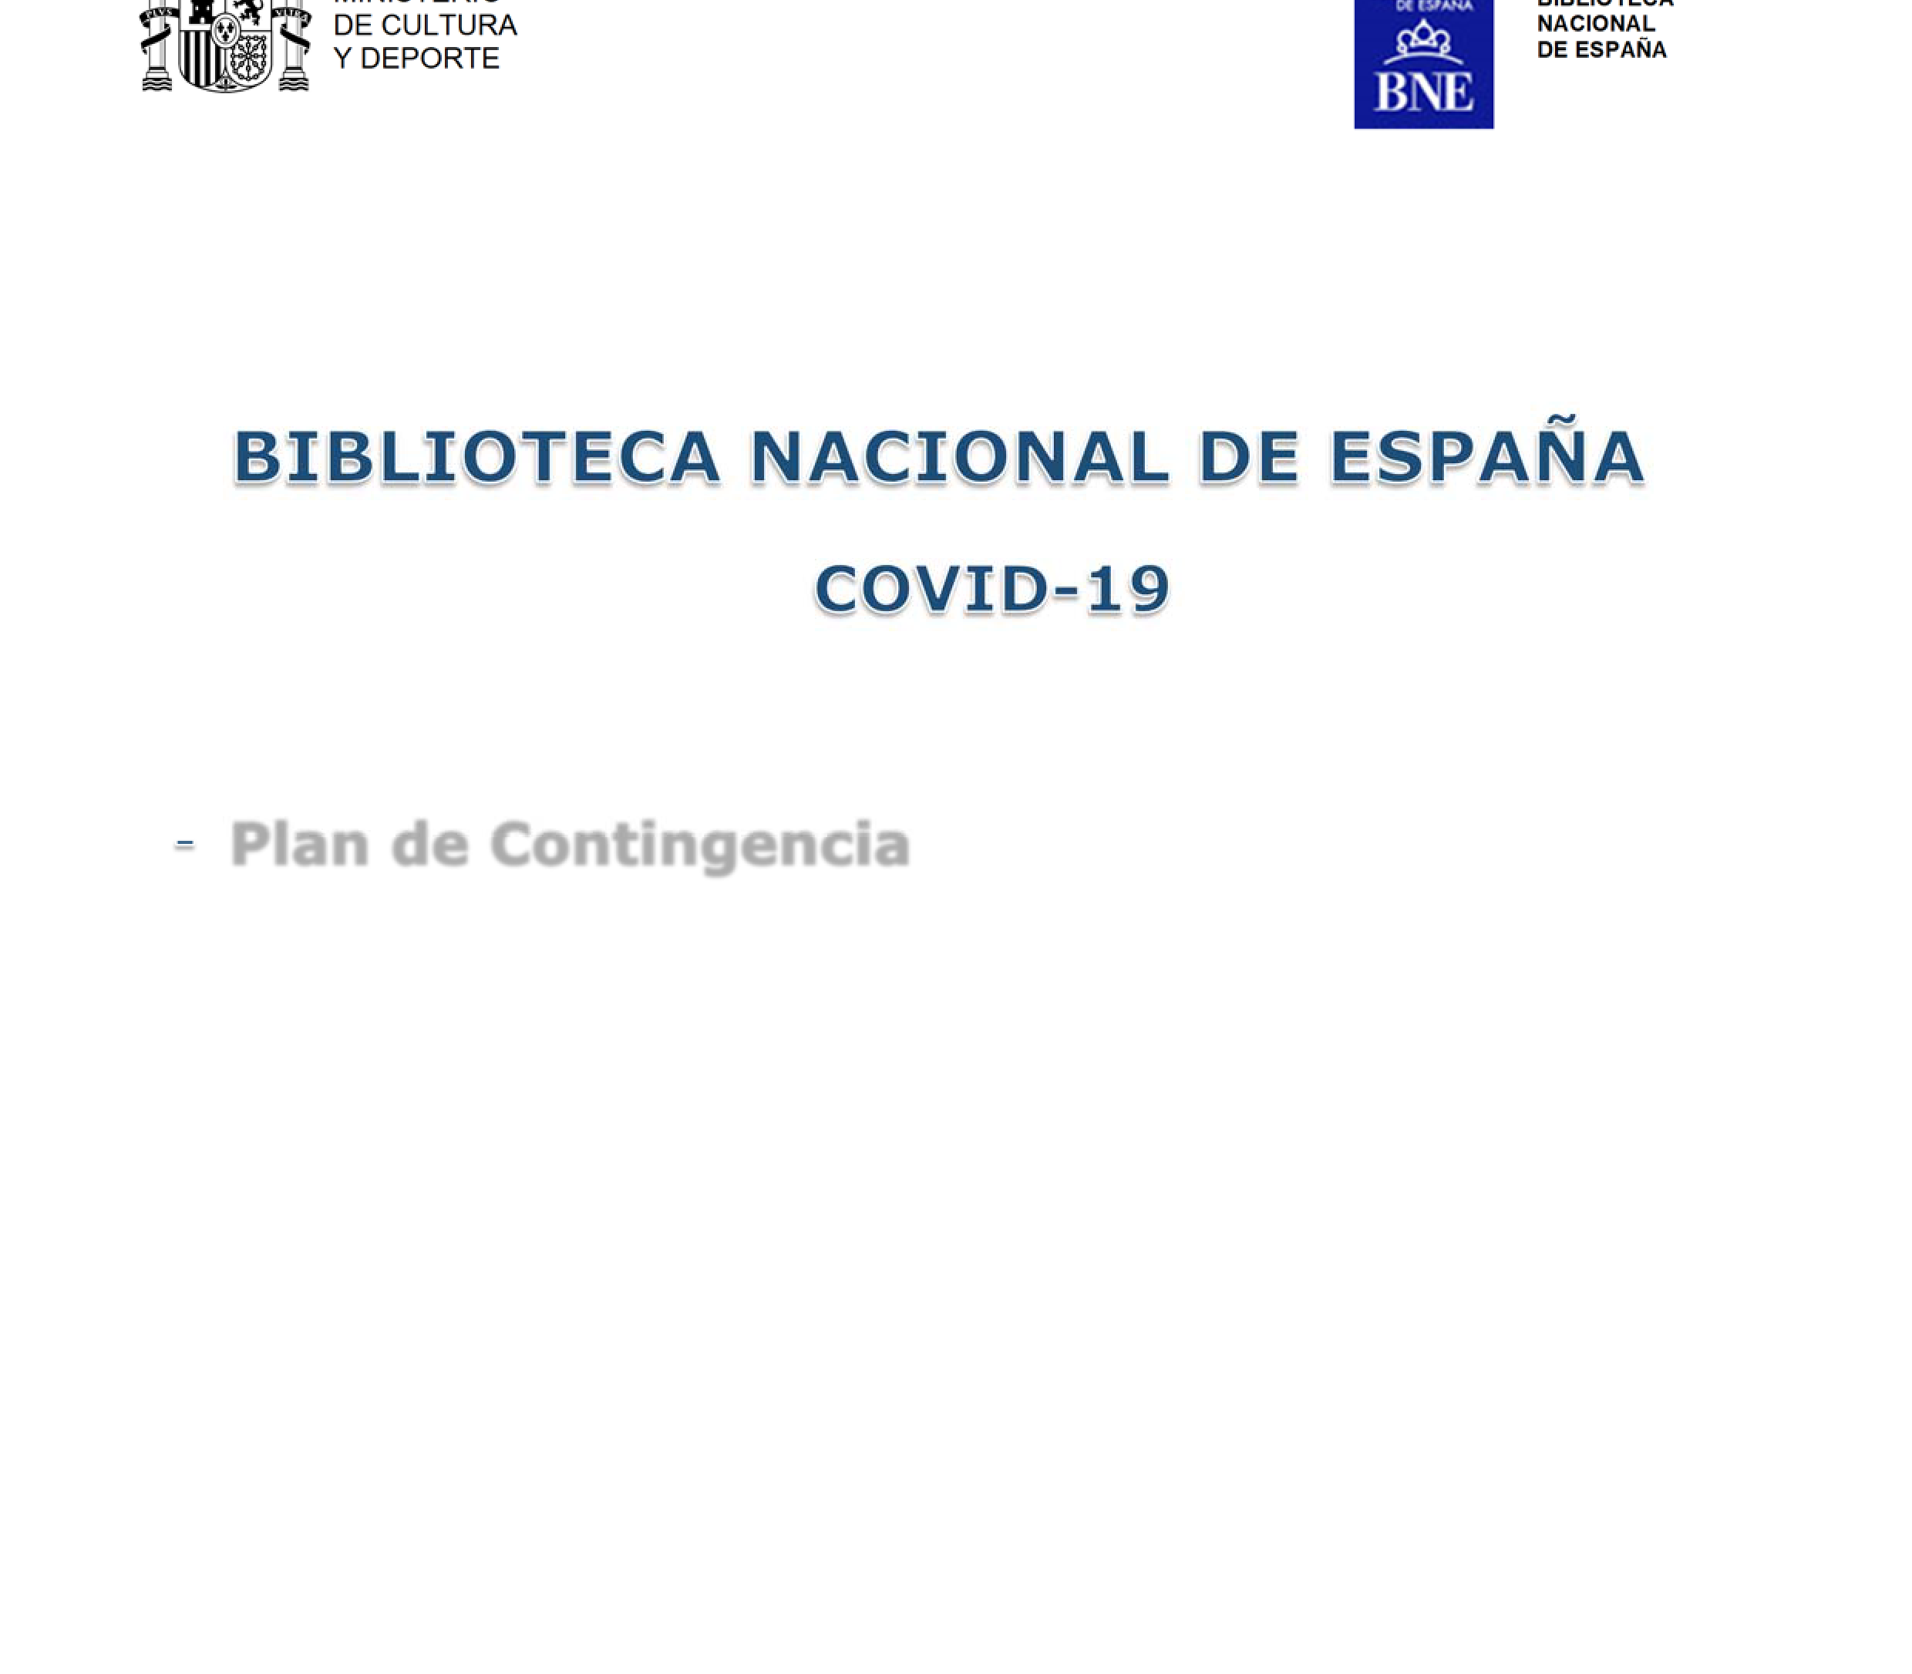
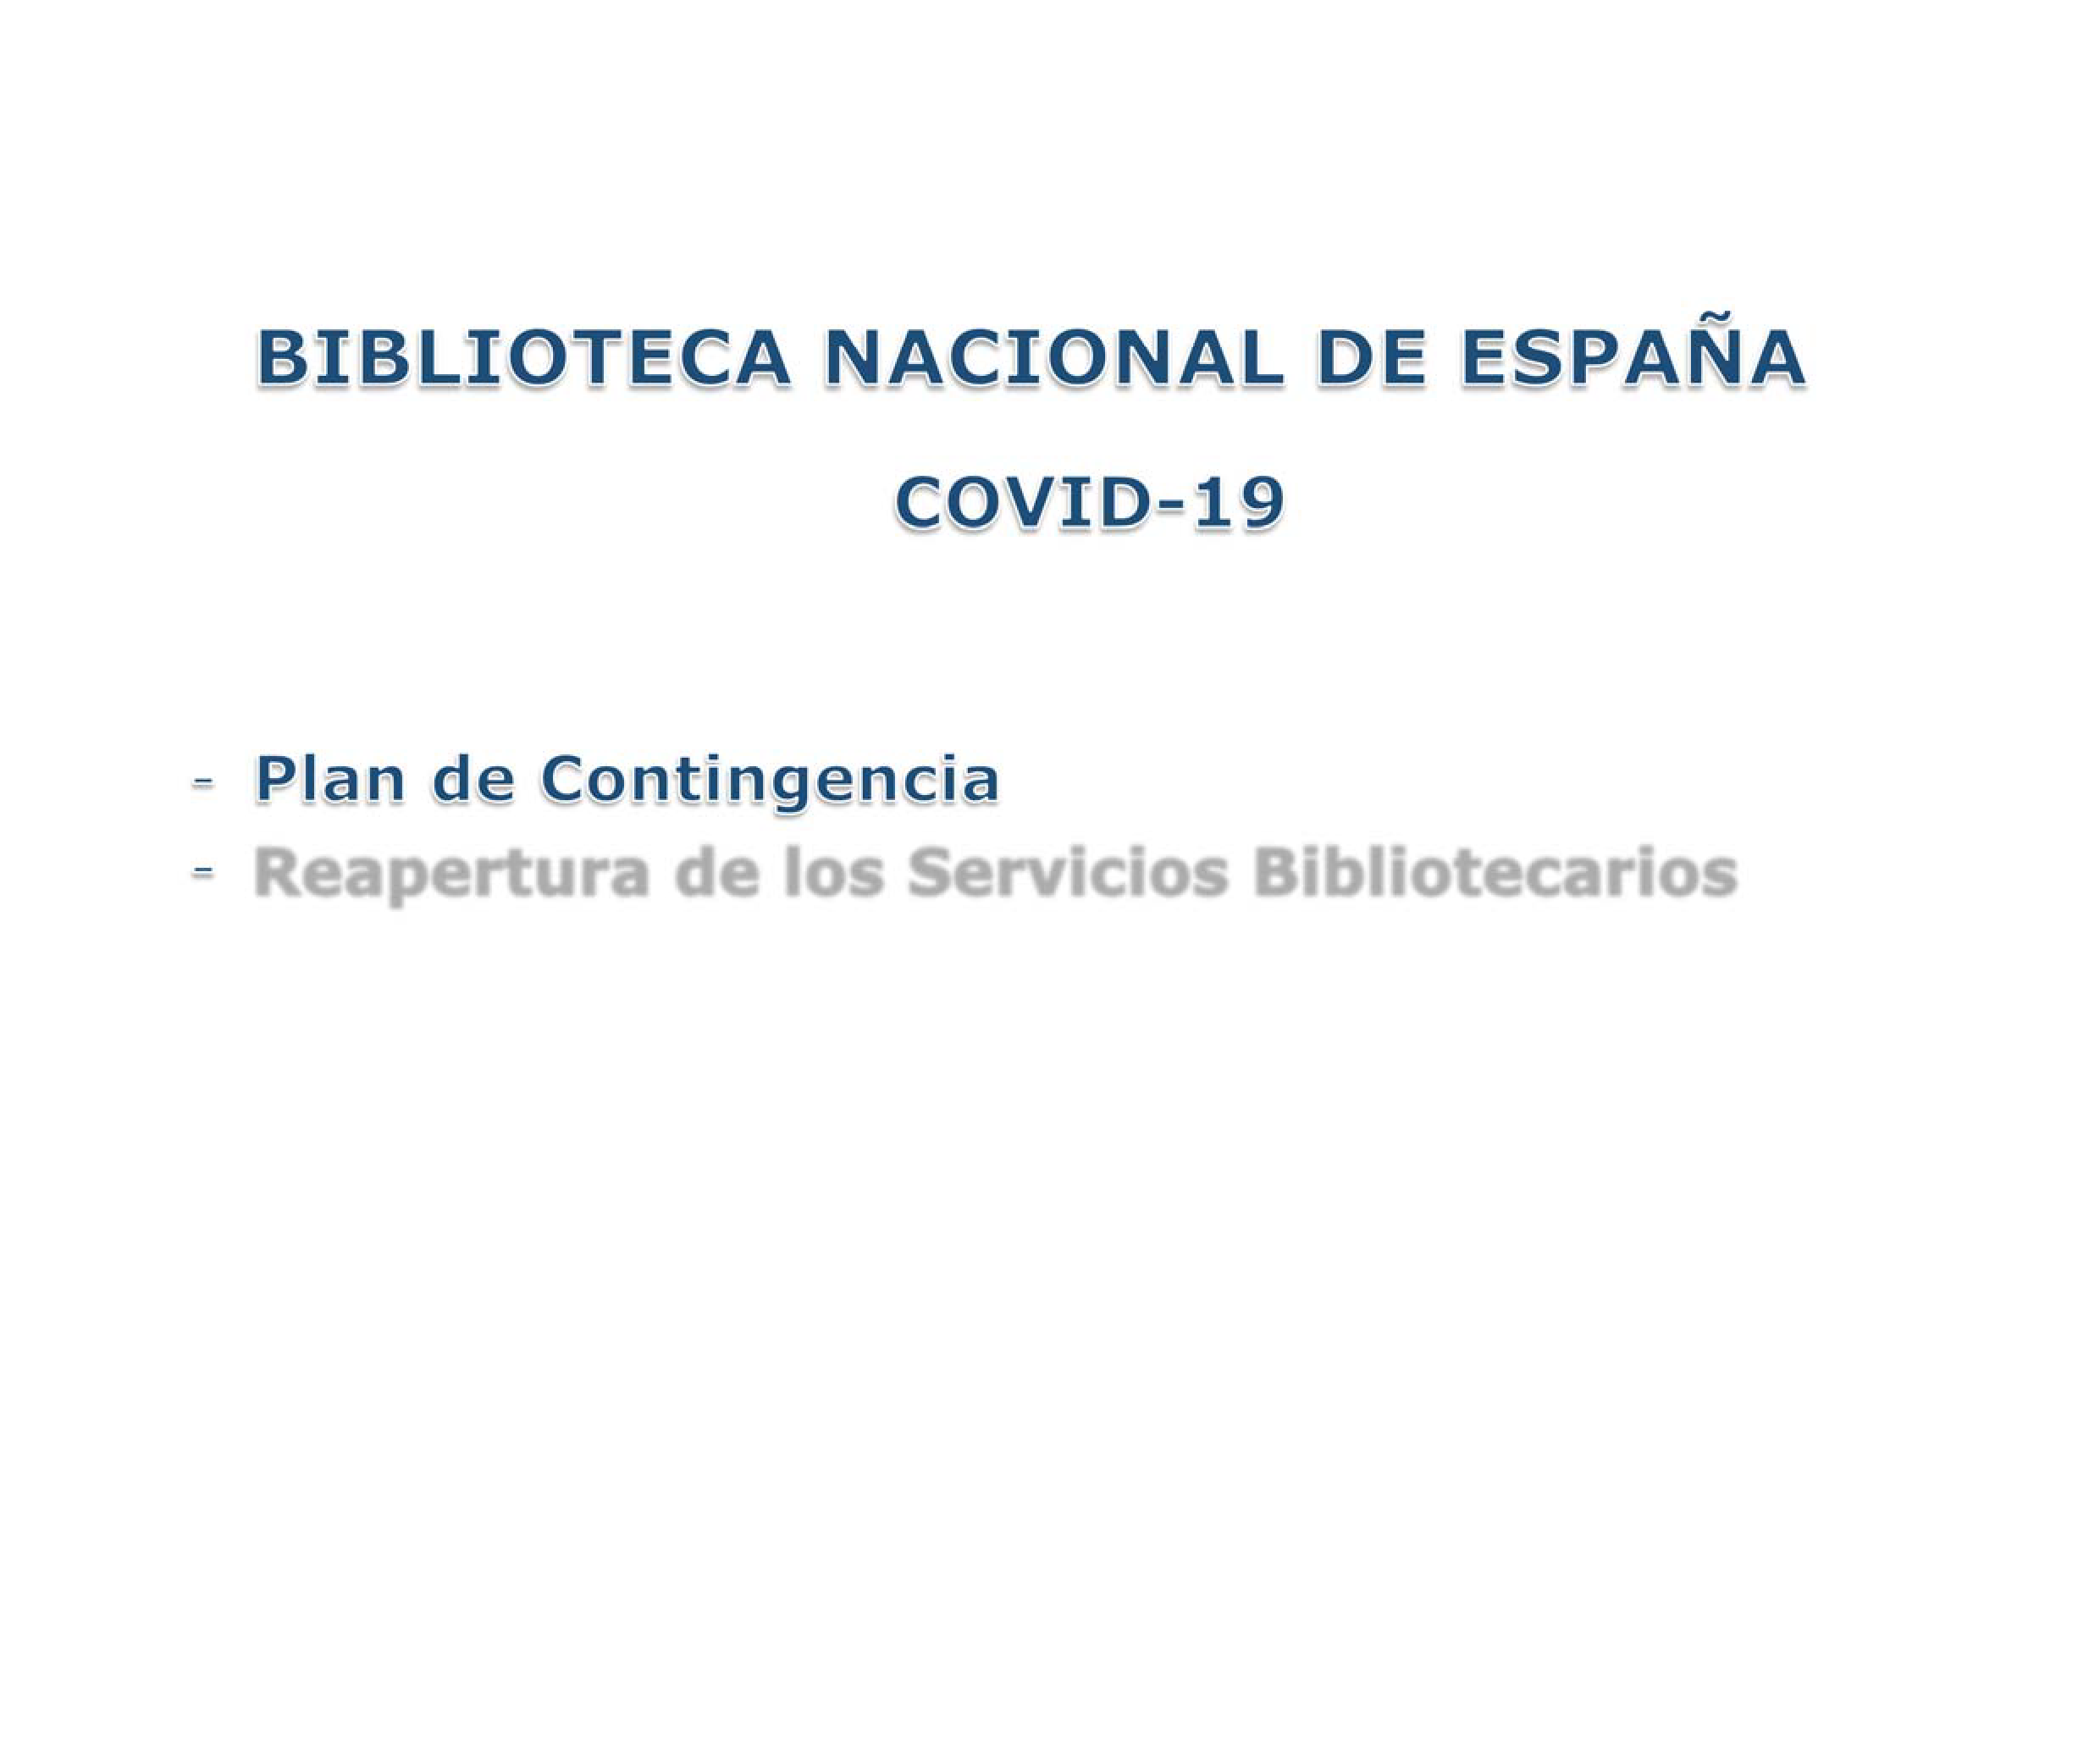
LIBRARY MINISTRY
NATIONAL CULTURE
AND SPORT OF SPAIN

PASEO DE RECOLETOS, 20 28071 MADRID
TEL: 91 580 78 00
FAX: 91 577 56 34

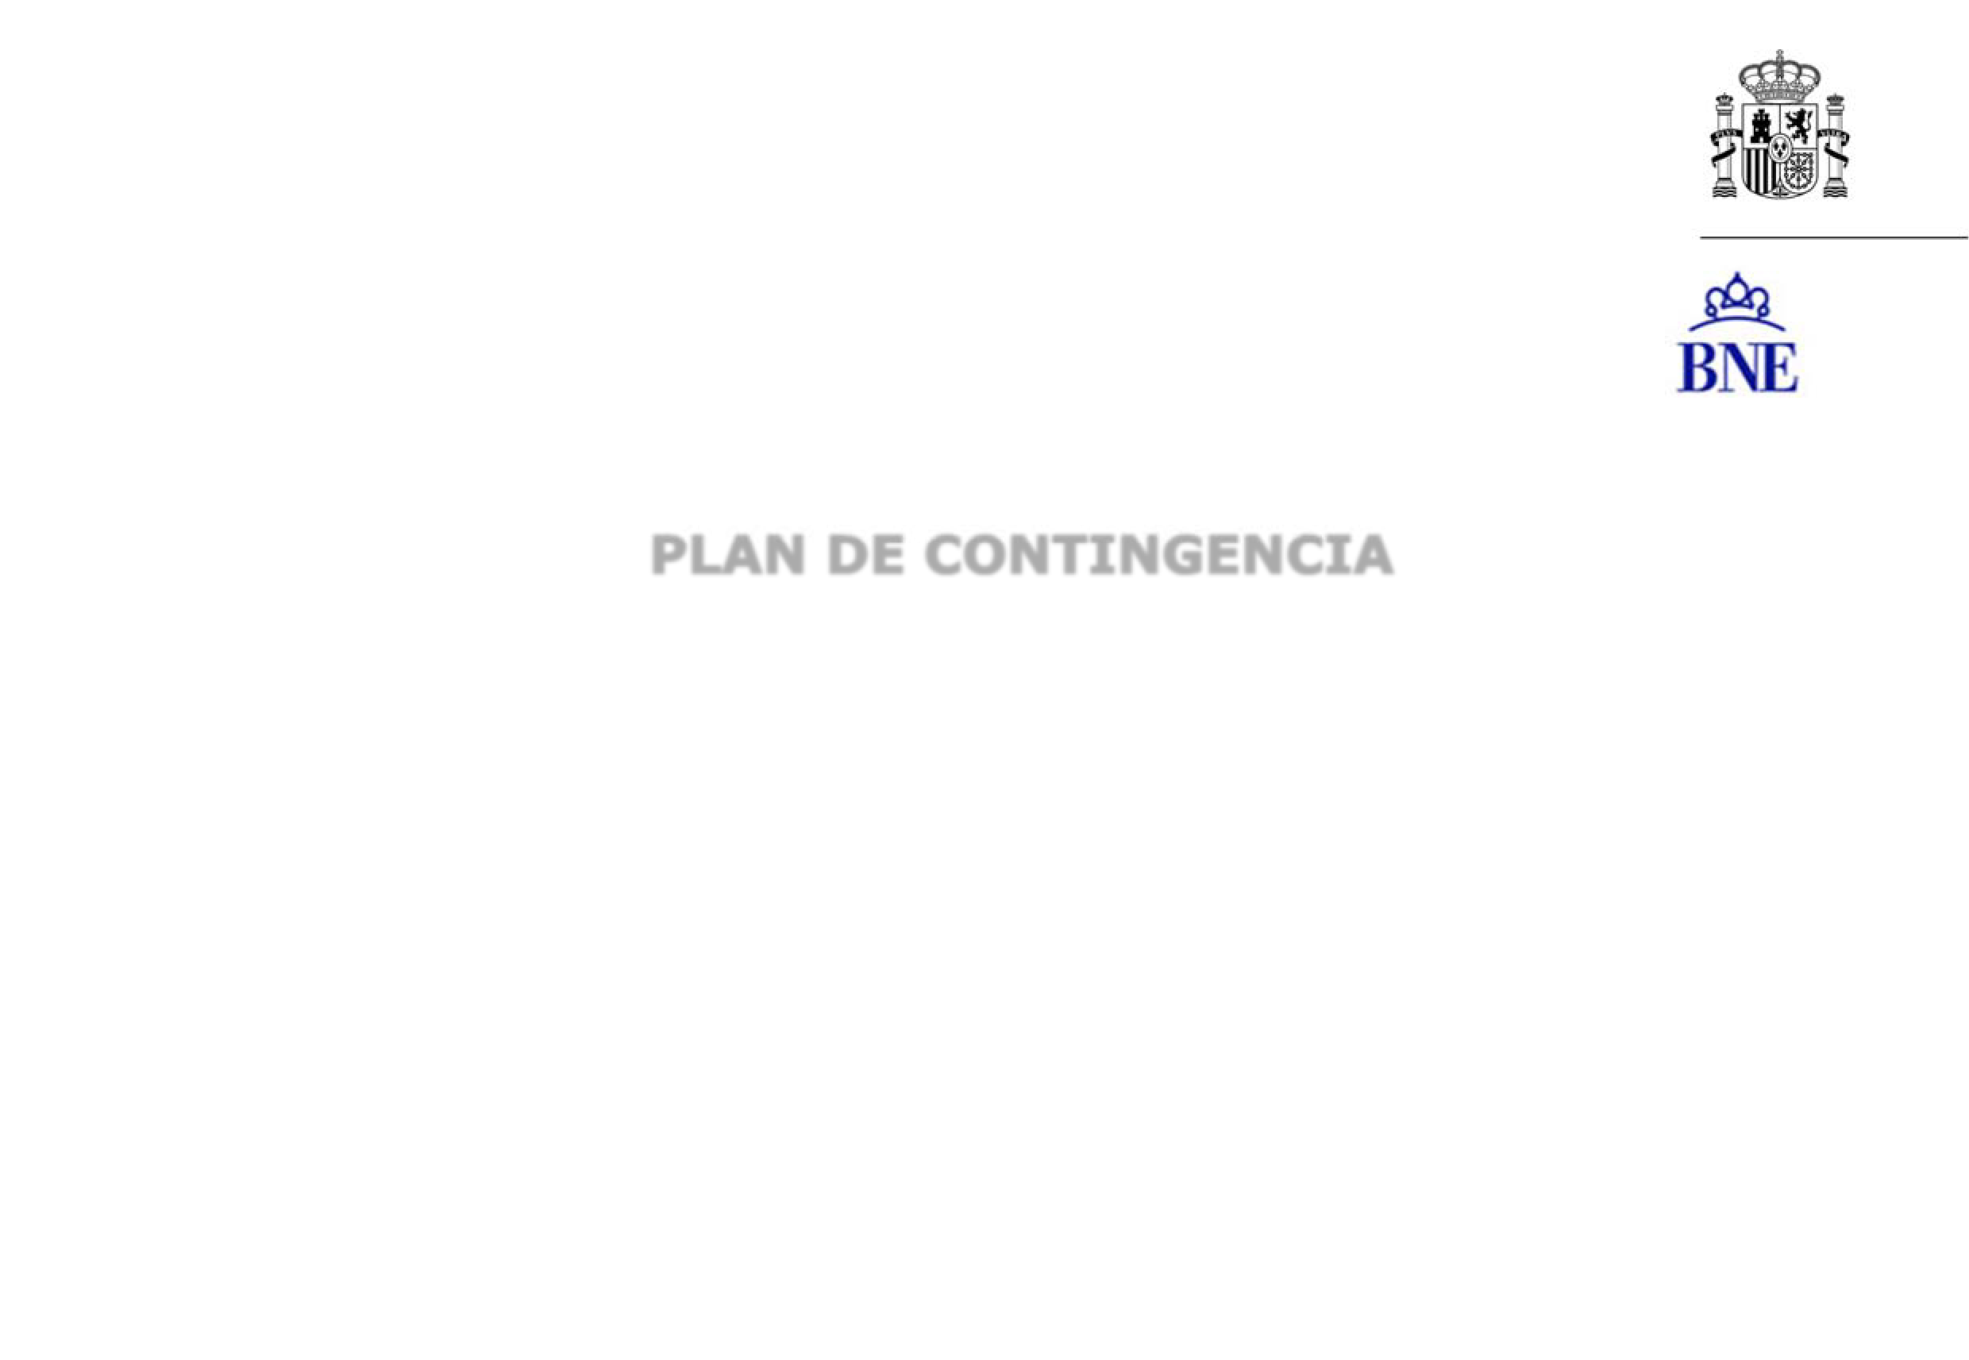

- INTRODUCTION
- ANDDIGITAL STRATEGY
  - Telework Plan
  - Improve Digital Services
  - Infrastructures and Tools
- PROCEDITIONS AND CRITICAL SERVICES
  - Management
    - Essential Services
    - Computer Services
  - Digital Processes and Services Division
    - Essential Services
  - Technical Direction
    - Essential Services
  - Cultural Division
- ANDCONFINEMENT SCENARIO
  - Critical Services (Management)
  - Remote library services
  - Library processes
  - Cultural activity
- OPENINGSCENARIO WITH HEALTH MEASURES
  - Reinstatement of public employees
  - Opening of library service with limitations for face-to-face work
  - Cultural activity
- FUTURO PLAN ESTRATÉGICO

INTRODUCTION

This Plan is carried out on the occasion of the situation raised by COVID-19 and after assessing what happened during the confinement period and the closure of the National Library of Spain which took place between 12 March and 8 June 2020.

Since the pandemic has not yet been overcome, there is still a period of uncertainty that makes us come up with a plan that contemplates various scenarios in anticipation of what might happen in the future, both in the medium and in the long term.

What happened should help us to reflect, to improve and promote the digital strategy undertaken a few years ago and to adapt the services and activities in person. Working on the new Strategic Plan is essential, but it will be of little use to us, if we do not adapt the objectives we already had envisaged to the experience experienced and a future that is uncertain.

In view of this situation this plan has two objectives:

  - Define the essential services and resources necessary for their compliance in the possible scenarios of a new confinement or setback of opening conditions in relation to the evolution of the pandemic.

  - Define and improve the digital strategy and face-to-face services of the BNE in such a way as to achieve a sustainable situation that guarantees the mission, functions and service that the institution must provide in different types of situations.

ANDDIGITAL STRATEGY

Although the National Library has been promoting its digital strategy for several years, the situation that has occurred reinforces us in the idea that it must be prioritized in both internal processes and library services, cultural activities and the drive of projects aimed at providing greater accessibility and use of the collections that are preserved.

This digital strategy is conceived as a cross-cutting process that affects all areas of the institution and that conditions the adoption of solutions to the evidence of the situation produced. Its proper development requires an impetus for the use of ICT technologies, which not only corresponds to an evolution of current services, but responds to new challenges and, in turn, offers new opportunities.

  - PLAN DE TELETRABAJO

The BNE has had a Telework Plan for some years that some public employees have been welcoming. However, the situation at the moment is different so it is necessary to update and adapt it.

This Plan should define the tasks that different posts can carry out through telework, as well as define the necessary level of presence and the mechanisms for assessing the tasks performed.

For its implementation and regulation it is necessary to have the regulations that are being developed from the Public Service and that affects the public employees of the AGE.

The emergence of telework must change the computer park management model. The use of laptops fully connected to the BNE network from any location, with the necessary security guarantees, also involve new needs for remote attention to them. Further deployment of corporate mobile phones may also be necessary for telework communication.

Another need for this telework is to find a video conferencing solution for virtual meetings. Zoom licenses ceded by RedIris are currently being used, but it is necessary to evaluate, together with the IP telephony/Unified Messaging project mentioned later, how this need is handled.

  - MREJORA SERVICIOS DIGITALES

Digital services have become key, so the mechanisms for their improvement have been evaluated.

As a general rule, current applications and tools should be renewed and modernized.

The services and procedures to be renewed and which are in need of new impetus affect:

    - Obsolescence of the library management system: new Library System Platform (PSBI formerly SIGB).
    - Need to improve web content: Boost project renewal of the web.
    - Prioritization of digitization: evaluation of resources and search for alternative models.
    - Reinforcement and consolidation of the digital preservation system as a guarantee of the security of our long-term digital collections and basic source for obtaining reproductions and for online dissemination.
    - Viewer of digital collections. New tool that is more robust and more powerful.
    - Access and management of the Electronic Legal Deposit: improvement in search and access in open.
    - Management of all BNE digital documents: improvement of formats and processes.
    - Increased offering of digital content reuse projects: strengthening distance learning tools. Project boost BNScolar, CommunityBNE.
    - Increase of works by authors in the public domain: Impulse WritersBNE and generation epubs.

  - INFRAESTRUCTURAS Y HERRAMIENTAS

Internal processes are conditioned by the availability of tools and infrastructures that must also be modernized and updated. Its purpose is to improve the teleworking of public employees and provide better communication with users.

To do this it is necessary to:

    - Strengthen network infrastructure
    - Having IP Telephony
    - Improvement of electronic headquarters: upgrade and improvement. Electronic registration.
    - Improves apps for reader and visitor presence control and appointment
    - Dashboard
    - Improves audiovisual infrastructure hall of events
    - Connecting spaces for video conferencing and distance learning

PROCEDIMIENTOS Y SERVICIOS CRÍTICOS

It analyses those procedures and services that are critical to the operation of the BNE, the problems raised during the confinement and the solutions that are expected to be adopted.

  - GERENCIA

ESSENTIAL SERVICES

Essential services are those affecting the basic functioning of the institution, both in a situation of confinement and in openness with restrictions.

Given the transversality of the management carried out through Management, the tasks carried out in all services and sections dependent on Management are essential.

      - Security:
 Control to your BNE entry
 Use of EPI systems
 Implementation of access systems for people with disabilities
 Occupational Risk Prevention Activities
 Maintenance of electronic security systems
      - Maintenance of the facilities:
 Proper ventilation system
 Fire Protection System (PCI)
 Elevator Maintenance
 Temperature and humidity control of rooms and bottoms
      - General affairs:
 Cafeteria: vending machines
 Cleaning: Proper disinfection in accordance with health regulations in the fight against COVID- 19
 Transport Service: Transfer of cultural funds and furniture, including travel with vehicles
 First call to the user and through corporate mailboxes
 adequacy of the registry to the teleworking – electronic system.
      - Information and Communications Systems (see specific section)
      - Human Resources Area:
 And social insurance management
 Information System possible doubts/issues raised by BNE staff
 Processing IT situations

      - Economic Affairs Area:
 Processing of administrative procurement of the BNE
 Accounting and Payroll and Social Insurance
 IRPF Declaration and Payment
 Bill Pay
 Answer to questions raised by the IGAE
      - Legal Affairs Area
 Resolution of complaints filed.
 Analysis of legal issues raised in relation to the functioning of the BNE.

COMPUTER SERVICES

The IT Coordination Unit offers services that support the other digital services of the Library. This provides services both for the outside (BNE users or citizens) and for the interior (workers and internal management services). Proper functioning is essential in the current situation.

Essential services:

      - Operation of the communications network, critical support for all other services. Monitoring and management of communications nodes, routers (internet and Sara Network) and VPN.
      - Operation of security systems. Monitoring and management of firewalls, balancers and CCN probe
      - Operation of system infrastructure. Monitoring of critical servers, storage system, backup system, Active Directory, email, network drives.
      - Exploitation and monitoring services to the citizen. Web, Electronic Headquarters, Catalogue, Hispanic Digital Library, Digital Library, Electronic Legal Deposit, other web portals, Spanish Web Archive, remote library services, etc.

      - Exploitation and monitoring of internal services. Vertical management applications (Reproduction of Integral Funds, Advance Request for Documents, Event Management, Exhibition Management, Management of Web Archiving Collections, NetArchiveSuite, etc.) and horizontal (Intranet, Sancho, Sorolla, SIC3, SILTRA, Badaral, Nedaes, SIGP, Geiser, Docelweb, Portafirmas, etc.)
      - Attention to users and resolution of incidents.

A Unit Contingency Plan has been developed, which includes the internal management tools necessary for the operation of the unit, the prioritization of daily tasks to be carried out according to the criticality of the services with the points to be reviewed for each of the levels. A review procedure has been developed for each of them.

  - DIVISION DE PROCESOS Y SERVICIOS DIGITALES

    - ESSENTIAL SERVICES

The Digital Processes and Services Division manages several essential BNE services that must be kept operational even in the contingency of a new BNE confinement and closure:

      - Bibliographic catalogue
      - Institutional website and portals
      - Dissemination of content and contact with users through social networks
      - Hispanic Digital Library
      - Contact mailboxes

  - DIRECCION TECNICA

    - ESSENTIAL SERVICES

In a very summary and schematic way, five large lines of work of the Technical Directorate can be established:

      - Deposit of collections by purchase, redemption, donation and legal deposit.
      - Technical process of the re-entry collections and the historical collection pending cataloging.
      - Preservation and preservation of collections.
      - Dissemination of collections through face-to-face and virtual library services.
      - Collaboration with other BNE units in essential processes such as digitization, digital dissemination of collections and holding exhibitions.

While virtually all services are essential to the BNE's mission under its Regulatory Law, the following could be noted as the main ones:

      - Receiving legal deposit income
      - Cataloguing and depositing such income
      - Ensuring the conservation of collections
      - Access to the document in person or virtually (through the document delivery service)

The essential services of the Technical Directorate have been affected in the situation of confinement, but a number of fundamental tasks have been determined that librarians have carried out through telework.

  - DIVISISON CULTURAL

    - ESSENTIAL SERVICES

The Cultural Division is responsible for planning, coordinating and developing the exhibitions - own and external - of the BNE and its cultural activities; coordination and management of the Library's editorial program; and responsible for the dissemination of BNE collections and teaching actions aimed at the general public and school.

The following services are considered essential for the implementation of the maintenance of projects aimed at promoting the pedagogical and cultural dissemination function of the National Library of Spain:

      - Cultural activities:
      - BNE editorial program: management and processing
      - Exhibitions: maintenance of tasks aimed at managing own exposures and external loans
      - Museum: collection maintenance efforts

ANDSCENARIO DE CONFINAMIENTO

PROCEDIMIENTOS Y SERVICIOS INTERNOS

These procedures and services are considered critical in any circumstance, but in a scenario of closure of the institution the persons responsible must have the capacity to carry out their tasks remotely and have the necessary means to do so.

Definition of jobs whose tasks can be performed remotely. To do this it is necessary and responsibility for it services:
- Maintain the possibility of teleworking 100% of the human team
- Provide the workforce with the necessary devices to be able to develop by telework 100% of the work done in person
- Keep the internal communication network operational
- Keep operational the networked tools necessary for the management of internal work (IGAE, Badaral applications, signature holders...) and public digital platforms (catalogue, web, intranet, blog, Library and Digital Library, etc.)
- Keep access safely for external staff who maintain digital applications and services (digital preservation, digital library and library...)

- Having a corporate tool for virtual meetings
- Monitor and evaluate tasks performed remotely: develop tool that facilitates it

In addition, the attention of all corporate mailboxes, as well as telephone support for information telephones, should be ensured.

  - SERVICIOS CRÍTICOS → GERENCIA

During the regular operation of the BNE, and therefore also during a crisis situation, the participation of public employees and external staff is necessary for the provision of these services.

The following services shall be provided in person:

    - SEGURIDAD
      - Headquarters Recoletos:
Four (4) people from 8 to 20 hours
Three (3) people from 20 to 8 hours
      - Alcalá Headquarters:
Two (2) people 24 hours a day
    - MANTENIMIENTO
      - Headquarters Recoletos:
Four (4) day shift operators
One (1) night shift operator
Weekends one (1) 24-hour operator
      - Alcalá Headquarters:
One (1) day shift operator
    - TRANSPORTES
      - Headquarters Recoletos:
Two (2) people 24 hours

    - LIMPIEZA
      - Headquarters Recoletos:
One (1) person 12 hours
      - Alcalá Headquarters:
One (1) person 12 hours
    - EXPLOTATION OF SISTEMAS DE INFORMATION AND COMUNICATIONS
Given the nature of these services, interventions will preferably be carried out remotely. In the event that this option is not feasible, the presence of the Heads of Service involved, as well as the necessary technicians (internal or external) will be required for the restoration of the services.

Likewise, depending on the case of the computer incidents of users, the permanent presence of at least one technician from the ICU User Service Center will be required.

INCIDENCES: COORDINATION AND PROCEDURE OF ACTION

  - SEGURIDAD Y MANTENIMIENTO

The coordination of these incidents will be the responsibility of the Director of the Security and Maintenance Area.

Postman service (documents, packages and letters that come in physical format): weekly pickup, can be taken care of by person of the Registry.

Vending machines need to be recharged, so the cafeteria contract, even if the cafeteria staff does not come, must be kept at an appropriate percentage to provide this service.

  - SERVICIOS BIBLIOTECARIOS A DISTANCIA

All library services will be kept running remotely

- Access to the bibliographic catalogue.
- Access to digitized collections through Hispanic Digital Library, Digital Library and Electronic Legal Deposit.
- Attention to consultations of bibliographic information and general information.
- In the case of the Document Supply Service, the presence of staff in the BNE may not be suspended (in this case) and new reproductions could not be made, although, if it is possible to access all the storage units of the BNE, this service could be provided on the documents already reproduced with which the BNE has.
- REGISTRATION OF ISSN and ISNI.
- Attention to all professional consultations.
- Communication and dissemination on social networks.
- Updated institutional website.
- Updated corporate intranet.
- Reuse projects: BNScolar and ComunidadBNE.
- Advance request for documents.
- Remote license application.
- Request for donation.
- Suggestion of purchase.
- Application for internships.

  - PLIBRARIAN ROCESOS

In the event of confinement measures preventing staff from assisting the BNE facilities, the functions of the Technical Directorate, by their very nature, would be greatly affected. The main processes and work of this unit are closely linked to the presence at the headquarters of the Library: the technical process of the documents, the attention to users in the room and the management of deposits are the usual and essential tasks of the institution that does not

can be carried out without being physically located in the buildings of both BNE headquarters. All other tasks to support the digitization of collections and the holding of exhibitions would also be suspended.

Faced with the impossibility of going to the Library in person, practically the only possibility is to focus on all the usual work that can be done remotely and try to devote more efforts to tasks that are usually secondary to those described above. In a very short way, the work that can be carried out are:

    - Administrative processing of all kinds: agreements, contracts, purchases, donations...
    - Preparation of technical and policy documents of each Department as well as reports, reports or strategic documents.
    - Cataloging of electronic documents.
    - Attention of institutional mailboxes.
    - Translation of professional documents.
    - Collaboration in reuse projects.
    - Participation in national and international working groups.
    - Preparation of content for the blog or social networks of the Library.
    - Correction or review of bibliographic records
    - Review of contents on the website.
    - Self.

The services that from Technical Management could continue to be served in this scenario are:

    - Bibliographical, professional and general information.
    - Attention of institutional mailboxes.
    - Assignment of ISSN and ISNI.
    - Supply of already digitized documents to users.

PROBLEMATICS RAISED

A consequence of the closure of the facilities may be the accumulation of works received under the Legal Deposit. In view of this situation, from the Legal Deposit Service, as was done during the confinement that took place in March, the different provincial legal deposit offices would be contacted to ensure that they do not send to the BNE the documents they received until the BNE was not reopened. In any case, if any office needed to forward documents to the Library, a space for those documents would be enabled, in collaboration with the Security and Maintenance Area, pending the reinstatement of library staff.

This situation may cause delays in the documentation of the legal deposit, when irregular shipments occur. Although it is a difficult circumstance to avoid, the BNE is in a relatively good position to deal with it. Three Departments are mainly involved in the management of the Legal Deposit: Acquisitions, Bibliographic Control of Journals and Technical Process. Of the three, two already have a contract for the legal deposit process over the next few years and the third (Technical Process) is close to finalizing a contract on the same terms for modern monographs and other materials that enter by Legal Deposit, such as cartographic documents, video recordings, posters or sound documents. This implies that, while changes in the pace of shipment by legal deposit offices can lead to accumulations of documents, the possibility of resurbing the process of documents as soon as possible is possible to be physically in the BNE and to have a contract that in its object addresses the production of a sufficient number of bibliographic records. It is therefore possible to accumulate a certain delay in the technical process of the documents on time, but, in general terms, the institution is in a willingness to process everything that is received.

In the case of the Document Supply Service, the presence of staff in the BNE may not be suspended (in this case) and new reproductions could not be made, although, if it is possible to access all the storage units of the BNE, this service could be provided on the documents already reproduced with which the BNE has.

In the event of confinement measures preventing staff from assisting BNE facilities, the functions of the Digital Processes and Services Division, by their very nature, should not be greatly affected. The processes and work of this Division are oriented to the digital environment and to service through the Internet. The maintenance of the tasks and the management of the tools that support them are mostly accessible and manageable through remote access to the BNE network.

Only the digitization of funds, which is performed in the Library's Photography and Digitization Laboratories, would be suspended if workers are unable to go to their workplace.

Therefore, the tasks that can be developed remotely and the services that can continue to be provided are as follows:

    - Catalog maintenance.
    - Maintenance and publication of content on the institutional website and other portals.
    - Updating content on the corporate intranet.
    - Maintenance of web contact mailboxes.
    - Update content on the BNE blog.
    - Dissemination of content on the social media of the BNE: Twitter, Facebook, Instagram and LinkedIn.
    - Receipt of the electronic legal deposit (DLe).
    - Technical process and ingestion in the catalog of publications entered by DLe (in collaboration with Technical Directorate).
    - Load the DLe of deposited electronic documents into Pandora's environment.
    - Web collections and management of the collections generated.
    - I work in collaboration with regional conservation centers for the management of electronic legal deposit.
    - BDH upload of scanned documents.
    - Management and organization of network units with digital funds.

    - Preparation of intakes and loads in the digital preservation environment.
    - Attention of institutional mailboxes.
    - Management of reuse projects: mainly CommunityBNE and BNScolar.
    - Participation in national and international working groups and virtual events.
    - Obtaining and analyzing statistical data on digital services.
    - Provide digital document playback to users who request them, as long as they are already scanned.
    - Preparation of procedures related to the services and tasks of all units under the Division.

  - ACTIVIDAD CULTURAL

In a confinement scenario, cultural activity would be suspended. However, a number of tasks can be developed aimed at increasing the contents of the BNE website and improving the dissemination of exhibitions and activities over the Internet. In particular, the following activities would be carried out:

- Improvement and increase of virtual tours of exhibitions and the rooms of the Museum.
- In collaboration with the Departments, performing cross-cutting virtual samples taking advantage of digitized collections which can allow a better knowledge and dissemination of the copies.
- Cultural events through computer tools.
- Generation of digital content for web and social networks
- Virtual tours with contents on the web, before the visit that can be used for the scheduling of the visit, which even proposes certain itineraries according to the interests or time available of the visitor.

ESCENARIO DE APERTURA CON MEDIDAS SANITARIAS

This scenario will necessarily be conditioned by the measures and conditions for opening public and cultural spaces available to health authorities. The institution has a Reopening Plan, agreed with trade union representatives and the measures envisaged will be scrupulously respected.

In any case, the following conditions must always be taken into account:

- Reduction and control of capacity in all public spaces, both reading rooms and researchers and exhibition halls.
- Hygienic protective measures for both workers and readers, researchers and visitors.

  - REINCORPORACIÓN DE EMPLEADOS

The return to the job of public employees will be carried out in accordance with the measures issued by the Ministry of Culture and Sport and by Public Service.

These measures, adapted to the circumstances of the National Library, are those that have been taking place since 8 June.

General criteria:

    - Remote tasks have been defined by the different jobs, as well as indicators for evaluation.
    - The Deputy Directors authorize the attendance and telework time of each employee, according to the tasks and special circumstances of the Departments. Persons who perform responsibility and coordination of work teams such as Area Heads, Department Directors and Service Heads should be incorporated on a regular basis, at least 50% of the day.

However, these measures will be subject to an evaluation process in accordance with developments.

  - APERTURA OF PUBLIC SERVICE
WITH LIMITATIONS FOR FACE-TO-FACE WORK

The service to readers and researchers in the reading rooms would be provided by appointment, as has been done since 8 June and the same procedures would be followed: Technical Management Procedures for the reopening of the BNE during Phase II of the de-scalding, Coordination of the Technical Directorate with the Area of Security and Maintenance, Conditions of library services during Phase II of the transition to a new normal.

As has happened de facto since the reopening on 8 June, the following internal procedures and services could be reactivated:

- Deposit of collections by purchase, redemption, donation and legal deposit.
- Technical process of the re-entry collections and the historical collection pending cataloging.
- Preservation and preservation of collections.
- Dissemination of collections through face-to-face and virtual library services.
- Collaboration with other BNE units in essential processes such as digitization, digital dissemination of collections and holding exhibitions.
- Boosting and reactivating digitization, which would allow the service of requesting the reproduction of documents to those who were not yet digitized.

  - ACTIVIDAD CULTURAL

Cultural activity should be implemented in accordance with the health protocols defined by the Ministry of Health.

In addition to capacity control and special hygiene and cleaning measures, a number of actions will be encouraged to improve activities in current circumstances. Specifically:

- Booking tickets over the Internet, which will allow you to control capacity in both exhibitions and other cultural activities.
- Development of ICT-based projects as a means of improving the visitor experience and supporting and reinforcing exhibition and pedagogical discourse.
- Development of a model of autonomous guided tour, to the BNE and Museum. These autonomous visits can be either by downloading audio content for mobile or other devices, or with QR code readings.
- Transformation of audio guide services into "deviceless services".
- Adaptation of publications to a digital edition, which allows telematic access of users.

FUTURO PLAN ESTRATÉGICO

Lines outlined prior to the pandemic can serve us in part, but they need to be adapted and improved.

We must also work on the objectives and under no circumstances should we do so alone. Just listening to the demand is going to allow us to get it right on what we have to achieve.

TOSPECIFICCTUATIONS

  - Review of Plan lines
  - Development of a new document with greater explanatory content
  - Definition of groups and planning of meetings
  - Inform the Board of Trustees
  - Convene the Scientific Commission

REOPENING LIBRARY SERVICES AFTER CONFINEMENT

On 12 March, the BNE was forced to close its face-to-face services on the occasion of the health alert caused by the expansion of the SARS-CoV-2 coronavirus. This has remained until on 8 June the Library these services could be reopened, following the different regulations developed by the Ministry of Health and the Ministry of Culture and Sport.

Conditions for the provision of services:

In short, these opening conditions have been the need to make the advance request for documents or the license and to receive an appointment from library staff; the limitation of capacity to 30% of the Chambers; reducing hours of eight hours between 10 a.m. and 6:00; and the limitation of the stay in the room for the consultation of the documents, the study is prohibited. Likewise, all necessary hygienic-health measures have been taken to reduce as much as possible the risk of contagion of workers and users.

Organizational measures:

Given the capacity constraints, two shifts of consultation of funds were initially forees: from 10.00 to
  - and 14.00 to 18.00, in order to be able to serve a greater number of people. The idea was to be able to have 30% of the capacity in the morning and another 30% in the afternoon. After the first days of operation it became clear that this distinction was not necessary in the Salon General María Moliner, since the capacity of 30% was not reached so that in that Chamber it is not applied, so that there the consultation shifts are eight hours. In any case, during this period any user who requested extensions in the assigned consultation time, has been allowed to have it, whatever room in which he made the request. It should be noted that, although the service was reopened on the 8th, until day 9 the first users did not attend, as the appointment was necessary.

Another organizational decision that has been made in this period was to serve the funds in press and magazine paper in the Maria Moliner Salon, the Larra Room remains only for users who had to consult microfilms. The same has been done with requests for Bibliographic Information funds that have been served at the Maria Moliner Salon. This measure has made it possible to provide access services to these funds despite the personnel limitations arising from the instructions for the gradual incorporation of public employees, further minimizing user transit spaces and the need for disinfection by the cleaning service.
Together with the fund consultation service, the creation of cards (also by appointment) and the Document Supply service were also resumed. The latter Service, while not face-to-face, was not possible without the presence on the premises of the staff of the scanning laboratory. Given the mobility restrictions that have existed and, in general, the recommendation to limit movements, this Service is particularly relevant to facilitate the consultation of funds to those who are not able to move to the Library. In this sense, instructions were also given to facilitate self-copying by users in order to avoid requests for reproduction that could be made by the users themselves who were in the BNE.
A communication protocol between Technical Management and Safety and Maintenance was also established in order for this Area to have in advance the user relationship as well as to ensure the disinfection of all positions that required it.
Finally, coordination with the headquarters of Alcalá de Henares was ensured to ensure that the funds requested there were served in Recoletos without problem.

Occupation of the Rooms:

In this period a total of 1,360 users have come to the BNE to all consultation rooms. This represents an "medium" capacity of 20% (up from the maximum of 30%). By Rooms the level of occupancy varies quite significantly.

 | Users | Percentage of occupancy
Maria Moliner Reading Room | 991 | 20,11%
Sala Cervantes | 152 | 39,58%
Sala Goya | 132 | 45,83%
Barbieri Room | 25 | 6,01%
Larra room (microfilms only) | 60 | 7,65%
Total | 1360 | 20,00%

It should be noted that the average rate is affected down by the first few days when fewer appointments were made (because fewer were requested). Likewise, the Barbieri Room is most affected by the limitations that existed to the consultation of documents in breeders for public use and was also closed for two days as there was a suspicious case in a worker (which later turned out to be negative). In any case, appointments are always being made for the day following receipt of the application or, at most, two days later in exceptional cases.
It can be seen that the Salas Cervantes and Goya have percentages greater than 30%. This is due to the establishment of two shifts, which allowed to cite in one day up to a maximum of 60% of the capacity, if necessary.

As for the number of document loans, the figures are as follows:

Maria Moliner Reading Room | 1614
Sala Cervantes | 350
Sala Goya | 236
Barbieri Room | 36
Larra room (microfilms only) | 88
Total | 2324

It should be added that a total of 290 IDs have been processed during this period; of these, 161 are new, 6 are lost and 123 are renovations.

Supply of documents:

As mentioned above, a highly demanded Service has been that of Document Supply, which has been closed during the term of the closure of face-to-face services. On the one hand, some tasks of the Service staff have been adapted such as:
    - Signature and sending of invoices digitally.
    - Online access to the movements of Bank of Spain accounts.
    - Sending by certified mail or digital download of applications prior to June 8, as the applicant now chooses. From June 8th you can request only digital download.
    - Collection of data for room reports by Photocopying staff to the public.

As for the operating data:

    - Requests received since 8 June: 1,351. Of these, 27 are for private use, 1,094 for research, 136 for commercial public use, 35 for non-commercial public use and 39 for academic use.
    - States requests made since 8 June: In this period 88 applicants have already been handed over, 344 are in the Laboratory right now, 314 are pending the room report and 89 are pending payment by applicants.
    - Budget shipping: 392
    - Sending invoices: 43
    - Budgets paid 275
    - Total revenue recorded since June 8: 11,905.83 euros, of which 7,661.25 euros have been paid by the card payment gateway and 4,244.58 euros by bank transfer (the difference is exemptions granted).
    - Digital Playback Download Notifications: 190
    - Room reports: 737
    - Digital photography lab captures: 446
    - Digital captures made in scanning laboratory: 27,096
    - Digital captures made in reprographic lab: 1,686
    - Paper copies made: 156
    - Images edited in Photography Lab: 80
    - Images edited in Scanning Lab: 17,294
    - Images edited in reprographic lab: 1,180

Conclusions:

The balance sheet for this period can be described as very satisfactory. The BNE has been able to respond to all requests for funds that have been received so far, usually by providing overnight appointments. Thanks to the good collaboration between the Technical Management Departments and the Security and Maintenance Area, small incidents related to information that could be improved on the website or the convenience of quoting at different times have been detected and corrected in order to avoid queues

at the entrance. It should also be noted that the user's own behaviour has generally been very correct and sympathetic to the situation and the measures taken by the Library. So far no complaints have been received regarding the resumed services but, on the contrary, the attention and quality of the services has been highly valued.
This good result must be blamed on the care and interest that from the different rooms has been put in adequate care of the users as well as in resolving their doubts and even small document queries, in order to facilitate their work.

