ANNUAL REPORT TO CENL

YEAR 2019
Name of country: Latvia
Name of library or equivalent national-level organization: National Library of Latvia (NLL)
Name of Chief Executive: Andris Vilks
Name of contact person for international matters: Viktorija Moskina
Mailing address: 3 Mukusalas Street, Riga, LV – 1423, Latvia
Phone: +371 67806100, Fax: +371 67280851
Web address of the Library: http://www.lnb.lv/en
Email address for contacting the library: lnb@lnb.lv; viktorija.moskina@lnb.lv

1. General overview of recent major developments at the National Library of Latvia.
The NLL development strategy for 2019-2023 has been developed and adopted in 2018. The 2019 was the first planning year of the new strategy. In this new strategic period the priority axis of the NLL is the collection – its comprehensive development, conservation and research. The 2019 was the year to identify current situation and needs, and plan next steps for successful fulfilment of defined strategic goals.
In 2019, the NLL celebrated its centenary. Just a year younger than Latvia, it was founded on 29 August 1919 as the State Library of Latvia. There were exhibitions, conferences, concerts and other events dedicated to the centenary throughout the year.
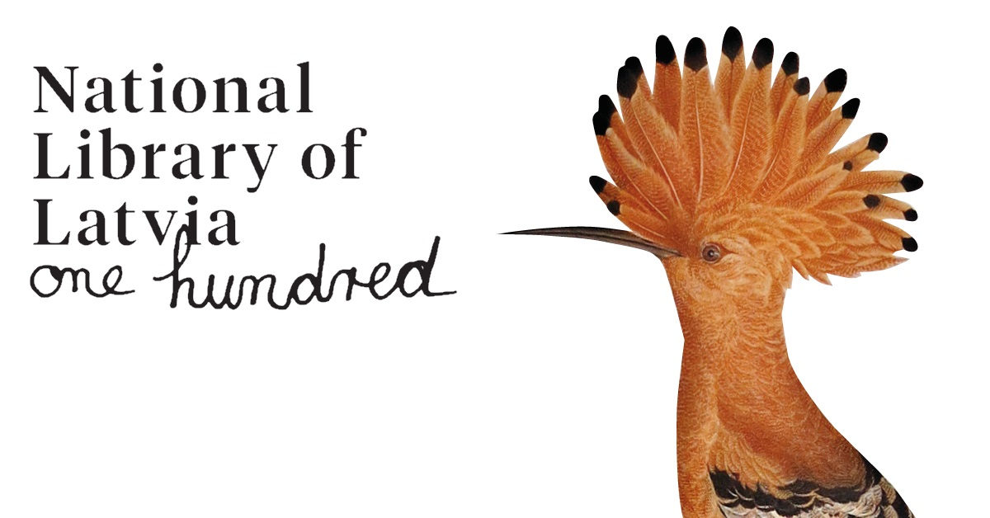

However, the main event of centenary took place on 31 August 2019 and gathered more than 100 partners of the NLL – friends and like-minded institutions who on daily basis maintain sustainable cooperation with the NLL. In collaboration with partner institutions the NLL organized more than 120 activities in a single day and welcomed more than 6000 visitors in total. Events for all ages and interests spread throughout the NLL’s premises (42 000 m2); including those not publicly accessible on a daily basis - repositories, rare book storage, the restoration centre, cellar, and even engineering and utility areas. Invited partners represented the diversity of the Library’s fields and opportunities – popular musicians, artists, scientists, athletes, authorities from various disciplines, such as the Constitutional Court, Samurai Martial Arts Club, Young Scientists Association, Riga International Film Festival, Ornithological Society, State Forests Service, etc. It is because the catchphrase for the NLL’s centenary became: Friendship endures! – paraphrase of Rainis (the famous turn of the 19th- and 20th-century Latvian poet, playwright and politician) who coined a phrase which has become part of national folklore: What changes, endures!
In 2019, the other priority axis of work focused on increasing and strengthening the role of the library in the academic environment and research, as well as in the educational environment. Intensive work has been done on the organization of the NLL scientific activities.
In 2019, the NLL in cooperation with the Institute of Humanities and Social Research of the Vidzeme University of Applied Sciences, has launched a project – The Significance of Documentary Heritage in Creating Synergies between Research and Society – under the national research program Latvia’s Heritage and Future Challenges for the Sustainability of the State. The aim of the project is to conduct interdisciplinary research into the Special Collection of the NLL, including using digital research methods, to update the previously insufficiently researched segments and aspects of Latvian documentary heritage, focusing on those historical periods and issues less studied to date, and overcoming the ethnic and linguistic barriers hampering research. These study results are expected to be approbated in scientific publications (publishing scientific articles, compiling articles and collective-body monographs for publication, organizing an international research conference), as well as being promoted to the public (exhibitions, public lectures and series of readings) – partially already realized in 2019.
In 2019 the NLL continued scientific activities also in digital humanities field. The project – Going beyond Search: Advancing Digital Competences in Libraries and Research Communities – has been developed in cooperation with the Institute of Literature, Folklore and Art of the University of Latvia, Umeå University, National Library of Estonia and National Library of Lithuania. The initiative seeks to foster the dissemination of digital competences in the ALM (archives, libraries and museums) and research communities and strengthen networks among ALM, education, and research sectors in order to improve practices of working with digital content and data analysis tools. As a project milestone in 2019, the Second Baltic Summer School of Digital Humanities took place in the NLL, which program offered must-have introductory courses for digital humanists and digital social scientists who wished to come to grips with programming and text encoding. The course was co-taught by an international team of researchers and practitioners of digital humanities and digital social sciences from Germany, Belgium, Bosnia and Herzegovina, Estonia, Lithuania, and Latvia. The Baltic Summer School of Digital Humanities was supported by the Common Language Resources and Technology Infrastructure (CLARIN) and the State Culture Capital Foundation of Latvia.
In 2019 another project was approved in cooperation with the University of Latvia and it will be launched in 2020 – Latvian Memory Institution Data in the Digital Space: Connecting Cultural Heritage – under the Program of Fundamental and Applied Research implemented by the Latvian Council of Science. The aim of the project is to study and describe "semantic cooperation" potential of cultural heritage institutions in Latvia and test particular models of knowledge management potentially applicable to Latvia’s case based on research of vocabularies and datasets available to the NLL, which have an open data potential and are essential for researchers from humanities, social sciences and their digital sub-fields, as well as arts. The purpose behind this objective is to make heterogeneous data interoperable in a digital space using structured and verified vocabularies and datasets.
In the field of education, the NLL is operating as an institution for continuing vocational education and training registered with the Register of Education Institutions of Latvia. Its educational work is realized according to the NLL Strategy for Educational Activities 2017–2021. In this document, the NLL put forward three basic directions for its educational activities: literacies, culture and science, vocational education and professional development for specialists of library and information science and allied fields.
Between 2018 and 2020, the NLL’s Competence Development Centre, as a partner of the State Education Development Agency, is implementing four educational programs in the library sector funded by European Social Fund project – Improvement of the Vocational Competence of Employed Persons. In total, the NLL organized 507 different educational events in 2019 with 15 395 participants.
In January 2020 the NLL received the traveling award from the Ministry of Education and Science of Latvia for the best work 2019 in adult non-formal education field in Latvia.
The NLL has strong traditions especially that regards to reading promotion - program “The Children, Youth and Parents Jury” was realized already for the nineteenth time. It showed good results in 2019 – in 654 libraries, including – 57 Latvian diaspora centres in 25 countries – Europe, Australia, America and Africa. In total, 80 reading promotion events for children took place with 37 653 participants.
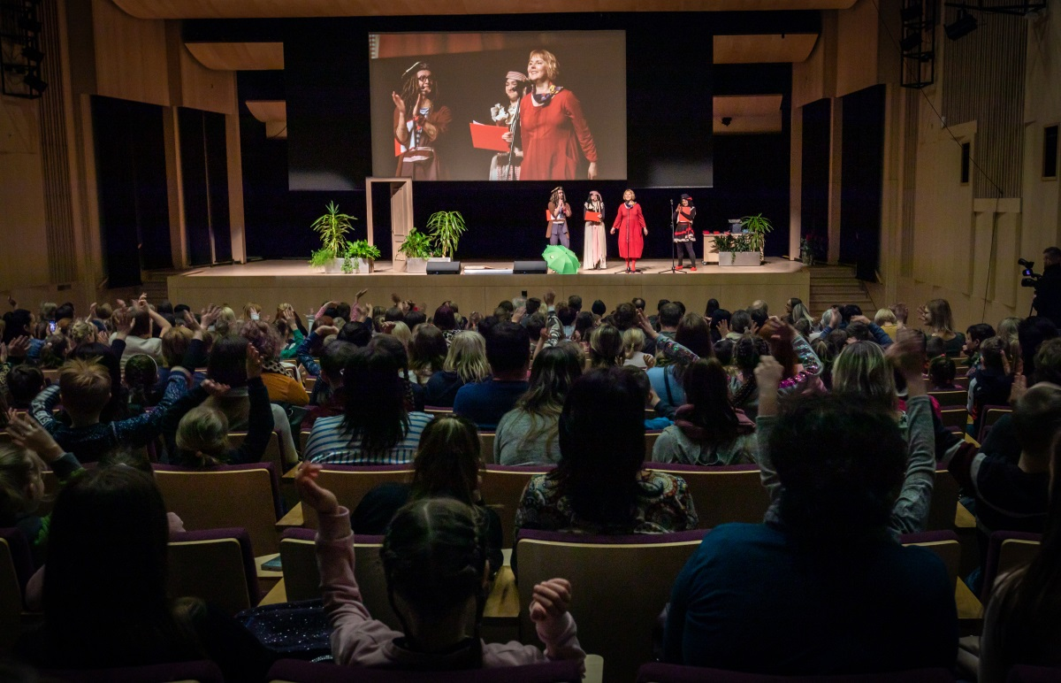
Closing event of “The Children, Youth and Parents Jury 2019” Photo: Kristians Luhaers
Implementation of the project Digitization of the Cultural Heritage Content (the 1st Stage) has been accomplished and the 2nd Stage was launched. The NLL is implementing a four-year (22.09.2017 - 21.09.2021) European Regional Development Fund (ERDF) and nationally co-funded project in the field of Latvia’s digital cultural heritage, together with project partners – the National Archives of Latvia, the State Inspection for Heritage Protection of Latvia, and the Culture Information Systems Centre. The main objective of the project is to ensure the wide availability of Latvian cultural heritage to society in the digital environment, which serves as a basis for strengthening national identity, developing the cultural, scientific, knowledge society and creative industries, and ensuring the long-term preservation of national cultural heritage in digital form, creating opportunities for its repeated use in new products and services, as well as its integration into a unified European and global cultural digital space. More about results in 2019 see in ch.5.

2. The National Library of Latvia relationship to government, citation of legislation, which sets out the library’s mandate, and any other legislation, which directly or indirectly affects the library’s operations.
The NLL is a state institution under supervision of the Ministry of Culture of the Republic of Latvia. The legal mandate for the operations of the NLL is provided by the Law On the National Library of Latvia, as well as the Legal Deposit Law and several regulations of the Cabinet of Ministers on different aspects of library operations. The budget of the library consists of a subsidy provided by the Ministry of Culture according to the annual Law on State Budget, as well as of own income for paid services and other income, such as projects and donations.
The NLL represents Latvia in international library organizations, participates in development and implementation of sector specific international programs, and cooperates with foreign libraries in accordance with inter-governmental and direct agreements. More about international cooperation see in ch.9.

3. Key facts and figures (size of major collections, number of staff, total operating budget, etc.)
Key facts given by 01.01.2020.
Number of registered users: 154 735
Number of on-site visits: 428 721
Number of virtual visits: 2 378 182
Number of loans: 302 644
Collection (total number of units): 4 240 976
books: 1 984 711
serials: 859 667
audio-visual materials: 77 860
microforms: 96 618
cartographic materials: 41 412
sheet music: 224 260
graphic documents: 243 697
manuscripts: 30 618
small prints: 646 357
other: 4 623
E – Resources collection (total number of units): 17 394
e-books: 7 293
e-serials: 8 118
Number of personnel: 364
Including 210 librarians
Size of premises used by NLL: 48 595 m2
Number of places for readers: 1 000
Total budget year 2019: 11 430 856 EUR
Including:
Financing from state budget: 10 619 885 EUR
Expenses – salaries: 5 065 662 EUR
Expenses – social insurance, allowances, compensations: 1 357 660 EUR
Expenses – building of collection: 482 842 EUR
Including:
periodicals 21 981 EUR
Expenses – goods and services: 4 083 038 EUR
Including IT services: 1 050 702 EUR

4. New developments in creating and building collections
At the end of 2019 the NLL’s stock had 4 240 976 physical units. New units – 53 944; excluded from the stock – 25 591. The most important increase in the number of books for 47 %. For example, the NLL special collections are supplemented with valuable historical editions – performed procurements for 400 units of manuscripts, maps, posters, photographs and audio-visual materials. Among them – outstanding units of exclusive editions. At the end of 2019, the NLL had 17 394 electronic document units in stock. The electronic document collection was supplemented with 3 338 units during the year.
A number of valuable donations have enriched the NLL’s stock in 2019. Most notable among them: collection of academician Jānis Stradiņš (1933-2019) (400 units), collections from Latvian film director Biruta Veldre, journalist Kārlis Streips, from the family of famous Latvian sinologist Edgars Katajs (1923-2019) and collection of more than 16 000 vinyl records from Latvian linguist Jānis Kušķis.

5. New developments in creating and building digital collections.
In 2019 the NLL finalized the 1st stage of the project co-financed by European Regional Development fund Digitization of the Cultural Heritage Content and launched the 2nd stage. In 2019 the NLL has digitized 127 714 text documents, 23 year sets of periodicals – all together 464 041 pages, 3 623 images, 4 059 scanned images, 267 sheet music editions – all together 81 671 pages; 3 cartographic editions, 127 562 segmented documents – all together 835 322 pages; 192 audio documents and 302 video documents. Overall in January 2020 there were 800 000 digital objects in the Digital Object Management System from more than 120 institutions and from 350 private collections.
In 2019 as the result of above-mentioned project the digital collection of linked open data about Latvian most famous poets Rainis and Aspazija (RunA) was launched, becoming valuable source of information for researchers and students in the field of humanities and other interested persons in Latvia and abroad.
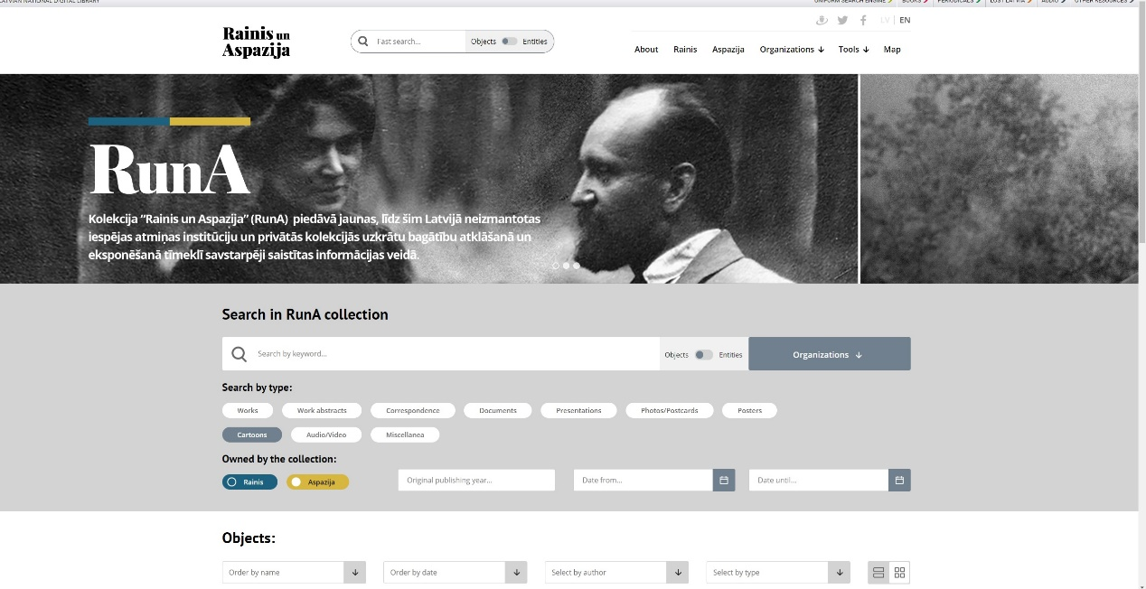
Web access to the digital collection of linked open data “Rainis and Aspazija”
Substantial improvements of the Web Archiving System were made, including new infrastructure, improved processes and technological solutions. In autumn 2019 new Web Archiving System was unveiled and archiving of selected web sites was resumed.

6. New developments in managing collections
In 2019 the NLL drew particular attention to the metadata quality control in terms of bibliographic and authoritative data. Comparing with 2018, the quality indicators have increased: by 14 % – the number of records in Electronic Union Catalogue of Latvian libraries of national significance; by 12 % – the indexation rate, especially, number of added subjects; by 23 % – the re-cataloguing; as well as the NLL performed data enrichment – for instance, the data enrichment of national bibliographic data increased by 40 %.
5 new methodologies with training materials were developed providing guidelines how to record sheet music editions, national analytics and events (as conferences, exhibitions, etc.) according to RDA principles; how to create authoritative records for compiled works. Working with cooperation partners’ collections in Lithuania, Poland and Sweden the experience in data recording of ancient prints has been obtained.
In 2019 the basis of internal environmental conditions monitoring document has been elaborated, and the work will be continued in 2020. In this pilot case the NLL tested the newly developed procedure for obtaining, fixing and analysing the internal environmental measurements in storages. The NLL’s Collections Preservation Centre began developing the guidelines with an aim to identify the impact of insects’ damages and other risk factors for the book condition. In 2019, 1094 units have been restored and 3763 units conserved.

7. New developments in providing access to collections
In 2019 to provide sustainable preservation of the NLL’s stock, special attention was dedicated to the design of collections to guarantee operative search and to improve aesthetics of the storages. In the NLL’s reading rooms special attention was dedicated to improvement of content and management of the free-access collections. As a gift for the NLL’s centenary the Reading Room of the Children’s Literature Centre has been re-opened after refurbishment. Cooperation with NGOs and orientation on special target group – persons with vision and hearing impairments – were developed and organized special workshops throughout the year.
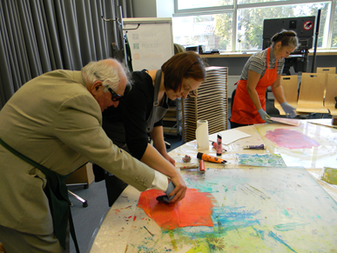
The workshop of paper casting and tactile paint

8. New developments in providing access to digital collections
Publishing new content in Periodicals and Book Portals and continuing marketing activities in order to ensure constant increase of the usability of the Latvian National Digital Library (LNDL) – compared to 2018, total attendance (number of sessions) has increased by 20 %, total number of users by 23 %, while the total number of pages viewed has increased by
11 %. In 2019 we resumed the work on the LNDL design improvements.
To develop digital skills among population, the NLL in cooperation with the Ministry of Environmental Protection and Regional Development elaborated three educational audio-visual guidelines for the digital platform “ManaLatvija.lv” – how to search information in the LNDL collections, as well as in Periodicals and Book Portals.
In the framework of Latvian Presidency of the Council of the Baltic Sea States and in cooperation with the National Heritage Board of Latvia, Digital Heritage Day took place for the first time on 22nd of May, 2019. During this event everyone had a chance to get acquainted with the results of cultural heritage digitization in the NLL and in other partner institutions.
9. Cooperation with national and international institutions
At the national level – as mentioned in ch.1 – the NLL is a leading partner in the European Regional Development Fund project Digitization of the Cultural Heritage Content together with project partners – the National Archives of Latvia, the National Heritage Board of Latvia and the Culture Information Systems Centre. The NLL also serves as a competence centre for Latvian library professionals by developing guidelines and terminology and adopting standards for library sector, providing consultations and organizing seminars and trainings for professional development.
At the international level – the NLL is a member of international organizations: IFLA, CENL, LIBER, EBLIDA, CERL, IIPC, IAML, IASA, BAAC, AABS, Bibliotheca Baltica, CODART, AEPM, IGELU, Consortium of legal resource centres and legal information specialists, ISBN, ISSN (CIEPS) and ISMN agencies. The NLL’s international cooperation strategy contains such tasks as the implementation of joint international projects and programs, cooperation with international organizations, foreign embassies in Latvia and Latvia’s embassies abroad, culture and information centres to promote Latvia's cultural heritage and organize international exhibitions and conferences; international document exchange and participation in the international book fairs.
Within the year the NLL was represented in the following international working groups: IFLA Bibliographic Conceptual Models Working Group (BCM WG) in Greece; Nordic Networking Group on bibliographic and infrastructure topics (NNG) in Denmark; European RDA Interest Group (EURIG) in Hungary; in the conference Semantic Web in Libraries (SWIB) in Germany; European Library Automation Group (ELAG) in Germany; BIBFRAME Workshop in Sweden; ISNI Summit for Libraries in France; Wikidata workshop for National libraries in Sweden.

