Survey of National Library Spaces and Services

Following on from CENL’s 2017 AGM and the keynote presentations, as well as the breakout session devoted to collection management, members concluded that a survey of library spaces, and the use of digital content within, would be beneficial to all. Data gathered by the CENL Secretariat will be used for analysis and to further discussion in the coming months with all CENL members. The full results of the survey are intended to be presented at CENL’s 2018 AGM.

All over the world we have seen the creation of new libraries during recent years, including new national library buildings that have been inaugurated or redesigned in Europe. The role of libraries and national libraries is changing and is in permanent transition. This process of transformation caused by the digital revolution and by changes within the economic and political environment has impacted library spaces, staffing and library services. To understand and to meet future needs of national libraries this survey aims to collect and analyse fundamental changes within national library spaces which have occurred over the last ten years.

The survey is structured in six chapters determined by the themes that were discussed during the 2017 AGM breakout session:

• The role of national libraries in collection management is changing – this affects library spaces

• National libraries are transforming from solely heritage institutions to also being leaders in digitisation

• Previously the role of digitisation was for preservation, but now there are new uses for our collections which include the combination of digital and heritage – how is this explored within national libraries?

• Staff development is key to the transformation of libraries – staff need to be integrated in the end to end process of digitisation and using that digital content, perhaps in physical and virtual exhibitions

• Skills and standards for digital content are needed for clarity of activity for researchers

 | Answer
Name of national library in full (in your own language and in anglicised form): | Koninklijke Bibliotheek van België – Bibliothèque royale de Belgique  Royal Library of Belgium
Name of Director General with official title: | Sara Lammens, General Director a.i.
Main library address: | Boulevard de l'Empereur 4, 1000 Bruxelles, Belgium
Current logo as a .jpg:
Contact name, email and telephone for this survey: | Sara Lammens  sara.lammens@kbr.be  +32 2 519 53 98

Instructions
The CENL Secretariat has pre-completed as much information as possible within this survey. Please check the information already provided and augment or correct this as necessary. Where no information is yet provided, please supply answers in full. Do contact cenl@bl.uk with any difficulties.

Chapter I: Scope and core functions of your national library
- Please check all that apply.
x |  |  | x |  | x | x | x
National Library | University Library | Public Library | Research Library / Research Centre | National Archives | Legal deposit centre | Digital Preservation centre | Museum | Other
If other please specify: -
- Are you the only library with a national remit in your country? If no (eg. there is also a National Technical Library) please specify.
Yes
- What is the legal status of your library?
Federal Scientific Institution
- Which ministry oversees your library?
Science Policy

Chapter II: Physical spaces
- Do you have multiple library sites? If so, please provide address details of all library buildings, including storage.
No
- Please provide a brief summary of all functions contained within the national library.
In 2017
x | x | x | x | x | x | x | x | x
Reading Rooms | Lounge | Exhibition space | Conference Centre | Conservation Studio | Gallery | Concert Hall | Café / Restaurant | Commercial space / shop | Other

If other please specify:

- Please provide the total square meterage for each of the following functions within your library:
3.846,7 M² | M2 | M2 | M2 | M2 | M2 | M2 | M2 | M2 | M2
Reading Rooms | Lounge | Exhibition space | Conference Centre | Conservation Studio | Gallery | Concert Hall | Café / Restaurant | Commercial space / shop | Other
If other please specify:
- What is the total size of all library buildings in square metres (includes storage areas)?
2017: 77.000 square meters
- What is the size of library buildings open to the public in square metres?
2017: 16.000 square meters
- Please provide .jpg images of your main public building(s) exterior
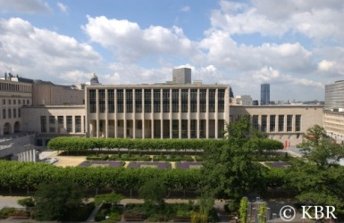

- If available, please provide .jpg images of all library sites described in question 5.
-
- If available, please provide .jpg images of all library spaces described in question 6.

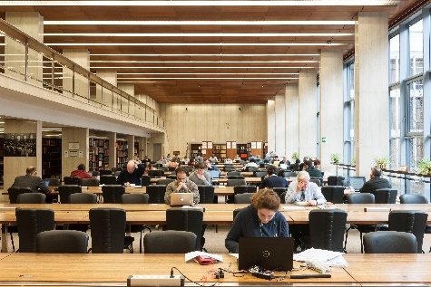 Main Reading Room

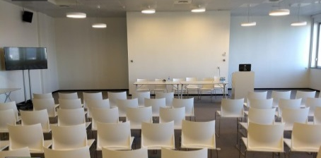
Royal Sky Room (Conference Hall)

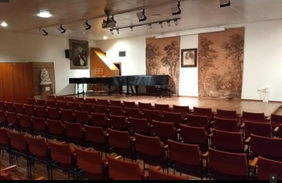
Auditorium (Concert Hall)

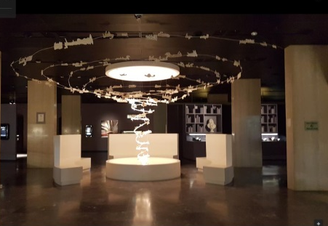
Exhibition Space (Librarium)

- Please provide simplified plans of your buildings, if possible in .jpg format (perhaps those used to guide visitors around your building).
See attatchment
- Please provide brief details on the history of your library buildings.

 | Answer
Year (first) library building opened | 1839
Architect of (first) library building | ?
Year (current) library building opened | 1969
Architect of (current) library building | Maurice Houyoux en Jules Ghobert
Any additional information. Eg length of build/cost of build/reason for build | Building took 15 years (started in 1954)

- If available, please provide a short text on the milestones of the history of your library and/or provide a link to this information online. Please include any bibliographic information about publications about your library and links to these publications in your library catalogue or an aggregated catalogue.
- Short list of milestones, text is available in French and Dutch only:
  - https://www.kbr.be/fr/histoire-de-la-bibliotheque-royale-de-belgique
  - https://www.kbr.be/nl/geschiedenis-van-de-koninklijke-bibliotheek-van-belgie

- Publications: Bibliothèque royale : Mémorial 1559-1969
In French. Search for Call number “FS XXV 1.525 1969 61 A” in the online catalogue: http://opac.kbr.be. (our catalogue is changing, so in a few months a direct link to the description would probably no longer work)
You can also download the book on http://uurl.kbr.be/1427387.

Chapter III: Location and Urban Spaces
- Please describe the location of your national library buildings (eg. main building in capital city with close proximity to universities, storage buildings in rural area, located two hours by train from building in capital).
The Royal Library of Belgium is located in the heart of Brussels, just a stone's throw away from Brussels Central Station, with underground parking nearby.
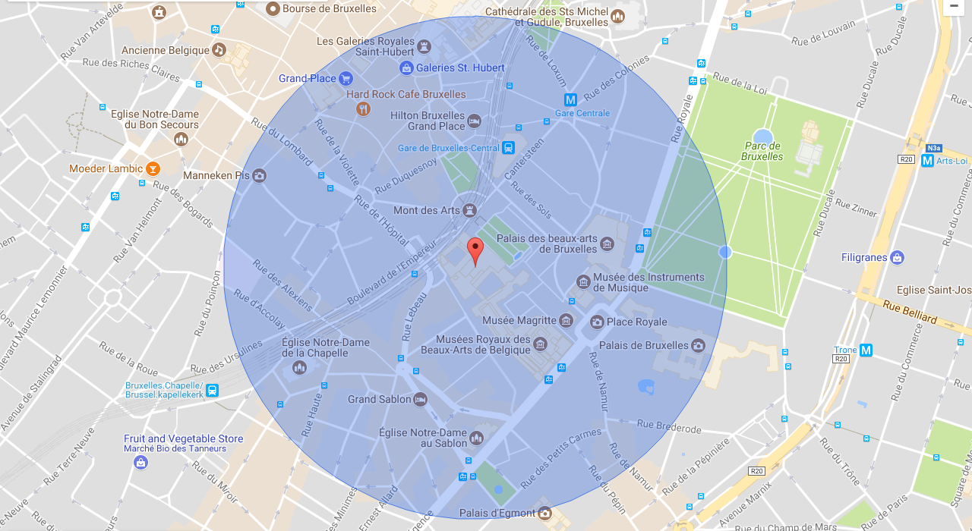
- CENL has provided a map of your headquarter location at the centre of a 500m radius – taken as a screenshot from Google maps. If this is not the correct location of your library building, please supply an alternative screen shot.

- Please provide details of major governmental, cultural or significant institutions within this vicinity (within a 500m radius).
Musical Instruments Museum, Bozar, Magritte Museum, Museum for Fine Arts Belgium, Royal Palace, Manneken Pis, Grand Place, City Hall
- Please describe all the transport options for reaching each of your library buildings open to researchers and the public.
- Train Brussels-Central station is a 2 minute walk
- Underground 1 and 5 (metro station Gare Centrale)
- Tram 92 - 93 (Place Royale)
- Bus 29 - 38 - 63 - 65 - 66 - 71 - 86 (Gare Centrale) and 27 - 38 - 71 - 95 (Place Royale)
- By car : Pay and display car park ‘Albertine’

Chapter IV: Reading Rooms, collections and other interior library spaces
- What is the total number of seats in all your reading rooms across all sites
756
- What is the total square meterage of all your reading rooms across all sites?
3.846,7 m²
- Please list your reading rooms (type, large, by collection) and individual capacity
Reading Room Name | Collection type | Individual room seat capacity | Individual room square metres
Center for American Studies | American Studies | 30 | 102,5m²
Coins and Medals | Coins and medals | 14 | 78,5m²
General reading room | Contemporary printed books | 482 | Public reading room: 1278,2  Including researchers’ room and study room: 2073,5
Manuscripts | Manuscripts, both old and modern | 27 | 526,4m²
Maps and Plans | Maps and Plans | 8 (this two departments actually share one reading room) | 90,1m²
Prints | Prints, drawings, posters
Rare books | Incunabula, printed works dating from before 1830, rare books, modern valuable special editions | 18 | 388,9m²
Music | Documents related to music collection (sheet music, CDs, LPs, photos, handwritten documents…) | 23 | 124,9m²
Newspapers | Old and recent newspapers | 190 | 412,7m² (recently renovated, therefore excluding the new mezzanine)
- Do users register to use your Reading Rooms? If so, how?
Yes, they need to buy a reader’s card at the registration desk.
- Do users pay to use your Reading Rooms? If so, how much?
Yes:
- day card: EUR 5.00
- annual card: EUR 25.00
- annual card for students and journalists: EUR 15.00
- How are your collections accessed within the Reading Rooms? Is collection material open access or called to order? Please describe.
Reference works and dictionaries are available on the shelves in the reading room, all other materials are called to order.
- What is the average number of visits per day to your Reading Rooms?
320
- What is the average number of visits per day to your library?
Number of visitors in 2016: 103.956
Number of visitors in 2017: 95.492

Chapter V: Staffing
- What is the number of staff employed by the library in total ?
2017: 280
- What is the number of staff employed by the library in FTE ?
2017:

The keynote presentation may be accessed via http://www.cenl.org/members/cenl-annual-general-meeting-2017-15-16-may-british-library-london/nggallery/page/1

