Survey of National Library Spaces and Services

Following on from CENL’s 2017 AGM1 and the keynote presentations, as well as the breakout session devoted to collection management, members concluded that a survey of library spaces, and the use of digital content within, would be beneficial to all. Data gathered by the CENL Secretariat will be used for analysis and to further discussion in the coming months with all CENL members.
The full results of the survey are intended to be presented at CENL’s 2018 AGM.

All over the world we have seen the creation of new libraries during recent years, including new national library buildings that have been inaugurated or redesigned in Europe. The role of libraries and national libraries is changing and is in permanent transition. This process of transformation caused by the digital revolution and by changes within the economic and political environment has impacted library spaces, staffing and library services. To understand and to meet future needs of national libraries this survey aims to collect and analyse fundamental changes within national library spaces which have occurred over the last ten years.

The survey is structured in six chapters determined by the themes that were discussed during the 2017 AGM breakout session:

- The role of national libraries in collection management is changing – this affects library spaces
- National libraries are transforming from solely heritage institutions to also being leaders in digitisation
- Previously the role of digitisation was for preservation, but now there are new uses for our collections which include the combination of digital and heritage – how is this explored within national libraries?
- Staff development is key to the transformation of libraries – staff need to be integrated in the end to end process of digitisation and using that digital content, perhaps in physical and virtual exhibitions
- Skills and standards for digital content are needed for clarity of activity for researchers

1 The keynote presentation may be accessed via http://www.cenl.org/members/cenl-annual-general-meeting- 2017-15-16-may-british-library-london/nggallery/page/1

 | Answer
Name of national library in full (in your own language and in anglicised form): | Milli Kütüphane Başkanlığı National Library of Turkey
Name of Director General with official title: | Zülfi Toman, President
Main library address: | Bahçelievler Son Durak 06490 Ankara  Turkey
Current logo as a .jpg:
Contact name, email and telephone for this survey: | Zülfi Toman zlf.tmn(at)mkutup.gov.tr Hafize Er hafize.er(at)mkutup.gov.tr  +90 312 222 41 48

Instructions

The CENL Secretariat has pre-completed as much information as possible within this survey. Please check the information already provided and augment or correct this as necessary. Where no information is yet provided, please supply answers in full. Do contact cenl@bl.uk with any difficulties.

Chapter I: Scope and core functions of your national library

Please check all that apply.

x | ○ | ○ | x | x | x | x | x | ○
National Library | University Library | Public Library | Research Library / Research Centre | National Archives | Legal deposit centre | Preservation centre | Museum | Other

If other please specify:

Are you the only library with a national remit in your country? If no (eg. there is also a National Technical Library) please specify.
yes

What is the legal status of your library?

Principal Service Unit under Public Law

Which ministry oversees your library?

Ministry of Culture and Tourism

Chapter II: Physical spaces

Do you have multiple library sites? If so, please provide address details of all library buildings, including storage.

No, solitary.

Please provide a brief summary of all functions contained within the national library. In 2017
x | x | x | x | x | ○ | ○ | x | ○ | x
Reading Rooms | Lounge | Exhibition space | Conference Centre | Conservation Studio | Gallery | Concert Hall | Café / Restaurant | Commercial space / shop | Other

If other please specify: Audio books studio, Digital park, Digital hall.

Please provide the total square meterage for each of the following functions within your library:

M2 | M2 | 300M2 | 350M2 | M2 | M2 | M2 | M2 | M2 | M2
Reading Rooms | Lounge | Exhibition space | Conference Centre | Conservation Studio | Gallery | Concert Hall | Café / Restaurant | Commercial space / shop | Other

  - What is the total size of all library buildings in square metres (includes storage areas)?

2017: ca. 39.000 m2

What is the size of library buildings open to the public in square metres?

2017: 9.000 m2

Please provide .jpg images of your main public building(s) exterior

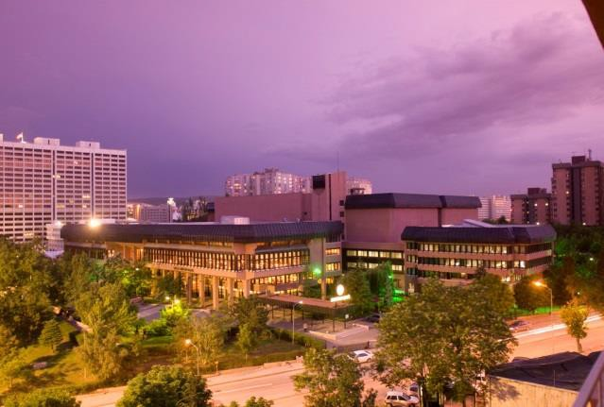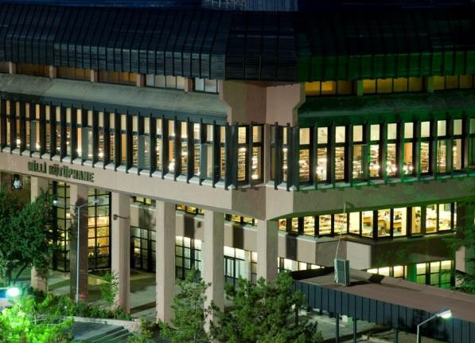

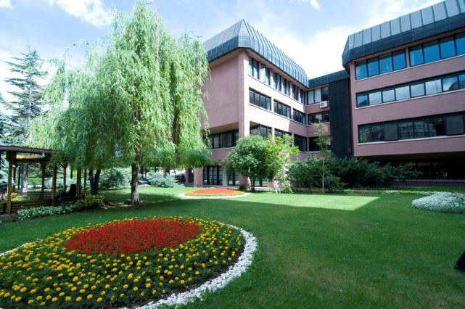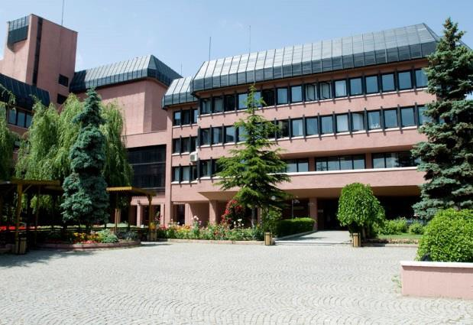

Exterior

If available, please provide .jpg images of all library sites described in question 5.
Images of the solitary site could be found above.

  - If available, please provide .jpg images of all library spaces described in question 6.

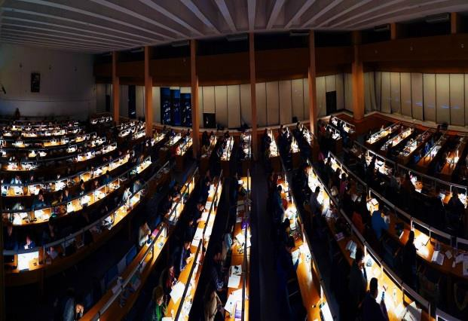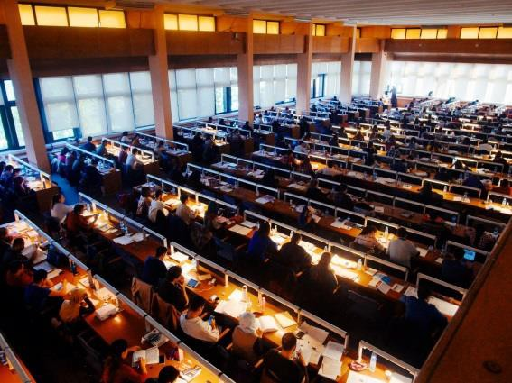

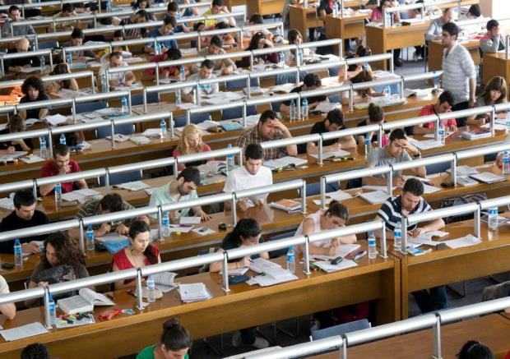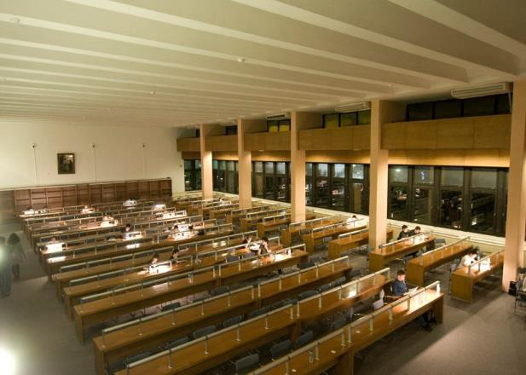

Reading Rooms

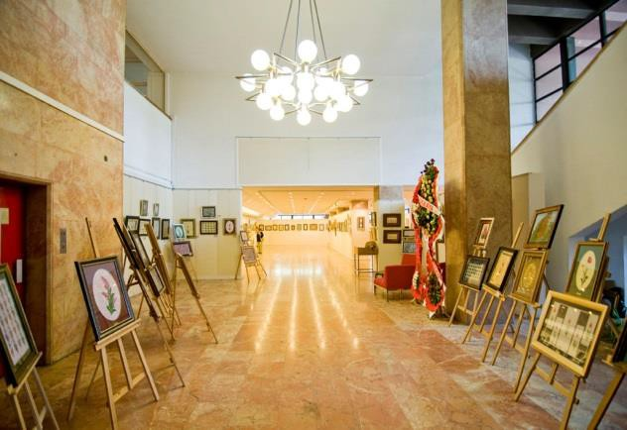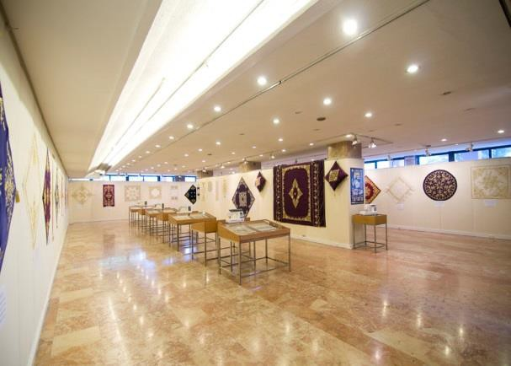

Exhibition Space

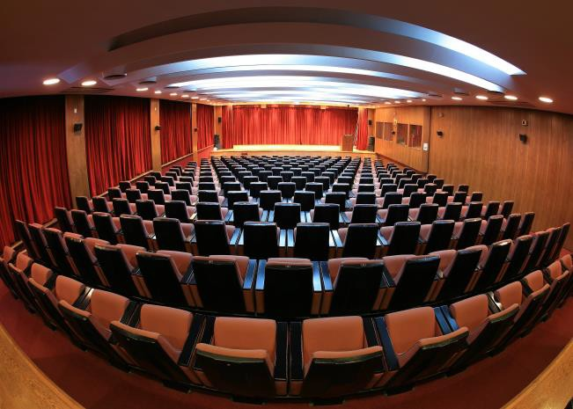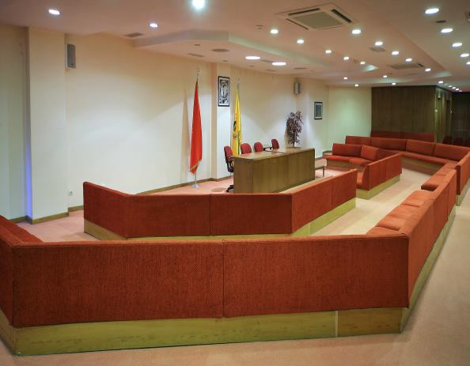

Conference Halls

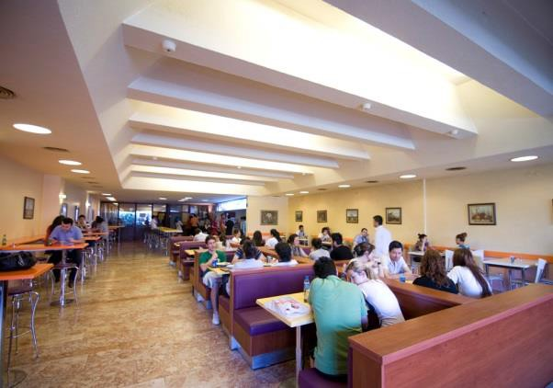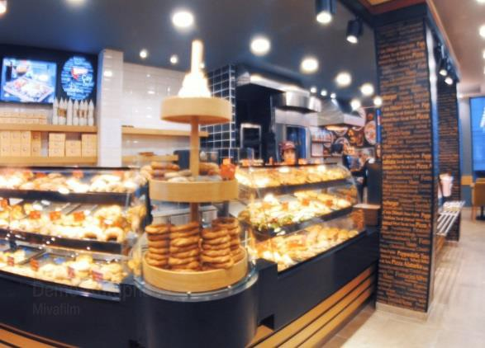

Cafe-Restaurant

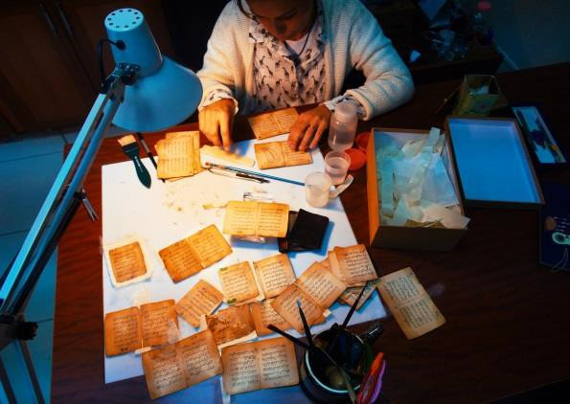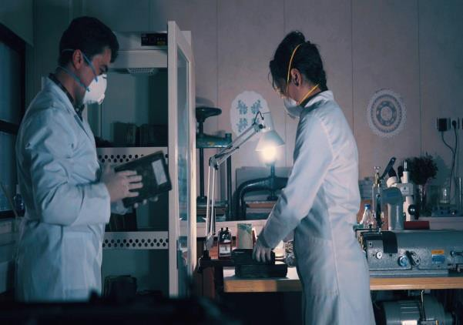

Conservation Studio

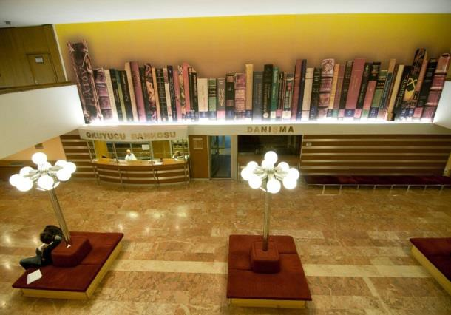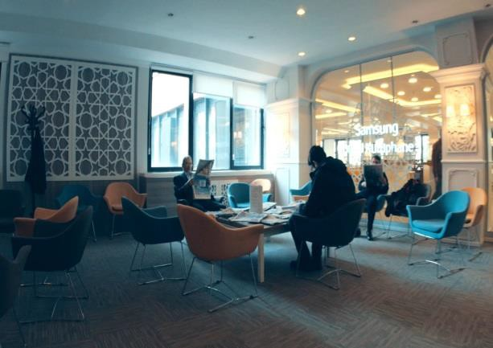

Lounge

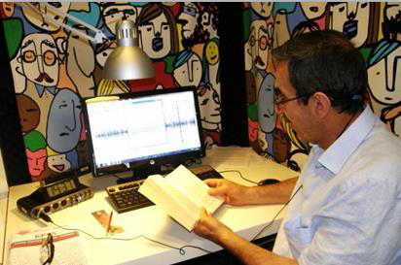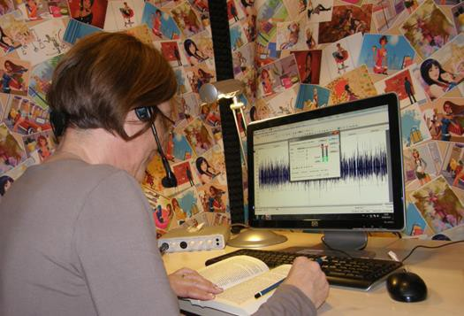

Audio Books Studio

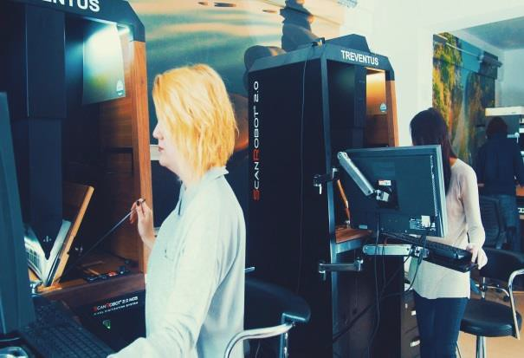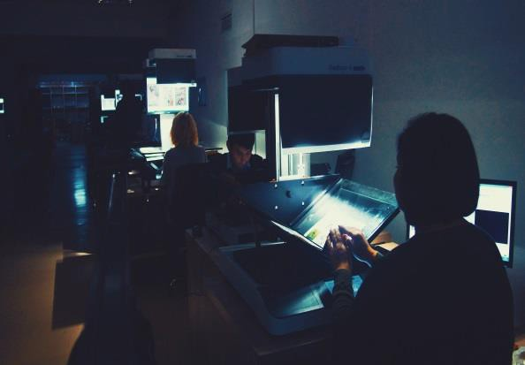

Digital Park

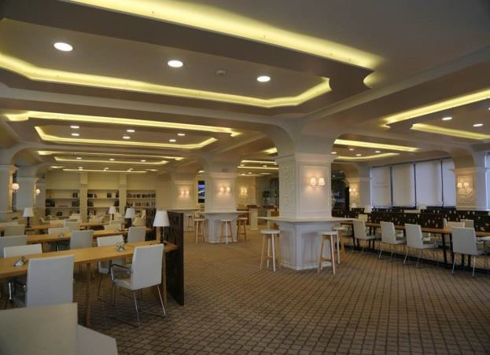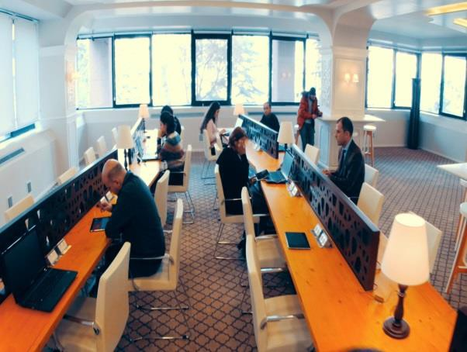

Digital Hall

Please provide simplified plans of your buildings, if possible in .jpg format (perhaps those used to guide visitors around your building).

  - Please provide brief details on the history of your library buildings.

 | Answer
Year (first) library building opened | 1948
Architect of (first) library building | Paul Bonatz
Year (current) library building opened | 1983
Architect of (current) library building | Şevki Vanlı, Ersen Gömleksiz
Any additional information. Eg length of build/cost of build/reason for build | Construction duration: 1973-1982. Rationale: Capacity-wise the former building became inadequate; therefore a new building was needed.

  - If available, please provide a short text on the milestones of the history of your library and/or provide a link to this information online. Please include any bibliographic information about publications about your library and links to these publications in your library catalogue or an aggregated catalogue.
Efforts to establish a comprehensive, national and general library have been thought to extend to the late Ottoman Empire. In 1870, construction of a “Library of the Nation” became a hot topic among the upper echelons of the intellectual segment, although whether the purpose was towards a genuine national library with recognised functions is up to debate. As a result of the concerted efforts at the time; ”The Common Library”, a.k.a. Beyazit State Library, was found in 1882 and according to some library historians, should be considered as the Ottoman national library for using the word “national” was thought to be inconvenient at the time of Empire. Eventually, Beyazit State Library in Istanbul might be the first national library on Anatolian soil.

After the Second Constitutionalist Period in the Ottoman Empire, there appeared many libraries with a title “national library”, though those were essentially public libraries with an emphasis to nationalist movements coming into prominence.

During the revamp following the declaration of the Republic, the parliament published the first Legal Deposit Law dated 1934, with a view to establish a much belated national library.

The works of foundation for the modern National Library was laid in a small office in the Ministry of National Education, Directorate of Publications on April 15, 1946 and a collection of 8.000 works were accumulated in a short time. On April 1, 1947 the library was temporarily moved to another building and during this period the collection reached to 60.000. A building on Kumrular Street is

allocated in order to put the collection into service and the National Library was opened to users on August 16, 1948.

With the enactment of the Establishment Law on March 29, 1950, the National Library assumed a legal identity. Foundation of a Bibliographical Institute working under the National Library was ensured the “Supplementary Law to the Establishment Law of the Turkish National Library” dated May 18, 1955.

Considering that the first building would not meet the future needs, planning of a new building was started in 1965. The construction work began after a long period of planning during 1965-1973, and the building was completed in 1982. The National Library started serving its users in the current building on August 5, 1983.
The National Library started to work in 1987 on a modern computer-based information system on a national and international basis. The system installed, which is based on a through feasibility, system analysis and design study. All the library hardware and software was integrated to the main system.

http://www.mkutup.gov.tr/tr/Sayfalar/Hakkimizda/tarihce-kronoloji.aspx

http://bibliyografyalar.mkutup.gov.tr/

https://makaleler.mkutup.gov.tr/

http://eyayinlar.mkutup.gov.tr/

Chapter III: Location and Urban Spaces

  - Please describe the location of your national library buildings (eg. main building in capital city with close proximity to universities, storage buildings in rural area, located two hours by train from building in capital).

The premises are located in the epicenter of the capital city Ankara. The vicinity is one of the most crowded and visited of the entire City. The facilities have close proximity to government and administrative centers, universities, cultural centers, museums, mausoleums, and historical sights.

  - CENL has provided a map of your headquarter location at the centre of a 500m radius – taken as a screenshot from Google maps. If this is not the correct location of your library building, please supply an alternative screen shot.

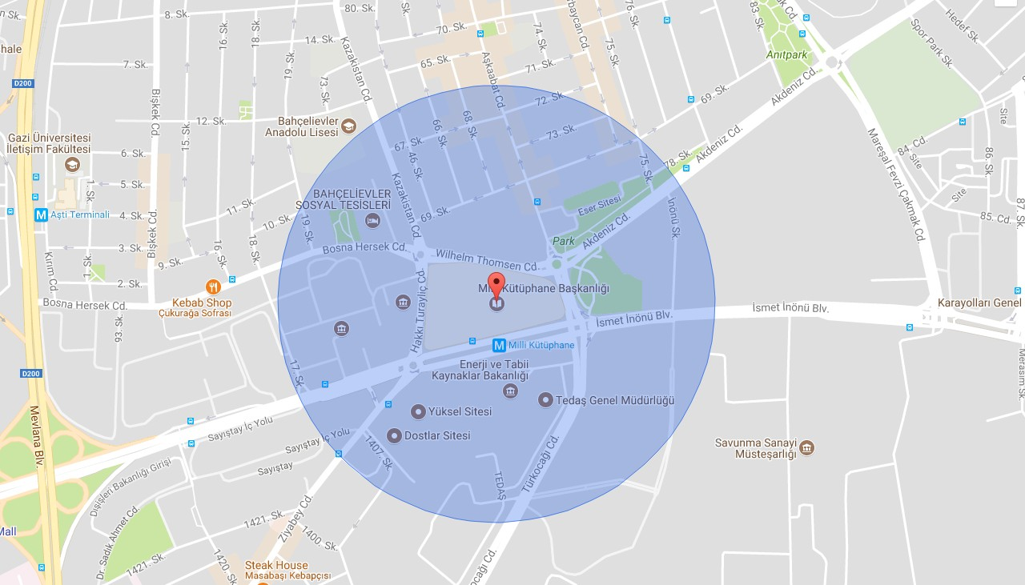

  - Please provide details of major governmental, cultural or significant institutions within this vicinity (within a 500m radius).
Political and administrative buildings:
The Ministry of Culture and Tourism: http://www.kultur.gov.tr/?_dil=2
The Ministry of Transport, Maritime Affairs and Communication: http://www.udhb.gov.tr/eng/ The Ministry of Labour and Social Security: https://www.csgb.gov.tr/En
The Ministry of Energy and Natural Resources: http://www.enerji.gov.tr/en-US/Mainpage Turkish Court of Accounts: https://www.sayistay.gov.tr/en/
Social Security Institution: http://www.sgk.gov.tr/wps/portal/sgk/en/home-page/mainpage

The Ministry of Foreign Affairs: http://www.mfa.gov.tr/default.en.mfa Turkish Electricity Distribution Corporation: http://www.tedas.gov.tr/ Defence Industry Undersecretariat: https://www.ssm.gov.tr/
The General Directorate of Agricultural Credit Cooperatives: http://www.tarimkredi.org.tr/index.php/genel-mudurluk.html

Culture and Sights:
Atatürk Culture Centre: http://akmb.gov.tr/en/default.aspx
Shoppe Wedding House: http://shoppe.com.tr/galeri/nikah-salonu/ Turkish Ice-Skating Federation: http://buzpateni.org.tr/
Angora Bakery: http://www.angorapastanesi.com/
Rumeli Chocolatier: http://www.rumelicikolatacisi.com/en/homepage Magic Lantern Cinema Bahçelievler: http://www.buyulufener.com.tr/ Turkish Radio and Television Institution Arı Studios
Adnan Ötüken Park Bahçelievler Social Club Dostlar Mosque

  - Please describe all the transport options for reaching each of your library buildings open to researchers and the public.

Bahçelievler Son Durak (Last Station) Çankaya/Ankara: The location is one of the reference points that most of the inhabitants of the City know and often visit around.

The Library building is just on the main boulevard that connects the east of the City to the west. This is also the second subway station which leaves Kizilay to Koru District (M2 Route). The premises are also available via buses, minibuses from Kizilay towards Balgat vicinity.

Chapter IV: Reading Rooms, collections and other interior library spaces

What is the total number of seats in all your reading rooms across all sites?

1,329 (1,262 reading rooms, 67 computer seats in lounges and public spaces)

What is the total square meterage of all your reading rooms across all sites?

Answer

Please list your reading rooms (type, large, by collection) and individual capacity

Reading Room Name | Collection type | Individual room seat capacity | Individual room square metres
Müjgan Cunbur Hall | General reading | 454
Adnan Ötüken Hall | General reading | 425
Halide Edip Adivar Hall | General reading | 150
Ibni Sina Hall | Manuscripts, rare books | 47

Periodicals Hall | Periodicals and reference collection | 48
Prof. Dr. Sabahattin Zaim Research Hall | Academicians | 130
Samsung Digital Library | Digital collection | 77
Atatürk Archives Section | Atatürk archival collection | 8

  - Do users register to use your Reading Rooms? If so, how?

Yes, Reading Rooms are only for the registered members. Graduates from high schools, university students, academicians, public and private officials who provided the required documents could use the rooms at will.

Do users pay to use your Reading Rooms? If so, how much?

No

How are your collections accessed within the Reading Rooms? Is collection material open access or called to order? Please describe.
Both. Reference resources are open access; all other materials are called to order.

  - What is the average number of visits per day to your Reading Rooms? Library visitors; excluding visitors to social events, gatherings and library tours. Open Days 2017 351 days

Visitors 2017 629,905 visitors Average per day 1,795 visits

Open Days 2007 352 days

Visitors 2007 408,690 visitors Average per day 1,161 visits

What is the average number of visits per day to your library?

The figure is slightly above the ones provided for the previous reply. The visits to social events have not been counted so far and 605 people (mostly students) had come to the library last year within the scope of library tours.

Chapter V: Staffing

What is the number of staff employed by the library in total ?
2017: 203
  - What is the number of staff employed by the library in FTE ?

2017: 153

