Survey of National Library Spaces and Services

Following on from CENL’s 2017 AGM and the keynote presentations, as well as the breakout session devoted to collection management, members concluded that a survey of library spaces, and the use of digital content within, would be beneficial to all. Data gathered by the CENL Secretariat will be used for analysis and to further discussion in the coming months with all CENL members. The full results of the survey are intended to be presented at CENL’s 2018 AGM.

All over the world we have seen the creation of new libraries during recent years, including new national library buildings that have been inaugurated or redesigned in Europe. The role of libraries and national libraries is changing and is in permanent transition. This process of transformation caused by the digital revolution and by changes within the economic and political environment has impacted library spaces, staffing and library services. To understand and to meet future needs of national libraries this survey aims to collect and analyse fundamental changes within national library spaces which have occurred over the last ten years.

The survey is structured in six chapters determined by the themes that were discussed during the 2017 AGM breakout session:

• The role of national libraries in collection management is changing – this affects library spaces

• National libraries are transforming from solely heritage institutions to also being leaders in digitisation

• Previously the role of digitisation was for preservation, but now there are new uses for our collections which include the combination of digital and heritage – how is this explored within national libraries?

• Staff development is key to the transformation of libraries – staff need to be integrated in the end to end process of digitisation and using that digital content, perhaps in physical and virtual exhibitions

• Skills and standards for digital content are needed for clarity of activity for researchers

 | Answer
Name of national library in full (in your own language and in anglicised form): | Schweizerische Nationalbibliothek  Swiss National Library
Name of Director General with official title: | Marie-Christine Doffey
Main library address: | Hallwylstrasse 15  3003 Bern  Switzerland
Current logo as a .jpg:
Contact name, email and telephone for this survey: | Marie-Christine Doffey  marie-christine.doffey@nb.admin.ch  +41 584628901

Instructions
The CENL Secretariat has pre-completed as much information as possible within this survey. Please check the information already provided and augment or correct this as necessary. Where no information is yet provided, please supply answers in full. Do contact cenl@bl.uk with any difficulties.

Chapter I: Scope and core functions of your national library
- Please check all that apply.
x
National Library | University Library | Public Library | Research Library / Research Centre | National Archives | Legal deposit centre | Preservation centre | Museum | Other
If other please specify:
- Are you the only library with a national remit in your country? If no (eg. there is also a National Technical Library) please specify.
Yes
- What is the legal status of your library?
National Library established by federal law in 1894
- Which ministry oversees your library?
Federal Department of Home Affairs

Chapter II: Physical spaces
- Do you have multiple library sites? If so, please provide address details of all library buildings, including storage.
Swiss National Library, Hallwystrasse 15, 3003 Bern www.nb.admin.ch
Swiss National Sound Archives, Via Soldino 9, 6900 Lugano https://www.fonoteca.ch/index_en.htm
Centre Dürrenmatt Neuchâtel, Pertuis-du-Sault 74, 2000 Neuchâtel http://www.bundesmuseen.ch/cdn/index.html?lang=en
- Please provide a brief summary of all functions contained within the national library.
In 2017
x | x | x |  | x |  |  | x
Reading Rooms | Lounge | Exhibition space | Conference Centre | Conservation Studio | Gallery | Concert Hall | Café / Restaurant | Commercial space / shop | Other

If other please specify:
- Please provide the total square meterage for each of the following functions within your library:
M2 | M2 | M2 | M2 | M2 | M2 | M2 | M2 | M2 | M2
Reading Rooms | Lounge | Exhibition space | Conference Centre | Conservation Studio | Gallery | Concert Hall | Café / Restaurant | Commercial space / shop | Other
If other please specify:
- What is the total size of all library buildings in square metres (includes storage areas)?
2017: 15500
- What is the size of library buildings open to the public in square metres?
2017: 4114
- Please provide .jpg images of your main public building(s) exterior

Exterior –
https://www.facebook.com/bibliothequenationale.suisse/

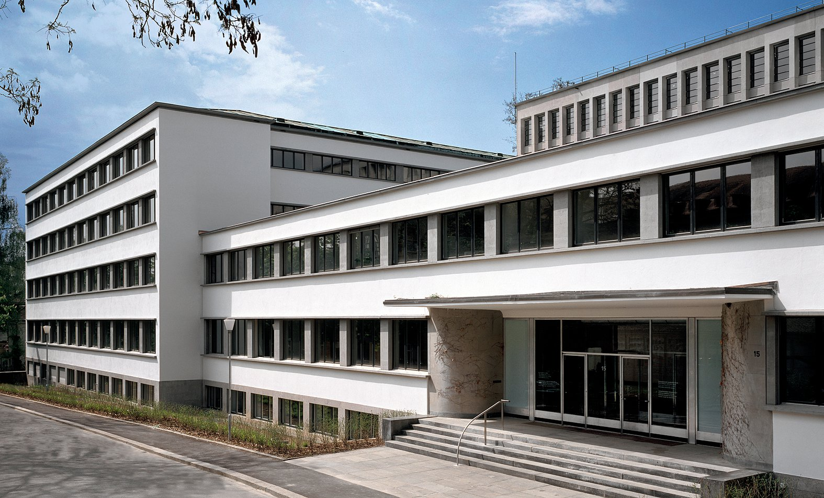

- If available, please provide .jpg images of all library sites described in question 5.
Main site – see above
Sound archives (uses only small part of the building )
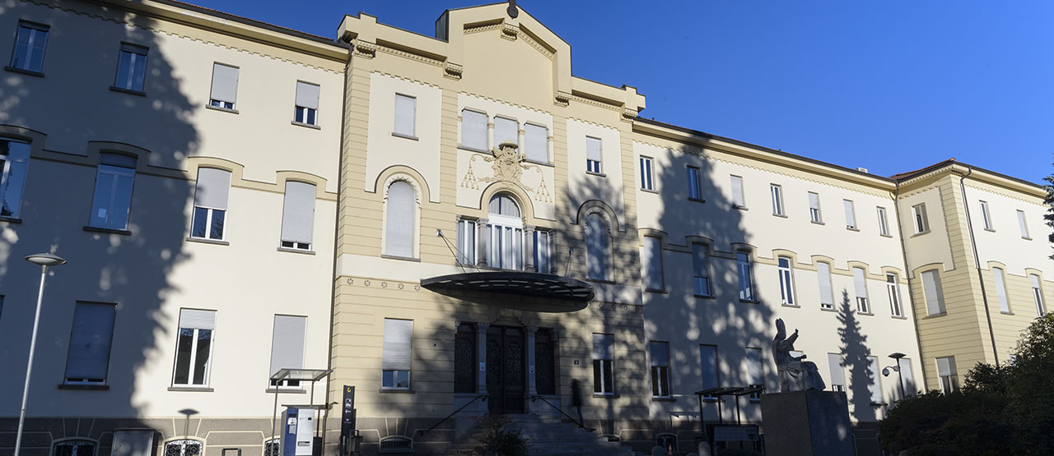
Centre Dürrenmatt Neuchâtel (photo: Pino Musi)
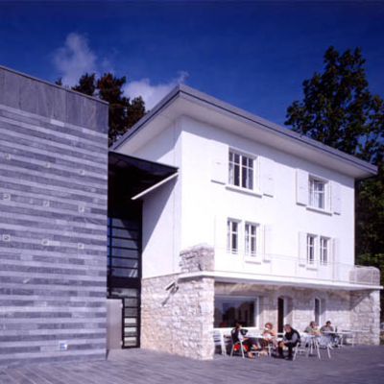

- If available, please provide .jpg images of all library spaces described in question 6.
Newspaper room -
https://www.google.co.uk/maps/place/Swiss+National+Library/

Stackss -
https://www.google.co.uk/maps/place/Swiss+National+Library/

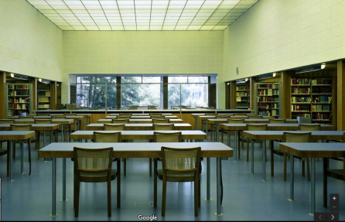
Reading room -
https://www.google.co.uk/maps/place/Swiss+National+Library/
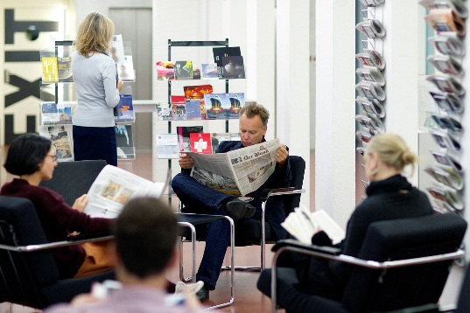Lounge area
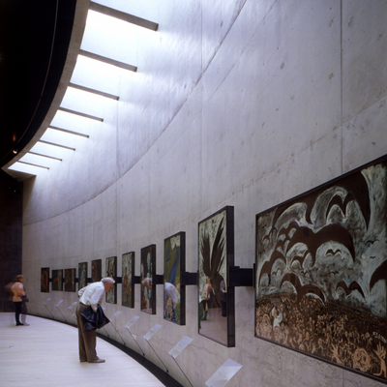
Exhibition area Centre Dürrenmatt Neuchâtel , Photo: Pino Musi

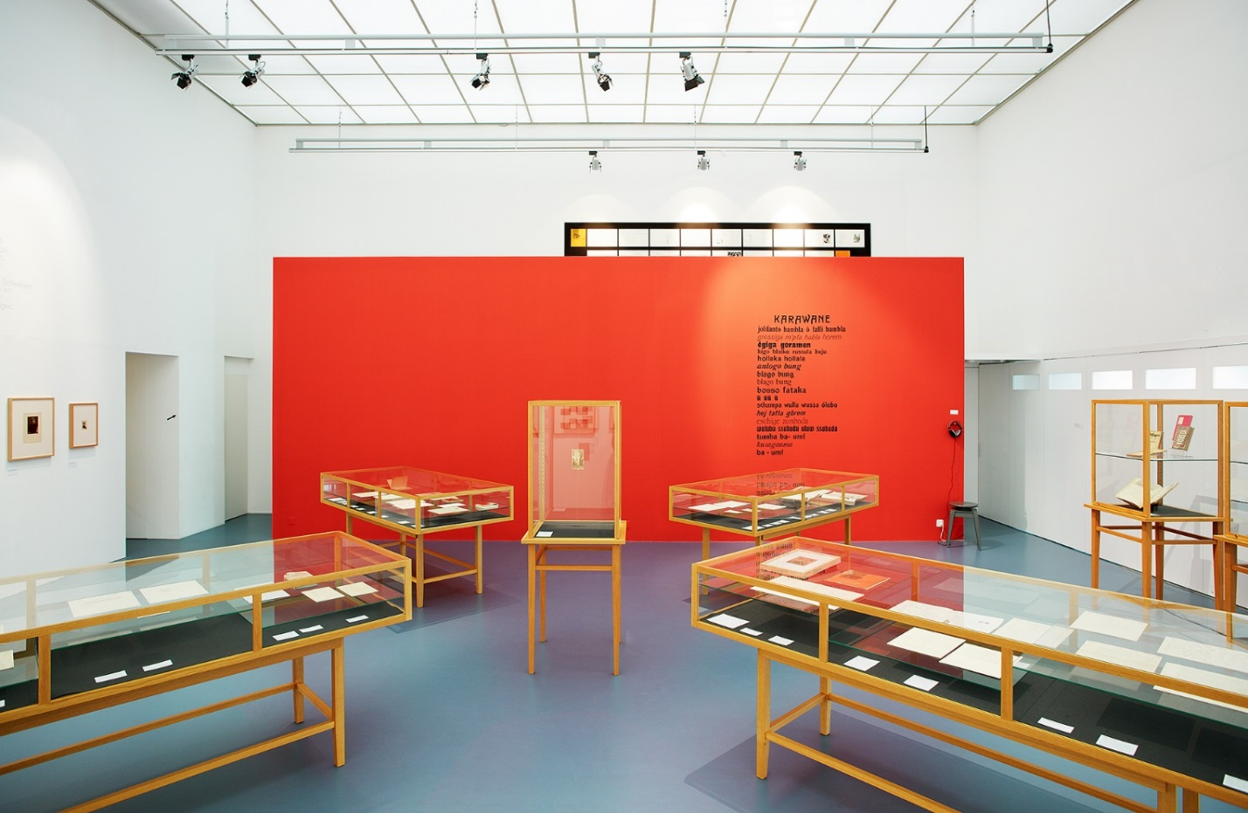Exhibition area Main Building, Bern

- Please provide simplified plans of your buildings, if possible in .jpg format (perhaps those used to guide visitors around your building).
- 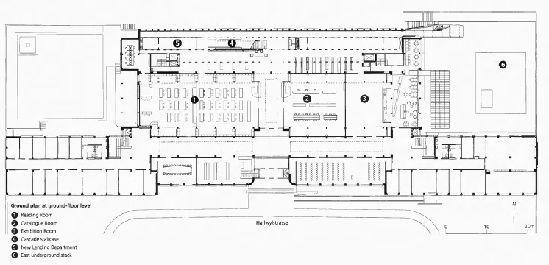Please provide brief details on the history of your library buildings.

 | Answer
Year (first) library building opened | 1931 (previously in Federal Archives)
Architect of (first) library building
Year (current) library building opened | 1931
Architect of (current) library building | Alfred Oeschger (1900-1963), Emil Hostettler (1887-1972) and Josef Kaufmann (1882-1962)
Any additional information. Eg length of build/cost of build/reason for build

- If available, please provide a short text on the milestones of the history of your library and/or provide a link to this information online. Please include any bibliographic information about publications about your library and links to these publications in your library catalogue or an aggregated catalogue.
1893 Survey about the creation of a Swiss National Library
1895 «Schweizerische Landesbibliothek» begins operations
1899 First reading room opened in the Swiss Federal Archives
1931 Move to the current building
1994-1997 Underground stacks east
1998 – 2001 Renovation of the main building
2005-2008 Underground stacks west

2000 Centre Dürrenmatt Neuchâtel opens
2016 Swiss National Sound Archives integrated in the Swiss National Library

(publications, see below. migration to a new system in 2018 will change links)

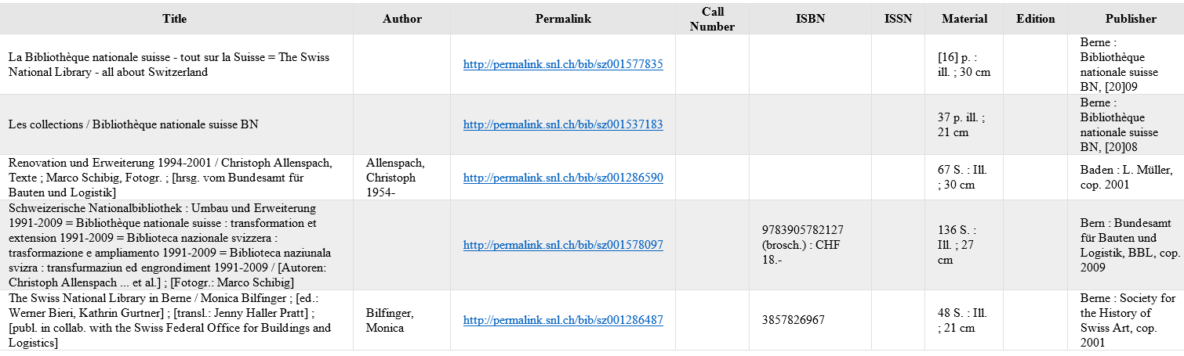

Chapter III: Location and Urban Spaces
- Please describe the location of your national library buildings (eg. main building in capital city with close proximity to universities, storage buildings in rural area, located two hours by train from building in capital).
The main building is in Bern, the capital city, in the Museum quarter but also close to part of the university library and the town library
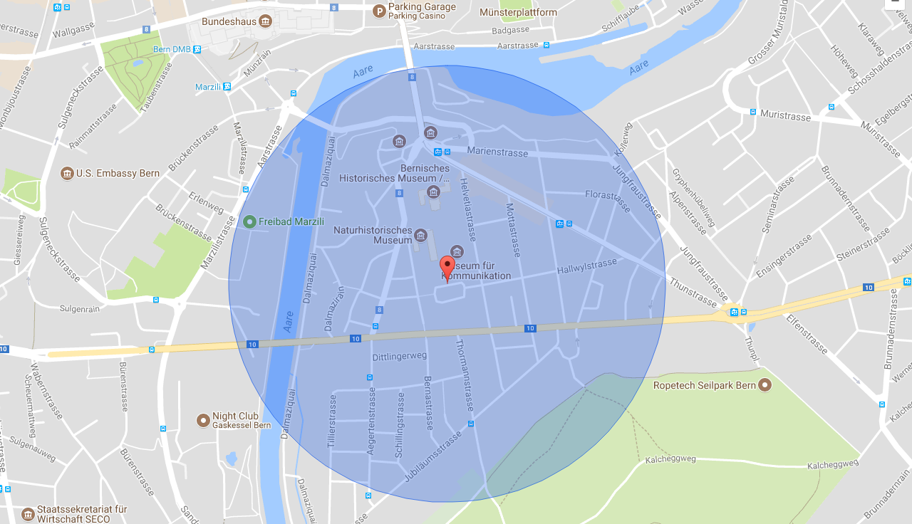
- CENL has provided a map of your headquarter location at the centre of a 500m radius – taken as a screenshot from Google maps. If this is not the correct location of your library building, please supply an alternative screen shot.

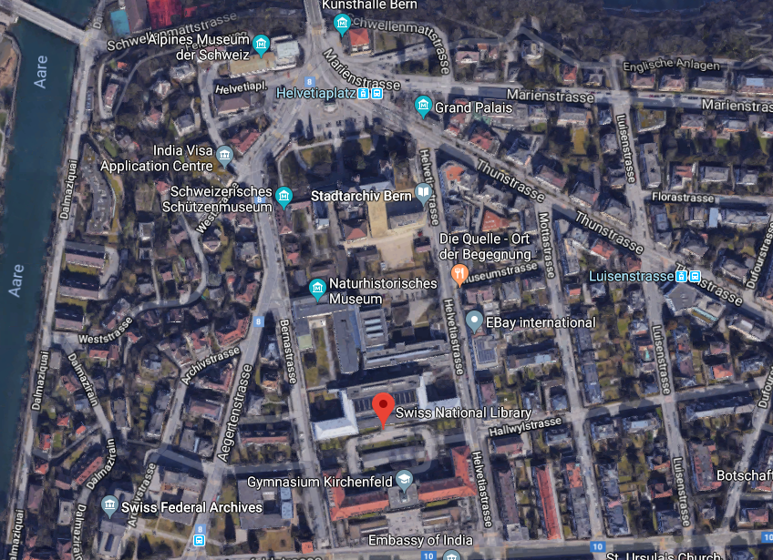
- Please provide details of major governmental, cultural or significant institutions within this vicinity (within a 500m radius).

Museums: Bern Historical Museum, Alpine History Museum, Bern Cantonal Archives Museum for Communication, Natural History Museum, Federal Archives. The Houses of Parliament (Bundeshaus) are just outside this radius
- 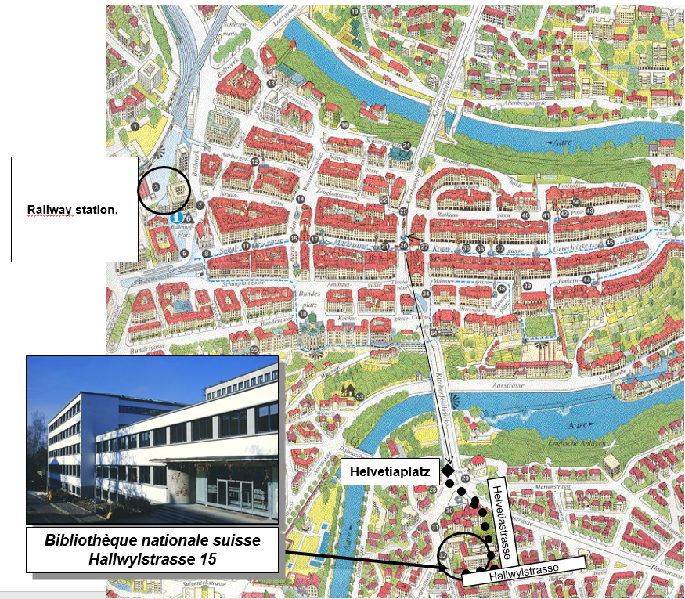Please describe all the transport options for reaching each of your library buildings open to researchers and the public.
Bern: train, car, bus/tram, https://www.nb.admin.ch/snl/en/home/the-swiss-national-library---all-about-switzerland/address-and-access-map.html
Lugano: train, car, bus
Neuchâtel: train, car, bus http://www.bundesmuseen.ch/cdn/00128/00146/index.html?lang=en

Chapter IV: Reading Rooms, collections and other interior library spaces
- What is the total number of seats in all your reading rooms across all sites?
151
- What is the total square meterage of all your reading rooms across all sites?
Answer
- Please list your reading rooms (type, large, by collection) and individual capacity
Reading Room Name | Collection type | Individual room seat capacity | Individual room square metres
Main Reading Room |  | 64
Info-room |  | 14
Level 2 |  | 16
Level 3 |  | 16
Prints & Drawings |  | 6
Other |  | 38
- Do users register to use your Reading Rooms? If so, how?
Users may use the Reading Rooms without registering but need to register for a reader’s card if they wish to order library material. Registration is free
- Do users pay to use your Reading Rooms? If so, how much?
No
- How are your collections accessed within the Reading Rooms? Is collection material open access or called to order? Please describe.
Reference literature is available in Reading rooms, also latest issues of serials and newspapers. All other material must be ordered from the stack.
- What is the average number of visits per day to your Reading Rooms?
The number of users are not calculated. Overall occupancy is average 21% capacity (except group work rooms: 36.8%, individual study carrels: 45%
- What is the average number of visits per day to your library?
Total visits in 2017: 88,516
Average ca. 295 /day

Chapter V: Staffing
- What is the number of staff employed by the library in total ?
2017: 189 people (147.55 FTE)
- What is the number of staff employed by the library in total?
2017: there is always one member of staff supervising the main reading room during opening hours, on a shared basis (2 hour sessions) across staff from all sectors of the library.

The keynote presentation may be accessed via http://www.cenl.org/members/cenl-annual-general-meeting-2017-15-16-may-british-library-london/nggallery/page/1

