Survey of National Library Spaces and Services 1.3-2018-273

Following on from CENL’s 2017 AGM and the keynote presentations, as well as the breakout session devoted to collection management, members concluded that a survey of library spaces, and the use of digital content within, would be beneficial to all. Data gathered by the CENL Secretariat will be used for analysis and to further discussion in the coming months with all CENL members. The full results of the survey are intended to be presented at CENL’s 2018 AGM.

All over the world we have seen the creation of new libraries during recent years, including new national library buildings that have been inaugurated or redesigned in Europe. The role of libraries and national libraries is changing and is in permanent transition. This process of transformation caused by the digital revolution and by changes within the economic and political environment has impacted library spaces, staffing and library services. To understand and to meet future needs of national libraries this survey aims to collect and analyse fundamental changes within national library spaces which have occurred over the last ten years.

The survey is structured in six chapters determined by the themes that were discussed during the 2017 AGM breakout session:

• The role of national libraries in collection management is changing – this affects library spaces

• National libraries are transforming from solely heritage institutions to also being leaders in digitisation

• Previously the role of digitisation was for preservation, but now there are new uses for our collections which include the combination of digital and heritage – how is this explored within national libraries?

• Staff development is key to the transformation of libraries – staff need to be integrated in the end to end process of digitisation and using that digital content, perhaps in physical and virtual exhibitions

• Skills and standards for digital content are needed for clarity of activity for researchers

 | Answer
Name of national library in full (in your own language and in anglicised form): | Kungliga Biblioteket  National Library of Sweden
Name of Director General with official title: | Gunilla Herdenberg  National Librarian
Main library address: | PO Box 5039  SE- 10241 Stockholm  Sweden
Current logo as a .jpg:
Contact name, email and telephone for this survey: | Christina Jönsson Adrial, Director of Public Programs Department  Christina.jonsson.adrial@kb.se  +46 10 709 2520

Instructions
The CENL Secretariat has pre-completed as much information as possible within this survey. Please check the information already provided and augment or correct this as necessary. Where no information is yet provided, please supply answers in full. Do contact cenl@bl.uk with any difficulties.

Chapter I: Scope and core functions of your national library
- Please check all that apply.
X |  |  | X |  | X
National Library | University Library | Public Library | Research Library / Research Centre | National Archives | Legal deposit centre | Preservation centre | Museum | Other
If other please specify:
-
- Are you the only library with a national remit in your country? If no (eg. there is also a National Technical Library) please specify.
No.
As for preservation of legal deposits the National Library of Sweden shares the responsibility for long term preservation of Swedish printed matter with the Lund University Library. However, the National library has the national remit for the collecting and long term preservation of Swedish audiovisual media and Swedish electronic materials.
- What is the legal status of your library?
National Library.
- Which ministry oversees your library?
Ministry of Education and Research.

Chapter II: Physical spaces
- Do you have multiple library sites? If so, please provide address details of all library buildings, including storage.
National Library of Sweden (main building)
Address: Humlegårdsgatan 26, Humlegården, Stockholm
https://www.kb.se/besok-och-anvand/hitta-till-kb.html (visit and use KB – website in Swedish)
Underground stops: Östermalmstorg (red line) or Hötorget (green line)
Bus stop: Stureplan
https://sl.se/ (Travel planner)
National Library of Sweden
Karlavägen 96, Stockholm
At Karlavägen we work on collecting, preserving and digitizing music, movies and games as well as newspapers, radio and television. The material is accessed at Humlegårdsgatan 26.
Roggebiblioteket (Rogge Library)
Lektorsgatan 4, Strängnäs
Contact in advance for a visit: rogge@kb.se
https://www.kb.se/besok-och-anvand/roggebiblioteket.html (visit and use the Rogge Library – website in Swedish)
Statens biblioteksdepå i Bålsta (National Library Deposit in Bålsta)
Contact in advance for a visit: sbd@kb.se
Phone: +46 171 52165 or +46 171 521 91
Filmarkivet I Grängesberg (Archival Film Collections in Grängesberg)
Dillnersväg 17
772 40 Grängesberg
Archive for nonprofessional films. Not publicly open.

- Please provide a brief summary of all functions contained within the national library.
In 2017
X | X | X |  | X | X | O | X | X | X
Reading Rooms | Lounge | Exhibition space | Conference Centre | Conservation Studio | Gallery | Concert Hall | Café / Restaurant | Commercial space / shop | Other

If other please specify: Auditorium.
- Please provide the total square meterage for each of the following functions within your library:
M2 | M2 | M2 | M2 | M2 | M2 | M2 | M2 | M2 | M2
Reading Rooms | Lounge | Exhibition space | Conference Centre | Conservation Studio | Gallery | Concert Hall | Café / Restaurant | Commercial space / shop | Other
The above functions are not measured one by one.
- If other please specify:
What is the total size of all library buildings in square metres (includes storage areas)?
2017: 47960 square metres.
- What is the size of library buildings open to the public in square metres?
2017: 4786 square metres.
- Please provide .jpg images of your main public building(s) exterior
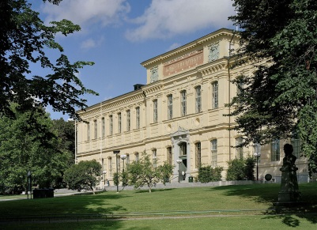
Exterior -https://en.wikipedia.org/wiki/National_Library_of_Sweden#/media/File:National_library_of_sweden.jpg

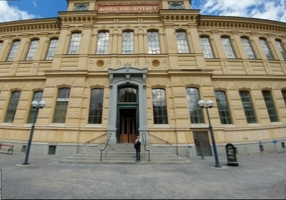
By National Library of Sweden/Ulf Lundin - Own work, CC BY 3.0, https://commons.wikimedia.org/w/index.php?curid=11571316

Front Entrance -

https://www.google.co.uk/maps/place/National+Library+of+Sweden/

- If available, please provide .jpg images of all library sites described in question 5.
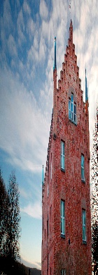
Roggebiblioteket, Strängnäs

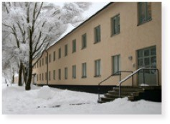
Filmarkivet, Grängesberg

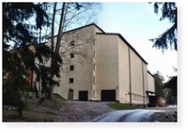
Statens Biblioteksdepå, Bålsta
- If available, please provide .jpg images of all library spaces described in question 6.

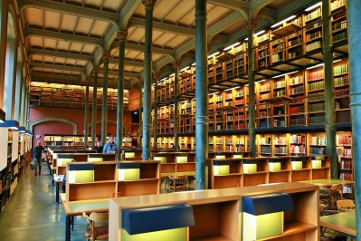
Reading room -https://en.wikipedia.org/wiki/National_Library_of_Sweden#/media/File:The_National_Library_of_Sweden_-_Kungliga_biblioteket_Stockholm_-_lesesalen_-_reading_hall.JPG
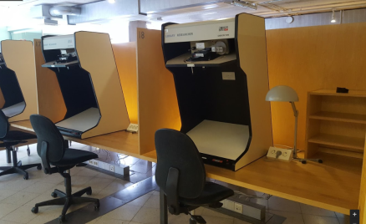
By Øyvind Holmstad - Own work, CC BY-SA 4.0, https://commons.wikimedia.org/w/index.php?curid=46058732
Reading Room 2
https://www.google.co.uk/maps/place/National+Library+of+Sweden/

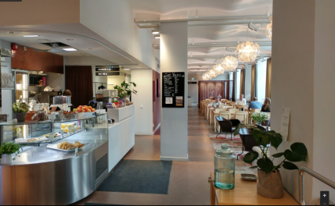
Restaurant -
https://www.google.co.uk/maps/place/National+Library+of+Sweden/

- Please provide simplified plans of your buildings, if possible in .jpg format (perhaps those used to guide visitors around your building).
There are no published plans of the buildings. See picture 1 and 2.
- Please provide brief details on the history of your library buildings.

 | Answer
Year (first) library building opened | The royal book collections were originally located at Tre Kronor (the former castle, “Three Crowns”). After the fire of 1697, the collections were housed elsewhere in Stockholm until they could be relocated in the newly built palace.
Architect of (first) library building | Gustaf Dahl
Year (current) library building opened | In January 1878 the doors of KB were opened for the public.
Architect of (current) library building | Gustaf Dahl
Any additional information. Eg length of build/cost of build/reason for build | Two wings were added in 1926-27.  The National Library was reopened in spring 1997 after comprehensive remodeling and additions. Two large underground stacks, which were built into the bedrock below the building, now contain the bulk of the library's collections, while library patrons, other visitors, and employees share the space in the main building.  The new section, called the Annex, contains auditoriums, exhibition rooms, and a microfilm reading room. All Swedish daily newspapers and a large number of foreign newspapers are available on microfilm in the Microfilm Reading Room.

- If available, please provide a short text on the milestones of the history of your library and/or provide a link to this information online. Please include any bibliographic information about publications about your library and links to these publications in your library catalogue or an aggregated catalogue.
Cirka 750 A.D. Codex aureus, one of KB’s oldest and most cherished manuscripts is created.
1483 The first book is printed in Sweden, Dialogus creaturarum, an edification work in latin. KB has acquired two editions.
16th century The Vasa kings book collections are housed in the castle Tre Kronor (Three Crowns) in Stockholm.
1568 The first inventory of books in the royal collection is drafted, said to be penned by Eric XIV of Sweden.
1649 The Devil’s Bible, Codex gigas, arrives at the castle as war booty from the Thirty Years’ War.
1661 Legislation is passed on legal deposits, requiring that printers submit a copy of all works reproduced to the royal book collections.
1697 Fire havocs at the former royal castle Tre Kronor. Three quarters of the royal book collections are lost to the fire.
1768 The royal book collections are reinstalled in the newly built castle in Stockholm.
1865-1890 KB is under the leadership of the legendary national librarian Gustaf Edvard Klemming.
1874-1882 August Strindberg is employed at KB.
1877 KB is appointed as an independent agency and formally designated as Sweden’s national library.
1878 The KB building in Humlegården is inaugurated and the genera public admitted. Gustaf Dahl is the architect.
1956-1976 The library undergoes renovations and additions. The first underground storage facility is in place.
1972 The national joint catalog LIBRIS is launched.
1979 The Swedish National Archive of Recorded Sound and Moving Images (later KB’s Department of Audiovisual Material) is established.
1979 Microfilming of all current Swedish daily newspaper commences.
1979 New legislature on legal deposits is passed, including sound recordings and moving images into the scope of materials required.
1992-1997 KB undergoes further extensive renovations and additions, including two underground storage facilities of 2 000 square meters.
1997 KB begins to systematically archive Swedish web pages.
1999 KB launches local library catalog Regina.
2005 Mass digitization of audiovisual media commences.
2009 KB and the National Archive of Recorded Sound and Moving Images are merged.
2012 Legislation passed for legal deposits of electronic materials.

Chapter III: Location and Urban Spaces
- Please describe the location of your national library buildings (eg. main building in capital city with close proximity to universities, storage buildings in rural area, located two hours by train from building in capital).
Kungliga Biblioteket is situated in the centre of Stockholm. The Underground will take you to the nearest situated university libraries which are The Stockholm University (red line Stockholms universitet) and, The Royal Institute of Technology (red line Tekniska högskolan). The Södertörn University College is situated in Flemingsberg, which is reached by local train from central Stockholm.
( https://sl.se/ )
- CENL has provided a map of your headquarter location at the centre of a 500m radius – taken as a screenshot from Google maps. If this is not the correct location of your library building, please supply an alternative screen shot.
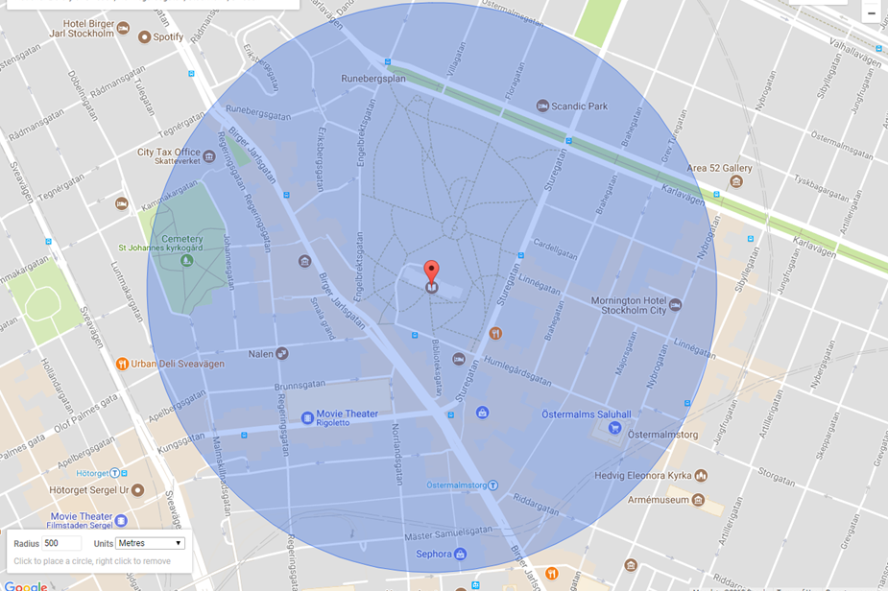

- Please provide details of major governmental, cultural or significant institutions within this vicinity (within a 500m radius).
-
- Please describe all the transport options for reaching each of your library buildings open to researchers and the public.
National Library of Sweden
Address: Humlegårdsgatan 26, Humlegården, Stockholm
https://www.kb.se/besok-och-anvand/hitta-till-kb.html (visit and use KB – website in Swedish)
Underground stops: Östermalmstorg (red line) or Hötorget (green line)
Bus stop: Stureplan
https://sl.se/ (Travel planner)
Roggebiblioteket (Rogge Library)
Lektorsgatan 4, Strängnäs
Contact in advance for a visit: rogge@kb.se
https://www.kb.se/besok-och-anvand/roggebiblioteket.html (visit and use the Rogge Library – website in Swedish)
Statens biblioteksdepå i Bålsta
Contact in advance for a visit: sbd@kb.se
Phone: +46 171 52165 or +46 171 521 91

Chapter IV: Reading Rooms, collections and other interior library spaces
- What is the total number of seats in all your reading rooms across all sites?
323
- What is the total square meterage of all your reading rooms across all sites?
Approximately 500 square metres.
- Please list your reading rooms (type, large, by collection) and individual capacity
Reading Room Name | Collection type | Individual room seat capacity | Individual room square metres
Stora läsesalen/Main reading room | Reference material on shelving. This is the primary location readers use to work with the Legal Deposit Copy of printed work younger than 1830. Such materials cannot be read elsewhere in the library. | 99
Forskarläsesalen  Researcher Reading room | Reference material on shelving. Book storage lockers available for researchers to hire. Only researchers requiring a storage locker may use this room. | 36
Microfilm and digitized newspapers reading room | Microfilmed newspapers and digitized newspaper collection.  Telephone directory collection. | 36
AV-media  Audiovisual reading room  &  Periodicals Reading room | AV-media reference material on shelving. Computers for access to TV & radio, film, music, games.  1000 periodicals are available on open shelving for use in the periodicals reading room. | 24  + 24
Study seating in the Annex. Not strictly a reading room for our collections. Wifi allows access to online collections. | This seating area is used by visitors who have their own study material with them for use in the library. It includes 3 group rooms.  Mainly occupied by students | 70
Special Reading room | Special collections, such as Printed Music, Posters, Manuscripts, Maps, books printed before 1830, Ephemera.  Also public documents from the Library's official archives | 24
Bålsta | Older newspapers | 8
Rogge | Special collections | 2
- Do users register to use your Reading Rooms? If so, how?
No, this is not necessary. All members of the public are welcome.
- Do users pay to use your Reading Rooms? If so, how much?
No, it is free.
- How are your collections accessed within the Reading Rooms? Is collection material open access or called to order? Please describe.
Called to order is the predominant form of access for print materials. Microfilm and digital newspapers are open access. Audiovisual materials are available online if a researcher account is held.
- What is the average number of visits per day to your Reading Rooms?
This is not measured at the National Library of Sweden.
- What is the average number of visits per day to your library?
550

Chapter V: Staffing
- What is the number of staff employed by the library in total ?
2017: 334
- What is the number of staff employed by the library in FTE ?
2017: 7 persons per day in a rolling staffing team

The keynote presentation may be accessed via http://www.cenl.org/members/cenl-annual-general-meeting-2017-15-16-may-british-library-london/nggallery/page/1

