Survey of National Library Spaces and Services

Following on from CENL’s 2017 AGM and the keynote presentations, as well as the breakout session devoted to collection management, members concluded that a survey of library spaces, and the use of digital content within, would be beneficial to all. Data gathered by the CENL Secretariat will be used for analysis and to further discussion in the coming months with all CENL members. The full results of the survey are intended to be presented at CENL’s 2018 AGM.

All over the world we have seen the creation of new libraries during recent years, including new national library buildings that have been inaugurated or redesigned in Europe. The role of libraries and national libraries is changing and is in permanent transition. This process of transformation caused by the digital revolution and by changes within the economic and political environment has impacted library spaces, staffing and library services. To understand and to meet future needs of national libraries this survey aims to collect and analyse fundamental changes within national library spaces which have occurred over the last ten years.

The survey is structured in six chapters determined by the themes that were discussed during the 2017 AGM breakout session:

• The role of national libraries in collection management is changing – this affects library spaces

• National libraries are transforming from solely heritage institutions to also being leaders in digitisation

• Previously the role of digitisation was for preservation, but now there are new uses for our collections which include the combination of digital and heritage – how is this explored within national libraries?

• Staff development is key to the transformation of libraries – staff need to be integrated in the end to end process of digitisation and using that digital content, perhaps in physical and virtual exhibitions

• Skills and standards for digital content are needed for clarity of activity for researchers

 | Answer
Name of national library in full (in your own language and in anglicised form): | Biblioteca Nacional de España  National Library of Spain
Name of Director General with official title: | Ana Santos Aramburo
Main library address: | Paseo de Recoletos 20  E-28071 Madrid  Spain
Current logo as a .jpg:
Contact name, email and telephone for this survey: | Ana Santos Aramburo  directora@bne.es  +34 1 580 78 70 / 77

Instructions
The CENL Secretariat has pre-completed as much information as possible within this survey. Please check the information already provided and augment or correct this as necessary. Where no information is yet provided, please supply answers in full. Do contact cenl@bl.uk with any difficulties.

Chapter I: Scope and core functions of your national library
- Please check all that apply.
National Library | University Library | Public Library | Research Library / Research Centre | National Archives | Legal deposit centre | Preservation centre | Museum | Other
If other please specify:
- Are you the only library with a national remit in your country? If no (eg. there is also a National Technical Library) please specify.
Yes, we are.
- What is the legal status of your library?
Autonomous Body
- Which ministry oversees your library?
Spanish Ministry of Education, Culture and Sport

Chapter II: Physical spaces
- Do you have multiple library sites? If so, please provide address details of all library buildings, including storage.
Yes, we have two library sites:
- Central Branch: Paseo de Recoletos, 20-22 28071 Madrid (http://www.bne.es/en/Servicios/InformacionPractica/SedeCentral/index.html)
- Alcalá Branch: Ctra. de Alcalá de Henares a Meco, Km 1'600, 28805 Madrid (http://www.bne.es/en/Servicios/InformacionPractica/SedeAlcala/index.html)
- Please provide a brief summary of all functions contained within the national library.
In 2017
Reading Rooms | Lounge | Exhibition space | Conference Centre | Conservation Studio | Gallery | Concert Hall | Café / Restaurant | Commercial space / shop | Other

If other please specify:
- Please provide the total square meterage for each of the following functions within your library:
2.893,2 M2 | 456,65 M2 | 1.850,27 M2 | 255,85 M2 | 632,54 M2 | M2 | M2 | 284,03 M2 | 44,76 M2 | M2
Reading Rooms | Lounge | Exhibition space | Conference Centre | Conservation Studio | Gallery | Concert Hall | Café / Restaurant | Commercial space / shop | Other
If other please specify:
- What is the total size of all library buildings in square metres (includes storage areas)?
2017: 99.334 square meters
- What is the size of library buildings open to the public in square metres?
2017: 99.334 square meters

- Please provide .jpg images of your main public building(s) exterior

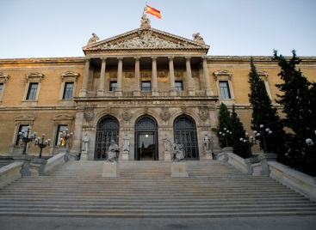
Exterior –
http://www.bne.es/es/AreaPrensa/MaterialGrafico/ImagenInstitucional/Sedes/index.html

- If available, please provide .jpg images of all library sites described in question 5.
Central Branch: Paseo de Recoletos, 20-22 28071 Madrid
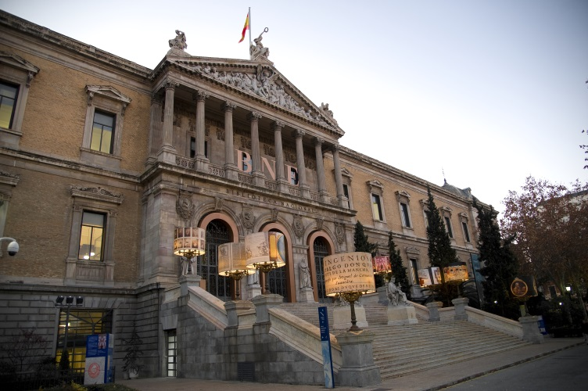
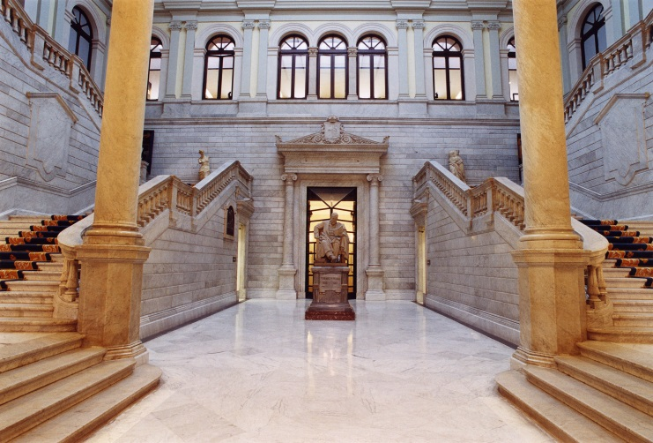

Alcalá Branch: Ctra. de Alcalá de Henares a Meco, Km 1'600, 28805 Madrid

- If available, please provide .jpg images of all library spaces described in question 6.
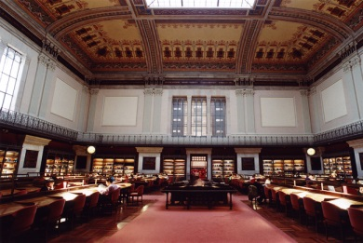
Main Reading room -
http://www.bne.es/es/AreaPrensa/MaterialGrafico/ImagenInstitucional/Sedes/index.html
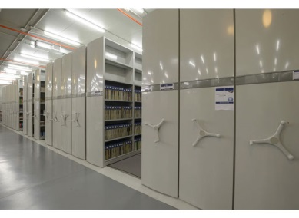
Storage rooms -
http://www.bne.es/es/AreaPrensa/MaterialGrafico/ImagenInstitucional/Sedes/index.html

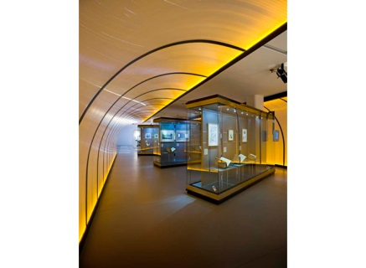
Exhibition Space -
http://www.bne.es/es/AreaPrensa/MaterialGrafico/ImagenInstitucional/Sedes/index.html

- Please provide simplified plans of your buildings, if possible in .jpg format (perhaps those used to guide visitors around your building).

- Please provide brief details on the history of your library buildings.

 | Answer
Year (first) library building opened | 1712
Architect of (first) library building | The Library was founded by the king Philip V in 1711 and opened its doors on 1 March 1712 in a passage that linked the Real Alcazar, originally built in the second half of the ninth century and enlarged over the centuries, with the Royal Monastery of the Incarnation, built by the architect and friar Alberto de la Madre de Dios.
Year (current) library building opened | 1896
Architect of (current) library building | Francisco Jareño
Any additional information. Eg length of build/cost of build/reason for build | Given its role as the legal deposit agency where every Spanish publication must be deposited, since 1991 the National Library of Spain has kept most of its collections in a secondary site in Alcalá de Henares, near Madrid.

- If available, please provide a short text on the milestones of the history of your library and/or provide a link to this information online. Please include any bibliographic information about publications about your library and links to these publications in your library catalogue or an aggregated catalogue.
http://www.bne.es/en/LaBNE/Historia/index.html

Chapter III: Location and Urban Spaces
- Please describe the location of your national library buildings (eg. main building in capital city with close proximity to universities, storage buildings in rural area, located two hours by train from building in capital).
http://www.bne.es/en/Servicios/InformacionPractica/index.html
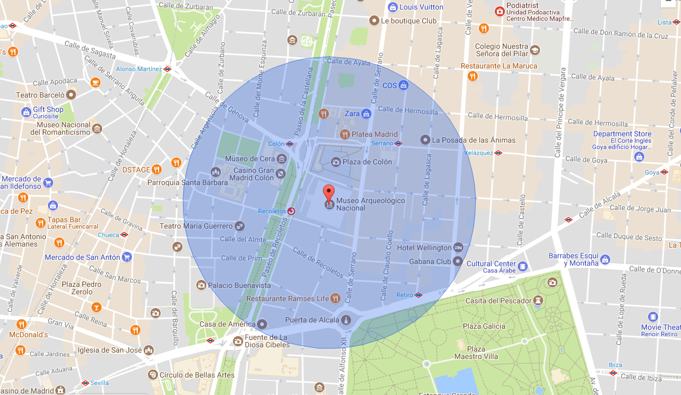
- CENL has provided a map of your headquarter location at the centre of a 500m radius – taken as a screenshot from Google maps. If this is not the correct location of your library building, please supply an alternative screen shot.

It is ok.
- Please provide details of major governmental, cultural or significant institutions within this vicinity (within a 500m radius).
- Museo Arqueológico Nacional: http://www.man.es/man/en/home
- Madrid Town Hall: http://www.madrid.es/portal/site/munimadrid
- Teatro María Guerrero: http://cdn.mcu.es/en/programming/present-season/maria-guerrero/
- Casa de América: http://www.casamerica.es/
- Teatro Fernán Gómez: https://www.teatrofernangomez.es/
- Institut Français: http://www.institutfrancais.es/madrid/cursosdefrances/frances-general/?gclid=EAIaIQobChMIwN-z2I2C2gIViWx-Ch0fggADEAAYASAAEgIdBvD_BwE
- Tribunal Supremo: http://www.poderjudicial.es/portal/site/cgpj/menuitem.7f36112237f0e77203f08712dc432ea0/?vgnextoid=6d70f20408619210VgnVCM100000cb34e20aRCRD&vgnextlocale=en&vgnextfmt=default&lang_choosen=en
- Audiencia Nacional: http://www.poderjudicial.es/portal/site/cgpj/menuitem.7f36112237f0e77203f08712dc432ea0/?vgnextoid=6880f20408619210VgnVCM100000cb34e20aRCRD&vgnextlocale=en&vgnextfmt=default&lang_choosen=en
- Please describe all the transport options for reaching each of your library buildings open to researchers and the public.
Central Branch: http://www.bne.es/en/Servicios/InformacionPractica/SedeCentral/index.html
By Metro: Line 4, Colón or Serrano stations.
By Bus: 1, 5, 9, 14, 19, 21, 27, 37, 45, 51, 53, 74, 150.
By Train: cercanías RENFE (local railway), Recoletos Station.
Alcalá Branch: http://www.bne.es/en/Servicios/InformacionPractica/SedeAlcala/index.html
BY BUS: from Madrid, routes 227 and 250; from Alcalá de Henares, routes 2 and 12
BY TRAIN: cercanías RENFE (local railway), Alcalá de Henares Station, lines C2 and C7 (near bus route 12 and intercity bus route 250); Alcalá-Universidad Station, line C2 (20 minutes' walk, near bus route 12)

Chapter IV: Reading Rooms, collections and other interior library spaces
- What is the total number of seats in all your reading rooms across all sites?
493 seats
- What is the total square meterage of all your reading rooms across all sites?
2.893,2 M2
- Please list your reading rooms (type, large, by collection) and individual capacity

Reading Room Name | Collection type | Individual room seat capacity | Individual room square metres
Main reading room | Books (all formats)  Reference works | 308 | 913,97 M2
Press and journals room | Newspapers and journals (all formats) | 53 | 557,18 M2
Cervantes room | Manuscripts, incunabula and rare books | 24 | 335,44 M2
Goya room | Drawings, photos, engravings, maps and other cartographic materials, ephemera, posters | 18 | 240,54 M2
Barbieri room | Printed and handwritten music scores, audiovisuals, sound recordings | 24 | 266,92 M2
Alcalá de Henares reading room | All sorts of items including books, journals, newspapers, etc. (all formats) | 24 | 200,70 M2
Reference room and Library science & Documentation room | Reference works  Resources for library and information professionals | 42 | 378,45 M2
- Do users register to use your Reading Rooms? If so, how?
Users must register to use the reading rooms. They can pre-register online or register in person. Once registered, they obtain a reader pass. Passes are valid for a period of 3 years and they can be renewed.
http://www.bne.es/en/Servicios/InformacionPractica/CarnesBNE/index.html

- Do users pay to use your Reading Rooms? If so, how much?
No, they don’t pay to use the Reading Rooms.
- How are your collections accessed within the Reading Rooms? Is collection material open access or called to order? Please describe.
Most of the items are held in store. So, users have to request them for use within the reading rooms. Items can be ordered onsite or in advance (online).
- What is the average number of visits per day to your Reading Rooms?
300 - 350 visits per day
- What is the average number of visits per day to your library?
300 - 350 visits per day to the reading rooms
790 -990 visits per day to the exhibitions, guided tours for groups and other cultural events

Chapter V: Staffing
- What is the number of staff employed by the library in total ?
2017: 439
- What is the number of staff employed by the library in total FTE ?
2017: 110

The keynote presentation may be accessed via http://www.cenl.org/members/cenl-annual-general-meeting-2017-15-16-may-british-library-london/nggallery/page/1

