Survey of National Library Spaces and Services

Following on from CENL’s 2017 AGM and the keynote presentations, as well as the breakout session devoted to collection management, members concluded that a survey of library spaces, and the use of digital content within, would be beneficial to all. Data gathered by the CENL Secretariat will be used for analysis and to further discussion in the coming months with all CENL members. The full results of the survey are intended to be presented at CENL’s 2018 AGM.

All over the world we have seen the creation of new libraries during recent years, including new national library buildings that have been inaugurated or redesigned in Europe. The role of libraries and national libraries is changing and is in permanent transition. This process of transformation caused by the digital revolution and by changes within the economic and political environment has impacted library spaces, staffing and library services. To understand and to meet future needs of national libraries this survey aims to collect and analyse fundamental changes within national library spaces which have occurred over the last ten years.

The survey is structured in six chapters determined by the themes that were discussed during the 2017 AGM breakout session:

• The role of national libraries in collection management is changing – this affects library spaces

• National libraries are transforming from solely heritage institutions to also being leaders in digitisation

• Previously the role of digitisation was for preservation, but now there are new uses for our collections which include the combination of digital and heritage – how is this explored within national libraries?

• Staff development is key to the transformation of libraries – staff need to be integrated in the end to end process of digitisation and using that digital content, perhaps in physical and virtual exhibitions

• Skills and standards for digital content are needed for clarity of activity for researchers

 | Answer
Name of national library in full (in your own language and in anglicised form): | Narodna in univerzitetna knjižnica  National and University Library
Name of Director General with official title: | Martina Rozman Salobir
Main library address: | Turjaška ulica 1  1000 Ljubljana  Slovenia
Current logo as a .jpg:
Contact name, email and telephone for this survey: | Martina Rozman Salobir  martina.rozman-salobir@nuk.uni-lj.si  +386 1 2001 100

Instructions
The CENL Secretariat has pre-completed as much information as possible within this survey. Please check the information already provided and augment or correct this as necessary. Where no information is yet provided, please supply answers in full. Do contact cenl@bl.uk with any difficulties.

Chapter I: Scope and core functions of your national library
- Please check all that apply.
X | X |  | X |  | X | x |  | X
National Library | University Library | Public Library | Research Library / Research Centre | National Archives | Legal deposit centre | Preservation centre | Museum | Other
If other please specify:
- Holder and development actor of the Digital Library of Slovenia
- The national aggregator of e-contents from the field of Slovenian culture
- Responsibilities in development of the Slovenian libraries and its library system:
  - To keep the national library statistics and system of performance indicators of libraries (BibSiSt);
  - To keep a register of libraries with a public-service mission;
  - Organization and implementation of non-formal education and professional training for librarians;
  - Professional counseling and support to libraries and librarians.
- Research work in the librarianship and in the library and information science
- Participation in quality assurance processes of the Slovenian Union Catalogue
- Organization and implementation of librarianship professional exams as national examination to enter the profession
- Conducting of procedures for acquiring professional titles in librarianship
- Setting up professional basis for development of the library system and the national bibliographic system
- Preparation of legislative and regulatory provisions in the field of librarianship
- Are you the only library with a national remit in your country? If no (eg. there is also a National Technical Library) please specify.
Yes, the only one with a national remit
- What is the legal status of your library?
Legal status: independent legal entity
Form of organization: public institution
Founder: Republic of Slovenia
Founder's rights are exercised by the Government of the Republic of Slovenia

- Which ministry oversees your library?
Ministry for Culture

Chapter II: Physical spaces
- Do you have multiple library sites? If so, please provide address details of all library buildings, including storage.
Yes, the main and also one dislocated library site
Main library building:
Turjaška ulica 1, 1000 Ljubljana, Slovenia

Dislocated unit (main library collection – legal deposit storage, services for publishers, bibliographic control, cataloging, ISBD and ISMN centres, etc.):
Leskoškova ulica 12, 1000 Ljubljana, Slovenia

Details: http://www.nuk.uni-lj.si/eng/node/438
- Please provide a brief summary of all functions contained within the national library.
In 2017
x |  | x |  | x |  |  | x | x
Reading Rooms | Lounge | Exhibition space | Conference Centre | Conservation Studio | Gallery | Concert Hall | Café / Restaurant | Commercial space / shop | Other

If other please specify:

- Please provide the total square meterage for each of the following functions within your library:
960 M2 | 230 M2 | 65 M2 | - M2 | 360 M2 | - M2 | - M2 | 165 M2 | 22 M2 | - M2
Reading Rooms | Lounge | Exhibition space | Conference Centre | Conservation Studio | Gallery | Concert Hall | Café / Restaurant | Commercial space / shop | Other
If other please specify:
- What is the total size of all library buildings in square metres (includes storage areas)?
2017: 14.359
- What is the size of library buildings open to the public in square metres?
2017: 1.350
Library spaces and equipment for the public: http://www.nuk.uni-lj.si/eng/node/437
  - Entry hall, office for registration and borrowing materials, Information centre (with computer stations),
  - Reading rooms (Main Reading Room, Newspaper Reading Room, Special Collections reading rooms),
  - Basement hallway with reading seats, cloakroom, Café / Restaurant, Reproduction (Photocopying and Printing) Centre
- Please provide .jpg images of your main public building(s) exterior

Main library building (Turjaška ulica 1) – Exterior https://www.google.co.uk/maps/place/National+and+University+Library/
- If available, please provide .jpg images of all library sites described in question 5.
Comment: images will be send in a separate file by WeTransfer.
- If available, please provide .jpg images of all library spaces described in question 6.
Main reading room (Turjaška ulica 1)
https://www.google.co.uk/maps/place/National+and+University+Library/
- Please provide simplified plans of your buildings, if possible in .jpg format (perhaps those used to guide visitors around your building).
See:
For visitors: http://www.nuk.uni-lj.si/eng/node/454/
For users: http://www.nuk.uni-lj.si/eng/sites/default/files/dokumenti/2016/WelcomeToNUK_2016.pdf

Comment: if you need, also detailed plans of library buildings could be sent as a separate file
- Please provide brief details on the history of your library buildings.

 | Answer
Year (first) library building opened | 1941*
Architect of (first) library building | Jože Plečnik
Year (current) library building opened | 1941
Architect of (current) library building | Jože Plečnik
Any additional information. Eg length of build/cost of build/reason for build | build 1936-1941
Year (dislocated unit) opened | 2000
The Library was established in 1774 as Lyceum Library. First, it has been located in the building of Ljubljana lyceum, in 1907 moved in to building of the Poljane Grammar School. In 1930–31 plans for a new building were created by an architect Jože Plečnik, and the new building was constructed between years 1936 and 1941. Library moved to a new premises just before the beginning of the Second World War. The building is considered one of the greatest achievements by Plečnik.
A construction of new building of the National and University Library, named NUK II, has been planned since 1987. The date of the beginning of construction is not yet known, the site is using as a provisional parking lot, named NUK (see: http://www.lpt.si/en/parkings/personal_cars/nuk).
- If available, please provide a short text on the milestones of the history of your library and/or provide a link to this information online. Please include any bibliographic information about publications about your library and links to these publications in your library catalogue or an aggregated catalogue.
- A brief history and video: http://www.nuk.uni-lj.si/eng/node/455
- Wikipedia: https://en.wikipedia.org/wiki/National_and_University_Library_of_Slovenia
- The European Library: http://www.theeuropeanlibrary.org/tel4/contributor/P01238
- For turists: https://www.visitljubljana.com/en/visitors/things-to-do/sightseeing/national-and-university-library/
- Google Arts & Culture: https://artsandculture.google.com/partner/national-and-university-library-of-slovenia
- Building, architecture: https://zalozba.zrc-sazu.si/sites/default/files/01_nuk_zak.pdf
- Architecture, Jože Plečnik: National and University Library Ljubljana : [Jože Plečnik] : architecture in detail / [text by] Mel Gooding ; [photography Mark Fiennes ; drawings Marko Mušič]. - London : Phaidon, 1997 (printed in Hong Kong). - 60 str. : ilustr. ; 30 cm
ISBN 0-7148-2938-2; UDC 72(497.4):929 Plečnik J.; 727.8(497.4 Ljubljana)(084.12),
Union Catalogue: COBISS.SI-ID 69831168
- History, organisation, departments, collections: Slovenska nacionalna knjižnica : ob 60-letnici preimenovanja v Narodno in univerzitetno knjižnico / [avtorji besedil Melita Ambrožič ... [et al.] ; glavni urednik Dare Balažic ; fotografije Milan Štupar ... et al.]. - Ljubljana : Narodna in univerzitetna knjižnica, 2006 ([Ljubljana] : Simčič). - 205 str. : ilustr. ; 30 cm
ISBN 961-6551-12-4; UDC 027.54(497.4)(082), Union Catalogue: COBISS.SI-ID 225670144
- CERL: https://www.cerl.org/resources/hpb/content/national_and_university_library_ljubljana

Chapter III: Location and Urban Spaces
- Please describe the location of your national library buildings (eg. main building in capital city with close proximity to universities, storage buildings in rural area, located two hours by train from building in capital).
The main library building is located in the centre of capital city (Ljubljana), close (about 100 m) to main (administrative unit) building of University of Ljubljana. University’s departments (schools) are located in different parts of Ljubljana, so some higher educational institutions are only a few hundred meters or kilometer or two from the library main building, some of them are located in the North-East and North-West part of the town with a distance above 6-7 kilometers from the main library building.
Library dislocated unit, placed at Leskoškova street 12, is above 11 kilometers from the main building, North-East part of Ljubljana.
- CENL has provided a map of your headquarter location at the centre of a 500m radius – taken as a screenshot from Google maps. If this is not the correct location of your library building, please supply an alternative screen shot.
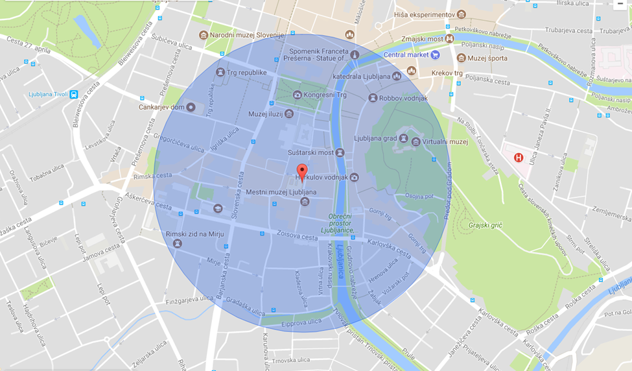
- Please provide details of major governmental, cultural or significant institutions within this vicinity (within a 500m radius).
- University of Ljubljana main building: http://www.uni-lj.si/eng/
- City Museum of Ljubljana: http://www.mgml.si/en/
- Cankarjev dom (main cultural and congress centre in Ljubljana): https://www.cd-cc.si/en
- National Assembly of Slovenia Building: https://www.dz-rs.si/wps/portal/en/Home/ODrzavnemZboru/Poslopje/OParlPoslopju/!ut/p/z1/04_Sj9CPykssy0xPLMnMz0vMAfIjo8zinfyCTD293Q0NDCw8XA0c_Y0dfQycDQycQwz0wwkpiAJKG-AAjgb6BbmhigCqKhbE/dz/d5/L2dBISEvZ0FBIS9nQSEh/
- Faculty for Arts: http://www.ff.uni-lj.si/an/
- Faculty of Pharmacy: http://www.ffa.uni-lj.si/en/
- Faculty of Architecture: http://www.fa.uni-lj.si/default.asp?id=1721
- Faculty of Mechanical Engineering: https://www.fs.uni-lj.si/en/
- Faculty of Natural Sciences and Engineering: https://www.ntf.uni-lj.si/en/
- Academy of Music: https://www.ag.uni-lj.si/en
- Central Technological Library of Ljubljana University: http://www.ctk.uni-lj.si/english.html
- Please describe all the transport options for reaching each of your library buildings open to researchers and the public.
SEE: http://www.nuk.uni-lj.si/eng/node/438 and http://www.nuk.uni-lj.si/eng/sites/default/files/dokumenti/2016/WelcomeToNUK_2016.pdf

Chapter IV: Reading Rooms, collections and other interior library spaces
- What is the total number of seats in all your reading rooms across all sites?
326
- What is the total square meterage of all your reading rooms across all sites?
960 m²
- Please list your reading rooms (type, large, by collection) and individual capacity
Reading Room Name | Collection type | Individual room seat capacity | Individual room square metres
Main Reading Room | Reference Materials | 176 seats | 510
Newspaper Reading Room | Newspapers and other Serials Collection | 47 seats | 150
Special collections rooms | - LIS Collection  - Slovenian Diaspora Publications Collection  - Ephemera and Grey Literature Collection  - Map and Pictorial Collection  - Music Collection  - Manuscript, Rare and Old Prints Collection | Together: 41 seats | Together: 125
Basement hallway | Users’ own materials | 20 seats | 35
Information Centre | Users’ own materials | 42 seats | 140
- Do users register to use your Reading Rooms? If so, how?
For the Newspaper reading room the users have to use their membership card to enter.
For the Main reading room users first have to reserve a seat in the Cloakroom, then they have to use their membership card to open the reading room’s door and register again once they enter so that their seat is marked as occupied. Also every exit from the Main reading room has to be registered.
To visit the reading rooms of special collections users have to be library members, but they don’t have to register/reserve reading seats.
User seats in Basement Hallway and Information Centre are free accessible for library members and also other library visitors.
- Do users pay to use your Reading Rooms? If so, how much?
Library members can use the reading rooms free of charge. Day pass:
Non-members can use free of charge reading seats in Basement Hallway and Information Centre.
Day Pass: 3 Euro; Three months Pass: 6 EUR; Annual Reader Pass: 15 EUR
Some categories of users are entitled to a free membership or a reduced membership fee (See: http://www.nuk.uni-lj.si/eng/node/445 ).
- How are your collections accessed within the Reading Rooms? Is collection material open access or called to order? Please describe.
Called to order. Users have to order materials via library’s catalogue or by manual order form. A part of the special collections materials is open accessed.
- What is the average number of visits per day to your Reading Rooms?
383 visitors daily
- What is the average number of visits per day to your library?
880 visitors daily

Chapter V: Staffing
- What is the number of staff employed by the library in total ?
2017: 139 persons
Comment: because of the economic situation in our country and introduced budget restrictions in past years, we have had to reduce a number of library staff: 2007: 157 persons (148,25 FTE)

- What is the number of staff employed in FTE ?
2017: 137.25 FTE

The keynote presentation may be accessed via http://www.cenl.org/members/cenl-annual-general-meeting-2017-15-16-may-british-library-london/nggallery/page/1

