Survey of National Library Spaces and Services

Following on from CENL’s 2017 AGM and the keynote presentations, as well as the breakout session devoted to collection management, members concluded that a survey of library spaces, and the use of digital content within, would be beneficial to all. Data gathered by the CENL Secretariat will be used for analysis and to further discussion in the coming months with all CENL members. The full results of the survey are intended to be presented at CENL’s 2018 AGM.

All over the world we have seen the creation of new libraries during recent years, including new national library buildings that have been inaugurated or redesigned in Europe. The role of libraries and national libraries is changing and is in permanent transition. This process of transformation caused by the digital revolution and by changes within the economic and political environment has impacted library spaces, staffing and library services. To understand and to meet future needs of national libraries this survey aims to collect and analyse fundamental changes within national library spaces which have occurred over the last ten years.

The survey is structured in six chapters determined by the themes that were discussed during the 2017 AGM breakout session:

• The role of national libraries in collection management is changing – this affects library spaces

• National libraries are transforming from solely heritage institutions to also being leaders in digitisation

• Previously the role of digitisation was for preservation, but now there are new uses for our collections which include the combination of digital and heritage – how is this explored within national libraries?

• Staff development is key to the transformation of libraries – staff need to be integrated in the end to end process of digitisation and using that digital content, perhaps in physical and virtual exhibitions

• Skills and standards for digital content are needed for clarity of activity for researchers

 | Answer
Name of national library in full (in your own language and in anglicised form): | Slovenská národná knižnica  Slovak National Library
Name of Director General with official title: | Ing. Katarína Krištofová, PhD.
Main library address: | Námestie J.C.Hronského 1  036 01 Martin  Slovakia
Current logo as a .jpg: | 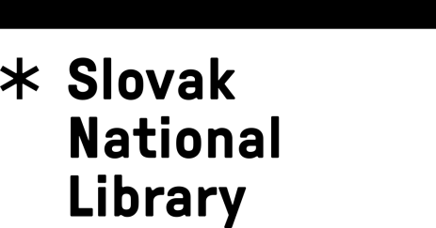
Contact name, email and telephone for this survey: | Katarína Krištofová  katarina.kristofova@snk.sk  421 43 2451 131

Instructions
The CENL Secretariat has pre-completed as much information as possible within this survey. Please check the information already provided and augment or correct this as necessary. Where no information is yet provided, please supply answers in full. Do contact cenl@bl.uk with any difficulties.

Chapter I: Scope and core functions of your national library
- Please check all that apply.
National Library | University Library | Public Library | Research Library / Research Centre | National Archives | Legal deposit centre | Preservation centre | Museum | Other
If other please specify: Literary archives collecting archivalia of Slovak writers, composers, painters, illustrators and other important figures of cultural life
- Are you the only library with a national remit in your country? If no (eg. there is also a National Technical Library) please specify.
Yes
- What is the legal status of your library?
State budgetary organization
- Which ministry oversees your library?
Ministry of Culture

Chapter II: Physical spaces
- Do you have multiple library sites? If so, please provide address details of all library buildings, including storage.
Yes:
Principal building with the main storage, reading rooms, patron services and administration
Building of the Digitisation and Conservation Centre
Building of the Literature Museum
Building of the Slavic Museum of A.S.Pushkin situated in the castle of his family
Building of a renaissance castle in Diviaky used for storing old & rare prints collection
Rented building of a historical library (Bibliotheca Apponiana) where the collection of books, originally belonging to this library are on display and made available to the researchers
- Please provide a brief summary of all functions contained within the national library.
In 2017
Reading Rooms | Lounge | Exhibition space | Conference Centre | Conservation Studio | Gallery | Concert Hall | Café / Restaurant | Commercial space / shop | Other

If other please specify: museums, literary archives
- Please provide the total square meterage for each of the following functions within your library:
2 714 M2 | 3 619 M2 | 2 900 M2 | 1 810 M2 | 720 M2 | M2 | M2 | 540 M2 | M2 | 2 900 M2
Reading Rooms | Lounge | Exhibition space | Conference Centre | Conservation Studio | Gallery | Concert Hall | Café / Restaurant | Commercial space / shop | Other
- If other please specify: museumsWhat is the total size of all library buildings in square metres (includes storage areas)?
2017: 43 485
- What is the size of library buildings open to the public in square metres?
2017: 7 500
- Please provide .jpg images of your main public building(s) exterior

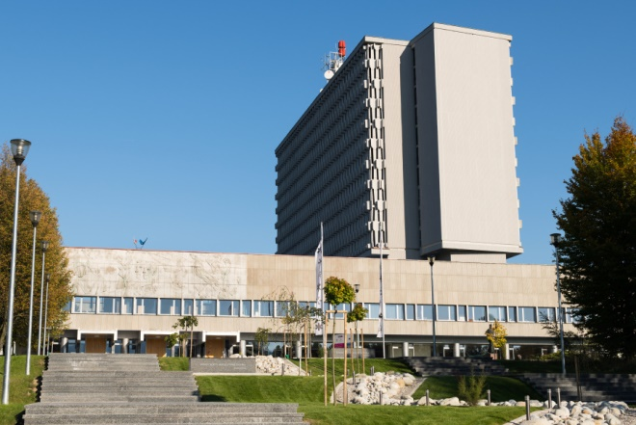
Exterior -
https://en.wikipedia.org/wiki/Slovak_National_Library

- If available, please provide .jpg images of all library sites described in question 5.
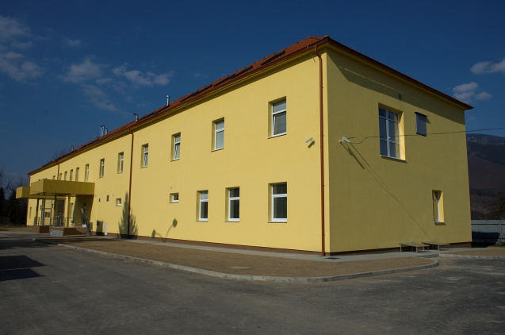
Digitisation and conservation centre

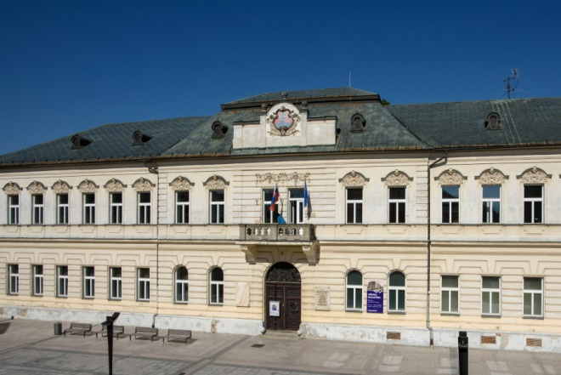
Literature Museum

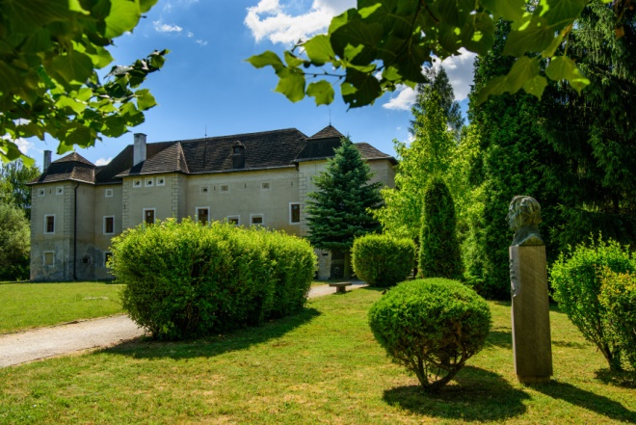
Slavic Museum of A. S. Pushkin

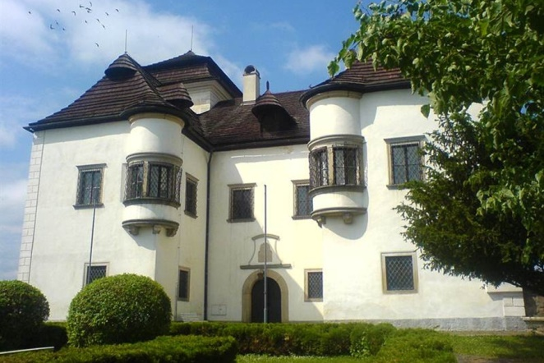
Castle in Diviaky (storage of old & rare prints collection)

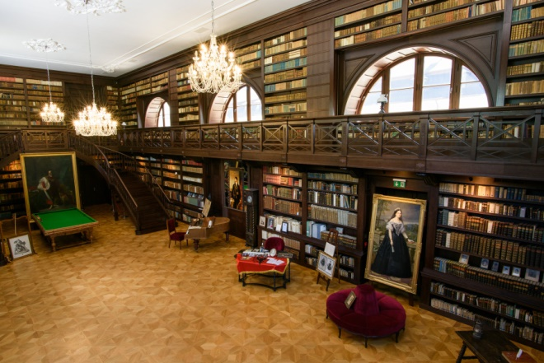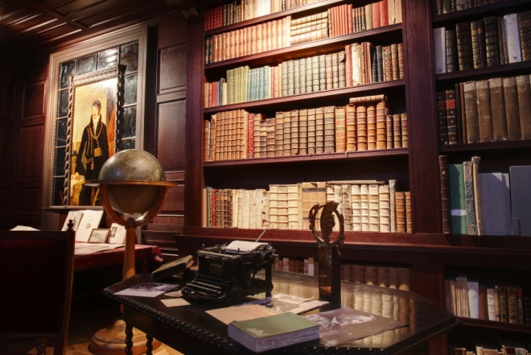

Bibliotheca Aponiana
- If available, please provide .jpg images of all library spaces described in question 6.
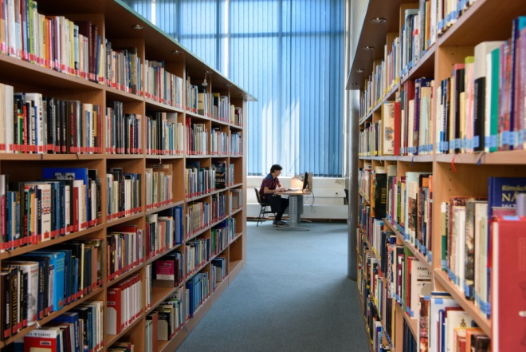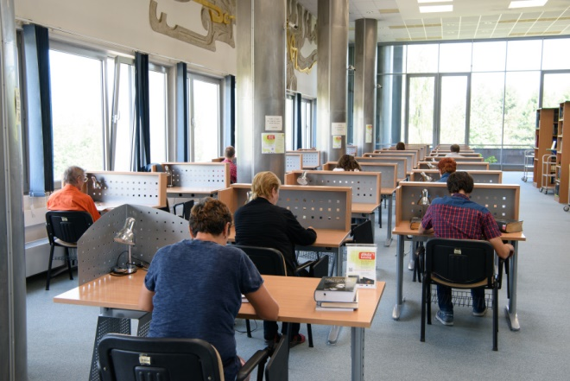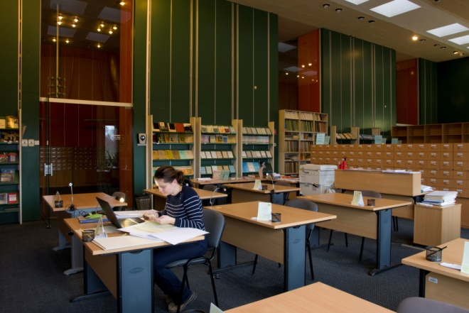
Reading rooms
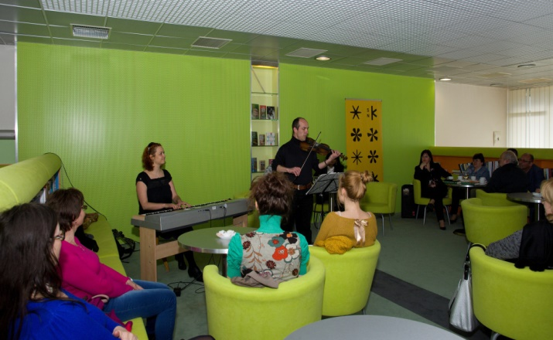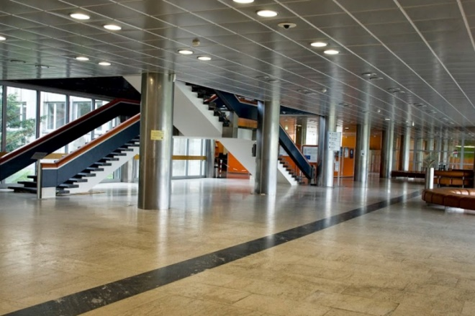
Lounge
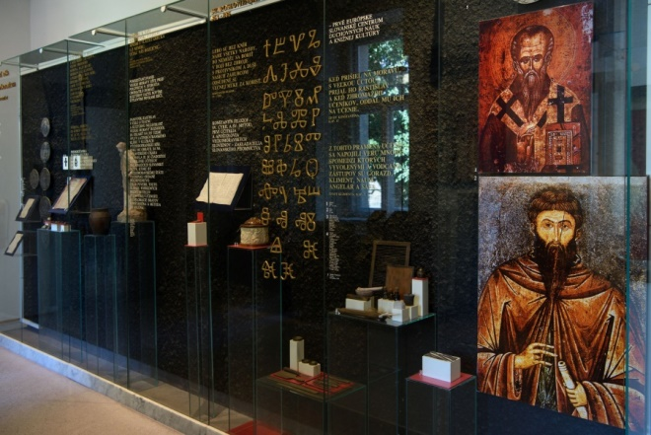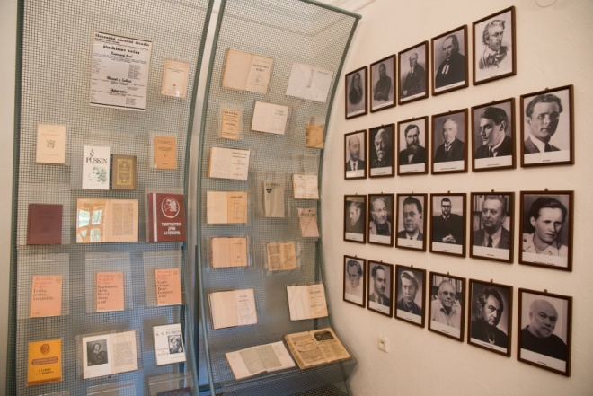
Exhibition spaces
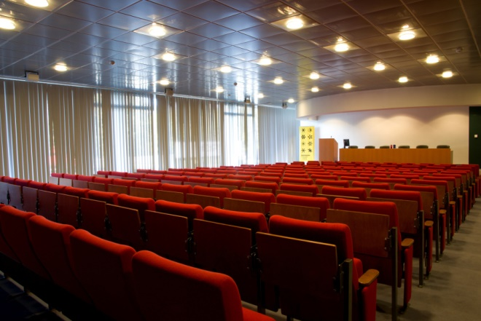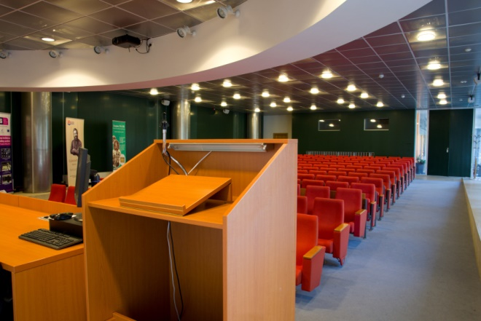
Conference centre
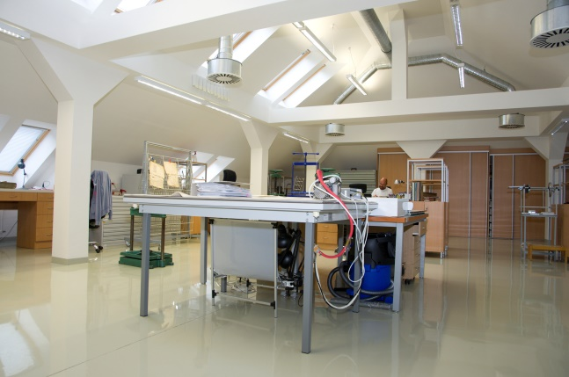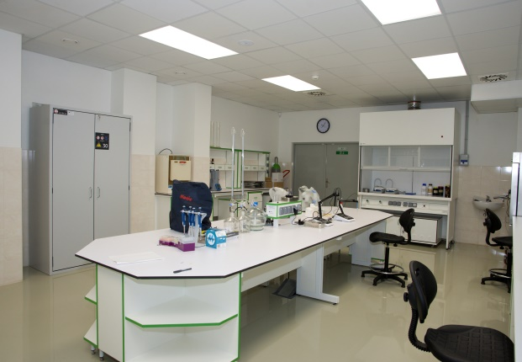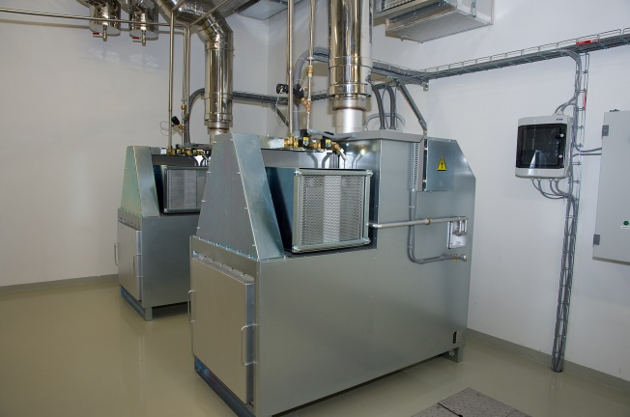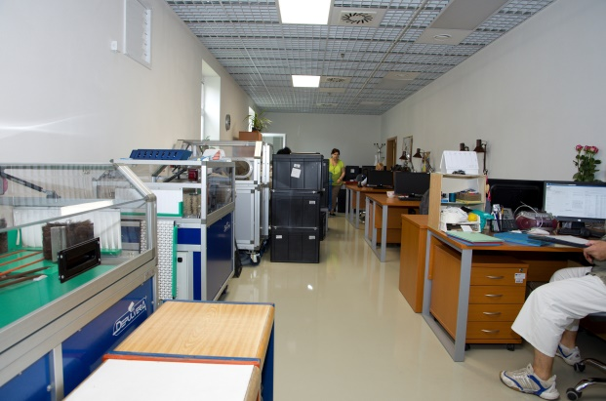
Conservation/restoration centre
- Please provide simplified plans of your buildings, if possible in .jpg format (perhaps those used to guide visitors around your building).
N/A
- Please provide brief details on the history of your library buildings.

 | Answer
Year (first) library building opened | 1865
Architect of (first) library building | Karol Horer
Year (current) library building opened | 1975
Architect of (current) library building | Dušan Kuzma, Anton Cimmerman
Any additional information. Eg length of build/cost of build/reason for build | 110 meters long, 42 metres high, 14 floors, built between 1963 and 1975

- If available, please provide a short text on the milestones of the history of your library and/or provide a link to this information online. Please include any bibliographic information about publications about your library and links to these publications in your library catalogue or an aggregated catalogue.
https://en.wikipedia.org/wiki/Slovak_National_Library
http://www.snk.sk/sk/o-kniznici/o-nas/slovenska-narodna-kniznica.html (Slovak only)

Chapter III: Location and Urban Spaces
- Please describe the location of your national library buildings (eg. main building in capital city with close proximity to universities, storage buildings in rural area, located two hours by train from building in capital).
The main building and the building of Literary museum (the first building of the library from 1875) are located in Martin, a medium-sized town (65 000 inhabitants) in central Slovakia (app. 2.5 hours drive away from the capital of Bratislava). This is due to historical reasons: in the 19th century Martin was the centre of the national movement unlike the cosmopolitan Bratislava (Pressburg).
The Digitisation and Conservation Centre is located in Vrútky, a small town neighbouring to Martin (app. 10 minutes drive away from the main building).
The Slavic museum of A. S. Pushkin is situated in a castle of Brodzany app. 1.5 hours drive away from the main building.
The castle of Diviaky, used for storing old and rare prints collection is situated som 0.5 hours drive away from the main building.
The rented building of the historical library Bibliotheca Apponiana is situated in the castle of Oponice (original family seat of the Apponyi family), app. 2 hours drive away from the main building.
- CENL has provided a map of your headquarter location at the centre of a 500m radius – taken as a screenshot from Google maps. If this is not the correct location of your library building, please supply an alternative screen shot.
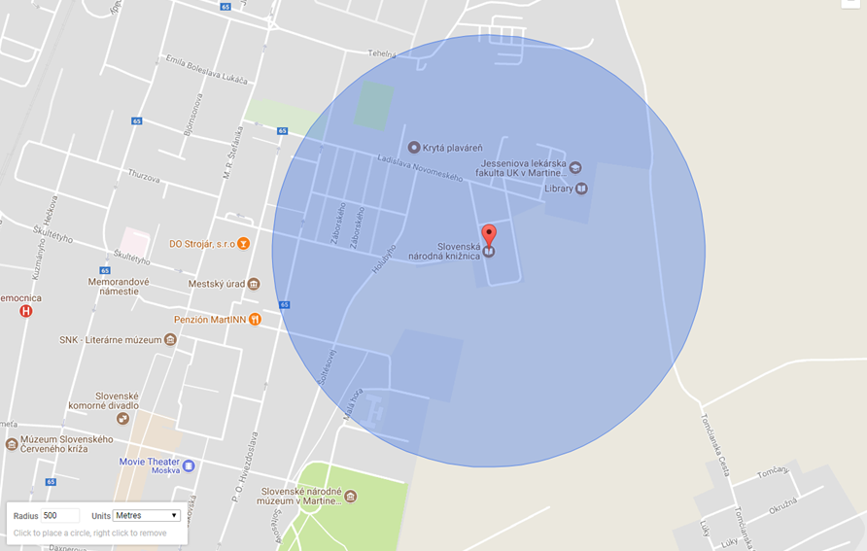
- Please provide details of major governmental, cultural or significant institutions within this vicinity (within a 500m radius).
City Hall, Medical Faculty of Comenius University, 3 secondary schools, Ethnographic museum of the Slovak National Museum
- Please describe all the transport options for reaching each of your library buildings open to researchers and the public.
The buildings in Martin, Vrutky and Diviaky are easily reached by public trains and buses, as well as by car. The remaining locations are reachable by public buses (though less frequent than the buildings in Martin, Vrutky and Diviaky) and by car.

Chapter IV: Reading Rooms, collections and other interior library spaces
- What is the total number of seats in all your reading rooms across all sites?
135
- What is the total square meterage of all your reading rooms across all sites?
2 714
- Please list your reading rooms (type, large, by collection) and individual capacity
Reading Room Name | Collection type | Individual room seat capacity | Individual room square metres
Universal reading room | General | 60 | 1 940
Microfilm reading room | Documents on microfilm and microfiche (mainly serials) | 5 | 60
Multimedia reading room | Mutlimedia (CDs, DVDs etc.) | 7 | 60
Information research centre | Digitised content accessible on-site (general collection digitised within the mass digitisation programme accessible via http://dikda.snk.sk) + external electronic resources | 40 | 376
Literary archives reading room | Archival documents | 23 | 278
- Do users register to use your Reading Rooms? If so, how?
Yes, they need to be our registered users (registration on-site, pre-registration possible online).
- Do users pay to use your Reading Rooms? If so, how much?
No.
- How are your collections accessed within the Reading Rooms? Is collection material open access or called to order? Please describe.
The most used / desired general reference materials and monographs, as well as the newest periodicals in the Universal reading room are open access, all the other materials in all reading rooms are called to order.
- What is the average number of visits per day to your Reading Rooms?
85
- What is the average number of visits per day to your library?
363

Chapter V: Staffing
- What is the number of staff employed by the library in total ?
2017: 303
- What is the number of staff employed in FTE ?
2017:

The keynote presentation may be accessed via http://www.cenl.org/members/cenl-annual-general-meeting-2017-15-16-may-british-library-london/nggallery/page/1

