Survey of National Library Spaces and Services

Following on from CENL’s 2017 AGM and the keynote presentations, as well as the breakout session devoted to collection management, members concluded that a survey of library spaces, and the use of digital content within, would be beneficial to all. Data gathered by the CENL Secretariat will be used for analysis and to further discussion in the coming months with all CENL members. The full results of the survey are intended to be presented at CENL’s 2018 AGM.

All over the world we have seen the creation of new libraries during recent years, including new national library buildings that have been inaugurated or redesigned in Europe. The role of libraries and national libraries is changing and is in permanent transition. This process of transformation caused by the digital revolution and by changes within the economic and political environment has impacted library spaces, staffing and library services. To understand and to meet future needs of national libraries this survey aims to collect and analyse fundamental changes within national library spaces which have occurred over the last ten years.

The survey is structured in six chapters determined by the themes that were discussed during the 2017 AGM breakout session:

• The role of national libraries in collection management is changing – this affects library spaces

• National libraries are transforming from solely heritage institutions to also being leaders in digitisation

• Previously the role of digitisation was for preservation, but now there are new uses for our collections which include the combination of digital and heritage – how is this explored within national libraries?

• Staff development is key to the transformation of libraries – staff need to be integrated in the end to end process of digitisation and using that digital content, perhaps in physical and virtual exhibitions

• Skills and standards for digital content are needed for clarity of activity for researchers

 | Answer
Name of national library in full (in your own language and in anglicised form): | Narodna biblioteka Srbije  National Library of Serbia
Name of Director General with official title: | Laslo Blašković
Main library address: | Skerlićeva 1  11000 Belgrade  Serbia
Current logo as a .jpg:
Contact name, email and telephone for this survey: | Laslo Blašković  upravnik@nb.rs  +381 11 2434 091

Instructions
The CENL Secretariat has pre-completed as much information as possible within this survey. Please check the information already provided and augment or correct this as necessary. Where no information is yet provided, please supply answers in full. Do contact cenl@bl.uk with any difficulties.

Chapter I: Scope and core functions of your national library
- Please check all that apply.
x |  |  | x |  | x | x |  | x
National Library | University Library | Public Library | Research Library / Research Centre | National Archives | Legal deposit centre | Preservation centre | Museum | Other
If other please specify: Parent Library, Reference Centre for Scientific Information, Centre of the Library Information System, Virtual Library of Serbia, Digital National Library, Educational Centre, National Agency for Publishers (CIP, ISBN, ISSN, ISMN, ISAN, DOI), Publishing House
- Are you the only library with a national remit in your country? If no (eg. there is also a National Technical Library) please specify.
There is also the Library of Matica Srpska in Novi Sad, in Vojvodina (province of Serbia).
- What is the legal status of your library?
The National Library of Serbia – a cultural institution of national significance founded by the Republic of Serbia - is a non-profit public service in the field of culture which serves the needs of its country’s citizens and works in accordance with its country’s laws and regulations.
- Which ministry oversees your library?
Ministry of Culture and Information of the Republic of Serbia.

Chapter II: Physical spaces
- Do you have multiple library sites? If so, please provide address details of all library buildings, including storage.
No.
- Please provide a brief summary of all functions contained within the national library.
In 2017
x |  | x | x | x |  | x | x | x | x
Reading Rooms | Lounge | Exhibition space | Conference Centre | Conservation Studio | Gallery | Concert Hall | Café / Restaurant | Commercial space / shop | Other

If other please specify: Multifunctional Atrium
- Please provide the total square meterage for each of the following functions within your library:
1620 M2 | M2 | 230 M2 | 150 M2 | 150 M2 | M2 | 200 M2 | 100 M2 | 70 M2 | 150 M2
Reading Rooms | Lounge | Exhibition space | Conference Centre | Conservation Studio | Gallery | Concert Hall | Café / Restaurant | Commercial space / shop | Other
If other please specify:
Multifunctional Atrium
- What is the total size of all library buildings in square metres (includes storage areas)?
2017: 24.000 m2
- What is the size of library buildings open to the public in square metres?
2017: 6.000
- Please provide .jpg images of your main public building(s) exterior

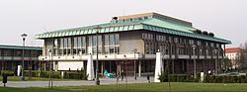
Exterior -

https://en.wikipedia.org/wiki/National_Library_of_Serbia

- If available, please provide .jpg images of all library sites described in question 5.
/
- If available, please provide .jpg images of all library spaces described in question 6.
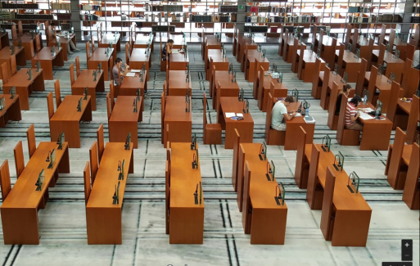
Reading Room -
https://www.google.co.uk/maps/place/National+Library+of+Serbia/

- Please provide simplified plans of your buildings, if possible in .jpg format (perhaps those used to guide visitors around your building).
https://www.nb.rs/pages/article.php?id=881
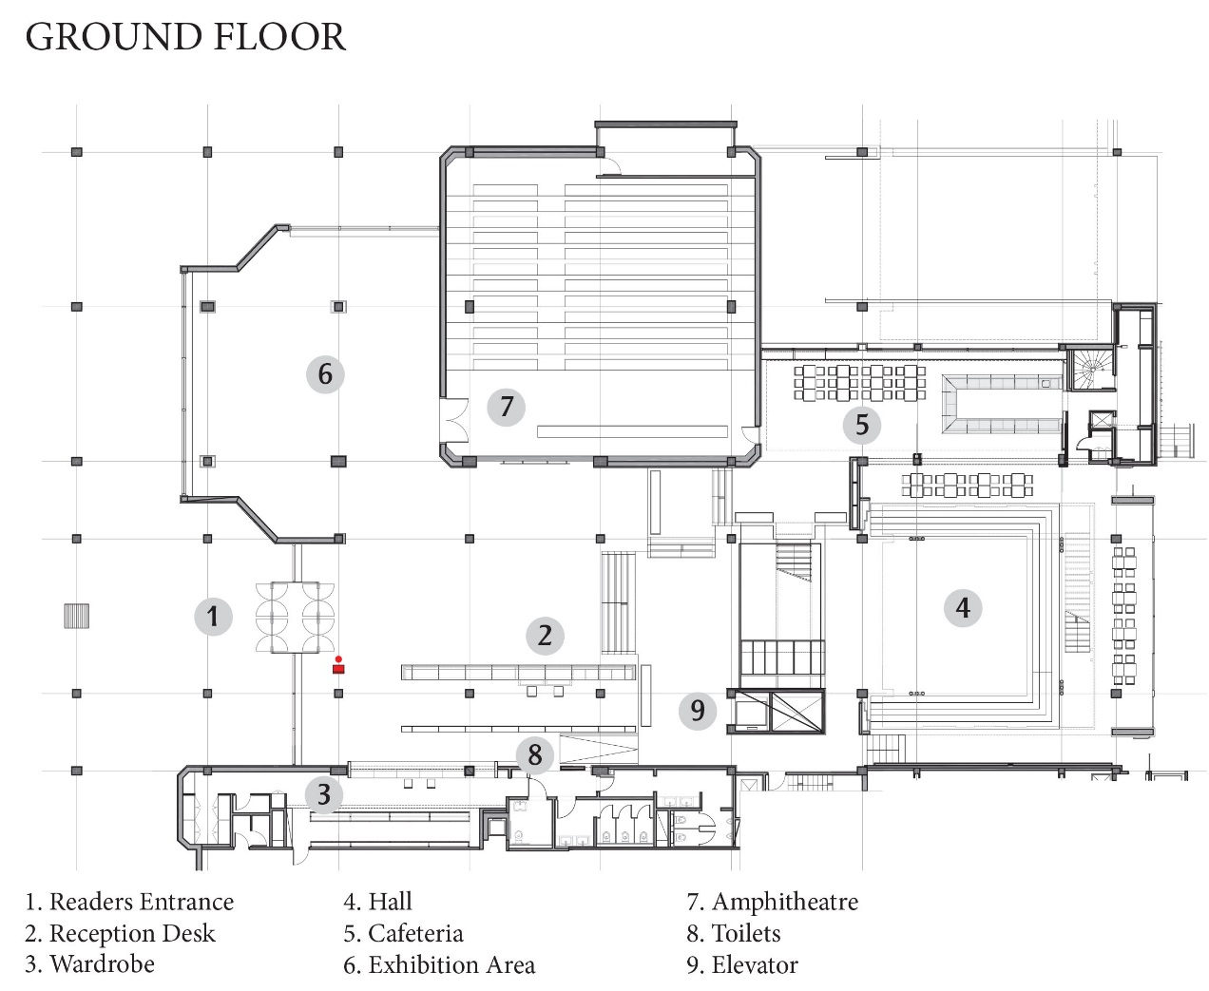

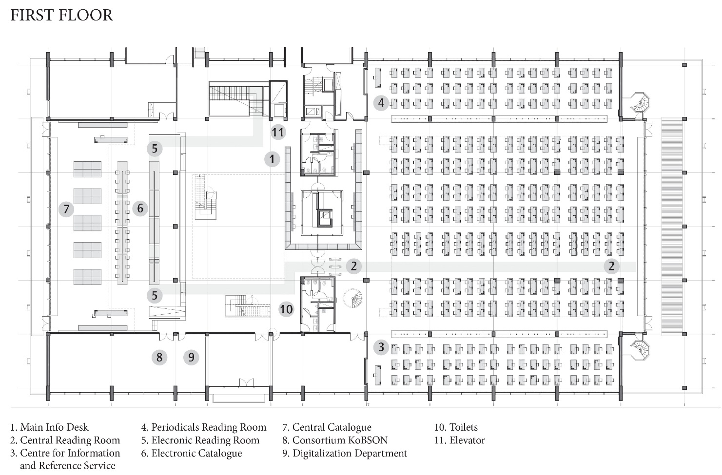
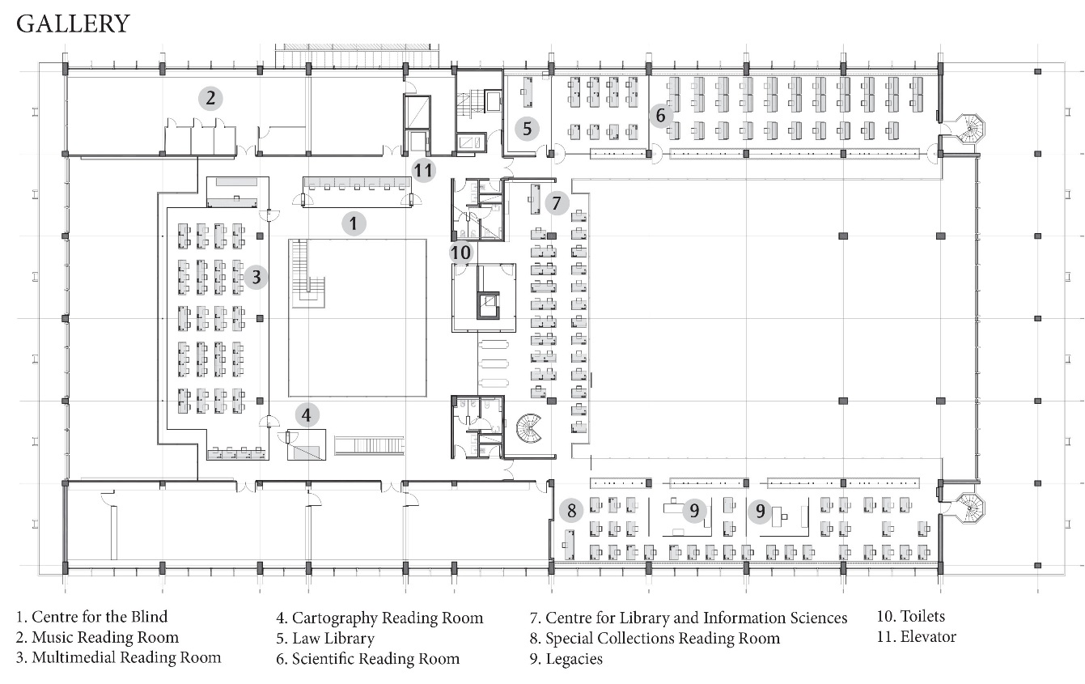

- Please provide brief details on the history of your library buildings.

 | Answer
Year (first) library building opened | The National Library of Serbia was founded in 1832, as the first cultural institution in Serbia. At first (1832-1833) it was placed in a bookshop near the Cathedral in Belgrade, and it was soon transferred to the building of the State Printing House in close vicinity.
Architect of (first) library building | /
Year (current) library building opened | The current building of the National Library of Serbia is practically the first purpose-built library after a long line of buildings that “merely hosted” the Library.
Architect of (current) library building | The architect of the current library building was Professor Ivo Kurtović (1910-1972).
Any additional information. Eg length of build/cost of build/reason for build | The foundation of the current library building was laid in October 1966. The works lasted till November 1972, and the building was officially opened on 6 April 1973 (which also had a symbolic meaning, since on that day, in 1941, the Library was burnt to the ground and its complete holdings were destroyed in an air raid in the Second World War). Anyway, with the first purpose-built library one solved the existential problem of this institution of culture.

- If available, please provide a short text on the milestones of the history of your library and/or provide a link to this information online. Please include any bibliographic information about publications about your library and links to these publications in your library catalogue or an aggregated catalogue.

https://www.nb.rs/pages/article.php?id=32

Chapter III: Location and Urban Spaces
- Please describe the location of your national library buildings (eg. main building in capital city with close proximity to universities, storage buildings in rural area, located two hours by train from building in capital).
The library building is located in the central area of the city of Belgrade.
- CENL has provided a map of your headquarter location at the centre of a 500m radius – taken as a screenshot from Google maps. If this is not the correct location of your library building, please supply an alternative screen shot.
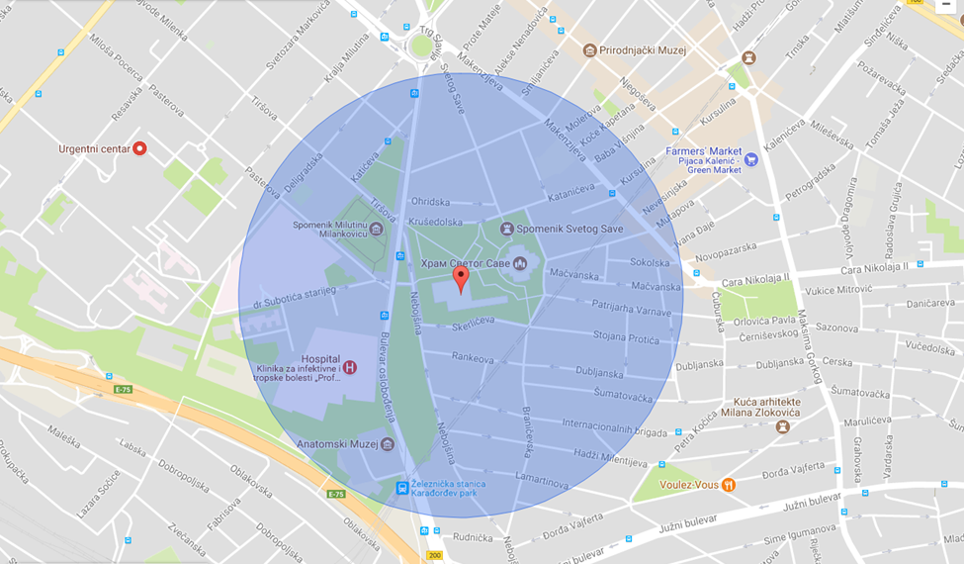
- Please provide details of major governmental, cultural or significant institutions within this vicinity (within a 500m radius).
The Library is located near the Temple of Saint Sava, one of the largest church buildings in the world. There are numerous major governmental, cultural and other institutions within a 500-1000m radius.
- Please describe all the transport options for reaching each of your library buildings open to researchers and the public.
The area is covered with a network of buses, trolleybuses and trams.

Chapter IV: Reading Rooms, collections and other interior library spaces
- What is the total number of seats in all your reading rooms across all sites?
609
- What is the total square meterage of all your reading rooms across all sites?
1620
- Please list your reading rooms (type, large, by collection) and individual capacity
Reading Room Name | Collection type | Individual room seat capacity | Individual room square metres
Central Reading Room | Books | 281 | 600
Reference Reading Room | Books | 54 | 160
Periodicals Reading Room | Periodicals | 54 | 160
Multimedia Reading Room | Audio-visual materials | 52 | 120
Electronic Reading Room |  | 46 | 60
Special Collections Reading Room | Special collections materials | 37 | 160
Library and Information Sciences Reading Room | Books and periodicals | 31 | 120
Scientific Reading Room | Books and periodicals | 30 | 140
Law Reading Room | Books and periodicals | 12 | 25
Music Reading Room | Music | 6 | 50
Reading Room for the Blind and Visually Impaired |  | 5 | 20
Cartography Reading Room | Maps | 1 | 5
- Do users register to use your Reading Rooms? If so, how?
Registration at the reception desk, with the membership card
- Do users pay to use your Reading Rooms? If so, how much?
Two days: 2 Euro
Ten days: 4,5 Euro
One month: 6,5 Euro
One year: 20 Euro
- How are your collections accessed within the Reading Rooms? Is collection material open access or called to order? Please describe.
There are two kinds of access to collections: open access (reference literature in reading rooms) and called to order (all other library materials).
- What is the average number of visits per day to your Reading Rooms?
700
- What is the average number of visits per day to your library?
800

Chapter V: Staffing

- What is the total number of staff employed by the library in total ?
2017: 252
- What is the total number of staff employed by the library in FTE ?
2017: 44

The keynote presentation may be accessed via http://www.cenl.org/members/cenl-annual-general-meeting-2017-15-16-may-british-library-london/nggallery/page/1

