Survey of National Library Spaces and Services

Following on from CENL’s 2017 AGM and the keynote presentations, as well as the breakout session devoted to collection management, members concluded that a survey of library spaces, and the use of digital content within, would be beneficial to all. Data gathered by the CENL Secretariat will be used for analysis and to further discussion in the coming months with all CENL members. The full results of the survey are intended to be uploaded on CENL website / member area and presented at CENL’s 2019 AGM.

All over the world we have seen the creation of new libraries during recent years, including new national library buildings that have been inaugurated or redesigned in Europe. The role of libraries and national libraries is changing and is in permanent transition. This process of transformation caused by the digital revolution and by changes within the economic and political environment has impacted library spaces, staffing and library services. To understand and to meet future needs of national libraries this survey aims to collect and analyse fundamental changes within national library spaces which have occurred over the last ten years.

The survey is structured in five chapters

• Scope and core functions of National Libraries

• Physical Spaces

• Location and Urban Spaces

• Reading Rooms

• Staffing

 | Answer
Name of national library in full (in your own language and in anglicised form): | Президентская библиотека  Boris Yeltsin Presidential Library
Name of Director General with official title: | Ilya Bykovnikov
Main library address: | Senatskaya Str. 3  190 000 St. Petersburg  Russia
Current logo as a .jpg:
Contact name, email and telephone for this survey: | Maxim Chernov  chernov@prlib.ru  +7812 305 16 39

Instructions
The CENL Secretariat has pre-completed as much information as possible within this survey. Please check the information already provided and augment or correct this as necessary. Where no information is yet provided, please supply answers in full. Do contact cenl@bl.uk with any difficulties.

Chapter I: Scope and core functions of your national library
- Please check all that apply.
X |  |  |  |  |  | X
National Library | University Library | Public Library | Research Library / Research Centre | National Archives | Legal deposit centre | Digital  Preservation centre | Museum | Other
If other please specify:
Definitions: Public Library: defined by national law (community library, not research library)
- Are you the only library with a national remit in your country? If no (eg. there is also a National Technical Library) please specify.
National Library of Russia.
Russian State Library.
- What is the legal status of your library?
The Federal State Budgetary Institution
- Which ministry oversees your library?
Department of affairs of the President of the Russian Federation

Chapter II: Physical spaces
- Do you have multiple library sites? If so, please provide address details of all library buildings, including storage.
Reserve Center in Moscow
Moscow, Slavyanskaya Square, 4, building 1
Phone: +7 (495) 620-80-91
Email: msk@prlib.ru

Tyumen Region branch
Tyumen, Ordzhonikidze Street, 59, 2 floor
Phone: +7 (34-52) 565-280
Email: info@tyumen.prlib.ru
- Please provide a brief summary of all functions contained within the national library.
In 2017
X |  | X | X |  | X |  | X |  | X
Reading Rooms | Lounge | Exhibition space | Conference Centre | Conservation Studio | Gallery | Concert Hall | Café / Restaurant | Commercial space / shop | Other

If other please specify: multimedia hall
- Please provide the total square meterage for each of the following functions within your library:
383M2 | M2 | 238M2 | 773M2 | M2 | M2 | M2 | 287M2 | M2 | M2
Reading Rooms | Lounge | Exhibition space | Conference Centre | Conservation Studio | Gallery | Concert Hall | Café / Restaurant | Commercial space / shop | Other
If other please specify: multimedia hall – 554 M2, session hall – 115M2, academic board hall – 80M2, meeting hall – 73M2

- What is the total size of all library buildings in square metres (includes closed storage areas and staff areas)?
2017: 6048M2
- What is the size of library buildings open to the public in square metres (minus closed storage areas and staff areas)?
2017: 4290M2
- Please provide .jpg images of your main public building(s) exterior
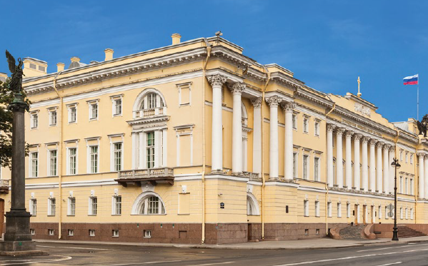 Exterior –
https://en.wikipedia.org/wiki/Boris_Yeltsin_Presidential_Library

- If available, please provide .jpg images of all library sites described in question 5.
Answer
- If available, please provide .jpg images of all library spaces described in question 6.
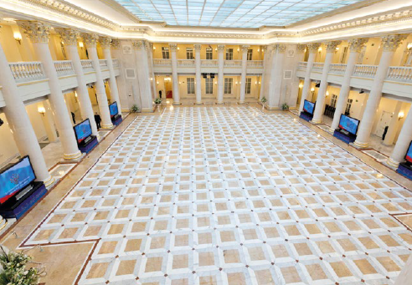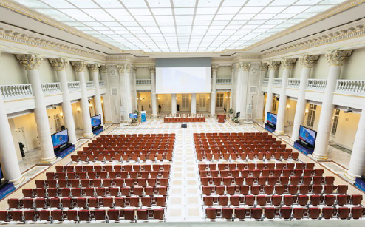– conference centre
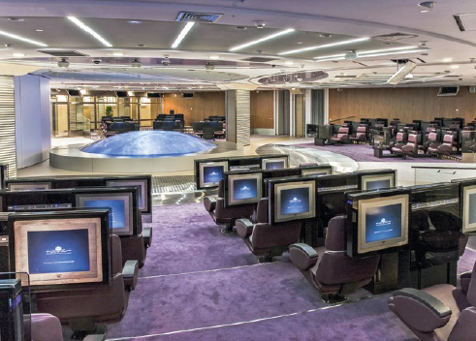 – multimedia hall
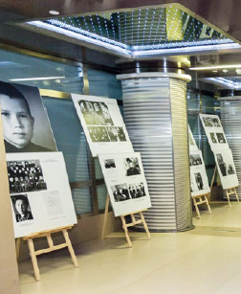 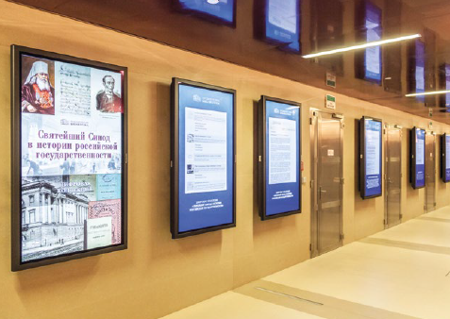 – Gallery

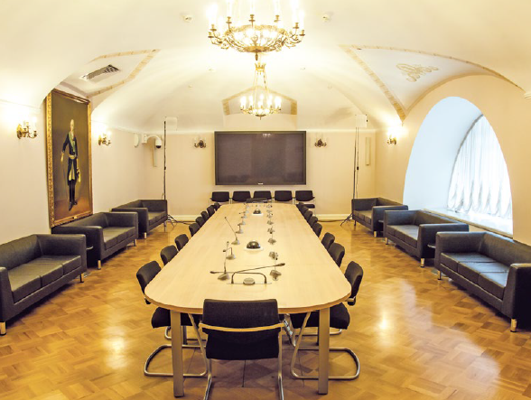 – meeting hall
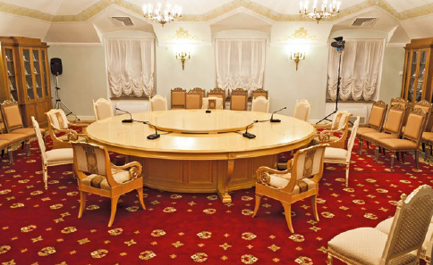 – session hall
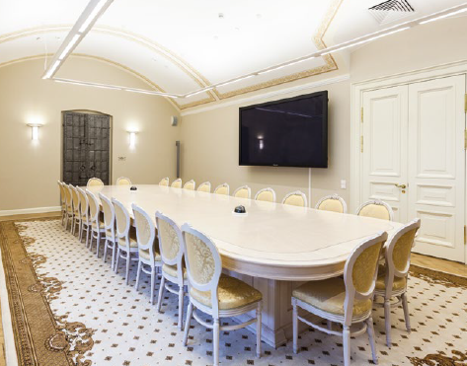 – academic board hall
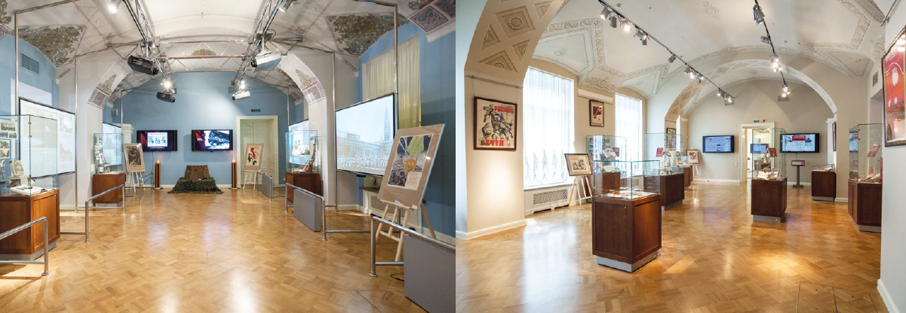 – exhibition halls
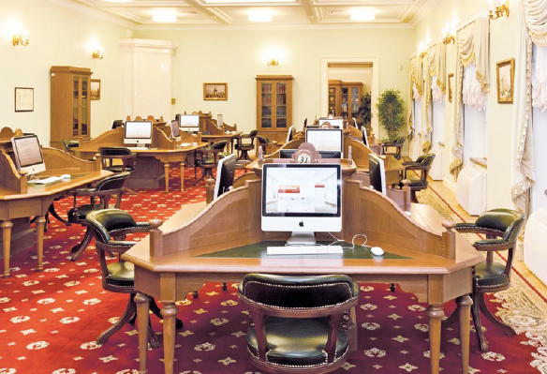 – electronic reading room
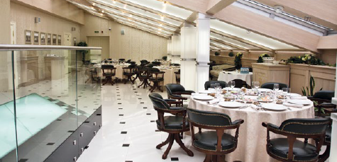 – panoramic cafe

- Please provide simplified plans of your buildings, if possible in .jpg format (perhaps those used to guide visitors around your building).
Answer
- Please provide brief details on the history of your library buildings.

 | Answer
Year (first) library building opened | 1834 - originally built to house the two main governance bodies of the Russian Empire – the Governing Senate and the Holy Synod.  2009 – opened after reconstruction as the Presidential library
Architect of (first) library building | Carlo Rossi
Year (current) library building opened | 2009
Architect of (current) library building | Carlo Rossi
Any additional information. Eg length of build/cost of build/reason for build
- If available, please provide a short text on the milestones of the history of your library and/or provide a link to this information online. Please include any bibliographic information about publications about your library and links to these publications in your library catalogue or an aggregated catalogue.
https://www.prlib.ru/en/about

Chapter III: Location and Urban Spaces
- Please describe the location of your national library buildings (eg. main building in capital city with close proximity to universities, storage buildings in rural area, located two hours by train from building in capital).
Located in the center of St. Petersburg in the historical building of the Synod, the Presidential Library has its structural units in Moscow (reserve center) and Tyumen (the branch in the Tyumen region)
- CENL has provided a map of your headquarter location at the centre of a 500m radius – taken as a screenshot from Google maps. If this is not the correct location of your library building, please supply an alternative screen shot.
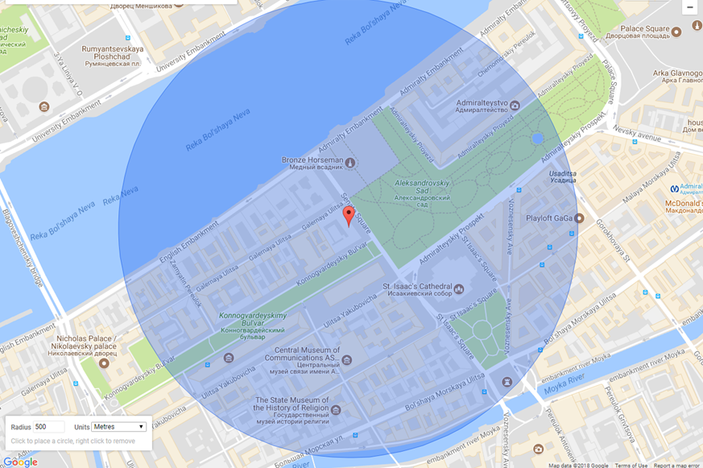
- Please provide details of major governmental, cultural or significant institutions within this vicinity (within a 500m radius).
Constitutional Court of Russian Federation, Bronze Horseman, Saint Isaac's Cathedral, A.S. Popov Central Museum of Communications, State Museum of the History of Religion, Admiralty building, Mariinsky palace (Legislative Assembly of Saint Petersburg).
- Please describe all the transport options for reaching each of your library buildings open to researchers and the public.
Trolleybuses № 5, 22 or buses № 3, 22, 27 from metro stations “Gostiny Dvor”, “Nevsky Prospect”, and “Admiralteyskaya”.

Chapter IV: Reading Rooms, collections and other interior library spaces
- What is the total number of seats in all your reading rooms across all sites?
56 workstations
- What is the total square meterage of all your reading rooms across all sites?
383M2
- Please list your reading rooms (type, large, by collection) and individual capacity
Reading Room Name | Collection type | Individual room seat capacity | Individual room square metres
Еlectronic reading room | Provide access to all digital collections of the Presidential Library including 600 000 items: digitized or digital born books, archival collections, old manuscripts, graphic and cartographic materials, multimedia content (audio and video recordings). | 56 seats | 383 M2
- Do users register to use your Reading Rooms? If so, how?
Only registered users may use Electronic reading room. To register the visitor need to have a passport or other identity document. Each registered user receives personal login and password for access to the User account. This allows him to save the information retrieved, to build own collection of search results, and also to order copies of materials that are not protected by copyright law.
- Do users pay to use your Reading Rooms? If so, how much?
Using the Еlectronic reading room is free of charge
- How are your collections accessed within the Reading Rooms? Is collection material open access or called to order? Please describe.
The electronic reading room provides open access to all digital collections of the Presidential library, unlike the Internet portal where only 30% of the materials are available for everybody (including unregistered users).
- What is the average number of visits per day to your Reading Rooms?
15-20 people
- What is the average number of visits per day to your library?
40-50 people

Chapter V: Staffing
What is the number of staff employed by the library in total ?
2017: 250
- What is the number of staff employed by the library in FTE l?
2017:

The keynote presentation may be accessed via http://www.cenl.org/members/cenl-annual-general-meeting-2017-15-16-may-british-library-london/nggallery/page/1

