Survey of National Library Spaces and Services

Following on from CENL’s 2017 AGM1 and the keynote presentations, as well as the breakout session devoted to collection management, members concluded that a survey of library spaces, and the use of digital content within, would be beneficial to all. Data gathered by the CENL Secretariat will be used for analysis and to further discussion in the coming months with all CENL members.
The full results of the survey are intended to be presented at CENL’s 2018 AGM.

All over the world we have seen the creation of new libraries during recent years, including new national library buildings that have been inaugurated or redesigned in Europe. The role of libraries and national libraries is changing and is in permanent transition. This process of transformation caused by the digital revolution and by changes within the economic and political environment has impacted library spaces, staffing and library services. To understand and to meet future needs of national libraries this survey aims to collect and analyze fundamental changes within national library spaces which have occurred over the last ten years.

The survey is structured in six chapters determined by the themes that were discussed during the 2017 AGM breakout session:

- The role of national libraries in collection management is changing – this affects library spaces
- National libraries are transforming from solely heritage institutions to also being leaders in digitization
- Previously the role of digitization was for preservation, but now there are new uses for our collections which include the combination of digital and heritage – how is this explored within national libraries?
- Staff development is key to the transformation of libraries – staff need to be integrated in the end to end process of digitization and using that digital content, perhaps in physical and virtual exhibitions
- Skills and standards for digital content are needed for clarity of activity for researchers

1 The keynote presentation may be accessed via http://www.cenl.org/members/cenl-annual-general-meeting- 2017-15-16-may-british-library-london/nggallery/page/1

 | Answer
Name of national library in full (in your own language and in anglicised form): | Biblioteca Naţională a României  National Library of Romania
Name of Director General with official title: | Maria Răducu
Main library address: | Bd. Unirii nr. 22, Sector 3,  030833 Bucharest
Current logo as a .jpg:
Contact name, email and telephone for this survey: | Maria Răducu biblioteca@bibnat.ro  +401 314 2434

Instructions

The CENL Secretariat has pre-completed as much information as possible within this survey. Please check the information already provided and augment or correct this as necessary. Where no information is yet provided, please supply answers in full. Do contact cenl@bl.uk with any difficulties.

Chapter I: Scope and core functions of your national library

Please check all that apply.

x | ○ | x | x | ○ | x | x | ○ | ○
National Library | University Library | Public Library | Research Library / Research Centre | National Archives | Legal deposit centre | Preservation centre | Museum | Other

If other please specify:

Are you the only library with a national remit in your country? If no (eg. there is also a National Technical Library) please specify.
Biblioteca Academiei Române/ Romanian Academy library http://www.biblacad.ro/eng_index.html

Biblioteca Militară Națională/ National Military Library

What is the legal status of your library?

Public cultural institution, subordinated to the Ministry of Culture and National Identity

Which ministry oversees your library?

Ministry of Culture and National Identity

Chapter II: Physical spaces

Do you have multiple library sites? If so, please provide address details of all library buildings, including storage.

The National Library of Romania, apart of the central headquarter, has two more branches: The Batthyaneum Library, situated in Alba-Iulia, Str. Gabriel Bethlen nr. 1, cod 51009.
Omnia Library, situated in Craiova. 21, M. Kogălniceanu Street, 200762.

Please provide a brief summary of all functions contained within the national library. In 2017
x | ○ | x | x | X | ○ | ○ | ○ | ○ | X
Reading Rooms | Lounge | Exhibition space | Conference Centre | Conservation Studio | Gallery | Concert Hall | Café / Restaurant | Commercial space / shop | Other

The new building of the National Library of Romania has spaces designated for a Café/Restaurant and a Bookstore, but for the time being, those services are not available for our users. We have to launch an auction procedure in order to externalize those services.

If other please specify:

Open reading and socializing areas (spaces equipped with tables, seats, plugs, lights – similar with those from the reading rooms, where our users have free access to internet, data bases so on).

Please provide the total square meterage for each of the following functions within your library:

2072 M2 | M2 | 3065 M2 | 401 M2 | 1117 M2 | M2 | M2 | 718 M2 | 169 M2 | M2
Reading Rooms | Lounge | Exhibition space | Conference Centre | Conservation Studio | Gallery | Concert Hall | Café / Restaurant | Commercial space / shop | Other

If other please specify:
  - What is the total size of all library buildings in square meters (includes storage areas)?

2017: 74310 sm

  - What is the size of library buildings open to the public in square meters?

2017: currently around 24.000 square meters are opened for the public, but in the future other spaces could be opened.

Please provide .jpg images of your main public building(s) exterior

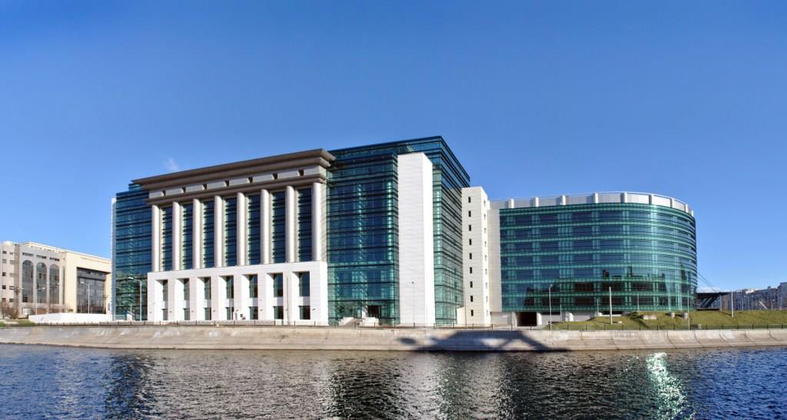

Exterior – the central headquarter

  - If available, please provide .jpg images of all library sites described in question 5.

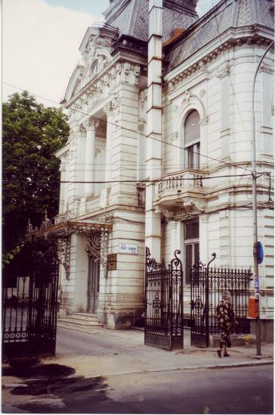

Omnia Library, the Craiova Branch of the National Library of Romania

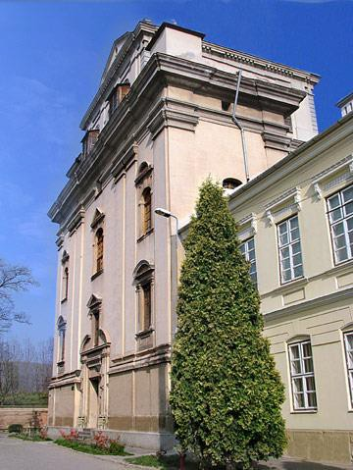

Batthyaneum Library, the Alba Iulia Branch of the National Library of Romania

  - If available, please provide .jpg images of all library spaces described in question 6. 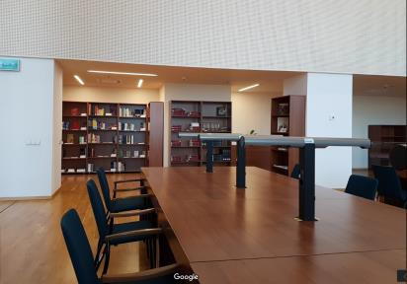 Reading room
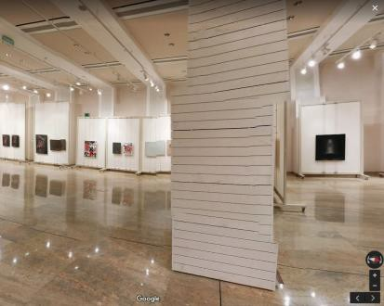 Exhibition space
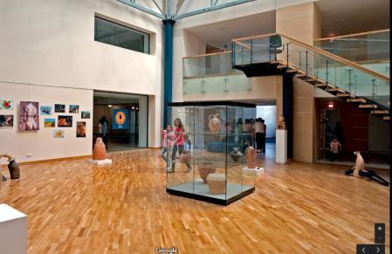
Exhibition space

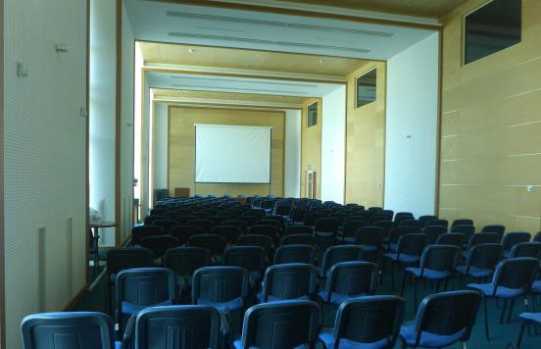 Conference Room

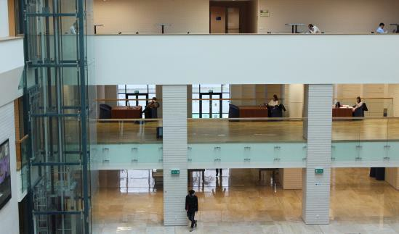
Open reading and socializing areas

  - Please provide simplified plans of your buildings, if possible in .jpg format (perhaps those used to guide visitors around your building).

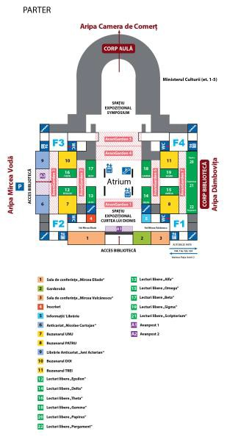 Plan of the grand flour of the National library of Romania

  - Please provide brief details on the history of your library buildings.

 | Answer
Year (first) library building opened | 1955
Architect of (first) library building | The first headquarter assigned to the National Library of Romania, in 1955, was located in the Court Building. That building was constructed between 1890-1895, by the plans of architects Albert Ballu and Ion Mincu.  In 1957, the Library moved in another building, the former Palace of Stock Market, constructed between 1906-1912, after the plans of architect Ștefan Burhuș.
Year (current) library building opened | 2012
Architect of (current) library building | The construction of the new building of the National Library of Romania began in the ‘80s, coordinated by the architect Cezar Lăzărescu and ceased after the 1989 Revolution. The remodelling of the premises was conducted between 2007 and 2008 by architect Eliodor Popa. The construction work was carried out in 2009-2011.
Any additional information. Eg length of build/cost of build/reason for build | The total value of the investment for the building in which has the headquarters the National Library of Romania and the Ministry of Culture and National Identity was 104.839.121 Euro.

  - If available, please provide a short text on the milestones of the history of your library and/or provide a link to this information online. Please include any bibliographic information about publications about your library and links to these publications in your library catalogue or an aggregated catalogue.
Brief history

The most important chapter in the biography of the National Library of Romania can be considered to be the year 1955 when the Central State Library was founded (by D.G. No. 1193/25.06.1955). This library was to be the country's main public library, an institution created on modern library basis, complying with the specific duties of a national library according to UNESCO standards.
According to most historians and researchers, the National Library of Romania finds its origins in one of the oldest and most representative libraries from Romania-the Saint Sava High School Library in Bucharest. This library opened its’ collections to the general public in 1838, when around 1000 French volumes were catalogued. After the Union from 1859, it achieves the status of a national library, alternatively being

referred to as the National Library and The Central Library. In 1864, by public Regulations Law, it is named the Central Library of the State, name and status kept until 1901, when it is disbanded and its collections are transferred to the Romanian Academy Library that receives the status of national library. During this period, only a single national function can be considered relevant for the library, namely, the heritage function. In 1955 the book fund is assigned to the new founded Central State Library, the main public library in Romania.
Immediately after the collapse of communism, in early January 1990, the Central State Library became the National Library of Romania, following the decision of the new power. After the entry of Romania in the European Union it developed its’ functions, being actively involved in numerous national and international projects such as Manuscriptorium, TELplus, Rediscover etc.
http://www.bibnat.ro/Scurt-istoric-s2-ro.htm

Chapter III: Location and Urban Spaces

Please describe the location of your national library buildings (eg. main building in capital city with close proximity to universities, storage buildings in rural area, located two hours by train from building in capital).

The central headquarter of the National Library of Romania is situated in the core of Bucharest, near Unirii Square and has a beautiful view to the Dambovita river toward the Parliament Building.

The Batthyaneum Library is a branch of the National Library of Romania, situated in Alba Iulia, at around 350 kilometers from the central headquarters.

The Omnia Library is situated in Craiova, at around 230 kilometers from Bucharest.

CENL has provided a map of your headquarter location at the centre of a 500m radius – taken as a screenshot from Google maps. If this is not the correct location of your library building, please supply an alternative screen shot.

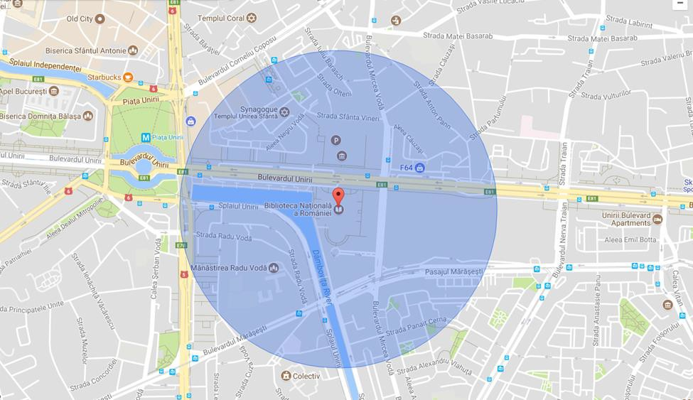

  - Please provide details of major governmental, cultural or significant institutions within this vicinity (within a 500m radius).
Ministerul Culturii și Identității Naționale/ Ministry of Culture and National Identity http://www.cultura.ro/culturaro

Tribunalul București/ Bucharest Court

http://tmb.ro/

Camera de Comerț și Industrie a României/ The Chamber of Commerce and Industry of Romania http://ccir.ro/

Parlamentul României / Parliament of Romania http://www.parlament.ro/index_en.html

Muzeul Național de Artă Contemporană/ National Museum of Contemporary Art http://www.mnac.ro/

Universitatea din București/University of Bucharest http://www.unibuc.ro/

Teatrul Național de Operetă și Musical Ion Dacian

Please describe all the transport options for reaching each of your library buildings open to researchers and the public.

    - The main headquarter of the National Library of Romania, located in Unirii Blv. 22, Sector 3, Bucharest:

Subway: Unirii Station, Lines:

Bus: 104, 116, 117, 123, 124, 385

- Batthyaneum Library, located in Str. Gabriel Bethlen nr. 1, Alba-Iulia City.

- Omnia Library, located in 21, M. Kogălniceanu Street, Craiova.

Chapter IV: Reading Rooms, collections and other interior library spaces

What is the total number of seats in all your reading rooms across all sites? 572 seats in reading rooms
270 seats on open reading and socializing areas (spaces equipped with tables, seats, plugs, lights – similar with those from the reading rooms, where our users have free access to internet, data bases so on)

  - What is the total square meterage of all your reading rooms across all sites? 2072 sm (all the reading rooms currently opened for public)
4047 sm (open reading spaces currently open for the public)

Please list your reading rooms (type, large, by collection) and individual capacity

Reading Room Name | Collection type | Individual room seat capacity | Individual room square metres
Social Sciences and Literature “Mihai Eminescu” | Books | 80 | 421
Economic Sciences Room “Virgil Madgearu” | Books | 50 | 251
Legal Sciences Room “Mircea Djuvara” | Books | 40 | 208
Reading Room for Children and Teenagers “Ionel Teodoreanu” | Books | 50 | 251
American Corner Room | Books and audio-video materials | 27 | 158
Newspapers Reading Room “Gheorghe Asachi” | Newspapers | 110 | 386
References and Librarianship Reading Room | Books and Serial Publications | 150 | 150
“Alexandre Saint Georges” Reading Room | Special Collection Documents | 20 | 99
“George Enescu” Multimedia Reading Room | Scores and other musical recorders | 20 | 104

The main building of the National Library of Romania has 16 spaces dedicated for reading rooms, but only nine of them (the above mentioned ones) are currently opened for public.

Apart from the reading rooms from the central headquarter, Omnia Branch has a reading room opened. More information about you can find in the table below.
Reading Room Name | Collection type | Individual room seat capacity | Individual room square metres
Omnia Library’s Reading Room | Books, serial publications, audio- video materials | 25 | 44

Do users register to use your Reading Rooms? If so, how?

In order to use our Reading Rooms an access card is required. The access card is free and non-transferable.
Documents required for obtaining the access card:

- ID document

- passport / residence permit (for foreigners).

Do users pay to use your Reading Rooms? If so, how much?

No, the access card is free of charge.

How are your collections accessed within the Reading Rooms? Is collection material open access or called to order? Please describe.

A small part of the collection is open access in the reading rooms, but the main part of it is stored in storage rooms.
Steps for accessing the collection in a reading room:

- Give your access card to the custodian and sign in the register;

- Fill in the application bulletin for the desired document (if the document is not in open access);

- After consultation, return the document to the custodian and the access card will be returned.

  - What is the average number of visits per day to your Reading Rooms?

Average per day in reading rooms: 98

What is the average number of visits per day to your library?

Library visitors, including the readers that use our library’s open reading and socializing areas: 515

Chapter V: Staffing

What is the number of staff employed by the in total ?

2017: 221 employees

What is the number of staff employed by the in FTE ?

2017: 17 employees

