Survey of National Library Spaces and Services

Following on from CENL’s 2017 AGM and the keynote presentations, as well as the breakout session devoted to collection management, members concluded that a survey of library spaces, and the use of digital content within, would be beneficial to all. Data gathered by the CENL Secretariat will be used for analysis and to further discussion in the coming months with all CENL members. The full results of the survey are intended to be presented at CENL’s 2018 AGM.

All over the world we have seen the creation of new libraries during recent years, including new national library buildings that have been inaugurated or redesigned in Europe. The role of libraries and national libraries is changing and is in permanent transition. This process of transformation caused by the digital revolution and by changes within the economic and political environment has impacted library spaces, staffing and library services. To understand and to meet future needs of national libraries this survey aims to collect and analyse fundamental changes within national library spaces which have occurred over the last ten years.

The survey is structured in six chapters determined by the themes that were discussed during the 2017 AGM breakout session:

• The role of national libraries in collection management is changing – this affects library spaces

• National libraries are transforming from solely heritage institutions to also being leaders in digitisation

• Previously the role of digitisation was for preservation, but now there are new uses for our collections which include the combination of digital and heritage – how is this explored within national libraries?

• Staff development is key to the transformation of libraries – staff need to be integrated in the end to end process of digitisation and using that digital content, perhaps in physical and virtual exhibitions

• Skills and standards for digital content are needed for clarity of activity for researchers

 | Answer
Name of national library in full (in your own language and in anglicised form): | Biblioteka Narodowa  National Library of Poland
Name of Director General with official title: | Tomasz Makowski
Main library address: | Al. Niepodleglosci 213  02-086 Warsaw 22  Poland
Current logo as a .jpg:
Contact name, email and telephone for this survey: | Tomasz Makowski  dyrektor@bn.org.pl  +48 22 608 2233

Instructions
The CENL Secretariat has pre-completed as much information as possible within this survey. Please check the information already provided and augment or correct this as necessary. Where no information is yet provided, please supply answers in full. Do contact cenl@bl.uk with any difficulties.

Chapter I: Scope and core functions of your national library
- Please check all that apply.
X |  |  |  |  |  | x
National Library | University Library | Public Library | Research Library / Research Centre | National Archives | Legal deposit centre | Preservation centre | Museum | Other
If other please specify:
- Are you the only library with a national remit in your country? If no (eg. there is also a National Technical Library) please specify.
Yes
- What is the legal status of your library?
National Library – The Central Library of the State
- Which ministry oversees your library?
Ministry of Culture and National Heritage

Chapter II: Physical spaces
- Do you have multiple library sites? If so, please provide address details of all library buildings, including storage.
Main Building - Address: al. Niepodległości 213, 02-086 Warszawa

Palace of the Commonwealth – Address: pl. Krasińskich 3/5, 00-207 Warszawa
- Please provide a brief summary of all functions contained within the national library.
In 2017
x |  | x | x | x |  |  | x | x
Reading Rooms | Lounge | Exhibition space | Conference Centre | Conservation Studio | Gallery | Concert Hall | Café / Restaurant | Commercial space / shop | Other

If other please specify:

- Please provide the total square meterage for each of the following functions within your library:
2748 M2 | M2 | M2 | 344 + 100 M2 | 1811 M2 | M2 | M2 | 578 M2 | 33 M2 | M2
Reading Rooms | Lounge | Exhibition space | Conference Centre + foyer | Conservation Studio | Gallery | Concert Hall | Café / Restaurant | Commercial space / shop | Other
If other please specify:
- What is the total size of all library buildings in square metres (includes storage areas)?
2017: 66 418 m² (Main building) al. Niepodległości 213 + 4519,59 m² (Palace of the Commonwealth) pl. Krasińskich 3/5
- What is the size of library buildings open to the public in square metres?
2017: 5722,34 m² (Main building) al. Niepodległości 213 + 406,77 m² (Palace of the Commonwealth) pl. Krasińskich 3/5
- Please provide .jpg images of your main public building(s) exterior
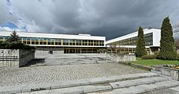

Exterior -

https://en.wikipedia.org/wiki/National_Library_of_Poland

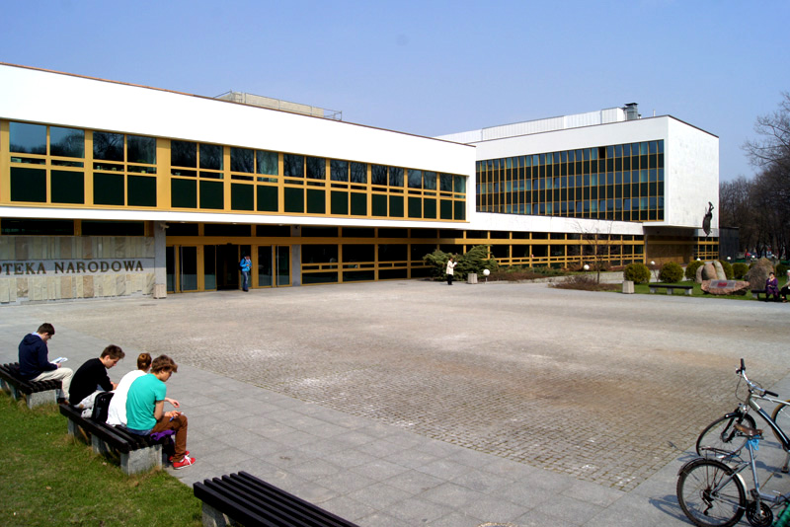
Exterior - http://www.bn.org.pl/aktualnosci,93
- If available, please provide .jpg images of all library sites described in question 5.
Palace of the Commonwealth
http://www.bn.org.pl/aktualnosci/764-xvii-wieczny-palac-rzeczypospolitej-pieknieje.html

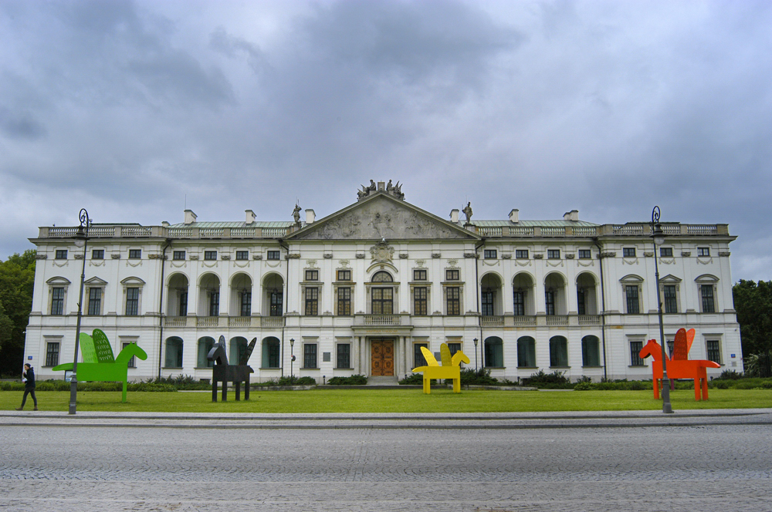
- If available, please provide .jpg images of all library spaces described in question 6.
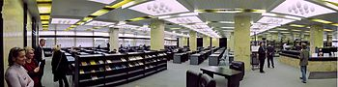
Reading room - https://en.wikipedia.org/wiki/National_Library_of_Poland

http://www.bn.org.pl/dla-czytelnikow/czytelnie :
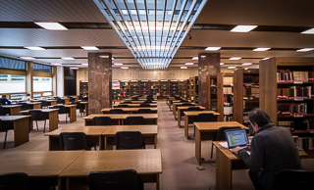 Humanities Reading Room
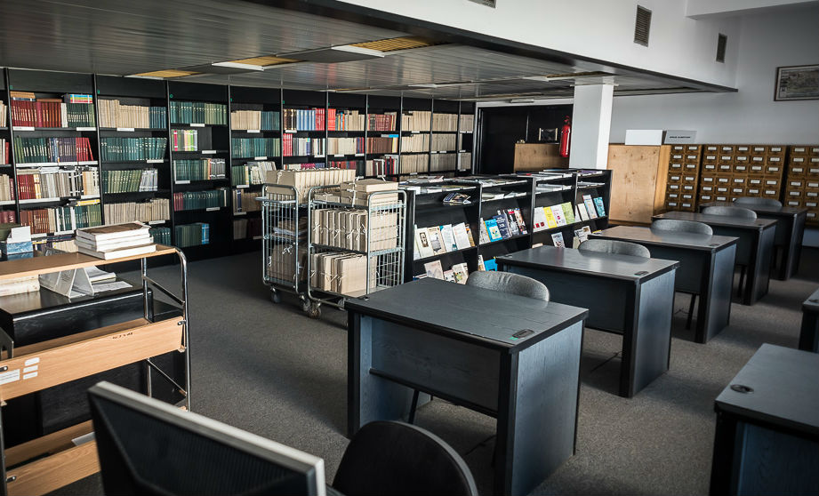 Librarianship and Information Science Reading Room
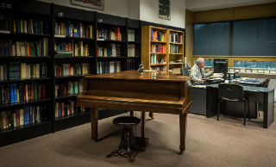 Music Reading Room
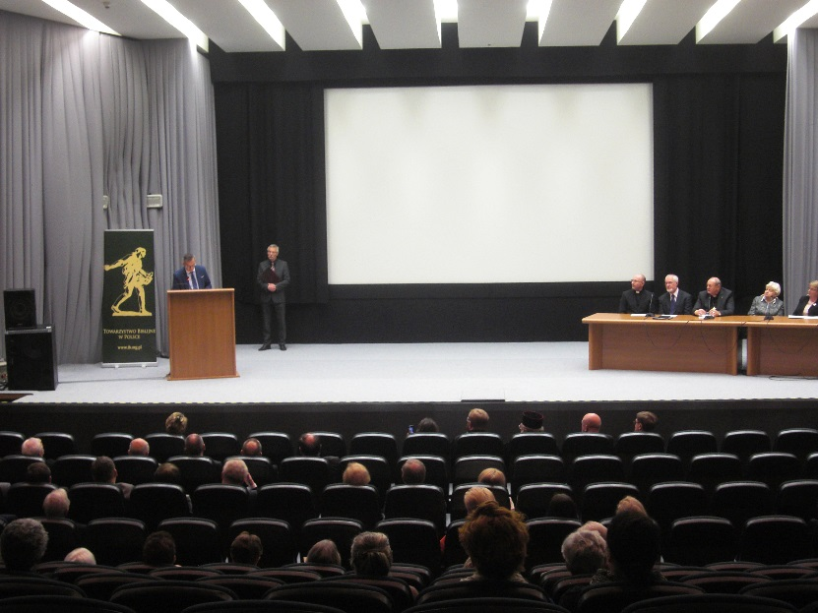 Stefan Demby Conference Hall https://commons.wikimedia.org/wiki/File:BN_Sala_im._Stefana_Dembego_prezentacja_ekumenicznego_Pi%C4%99cioksi%C4%99gu_2014-04-27.JPG

- Please provide simplified plans of your buildings, if possible in .jpg format (perhaps those used to guide visitors around your building).
http://www.bn.org.pl/en/interactive-map/
- Please provide brief details on the history of your library buildings.

 | Answer
Year (first) library building opened | In the years 1928-1998 the National Library did not have its own building and used the buildings of cultural institutions (libraries and archives) in Warsaw.
Architect of (first) library building
Year (current) library building opened | 1998
Architect of (current) library building | Stanislaw Fijałkowski
Any additional information. Eg length of build/cost of build/reason for build

- If available, please provide a short text on the milestones of the history of your library and/or provide a link to this information online. Please include any bibliographic information about publications about your library and links to these publications in your library catalogue or an aggregated catalogue.

The National Library was established under the Decree of the President of the Republic of Poland of February 24, 1928.
The National Library continues the tradition of the Załuski Library of the Commonwealth, set up in Warsaw by the Załuski brothers, Józef Andrzej and Andrzej Stanisław, both of whom were bishops. That Library opened to the public in 1747. It was one of the first libraries in the world intended to fulfill the tasks of a modern library in developing collections covering the entire body of Polish literature and making those works accessible to the public. In 1780 the Polish Parliament [the Sejm] granted the Library the right to receive a free legal deposit copy of every book printed in the country.
After Warsaw was invaded by Russian troops in 1794, the collections of the library were taken as war booty to St. Petersburg where they formed the core of the newly founded Imperial Library. The collections taken to Russia numbered 394,150 volumes, including about 11,000 manuscripts and over 24,500 etchings. After Poland was partitioned in three, the idea of the national library was cultivated by other book repositories, and primarily by foundation libraries of Polish aristocratic families who – beside national literature – also made efforts to collect and protect other memorabilia of national heritage. Many treasures of national literature held in foundation libraries were later incorporated in the National Library’s collections, the building of which began immediately after Poland regained independence in 1918.
The reconstituted holdings of the National Library included the collections of the Załuski Library previously taken to Russia and restituted from the Soviet Union over the period of 1923–1935, as well as the collections of other Warsaw-based libraries and the collections from Rapperswil and Paris created by Polish émigré communities and transferred to Poland.
During World War II the most valuable part of the National Library’s holdings – almost 800,000 registered items – was lost forever. The Library’s special collection was almost completely destroyed, including ca. 50,000 manuscripts, 2,500 incunabula, 80,000 early printed books, and 100,000 drawings and engravings. The few most precious treasures evacuated to Canada survived the ravages of war: this included the earliest manuscript records in the Polish language: the mid 14th century Kazania świętokrzyskie [The Holy Cross Sermons] and the late 14th century Psałterz floriański [Psalterium trilingue – The Sankt Florian Psalter].
http://www.bn.org.pl/en/about-us/history/

The National Library and the Polish Libraries Network: Meeting the challengers of the future. Warszawa: Biblioteka Narodowa, 2015.
http://katalogi.bn.org.pl/iii/encore/record/C__Rb5952265__Spolish%20libraries__P0%2C3__Orightresult__U__X6?lang=pol&suite=cobalt
Palace of the Commonwealth: a gem of architecture. Warszawa: Biblioteka Narodowa, 2008.
http://katalogi.bn.org.pl/iii/encore/record/C__Rb4951882__SPalace%20of%20the%20Commonwealth%3A%20a%20gem%20of%20architecture__Orightresult__U__X2?lang=pol&suite=cobalt
Biblioteka Narodowa w Warszawie. Warszawa: Biblioteka Narodowa, 2007. http://katalogi.bn.org.pl/iii/encore/record/C__Rb1956767__Sbiblioteka%20narodowa__Ff%3Afacetgen9%3AKsi%C4%85%C5%BCki%3AKsi%C4%85%C5%BCki%3AKsi%C4%85%C5%BCki%3A%3A__P0%2C1__Orightresult__U__X6?lang=pol&suite=cobalt
Biblioteka Narodowa w Warszawie : tradycja i współczesność / Joanna Pasztaleniec-Jarzyńska, Halina Tchórzewska-Kabata. Warszawa: Biblioteka Narodowa, 2003.
http://katalogi.bn.org.pl/iii/encore/record/C__Rx1601248__SBiblioteka%20Narodowa%20w%20Warszawie%20%3A%20tradycja%20i%20wsp%C3%B3%C5%82czesno%C5%9B%C4%87%20__Orightresult__U__X4?lang=pol&suite=cobalt
The National Library in Warsaw : tradition and the present day / Joanna Pasztaleniec-Jarzyńska, Halina Tchórzewska-Kabata. Warszawa: Biblioteka Narodowa, 2000.
http://katalogi.bn.org.pl/iii/encore/record/C__Rb1423107__SBiblioteka%20Narodowa%20w%20Warszawie%20%3A%20tradycja%20i%20wsp%C3%B3%C5%82czesno%C5%9B%C4%87%20__P0%2C4__Orightresult__U__X3?lang=pol&suite=cobalt

Chapter III: Location and Urban Spaces
- Please describe the location of your national library buildings (eg. main building in capital city with close proximity to universities, storage buildings in rural area, located two hours by train from building in capital).
The main building is situated in the city centre, it is surrounded by a park. The Palace of the Commonwealth is located in the Old Town, it is partly surrounded by a park.
- CENL has provided a map of your headquarter location at the centre of a 500m radius – taken as a screenshot from Google maps. If this is not the correct location of your library building, please supply an alternative screen shot.
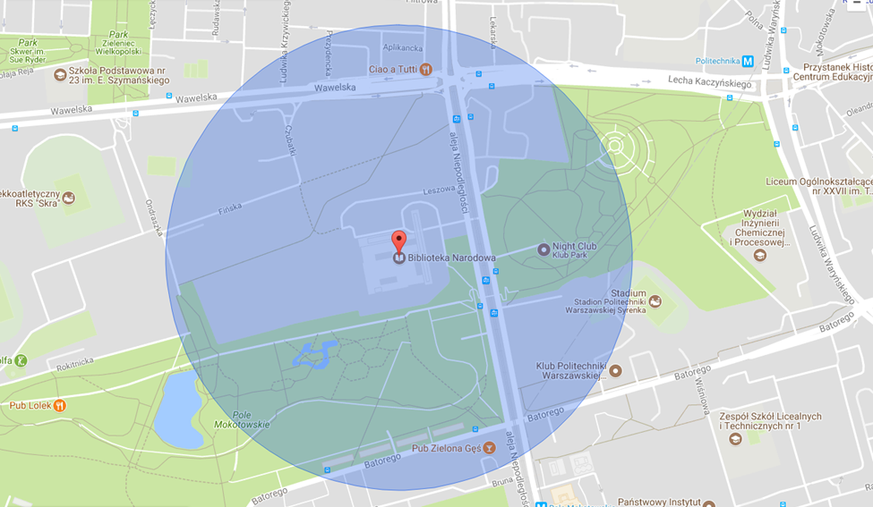
- Please provide details of major governmental, cultural or significant institutions within this vicinity (within a 500m radius).
Close to the main building there is the Central Statistical Office, the Main Patent Office and Warsaw School of Economics.
Close to the Palace of the Commonwealth there is the Highest Court, Embassy of China and Ministry of Health.
- Please describe all the transport options for reaching each of your library buildings open to researchers and the public.
The main building can be reached by metro, bus and tram. The bus and tram stop are in the front of the library, metro station is a 5 minute walk.
The Palace of the Commonwealth can be reached by metro and bus. The bus stop is in the front of the building, the metro station is a 10 minute walk.

Chapter IV: Reading Rooms, collections and other interior library spaces
- What is the total number of seats in all your reading rooms across all sites?
453
- What is the total square meterage of all your reading rooms across all sites?
2748 m²
- Please list your reading rooms (type, large, by collection) and individual capacity
Reading Room Name | Collection type | Individual room seat capacity | Individual room square metres
Main Reading Room | books and periodicals from the 19th –21st century, microfilms | 296 | 1500
Humanities Reading Room | archival copies of books and periodicals from the 19th –21st century | 104 | 617
Manuscripts and Old Prints Reading Room | Manuscripts and early printed books | 11 | 215
Librarianship and Information Science Reading Room | items from the fields of library and information science and ephemera | 15 | 126
Cartography Reading Room | maps, graphic materials, drawings and photographs, | 7 | 76
Music Reading Room | music scores | 7 | 100
Sound and Audiovisual Recordings Reading Room | sound and audiovisual recordings | 13 | 114
- Do users register to use your Reading Rooms? If so, how?
Yes, they should have the library card available in the Reference Department
- Do users pay to use your Reading Rooms? If so, how much?
No
- How are your collections accessed within the Reading Rooms? Is collection material open access or called to order? Please describe.
In all reading rooms there are reference collections. Publications from the storage areas must be ordered by users online or traditionally (paper forms).
- What is the average number of visits per day to your Reading Rooms?
400
- What is the average number of visits per day to your library?
We register only Reading Rooms users

Chapter V: Staffing
- What is the number of staff employed by the library in total ?
2017: 882
- What is the number of staff employed by the library in FTE ?
2017: 848,3

The keynote presentation may be accessed via http://www.cenl.org/members/cenl-annual-general-meeting-2017-15-16-may-british-library-london/nggallery/page/1

