Survey of National Library Spaces and Services

Following on from CENL’s 2017 AGM and the keynote presentations, as well as the breakout session devoted to collection management, members concluded that a survey of library spaces, and the use of digital content within, would be beneficial to all. Data gathered by the CENL Secretariat will be used for analysis and to further discussion in the coming months with all CENL members. The full results of the survey are intended to be presented at CENL’s 2018 AGM.

All over the world we have seen the creation of new libraries during recent years, including new national library buildings that have been inaugurated or redesigned in Europe. The role of libraries and national libraries is changing and is in permanent transition. This process of transformation caused by the digital revolution and by changes within the economic and political environment has impacted library spaces, staffing and library services. To understand and to meet future needs of national libraries this survey aims to collect and analyse fundamental changes within national library spaces which have occurred over the last ten years.

The survey is structured in six chapters determined by the themes that were discussed during the 2017 AGM breakout session:

• The role of national libraries in collection management is changing – this affects library spaces

• National libraries are transforming from solely heritage institutions to also being leaders in digitisation

• Previously the role of digitisation was for preservation, but now there are new uses for our collections which include the combination of digital and heritage – how is this explored within national libraries?

• Staff development is key to the transformation of libraries – staff need to be integrated in the end to end process of digitisation and using that digital content, perhaps in physical and virtual exhibitions

• Skills and standards for digital content are needed for clarity of activity for researchers

 | Answer
Name of national library in full (in your own language and in anglicised form): | Latvijas Nacionālā bibliotēka  National Library of Latvia
Name of Director General with official title: | Andris Vilks, Director
Main library address: | Mūkusalas iela 3  LV-1423 Riga  Latvia
Current logo as a .jpg: | 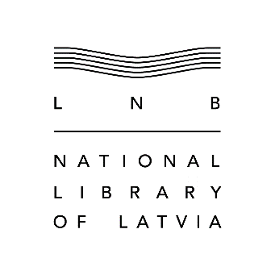  Online: https://lnb.lv/en/about-institution/logo
Contact name, email and telephone for this survey: | Andris Vilks  andris.vilks@lnb.lv  +371 6 780 61 00

Instructions
The CENL Secretariat has pre-completed as much information as possible within this survey. Please check the information already provided and augment or correct this as necessary. Where no information is yet provided, please supply answers in full. Do contact cenl@bl.uk with any difficulties.

Chapter I: Scope and core functions of your national library
- Please check all that apply.
X |  |  | X |  | X |  |  | X
National Library | University Library | Public Library | Research Library / Research Centre | National Archives | Legal deposit centre | Preservation centre | Museum | Other
If other please specify: Educational institution
- Are you the only library with a national remit in your country? If no (eg. there is also a National Technical Library) please specify.
Yes
- What is the legal status of your library?
Institution of direct administration
- Which ministry oversees your library?
Ministry of Culture

Chapter II: Physical spaces
- Do you have multiple library sites? If so, please provide address details of all library buildings, including storage.
Yes
Main library building – Mūkusalas iela 3, Riga, LV-1423, Latvia
Infrastructure building – Mūkusalas iela 5, Riga, LV-1423, Latvia
Repository building – “Raksti”, Silakrogs Parish, Ropaži Municipality, LV-2104, Latvia
- Please provide a brief summary of all functions contained within the national library.
In 2017
X | X | X | X | X |  | X | X | X | X
Reading Rooms | Lounge | Exhibition space | Conference Centre | Conservation Studio | Gallery | Concert Hall | Café / Restaurant | Commercial space / shop | Other

If other please specify:
Classrooms
Audio recording studio
Digitisation studio
- Please provide the total square meterage for each of the following functions within your library:
11 688 m2 | 2108 m2 | 812 m2 | 788 m2 | 434 m2 | 0 m2 | 731 m2 | 849 m2 | 159 m2
Reading Rooms | Lounge | Exhibition space | Conference Centre | Conservation Studio | Gallery | Concert Hall | Café / Restaurant | Commercial space / shop | Other
If other please specify:
Both lounge and galleries on 8 levels of the building, as well as parts of reading rooms are used as exhibition spaces
Observation platform on Level 11 and 12 – 352 m2
Silence and Meditation Room – 254 m2
Permanent exhibition “Book in Latvia” – 257 m2
Museum pedagogy room (Virtaka Class) – 154 m2
- What is the total size of all library buildings in square metres (includes storage areas)?
2017: Main library building (42 887 m²) + Infrastructure building (1 678 m²) + Repository building (4 141 m²) = 48 706 m²
2007: 15 250 m²
- What is the size of library buildings open to the public in square metres?
2017: 16 676 m²
2007: ~5 000 m²

- Please provide .jpg images of your main public building(s) exterior
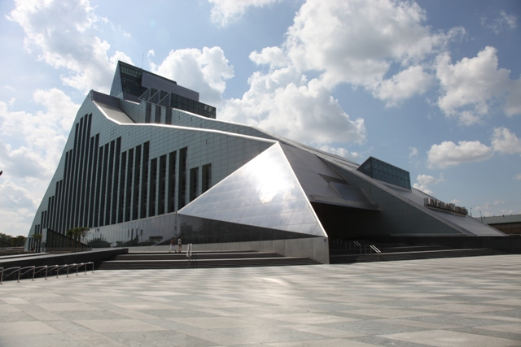

- If available, please provide .jpg images of all library sites described in question 5.
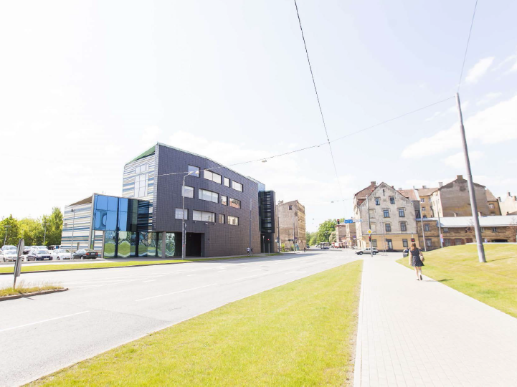
Infrastructure building

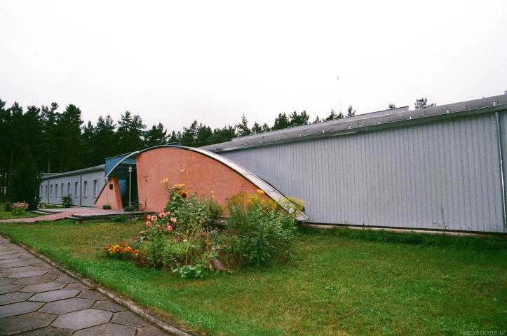
Repository building
- If available, please provide .jpg images of all library spaces described in question 6.
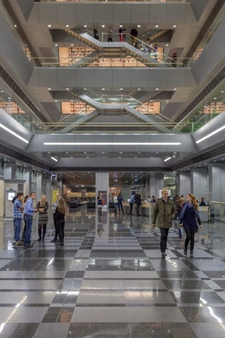
Lounge

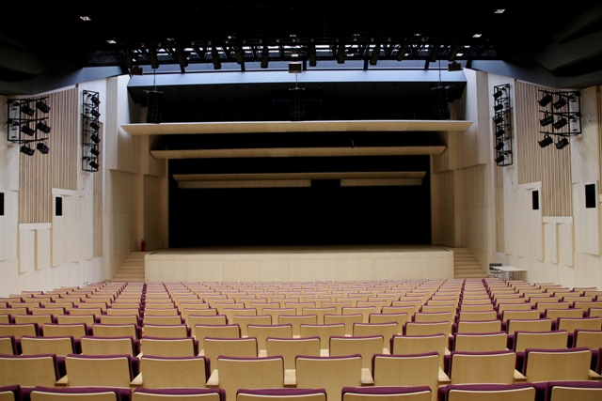
Concert hall
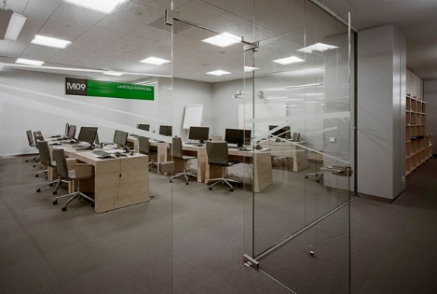
Classroom
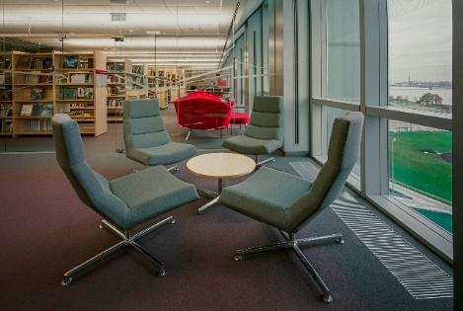
Reading room
- Please provide simplified plans of your buildings, if possible in .jpg format (perhaps those used to guide visitors around your building).
https://lnb.lv/en/about-library/level-map
- Please provide brief details on the history of your library buildings.

 | Answer
Year (first) library building opened | 1920
Architect of (first) library building | Unknown
Year (current) library building opened | 2014
Architect of (current) library building | Gunnar Birkerts
Any additional information. Eg length of build/cost of build/reason for build | Height: 68.3 m, Length: 170 m, Width: 44 m  Cubage: 263 000 m3  Building time: 2008 – 2014 (although the decision to build the library in this location was adopted already in 1988)  Cost of build: 268 000 000 EUR (including cost of land, constructing, equipment, IT, furniture, network for public libraries etc.)  Reason for build: until 2014 the National Library of Latvia was located in five different buildings in Riga, all of them rather old, in bad condition and not suitable for library purposes, both preservation of holding and user service.

- If available, please provide a short text on the milestones of the history of your library and/or provide a link to this information online. Please include any bibliographic information about publications about your library and links to these publications in your library catalogue or an aggregated catalogue.

History of library
https://lnb.lv/en/about-institution/facts-nll-history

Inde, Vilis R. The glass mountain. Riga : Latvian National Library Foundation, [2016]. 3 vol. ISBN 9789934861413.
https://kopkatalogs.lv/F/9XEGJYNDMJMJNPLBP8PUX5UA42G731FS3PP72TH6MDKP8L2ALQ-01573?func=full-set-set&set_number=017546&set_entry=000004&format=999

Gunnar Birkerts, National Library of Latvia, Riga. Stuttgart; London : Edition Axel Menges, [2015]. 60 p. Opus 70. ISBN 9783932565700.
https://kopkatalogs.lv/F/9XEGJYNDMJMJNPLBP8PUX5UA42G731FS3PP72TH6MDKP8L2ALQ-00101?func=full-set-set&set_number=017593&set_entry=000008&format=999

Latvijas Nacionālā bibliotēka : arhitekts Gunārs Birkerts = National Library of Latvia : architect Gunnar Birkerts. [Rīga] : Latvijas Nacionālās bibliotēkas Atbalsta biedrība, [2015]. 271 p., [4] p. ISBN 9789934144875.
https://kopkatalogs.lv/F/9XEGJYNDMJMJNPLBP8PUX5UA42G731FS3PP72TH6MDKP8L2ALQ-01431?func=full-set-set&set_number=017632&set_entry=000009&format=999

Vilks, Andris. Andris Vilks: Director of the National Library of Latvia. From: Lo, Patrick, Cho, Allan, Chiu, Dickson K.W. World´s Leading National, Public, Monastery and Royal Library Directors: Leadership, Management, Future of Libraries. Berlin : De Gruyter, 2017. p 63.-78. ISBN 9783110530834.
https://kopkatalogs.lv/F/9XEGJYNDMJMJNPLBP8PUX5UA42G731FS3PP72TH6MDKP8L2ALQ-05226?func=full-set-set&set_number=017739&set_entry=000001&format=999

Chapter III: Location and Urban Spaces
- Please describe the location of your national library buildings (eg. main building in capital city with close proximity to universities, storage buildings in rural area, located two hours by train from building in capital).
Library building is located in the city centre on the left bank of Daugava River opposite to the iconic view of the Old Town – UNESCO heritage site. The main building and accompanying infrastructure (technical) building is a landmark of the city, and is reachable in 10 minutes by foot from the city centre. University of Latvia is developing its new campus next to the main library building (5 minutes walk), the first opened building is the Academic Center for Natural Sciences. In the vicinity of the main library building (10-20 minutes drive) are located Riga Technical University and its campus, Riga Stradins University and its campus and RISEBA (University of Business, Arts and Technology) main building and Architecture and Media Centre.
Silakrogs Repository building is located 25km (40 minutes drive from the main building) away from Riga.
- CENL has provided a map of your headquarter location at the centre of a 500m radius – taken as a screenshot from Google maps. If this is not the correct location of your library building, please supply an alternative screen shot.
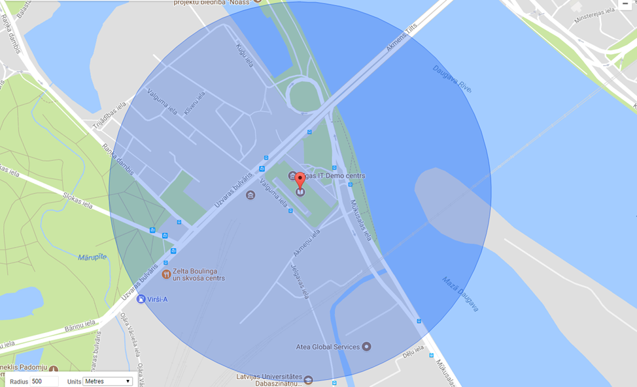
- Please provide details of major governmental, cultural or significant institutions within this vicinity (within a 500m radius).
Latvian Railway History Museum, Academic Center for Natural Sciences of the University of Latvia and new University campus area, across the river – Riga Old Town and Riga Municipality.
- Please describe all the transport options for reaching each of your library buildings open to researchers and the public.
Bus: #3, #4, #4Z, #7, #8, #10, #21, #22, #23, #25, #26, #30, #35, #38, #39, #43, #55
Tram: #1, #2, #5, #10
Trolleybus: #9, #27
Minibus: #222, #238, #244, #246, #263, #270, #271

Chapter IV: Reading Rooms, collections and other interior library spaces
- What is the total number of seats in all your reading rooms across all sites?
988 seats + 48 seats in public areas of reading rooms
- What is the total square meterage of all your reading rooms across all sites?
8688 m²
- Please list your reading rooms (type, large, by collection) and individual capacity
Reading Room Name | Collection type | Individual room seat capacity | Individual room square metres
Reference and Information Centre, including booths for visually impaired people and classroom |  | 150 | 1689
Reading Room for Youth (Room -15+) |  | 20 | 150
Baltic Research Centre for  East Asian Studies Library (AsiaRes) Reading Room |  | 22 | 375
Internet Reading Room |  | 22 | 155
Humanities and Social Sciences Reading Room, including 2 classrooms |  | 258 | 2394
Technology and Science  Reading Room, including individual booths |  | 121 | 873
Periodicals Reading Room |  | 72 | 480
Art Reading Room, including a classroom |  | 51 | 228
Music  Reading Room, including 2 practice rooms |  | 28 | 366
Audiovisual Reading Room, including 6 individual and group booths |  | 64 | 420
Lettonica and Baltic  Reading Room, including individual booths, and Rare Books and  Manuscripts Reading Room |  | 72 | 524
Archives of Latvian Folklore of the Institute of Literature, Folklore and Art* (University of Latvia) |  | 18 | 151
Maps Reading Room, Small Prints Reading Room |  | 30 | 315
Danish Cultural Institute**  (Government of Denmark) |  | 6 | 132
John Fitzgerald Kennedy reading room (US Embassy) |  | 4 | 106
Children's Literature Centre |  | 24 | 255
Library and Information Science  Reading Room, group work booth |  | 30 | 181
- Do users register to use your Reading Rooms? If so, how?
Yes. Any inhabitant or guest of Latvia can obtain a readers card free of charge from age of 5 at the registration desk of the library or online: https://lasreg.lnb.lv/

- Do users pay to use your Reading Rooms? If so, how much?
No
- How are your collections accessed within the Reading Rooms? Is collection material open access or called to order? Please describe.
350 000 items on open shelves, the rest on order; the items stored in the main library can be obtained in 5-15 minutes, the items stored at the repository can be obtained next day. Items can be also order online via electronic catalogue.
- What is the average number of visits per day to your Reading Rooms?
823
- What is the average number of visits per day to your library?
1480

Chapter V: Staffing
- What is the number of staff employed by the library in total ?
2017: 364
- What is the number of staff employed by the library in FTE ?
2017:

The keynote presentation may be accessed via http://www.cenl.org/members/cenl-annual-general-meeting-2017-15-16-may-british-library-london/nggallery/page/1

