Survey of National Library Spaces and Services

Following on from CENL’s 2017 AGM and the keynote presentations, as well as the breakout session devoted to collection management, members concluded that a survey of library spaces, and the use of digital content within, would be beneficial to all. Data gathered by the CENL Secretariat will be used for analysis and to further discussion in the coming months with all CENL members. The full results of the survey are intended to be presented at CENL’s 2018 AGM.

All over the world we have seen the creation of new libraries during recent years, including new national library buildings that have been inaugurated or redesigned in Europe. The role of libraries and national libraries is changing and is in permanent transition. This process of transformation caused by the digital revolution and by changes within the economic and political environment has impacted library spaces, staffing and library services. To understand and to meet future needs of national libraries this survey aims to collect and analyse fundamental changes within national library spaces which have occurred over the last ten years.

The survey is structured in six chaptersdetermined by the themes that were discussed during the 2017 AGM breakout session:

• The role of national libraries in collection management is changing - this affects library spaces

• National libraries are transforming from solely heritage institutions to also being leaders in digitization

• Previously the role of digitization was for preservation, but now there are new uses for our collections which include the combination of digital and heritage - how is this explored within national libraries?

• Staff development is key to the transformation of libraries - staff need to be integrated in the end to end process of digitization and using that digital content, perhaps in physical and virtual exhibitions

• Skills and standards for digital content are needed for clarity of activity for researchers

 | Answer
Name of national library in full (in your own language and in anglicised form): | Bibljoteka Nazzjonali  The National Library of Malta
Name of Director General with official title: | Ms Cheryl Falzon, National Librarian and CEO, Malta Libraries
Main library address: | Old Treasury Street  Valletta VLT 1410  Malta
Current logo as a .jpg:
Contact name, email and telephone for this survey: | Ms Joanne Sciberras  joanne.a.sciberras@gov.mt  +356 21220229

Instructions
The CENL Secretariat has pre-completed as much information as possible within this survey. Please check the information already provided and augment or correct this as necessary. Where no information is yet provided, please supply answers in full. Do contact cenl@bl.uk with any difficulties.

Chapter I: Scope and core functions of your national library
- Please check all that apply.
x |  |  | x |  | x | x
National Library | University Library | Public Library | Research Library / Research Centre | National Archives | Legal deposit centre | Preservation centre | Museum | Other
If other please specify:
- Are you the only library with a national remit in your country? If no (eg. there is also a National Technical Library) please specify.
The National Library of Malta as well as the National Library (Gozo) are both depositories as per Malta Libraries Act 2011
- What is the legal status of your library?
Government entity as per Malta Libraries Act 2011
- Which ministry oversees your library?
Ministry for Education

Chapter II: Physical spaces
- Do you have multiple library sites? If so, please provide address details of all library buildings, including storage.
One building
- Please provide a brief summary of all functions contained within the national library.
In 2017
x |  | x |  | x |  |  |  |  | x
Reading Rooms | Lounge | Exhibition space | Conference Centre | Conservation Studio | Gallery | Concert Hall | Café / Restaurant | Commercial space / shop | Area for Public Events

If other please specify:
- Please provide the total square meterage for each of the following functions within your library:
M2 | M2 | M2 | M2 | M2 | M2 | M2 | M2 | M2 | M2
Reading Room  525 m² | Lounge  N/A | Exhibition space*  c. a third of the Reading Room | Conference Centre*  c. a third of the Reading Room | Conservation Studio  160 m² | Gallery  N/A | Concert Hall*  c. a third of the Reading Room | Café / Restaurant  N/A | Commercial space / shop  Only a display case of items for sale is available. | Other
* We do not actually have a Conference Centre and a Concert Hall. However, we do hold conferences and also concerts in the space available for events and activities within the Reading Room. As explained above, our Reading Room is divided into 3 spaces used for exhibition, research and activities respectively.
- What is the total size of all library buildings in square metres (includes storage areas)?
2017: c. 2824m²
- What is the size of library buildings open to the public in square metres?
2017: c. 730 m²

- Please provide .jpg images of your main public building(s) exterior

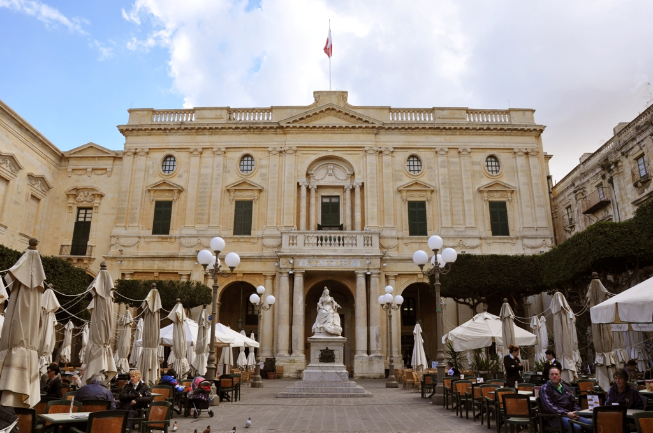

Exterior - The Façade of the National Library

- If available, please provide .jpg images of all library sites described in question 5.
Same image at Point 9.
- If available, please provide .jpg images of all library spaces described in question 6.
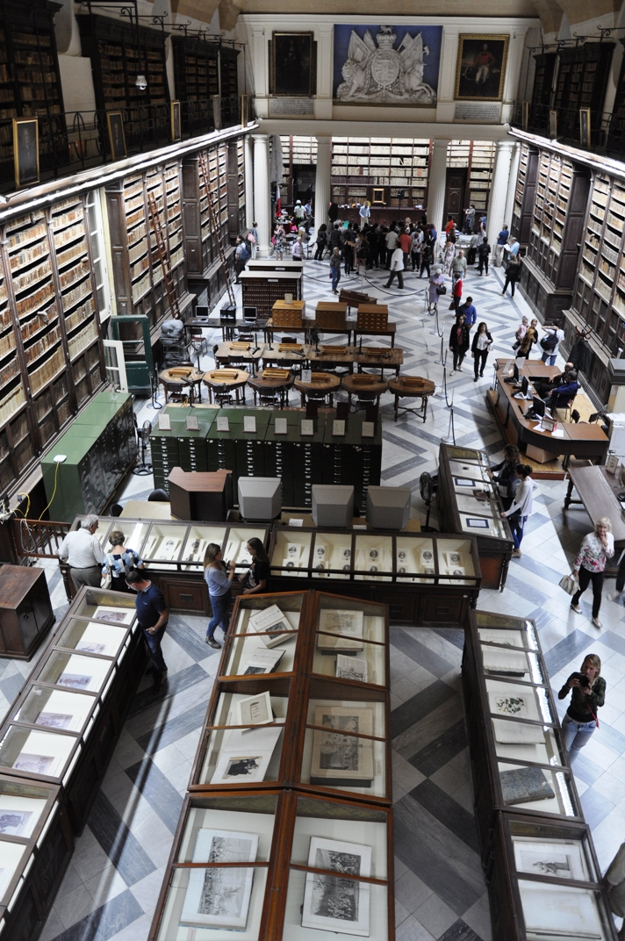The Reading Hall includes the exhibition area (in front), the research area (in the middle), and the area for public events (at the rear). This photo was taken during an event after research hours.

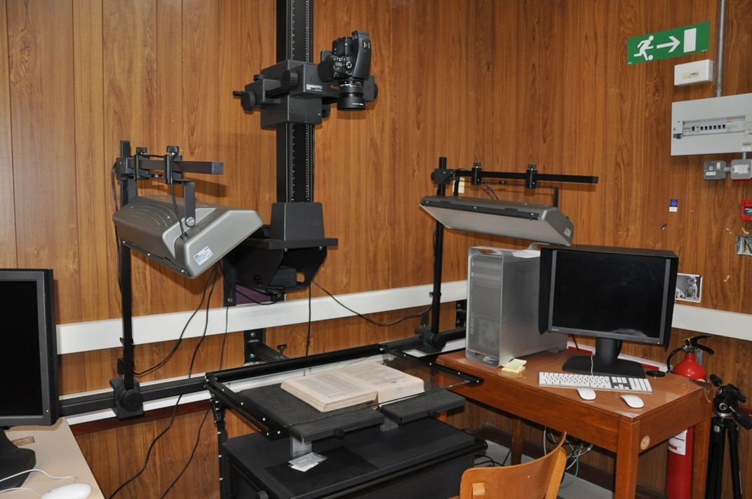
The Digitization Studio

- Please provide simplified plans of your buildings, if possible in .jpg format (perhaps those used to guide visitors around your building).
Not applicable, since only the Reading Hall is accessible to the public through the main staircase from the entrance hall. The footprint of the premises is basically a rectangular shape, and spaces within it are on different levels.
- Please provide brief details on the history of your library buildings.

 | Answer
Year (first) library building opened | 1761
Architect of (first) library building | Unknown
Year (current) library building opened | 1812
Architect of (current) library building | Stefano Ittar
Any additional information. Eg length of build/cost of build/reason for build | The current building was constructed between 1776 and 1786 but was inaugurated in 1812 during the British administration of Malta. It was designed purposely to house a library since the building previously in use had grown too small to contain the ever-growing collection.

- If available, please provide a short text on the milestones of the history of your library and/or provide a link to this information online. Please include any bibliographic information about publications about your library and links to these publications in your library catalogue or an aggregated catalogue.

1555 - issue of decree by Grand Master Claude de la Sengle whereby all books in the legacy of deceased knights are to pass to the Common Treasury of the Order
1649 - formation of a small library housed in a room over the oratory of St. John’s Conventual Church
1760 - purchase by Fra’ Louis Guérin de Tencin of the collection belonging to Cardinal Joaquìn Portocarrero
1761 - de Tencin identifes a large building known as “Il Forfantone” where to house his now enlarged collection. He pays a rent of 120 scudi a year to the Treasury of the Order
1766 - death of de Tencin, considered the founder of the Public Library. The Library is named the Bibliotheca Tanseana in his honour
1776 - formal foundation of a ‘Pubblica Biblioteca’ decreed at the Chapter General of the Order convened by Grand Master de Rohan. Decision to build new library premises to designs of Stefano Ittar, a Polish-born architect residing in Italy
1785 - Stefano Ittar (1724-90) appointed architect to design a new building to house the library
1786 - building of new premises begins
1796 - completion of new building (present premises) but library collection remains at the Forfantone. Two years later the Order of St John is expelled from Malta by Napoleon
1812 - official inauguration of new premises by British Civil Commissioner, Sir Hildebrand Oakes
1925 - the Library acquires its "legal deposit" status by an Act of Parliament
1936 - the Library receives the prefix "Royal" and becomes the Royal Malta Library
1937 - the Archives of the Order of St John are transferred to the Royal Malta Library from the Public Registry premises
1976 - With the setting up of the new Public Library in Floriana, the Library in Valletta is officially designated as the “National Library of Malta” and becomes solely a research and reference library
2011 - Through the Malta Libraries Act (Act No. VII of 2011) which came into effect in August 2011, a totally new set-up for the libraries sector in Malta was established. The former Department of Libraries was replaced by Malta Libraries, the agency now responsible for the National Library of Malta, the National Library (Gozo), the Central Public Library, the Gozo Public Library, and the Regional and Branch public libraries.
Links:

https://www.maltalibraries.gov.mt/iguana/www.main.cls?p=788374c8-8d6d-44d6-bd24-eb7a87b79d2c&v=010a42ff-6575-4531-adfa-dfbb8fb0cc61

https://www.maltalibraries.gov.mt/iguana/www.main.cls?surl=search&p=*#recordId=1.6477&srchDb=1

Chapter III: Location and Urban Spaces
- Please describe the location of your national library buildings (eg. main building in capital city with close proximity to universities, storage buildings in rural area, located two hours by train from building in capital).
The National Library of Malta is housed within a historically and architecturally significant building located at the centre of the capital city, Valletta. As such it is close to the most important administrative, historical and cultural buildings of the Maltese Islands, as well as in a central business and commercial hub. It is accessible by buses from all localities to Valletta, where the principle public transport terminus is located.
- CENL has provided a map of your headquarter location at the centre of a 500m radius - taken as a screenshot from Google maps. If this is not the correct location of your library building, please supply an alternative screen shot.
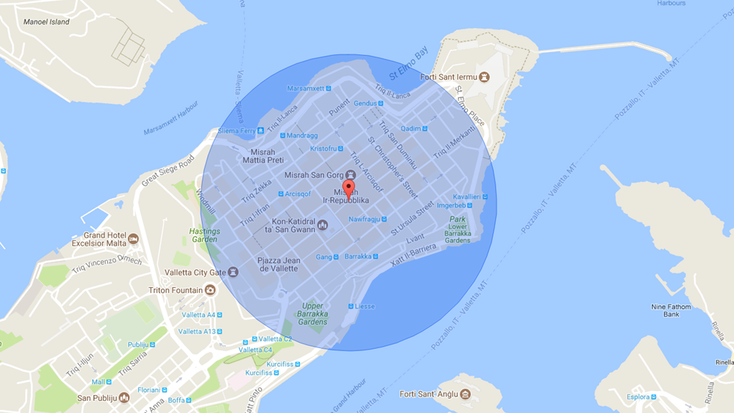
- Please provide details of major governmental, cultural or significant institutions within this vicinity (within a 500m radius).

The National Library of Malta is located at the very centre of Valletta, a fortified city which is itself a UNESCO World Heritage Site. Valletta was originally built by the Order of the Knights of St John and many of its buildings and architectural monuments from the period still survive. These include fortifications, Auberges, palaces, and elegant fine houses, as well as St John’s Co-Cathedral, a treasure of Baroque art and architecture that served as the Conventual church for the Knights of St John. Many of Valletta’s primary historical buildings now house several Government Ministries and public institutions, as well as many State Museums and Heritage Sites. The City is also adorned by historical churches, public squares and gardens. One of its most significant buildings dating from the Knights’ period is the Grandmasters Palace, which is actually within a few metres from the National Library building. Other important buildings are the Manoel Theatre and St James Cavalier, in which several cultural performances and exhibitions are held. Along with all historical buildings, one must also mention a modern architectural gem, namely the Parliament Building designed by Renzo Piano.
Further information about places of interest in Valletta can be found through this link: https://www.visitmalta.com/en/valletta

- Please describe all the transport options for reaching each of your library buildings open to researchers and the public.
The National Library is most easily accessible by buses from all localities to Valletta, where the principle public transport terminus is located just beyond the city’s main entrance. From there one can either walk to the building or else use electric cabs. One can also make use of private transport, but access to streets in Valletta are restricted and parking is not easy. An option would be to use one of the parking areas located outside the city walls. Ferries can be used to reach Valletta from Sliema and Cospicua.

Chapter IV: Reading Rooms, collections and other interior library spaces
- What is the total number of seats in all your reading rooms across all sites?
28
- What is the total square meterage of all your reading rooms across all sites?
1 Reading Room measuring 525 m² (Only a third of this area is actually used as reading space)
- Please list your reading rooms (type, large, by collection) and individual capacity
Reading Room Name | Collection type | Individual room seat capacity | Individual room square metres
1 Reading Room | All collections | 28 | 525 m²
- Do users register to use your Reading Rooms? If so, how?
Yes, readers are requested to produce their ID cards, passports or other identification document with a photo.
- Do users pay to use your Reading Rooms? If so, how much?
No
- How are your collections accessed within the Reading Rooms? Is collection material open access or called to order? Please describe.
Called to order, except for reference books and microfilms which are open access.
- What is the average number of visits per day to your Reading Rooms?
16 researchers per day
- What is the average number of visits per day to your library?
50 visitors per day

Chapter V: Staffing
- What is the number of staff employed by the library in total ?
2017: 28
- What is the number of staff employed by the library in FTE ?
2017:

The keynote presentation may be accessed via http://www.cenl.org/members/cenl-annual-general-meeting-2017-15-16-may-british-library-london/nggallery/page/1

