Survey of National Library Spaces and Services

Following on from CENL’s 2017 AGM and the keynote presentations, as well as the breakout session devoted to collection management, members concluded that a survey of library spaces, and the use of digital content within, would be beneficial to all. Data gathered by the CENL Secretariat will be used for analysis and to further discussion in the coming months with all CENL members. The full results of the survey are intended to be presented at CENL’s 2018 AGM.

All over the world we have seen the creation of new libraries during recent years, including new national library buildings that have been inaugurated or redesigned in Europe. The role of libraries and national libraries is changing and is in permanent transition. This process of transformation caused by the digital revolution and by changes within the economic and political environment has impacted library spaces, staffing and library services. To understand and to meet future needs of national libraries this survey aims to collect and analyse fundamental changes within national library spaces which have occurred over the last ten years.

The survey is structured in six chapters determined by the themes that were discussed during the 2017 AGM breakout session:

• The role of national libraries in collection management is changing – this affects library spaces

• National libraries are transforming from solely heritage institutions to also being leaders in digitisation

• Previously the role of digitisation was for preservation, but now there are new uses for our collections which include the combination of digital and heritage – how is this explored within national libraries?

• Staff development is key to the transformation of libraries – staff need to be integrated in the end to end process of digitisation and using that digital content, perhaps in physical and virtual exhibitions

• Skills and standards for digital content are needed for clarity of activity for researchers

Instructions
 | Answer
Name of national library in full (in your own language and in anglicised form): | Национална и универзитетска библиотека „Св. Климент Охридски“ - Скопје  St Clement of Ohrid National and University Library
Name of Director General with official title: | Ms Senka Naumovska
Main library address: | Blvd Goce Delchev 6  1000 Skopje  Republic of Macedonia
Current logo as a .jpg:
Contact name, email and telephone for this survey: | Ms Senka Naumovska  naumsen@gmail.com  +389 2 3226 846

The CENL Secretariat has pre-completed as much information as possible within this survey. Please check the information already provided and augment or correct this as necessary. Where no information is yet provided, please supply answers in full. Do contact cenl@bl.uk with any difficulties.

Chapter I: Scope and core functions of your national library
- Please check all that apply.
If other please specify:
☑ | ☑ | ○ | ☑ | ○ | ☑ | ☑ | ○ | ○
National Library | University Library | Public Library | Research Library / Research Centre | National Archives | Legal deposit centre | Preservation centre | Museum | Other

- Are you the only library with a national remit in your country? If no (eg. there is also a National Technical Library) please specify.
Yes
- What is the legal status of your library?
In addition to its basic role as a National Library, the Library carries out its activities of scientific and university library for the state university „Sts Cyril and Methodius“ and several private universities in Skopje. Also, it functions as central library headquarters and educational centre having the role of coordinator of the work of all libraries on the territory of the Republic of Macedonia.
At the same time, it functions as a national bibliographic and referral centre, research and developmental centre for librarianship and information sciences and it has central role in development and organization of the Library and Information System (LIS) on national level. In addition, it is the centre for restoration and conservation of library materials of the Republic of Macedonia, National centre for ISSN (International Standard Serial Number) and National Agency for ISBN (International Standard Book Number), International Agency for ISMN (International Standard Music Number), Centre for international landing of library materials, E-CRIS – centre that enables inclusion of the scientific and professional staff of the Republic of Macedonia in the European CRIS database of individual sources of information. In line with the Law for culture of the Republic of Macedonia, the National and University Library is identified as institution that works on preservation, digitization and promotion of the national written cultural heritage.

- Which ministry oversees your library?
Ministry of Culture of the Republic of Macedonia

Chapter II: Physical spaces
- Do you have multiple library sites? If so, please provide address details of all library buildings, including storage.
No
- Please provide a brief summary of all functions contained within the national library.
In 2017
☑ | ○ | ☑ | ☑ | ☑ | ☑ | ○ | ☑ | ○ | ○
Reading Rooms | Lounge | Exhibition space | Conference Centre | Conservation Studio | Gallery | Concert Hall | Café / Restaurant | Commercial space / shop | Other

- Please provide the total square meterage for each of the following functions within your library:
If other please specify:
1000 M2 | 100 M2 | 800 M2 | 200 M2 | 100 M2 | 200 M2 | M2 | 120 M2 | 40 M2 | M2
Reading Rooms | Lounge | Exhibition space | Conference Centre | Conservation Studio | Gallery | Concert Hall | Café / Restaurant | Commercial space / shop | Other

- What is the total size of all library buildings in square metres (includes storage areas)?
2017: 13.000 square metres
- What is the size of library buildings open to the public in square metres?
2017: 4.000 square metres
- Please provide .jpg images of your main public building(s) exterior

Exterior - https://en.wikipedia.org/wiki/National_and_University_Library_%22St._Kliment_of_Ohrid%22
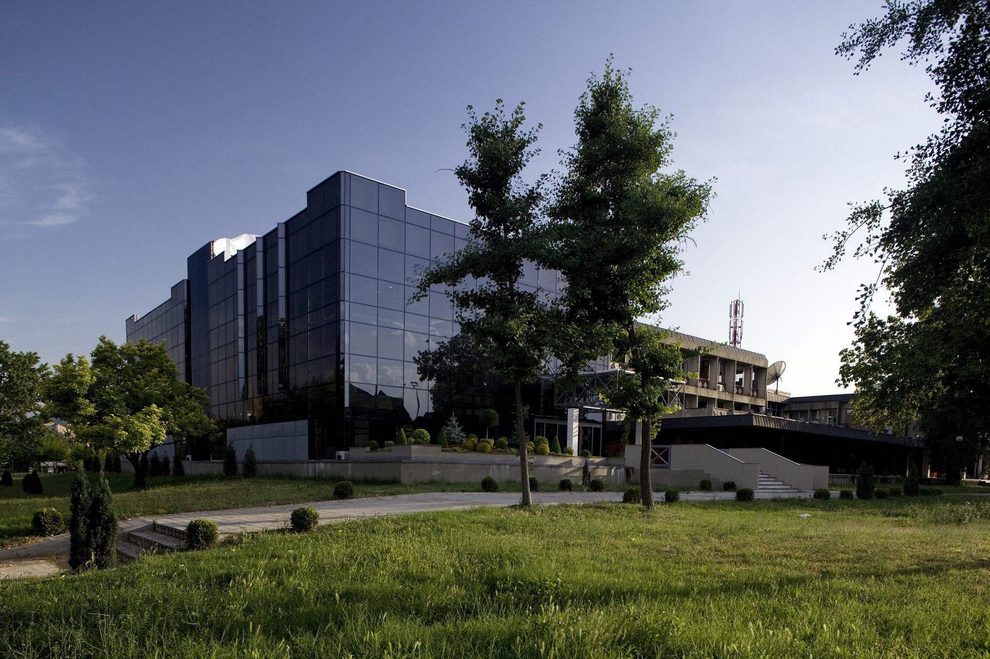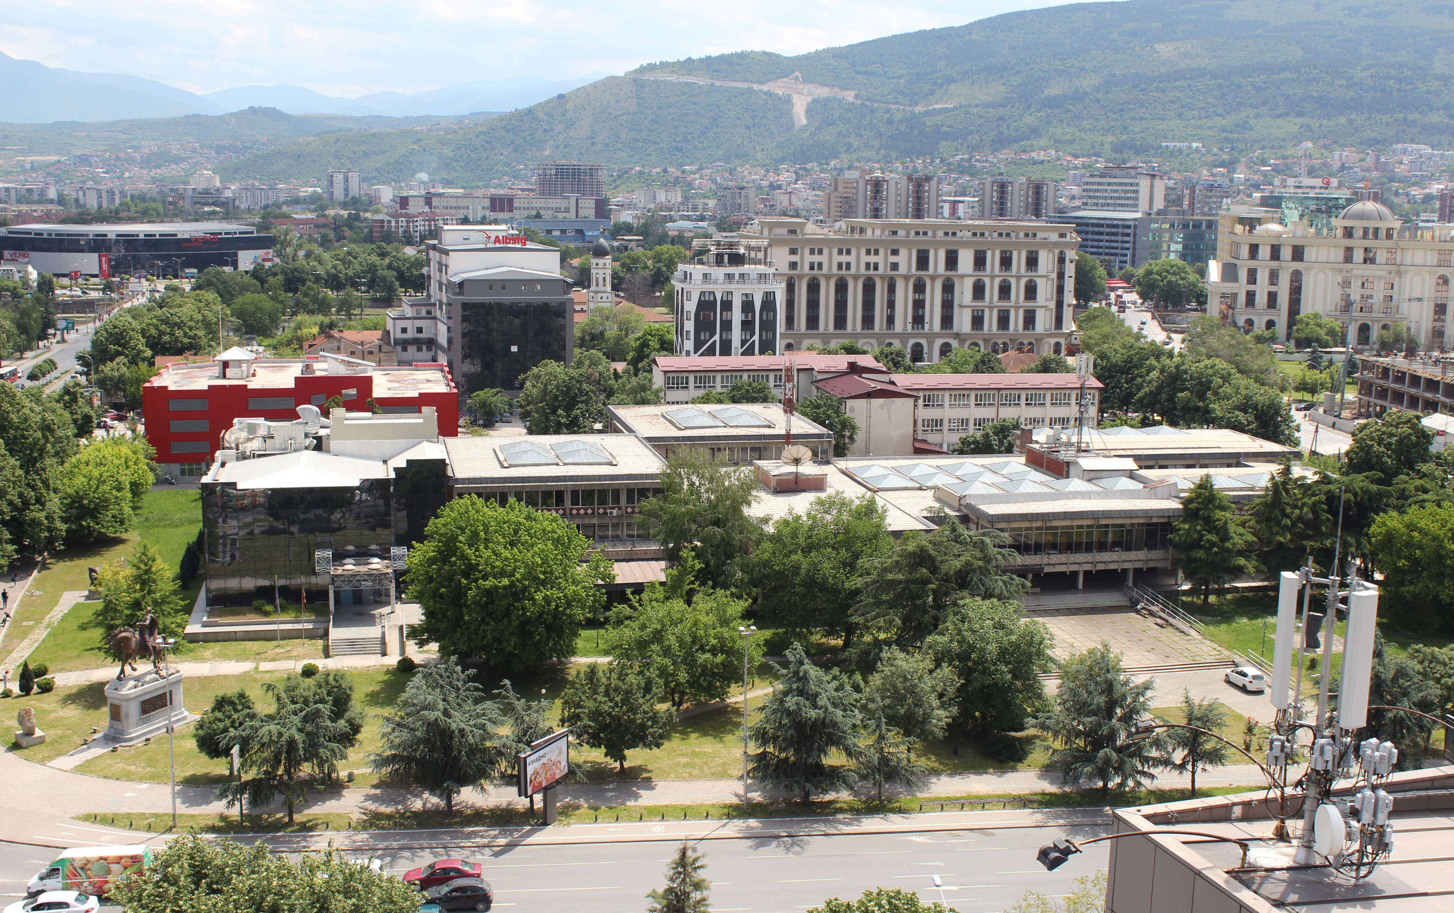

- If available, please provide .jpg images of all library sites described in question 5.
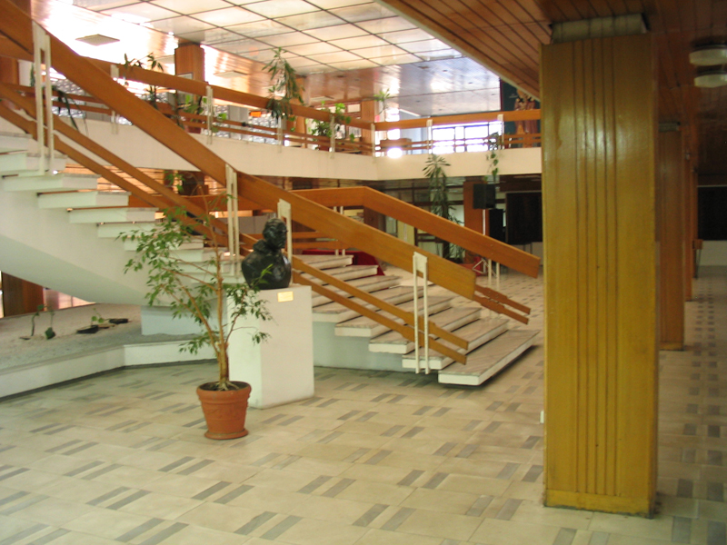

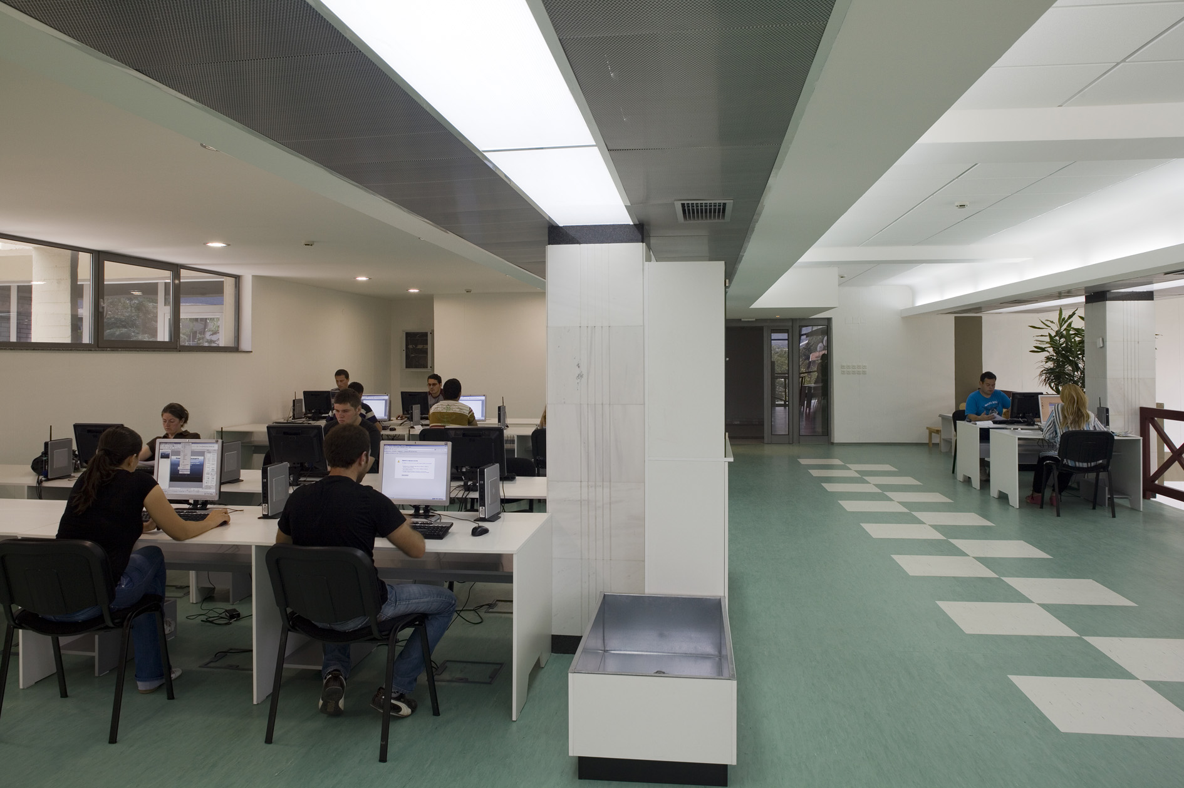

- If available, please provide .jpg images of all library spaces described in question 6.
Study Centre -
http://nubsk.edu.mk/en/services/other/conference-and-study-center

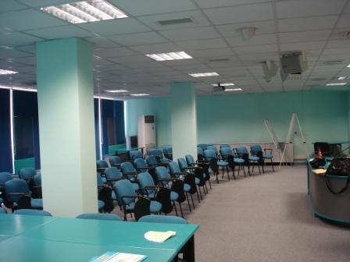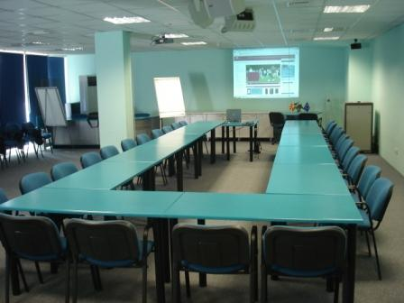
- Please provide simplified plans of your buildings, if possible in .jpg format (perhaps those used to guide visitors around your building).
Answer Not available at the moment
- Please provide brief details on the history of your library buildings.
The first building of the library had 6,500 m2 (in the same building from 1945 to 1952 was also settled Faculty of Philosophy). Since 1952, after the adaptation, there were opportunities for proper organization and accommodation of the book fund, improved working conditions and reading rooms (with up to 250 reader's places). In this period the formation of new services began.
The flood in November 1962 and soon after, and the catastrophic earthquake in Skopje on July 26 in 1963, violently and cruelly interrupted the development path of the Library. The building was almost completely destroyed, and the fund, which at that time numbered about 500,000 units, was largely destroyed and damaged. Of special importance was the assistance of a large number of libraries and other institutions from the world which were involved in the fund's renewal. These events in the history of the Library are marked as an unforgettable manifestation of professional solidarity and general humanity. In the first days after the earthquake, part of the library's fund, saved from the ruins, was evacuated to the historical building Daut Pasha Amam. Shortly thereafter, in early 1964, it was moved and placed in purpose-built prefabricated buildings. The construction of these prefabricated buildings with a total area of 1750 m2, of which 1200 m2 warehouse space, allowed the Library to continue its work even during those difficult times after the earthquake.
The construction of the new (current) building of the Library, specially designed to be national library with total area of 10.000 m2 , ended in 1972.
On May 24 in 2009 the new modern building in the continuation of the existing one was officially opened, with which the Library received an additional 3000 m2. One part of the special collections, the Virtual Library of Macedonia and the Digitalization Center, as well as extended warehouses are settled in the new building.

 | Answer
Year (first) library building opened | 1945 (this building was constructed in 1920, but St. Clement of Ohrid National and University Library was settled in a part of this building since 1945, alongside Faculty of Philosophy, and since 1952 the whole building, after the adaptation,was a seat of the National and University Library of Macedonia)
Architect of (first) library building | /
Year (current) library building opened | 1972
Architect of (current) library building | Petar Mulichkovski PhD
Any additional information. Eg length of build/cost of build/reason for build | New building was constructed because old building was destroyed by the catastrophic earthquake in 1963.

- If available, please provide a short text on the milestones of the history of your library and/or provide a link to this information online. Please include any bibliographic information about publications about your library and links to these publications in your library catalogue or an aggregated catalogue.
St Clement of Ohrid National and University Library (NUL) in Skopje is one of the first established institutions with the decision of Anti Fascist Assembly of the National Liberation of Macedonia (ASNOM) on 23rd November 1944, when the Second World War was not yet finished. The flood in 1962 and the earthquake in 1963, violently and cruelly interrupted the Library development. The Library building was almost completely destroyed, and the fund, which at that time numbered about 500,000 units, was largely damaged. In early 1964, the fund was moved and housed in a custom-built prefabricated building where the Library functioned until it moved into the new and modern building in 1972. At the beginning of 2008 the foundation stone of new and modern building as an extension of the current one was laid by which the Library has received additional 3000 m2.

http://nubsk.edu.mk/en/about-us/history

БИБЛИОГРАФИЈА на изданијата на Народната и универзитетска библиотека "Климент Охридски" - Скопје : 1951-1987 - Скопје : Народна и универзитетска библиотека "Климент Охридски", 1987

http://www.vbm.mk/scripts/cobiss?command=DISPLAY&base=40001&dept=00&rid=1220618&fmt=12&lani=mk

НАРОДНА и универзитетска библиотека Св. Климент Охридски - Скопје : НУБ "Св. Климент Охридски", 1994

http://www.vbm.mk/scripts/cobiss?command=DISPLAY&base=40001&dept=00&rid=19517706&fmt=12&lani=mk

БИБЛИОГРАФИЈА на изданија на Националната и универзитетска библиотека "Св. Климент Охридски" - Скопје од основањето до 2014 година - Скопје : Национална и универзитетска библиотека "Климент Охридски", 2014

http://www.vbm.mk/scripts/cobiss?command=DISPLAY&base=40001&dept=00&rid=97445642&fmt=12&lani=mk

Chapter III: Location and Urban Spaces
- Please describe the location of your national library buildings (eg. main building in capital city with close proximity to universities, storage buildings in rural area, located two hours by train from building in capital).
St. Clement of Ohrid National and University Library is located in the centre of Skopje, capital city of the Republic of Macedonia, near the headquarters of St. Cyril and Methodius University from across.
- CENL has provided a map of your headquarter location at the centre of a 500m radius – taken as a screenshot from Google maps. If this is not the correct location of your library building, please supply an alternative screen shot.
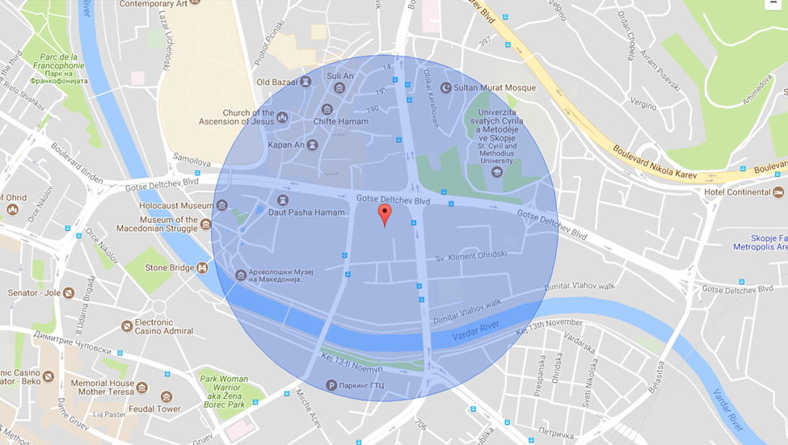
- Please provide details of major governmental, cultural or significant institutions within this vicinity (within a 500m radius).
Macedonian Academy of Sciences and Arts, Macedonian National Opera and Ballet, Ministry of Foreign Affairs as well as the Macedonian National Radio-Television and the Palace of Justice are in the near vicinity of NUL.
- Please describe all the transport options for reaching each of your library buildings open to researchers and the public.
Car and bus.

Chapter IV: Reading Rooms, collections and other interior library spaces
- What is the total number of seats in all your reading rooms across all sites?
350
- What is the total square meterage of all your reading rooms across all sites?
1000 m2
- Please list your reading rooms (type, large, by collection) and individual capacity
- Do users register to use your Reading Rooms? If so, how?
Reading Room Name | Collection type | Individual room seat capacity | Individual room square metres
General reading room 1 | general | 150 | 350 m2
General reading room 2 | general | 100 | 250 m2
Reading room with university textbooks on open access | university textbooks | 40 | 100 m2
Internet reading room | general and online | 20 | 60 m2
5 reading rooms (part of rooms) | special collections | 20 | 120 m2  (40+20+20+20+20 m2)
individual reading rooms | general | 20 | 120 m2

Users register at the Registration Desk and pay a membership fee.
- Do users pay to use your Reading Rooms? If so, how much?
Membership fee is 600 Macedonian denars (10 EUR) for one year, 200 Macedonian denars for one month and 150 Macedonian denars for one week.
- How are your collections accessed within the Reading Rooms? Is collection material open access or called to order? Please describe.
Access is combined, but mainly, collections of the Library are called to order except in one reading room (Reading room with university textbooks) there are publications on open access.
- What is the average number of visits per day to your Reading Rooms?
200
- What is the average number of visits per day to your library?
300

Chapter V: Staffing
- What is the number of staff employed by the library in total ?
2017: 114 of which 104 on full-time and 10 with fixed-term contracts
- What is the number of staff employed by the library in total
2017:

The keynote presentation may be accessed via http://www.cenl.org/members/cenl-annual-general-meeting-2017-15-16-may-british-library-london/nggallery/page/1

