Survey of National Library Spaces and Services

Following on from CENL’s 2017 AGM and the keynote presentations, as well as the breakout session devoted to collection management, members concluded that a survey of library spaces, and the use of digital content within, would be beneficial to all. Data gathered by the CENL Secretariat will be used for analysis and to further discussion in the coming months with all CENL members. The full results of the survey are intended to be presented at CENL’s 2018 AGM.

All over the world we have seen the creation of new libraries during recent years, including new national library buildings that have been inaugurated or redesigned in Europe. The role of libraries and national libraries is changing and is in permanent transition. This process of transformation caused by the digital revolution and by changes within the economic and political environment has impacted library spaces, staffing and library services. To understand and to meet future needs of national libraries this survey aims to collect and analyse fundamental changes within national library spaces which have occurred over the last ten years.

The survey is structured in six chapters determined by the themes that were discussed during the 2017 AGM breakout session:

• The role of national libraries in collection management is changing – this affects library spaces

• National libraries are transforming from solely heritage institutions to also being leaders in digitisation

• Previously the role of digitisation was for preservation, but now there are new uses for our collections which include the combination of digital and heritage – how is this explored within national libraries?

• Staff development is key to the transformation of libraries – staff need to be integrated in the end to end process of digitisation and using that digital content, perhaps in physical and virtual exhibitions

• Skills and standards for digital content are needed for clarity of activity for researchers

 | Answer
Name of national library in full (in your own language and in anglicised form): | Bibliothèque nationale de Luxembourg  National Library of Luxembourg
Name of Director General with official title: | Dr. Monique Kieffer
Main library address: | 37, Boulevard F.-D. Roosevelt  L-2450 Luxembourg  Luxembourg
Current logo as a .jpg:
Contact name, email and telephone for this survey: | Monique Kieffer  monique.kieffer@bnl.etat.lu / direction@bnl.etat.lu  +352 22 97 55 228

Instructions
The CENL Secretariat has pre-completed as much information as possible within this survey. Please check the information already provided and augment or correct this as necessary. Where no information is yet provided, please supply answers in full. Do contact cenl@bl.uk with any difficulties.

Chapter I: Scope and core functions of your national library
- Please check all that apply.
National Library | University Library | Public Library | Research Library / Research Centre | National Archives | Legal deposit centre | Preservation centre | Museum | Other
If other please specify:
Coordination of the Luxembourgish library network bibnet.lu and Consortium Luxembourg
- Are you the only library with a national remit in your country? If no (eg. there is also a National Technical Library) please specify.
Yes
- What is the legal status of your library?
The library is one of the seven cultural institutes of the State of Luxembourg. It has no legal entity.
- Which ministry oversees your library?
Ministry of Culture

Chapter II: Physical spaces
- Do you have multiple library sites? If so, please provide address details of all library buildings, including storage.
Yes, we have 7 library sites including storage. All the sites will be concentrated on a single site in a new building by the end of 2018.
- Please provide a brief summary of all functions contained within the national library.
In 2017
Reading Rooms | Lounge | Exhibition space | Conference Centre | Conservation Studio | Gallery | Concert Hall | Café / Restaurant | Commercial space / shop | Other

If other please specify:

- Please provide the total square meterage for each of the following functions within your library:
M2 | 12 M2 | M2 | M2 | M2 | M2 | M2 | M2 | M2 | M2
Reading Rooms | Lounge | Exhibition space | Conference Centre | Conservation Studio | Gallery | Concert Hall | Café / Restaurant | Commercial space / shop | Other
If other please specify:
- What is the total size of all library buildings in square metres (includes storage areas)?
2017: 13.755 m²
- What is the size of library buildings open to the public in square metres?
2017: 1988 m²

- Please provide .jpg images of your main public building(s) exterior
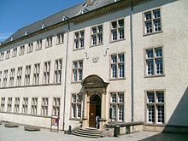

Exterior -
https://en.wikipedia.org/wiki/National_Library_of_Luxembourg

- If available, please provide .jpg images of all library sites described in question 5.
Not available
- If available, please provide .jpg images of all library spaces described in question 6.
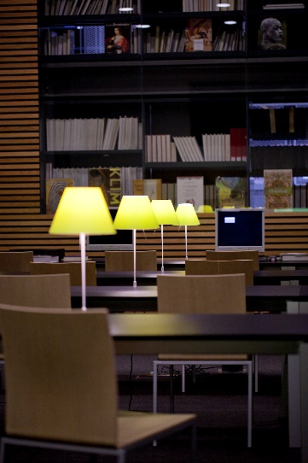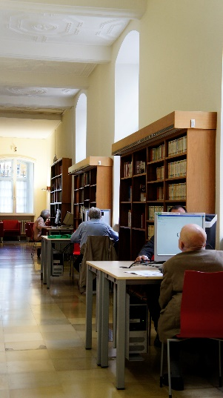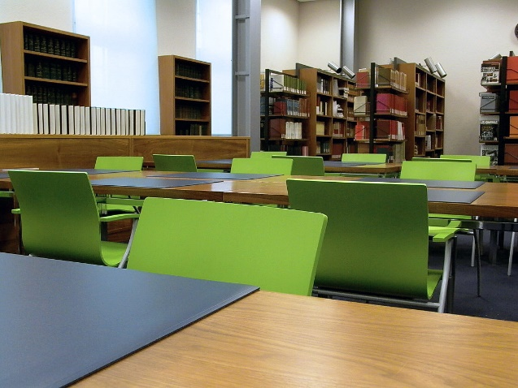
- Please provide simplified plans of your buildings, if possible in .jpg format (perhaps those used to guide visitors around your building).
Not available
- Please provide brief details on the history of your library buildings.

 | Answer
Year (first) library building opened | The library was created in 1798. Until WW2, it was located in the same building than the Athénée grand-ducal.
Architect of (first) library building
Year (current) library building opened | 1973
Architect of (current) library building | Historical, restored building
Any additional information. Eg length of build/cost of build/reason for build | The law of April 18, 2013, authorizing the construction of a new building puts an end to a long-standing discussion. Currently scattered on several different sites, all deposits and services of the BnL will be grouped on a single site in Luxembourg-Kirchberg, avenue John F. Kennedy. About 300,000 documents will be directly accessible in reading rooms. Construction began in June 2014 and is scheduled to open by the end of 2018. Architects: Bolles + Wilson, Münster (Germany)

- If available, please provide a short text on the milestones of the history of your library and/or provide a link to this information online. Please include any bibliographic information about publications about your library and links to these publications in your library catalogue or an aggregated catalogue.
- Bibliothèque nationale de Luxembourg (ed.), The National Library of Luxembourg, enter and discover, Luxembourg 2017 (http://www.bnl.public.lu/fr/publications/presentation-bnl/presentation-bnl.html).
- Christophory, Jul, La Bibliothèque nationale de Luxembourg : son histoire, ses collections, ses services, 3ème édition revue et corrigée, Luxemboug 1994.
- Monique Kieffer, The National Library of Luxembourg, in: Alexandria : the journal of national & international library and information issues, vol.23, n.1(2012), p.24-35.

Chapter III: Location and Urban Spaces
- Please describe the location of your national library buildings (eg. main building in capital city with close proximity to universities, storage buildings in rural area, located two hours by train from building in capital).
The main building is located in the City Center next to the Notre-Dame Cathedral. The Luxembourg city Museum as well as Casino Luxembourg - Forum d’Art Contemporain, the Museum of History and Art, the Museum of Natural History are within walking distance of main library building.
- CENL has provided a map of your headquarter location at the centre of a 500m radius – taken as a screenshot from Google maps. If this is not the correct location of your library building, please supply an alternative screen shot.
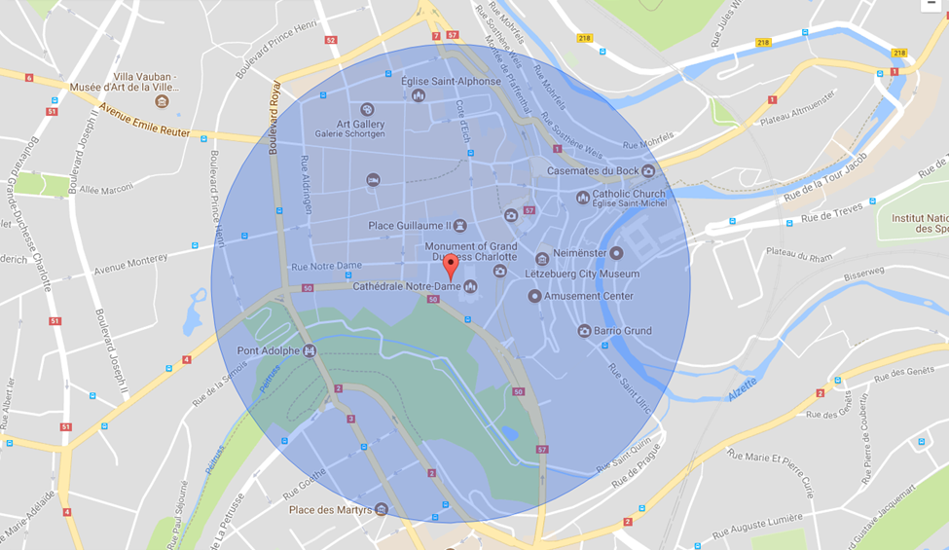
- Please provide details of major governmental, cultural or significant institutions within this vicinity (within a 500m radius).
Cf. screenshot
- Please describe all the transport options for reaching each of your library buildings open to researchers and the public.
Bus, Train + Tramway, Car, Bicycle, by foot

Chapter IV: Reading Rooms, collections and other interior library spaces
- What is the total number of seats in all your reading rooms across all sites?
124 (only one site for reading rooms)
- What is the total square meterage of all your reading rooms across all sites?
713 m²
- Please list your reading rooms (type, large, by collection) and individual capacity
Reading Room Name | Collection type | Individual room seat capacity | Individual room square metres
Salle des Arts | Arts, Music, Sports | 35 | 151
Salle latérale | Reference manuals | 16 | 234
Salle périodiques | Periodicals | 12 | 96
Médiathèque | DVD, CD’s, Multimedia Documents | 16 | 130
Salle Pétrusse | Luxemburgensia, biographical manuals, encyclopedias | 45 | 102
- Do users register to use your Reading Rooms? If so, how?
They do not need to register to use the rooms but they need to have a library card to use the wifi.
- Do users pay to use your Reading Rooms? If so, how much?
No.
- How are your collections accessed within the Reading Rooms? Is collection material open access or called to order? Please describe.
Only a limited number of documents can be accessed freely. The vast majority needs to be ordered online.
- What is the average number of visits per day to your Reading Rooms?
+- 500
- What is the average number of visits per day to your library?
Cf. question 26

Chapter V: Staffing
- What is the total number of staff employed by the library in total ?
2017:
- What is the total number of staff employed by the library in FTE ?
2017: 82,5 FTE

The keynote presentation may be accessed via http://www.cenl.org/members/cenl-annual-general-meeting-2017-15-16-may-british-library-london/nggallery/page/1

