Survey of National Library Spaces and Services

Following on from CENL’s 2017 AGM1 and the keynote presentations, as well as the breakout session devoted to collection management, members concluded that a survey of library spaces, and the use of digital content within, would be beneficial to all. Data gathered by the CENL Secretariat will be used for analysis and to further discussion in the coming months with all CENL members.
The full results of the survey are intended to be presented at CENL’s 2018 AGM.

All over the world we have seen the creation of new libraries during recent years, including new national library buildings that have been inaugurated or redesigned in Europe. The role of libraries and national libraries is changing and is in permanent transition. This process of transformation caused by the digital revolution and by changes within the economic and political environment has impacted library spaces, staffing and library services. To understand and to meet future needs of national libraries this survey aims to collect and analye fundamental changes within national library spaces which have occurred over the last ten years.

The survey is structured in six chapters determined by the themes that were discussed during the 2017 AGM breakout session:

- The role of national libraries in collection management is changing – this affects library spaces
- National libraries are transforming from solely heritage institutions to also being leaders in digitisation
- Previously the role of digitisation was for preservation, but now there are new uses for our collections which include the combination of digital and heritage – how is this explored within national libraries?
- Staff development is key to the transformation of libraries – staff need to be integrated in the end to end process of digitisation and using that digital content, perhaps in physical and virtual exhibitions
- Skills and standards for digital content are needed for clarity of activity for researchers

1 The keynote presentation may be accessed via http://www.cenl.org/members/cenl-annual-general-meeting- 2017-15-16-may-british-library-london/nggallery/page/1

 | Answer
Name of national library in full (in your own language and in anglicised form): | Lietuvos nacionalinė Martyno Mažvydo biblioteka Martynas Mažvydas National Library of Lithuania
Name of Director General with official title: | Prof. Dr. Renaldas Gudauskas
Main library address: | Gedimino pr. 51 LT-01504 Vilnius Lithuania
Current logo as a .jpg:
Contact name, email and telephone for this survey: | Alma Masevičienė alma.maseviciene@lnb.lt  +37068341921

Instructions

The CENL Secretariat has pre-completed as much information as possible within this survey. Please check the information already provided and augment or correct this as necessary. Where no information is yet provided, please supply answers in full. Do contact cenl@bl.uk with any difficulties.

Chapter I: Scope and core functions of your national library

  - Please check all that apply.

X | ○ | ○ | X | ○ | X | X | ○ | X
National Library | University Library | Public Library | Research Library / Research Centre | National Archives | Legal deposit centre | Preservation centre | Museum | Other

If other please specify: parliamentary library

  - Are you the only library with a national remit in your country? If no (eg. there is also a National Technical Library) please specify.
YES

  - What is the legal status of your library?

Budget institution

  - Which ministry oversees your library?

Ministry of Culture

Chapter II: Physical spaces

  - Do you have multiple library sites? If so, please provide address details of all library buildings, including storage.

Martynas Mažvydas National Library of Lithuania (main building): Gedimino pr. 51, 01504 Vilnius, Lithuania.

Palanga Summer Reading Room: Vytauto g. 72, 00132 Palanga, Lithuania. Raseiniai depository library unit: Bažnyčios g. 4, 60169 Raseiniai, Lithuania.
  - Please provide a brief summary of all functions contained within the national library. In 2017
X | X | X | X | X | ○ | ○ | X | ○ | X
Reading Rooms | Lounge | Exhibition space | Conference Centre | Conservation Studio | Gallery | Concert Hall | Café / Restaurant | Commercial space / shop | Other

If other please specify: Recording Studio; Cinema; Art Lab; Music Lab; Makerspace; Children's Activity Centre; Hub; TV studio; Meeting rooms; Events area.

  - Please provide the total square meterage for each of the following functions within your library:

M2 | M2 | M2 | M2 | M2 | M2 | M2 | M2 | M2 | M2
Reading Rooms  1.770 m2 | Lounge  1.039 m2 | Exhibition space  234 m2 | Conference Centre  140 m2 | Conservation Studio  310 m2 | Gallery | Concert Hall | Café / Restaurant  56 m2 | Commercial space / shop | Other:

If other please specify: Recording Studio: 34 m2 Cinema: 45 m2
Art Lab: 74 m2
Music Lab: 45 m2 Makerspace: 84 m2
Children's Activity Centre: 35 m2 Hub: 134 m2
TV studio: 80 m2 Meeting rooms: 185 m2 Events area: 185 m2
  - What is the total size of all library buildings in square metres (includes storage areas)?

2017: 29 524 m2

  - What is the size of library buildings open to the public in square metres?

2017: 6 300 m2 (Q7 minus storage and administrative facilities) Please provide .jpg images of your main public building(s) exterior

Exterior-

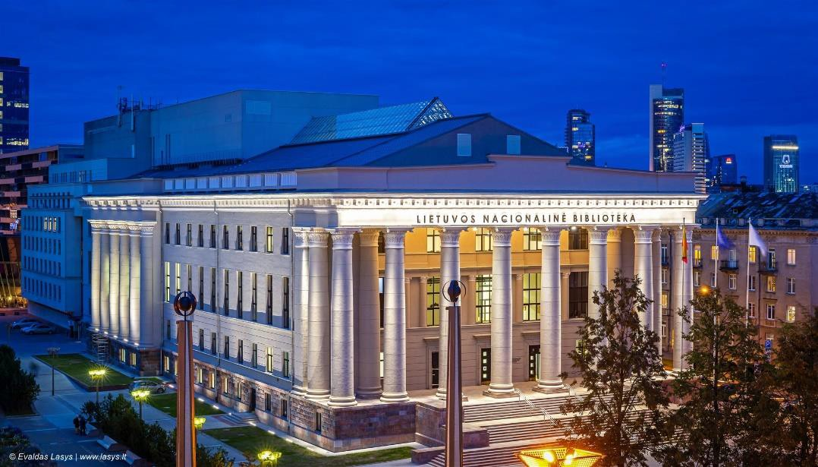

https://jp.lt/wp-content/uploads/2017/11/Evaldas-Lasys.jpg

  - If available, please provide .jpg images of all library sites described in question 5.

Palanga Summer Reading Room -

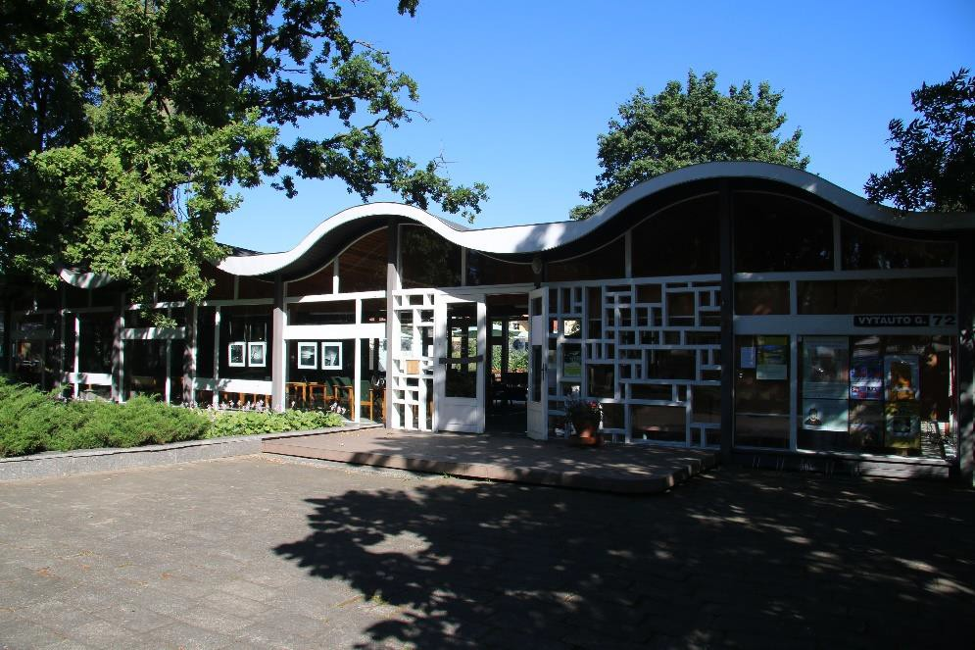
http://www.autc.lt/Handlers/ImageHandler.ashx?b=true&i=1605&fn=acefe752-487c-460f-ac94- 72fe3aa31907

  - If available, please provide .jpg images of all library spaces described in question 6.
Recording Studio
https://www.lnb.lt/en/services/for-visitor/creative-spaces https://www.lnb.lt/media/public/di/2013_2535_zoomed_dsc_1225.jpg https://www.lnb.lt/media/public/di/2013_2538_zoomed_dsc_1253.jpg Cinema
https://www.lnb.lt/en/services/for-visitor/creative-spaces https://www.lnb.lt/media/public/di/2093_2801_zoomed_dsc_1390.jpg Art Lab
https://www.lnb.lt/en/services/for-visitor/creative-spaces

https://www.lnb.lt/media/public/di/2037_2642_zoomed Music Lab
https://www.lnb.lt/en/services/for-visitor/creative-spaces https://www.lnb.lt/media/public/di/2023_2583_zoomed https://www.lnb.lt/media/public/di/2023_2580_zoomed Makerspace
mg_3308.jpg

mg_3114.jpg mg_3091.jpg

https://www.lnb.lt/en/services/for-visitor/pats-sau-workshop https://www.lnb.lt/media/public/di/1899_2220_zoomed_pats-sau-1.png Children's Activity Centre
https://www.lnb.lt/en/services/for-visitor/children-s-activity-centre Meeting rooms
https://www.lnb.lt/en/services/for-visitor/meeting-rooms https://www.lnb.lt/media/public/di/1872_2174_zoomed_dsc_1185-2.png Events area
https://www.lnb.lt/media/public/di/1984_3367_zoomed_bendradarbyst-s-erdv-img_3239-1.jpg Hub
https://www.lnb.lt/en/services/for-visitor/hub https://www.lnb.lt/media/public/di/2125_3057_zoomed_v1-1s.png Reading Rooms
https://www.lnb.lt/en/services/for-visitor/reading-rooms https://www.lnb.lt/media/public/di/1721_1668_zoomed_img_9334.jpg - More to follow on zip file Lounge
https://www.lnb.lt/media/public/di/1984_2492_zoomed_dsc_1214.jpg https://www.lnb.lt/media/public/di/1984_2485_zoomed_dsc_1125.jpg Exhibition space https://www.lnb.lt/media/public/di/1984_2492_zoomed_dsc_1214.jpg Conference Centre https://www.lnb.lt/media/public/di/1984_5080_zoomed_konfsale01.jpg

More images to follow in zipfile.

Spaces of the Martynas Mažvydas National Library of Lithuania in a short video: https://www.youtube.com/watch?time_continue=14&v=8ajnhdv245M

  - Please provide simplified plans of your buildings, if possible in .jpg format (perhaps those used to guide visitors around your building). Attached zipfile to follow

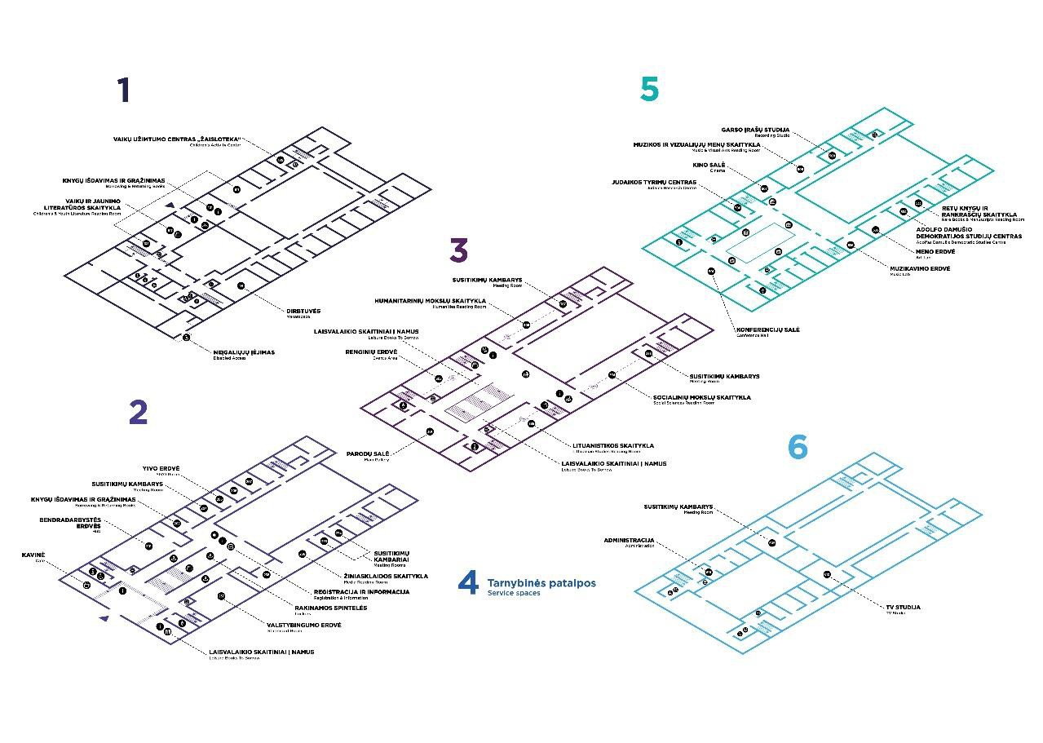

  - Please provide brief details on the history of your library buildings.

 | Answer
Year (first) library building opened | The Library had no suitable building for rather a long time; there were a few small temporarily adopted premises.
Architect of (first) library building | -
Year (current) library building opened | 1963
Architect of (current) library building | Viktor Anikin
Any additional information. Eg length of build/cost of build/reason for build | 1953–1963: construction period. Financed from the State budget.  The building was designed as the national library

Milestones • Due to the historical situation, the Library began its activities in Kaunas, the provisional capital of Lithuania, on 20 December 1919.
    - Since 1920, the Library has been responsible for the formation process of the Lithuanian public library network.
    - “The Law on State Public Libraries” (of 1936) obliged the Library to acquire and preserve the published output of Lithuania as well as foreign publications related to Lithuania.
    - After the annexation of Lithuania by the USSR in 1940, the Library considerably expanded its collections mainly by acquiring numerous Soviet Russian publications.
    - During the period of Nazi occupation (1941– 1944), the recently obtained premises of the Library were occupied by the German army. The reading-hall stopped functioning and the circulation [???aptarnavimo, tuomet “readers’ service”] department retained only part time working hours . The Library lost about 20 thousand valuable items which were inconsistent with the Nazi ideology.
    - In 1944, after the Second Soviet occupation, the Library started to accumulate collections scattered during WW II and the occupations.
    - In the spring of 1945, the Loans Department and the Reading Room resumed their work.
    - In the newly adopted library regulations of 1951, the name of the Library was designated as the State Republican Library.
    - In 1963, the Library was moved from Kaunas to Vilnius. On 6 December 1963, the State Republican Library was opened for readers.
    - During the National Revival of 1988, the Library was named after Martynas Mažvydas, the originator of printing in the Lithuanian language.
    - Publications from the special secret collection were made publicly accessible.
    - On May 30, 1989 the Library was officially named the Martynas Mažvydas National Library of Lithuania.

- Since 1991, the Library has been carrying out the functions of a parliamentary library.
- In 1992, the Centre of Bibliography and Book Science (the former Book Chamber) was incorporated into the structure of the Library and the Library began to operate as the national press archive and the centre for national bibliographical control.
- The Law on Libraries of the Republic of Lithuania of 1995 authorizes the Library as the basic public and research library.
- On 1 June 1998, The Union Catalogue of the Lithuanian public libraries began functioning.
- On 5 July 2003, the new annex of the Library was officially opened.
- On 29 September 2008, the Library and the company YIT Kausta AB entered into an agreement for the reconstruction of the main building of the Library.
- The main building of the Library was reopened on 2 September 2016.

  - If available, please provide a short text on the milestones of the history of your library and/or provide a link to this information online. Please include any bibliographic information about publications about your library and links to these publications in your library catalogue or an aggregated catalogue.
Short history of the National Library of Lithuania: https://www.lnb.lt/en/about-library/main- information/history

About the reconstruction of the main library building: https://www.lnb.lt/en/about- library/main-information/reconstruction

Short bibliography: attached and zipfile to follow. Links to these publications in the library catalogue:
https://www.ibiblioteka.lt/libis-portal/document- search#pages/standart/document/search/search.jsf?searchParams=mdwAGgHAkpQZ2gAxTGlldHV2b3Mgbm FjaW9uYWxpbsSXIE1hcnR5bm8gTWHFvnZ5ZG8gYmlibGlvdGVrYQABlA2gAAGQkJCQkJCQkJCQkJCQwMDAkM KQkJCAAAAUPJiSEAWSKgWSIwWSGAWSLAWSKwWSLQWSNgXDwsPD

Chapter III: Location and Urban Spaces

  - Please describe the location of your national library buildings (eg. main building in capital city with close proximity to universities, storage buildings in rural area, located two hours by train from building in capital).

The main Library building is located in the centre of the capital city Vilnius, with close proximity to political and cultural centres and historical sights. The Palanga Summer Reading Room is located in the center of the Palanga resort, about three and a half hours by car from the Library’s main building in Vilnius. The Raseiniai Depository Unit of the Library is located in the town of Raseiniai, about two hours by car from the main building in Vilnius.

  - CENL has provided a map of your headquarter location at the centre of a 500m radius – taken as a screenshot from Google maps. If this is not the correct location of your library building, please supply an alternative screen shot.

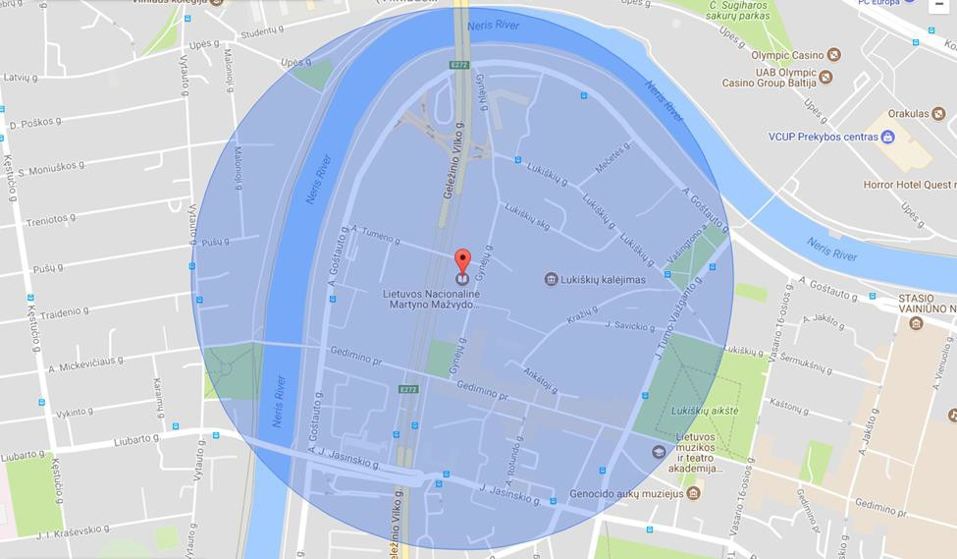

  - Please provide details of major governmental, cultural or significant institutions within this vicinity (within a 500m radius).
Political and administrative buildings:
Seimas (Parliament of the Republic of Lithuania): http://www.lrs.lt/sip/portal.show?p_r=135&p_k=2
Ministry of Foreign Affairs: https://www.urm.lt/default/en/about-us Ministry of Finance: https://finmin.lrv.lt/en/about-the-ministry

Embassy of the Kingdom of Spain: http://www.exteriores.gob.es/Embajadas/VILNIUS/en/Pages/inicio.aspx
Supreme Court of Lithuania: http://www.lat.lt/en/general-information/about-the-court.html

Academic institutions:
Institute of Theoretical Physics and Astronomy: http://www.tfai.vu.lt/index.php Lithuanian Social Research Centre: http://www.lstc.lt/general_info.php
Public Policy and Management Institute: http://www.ppmi.lt/en/about-us-8.html Lithuanian Institute of History: http://www.istorija.lt/about-us/about-the-institute/ Lithuanian Academy of Music and Theatre: https://lmta.lt/en/lithuanian-apie-mus/

Culture:
Prospekto Gallery: http://www.photography.lt/en.php/Exhibitions Washington Square Gallery

Sights:
Vilnius Independence Square: https://www.opengreenmap.org/greenmap/vilnius-green- map/nepriklausomybes-aikste-independence-square-27798
Washington Square: http://wikimapia.org/6883015/Washington-square Lukiškės Square: https://en.wikipedia.org/wiki/Luki%C5%A1k%C4%97s_Square

  - Please describe all the transport options for reaching each of your library buildings open to researchers and the public.

To the Library’s main building:

From Vilnius’s bus or railway stations:

Trolleybuses No 7 and 1 – Jokūbo Jasinskio stop (exit Jokūbo Jasinskio) From Vilnius airport:
Express bus No 3 – Juozo Tumo Vaižganto stop (exit Juozo Tumo Vaižganto)

Vilnius city public transport schedule and routes: http://www.vilniustransport.lt/en/

To the Library Palanga Summer Reading Room:

From the Vilnius Bus Station to the Palanga Bus Station by bus, travel duration: 4 h 30 min. Schedule of buses: https://www.autobusubilietai.lt/index.php?cl=start&lang=0

Chapter IV: Reading Rooms, collections and other interior library spaces

  - What is the total number of seats in all your reading rooms across all sites?

413 (reading rooms + lounges &public spaces)

  - What is the total square meterage of all your reading rooms across all sites?

1769 m2

  - Please list your reading rooms (type, large, by collection) and individual capacity

Reading Room Name | Collection type | Individual room seat capacity | Individual room square metres
Humanities Reading Room | Books, journals | 38 | 233,66
Social Sciences Reading Room | Books, journals | 38 | 278,15
Lithuanian Studies Reading Room | Books, journals | 34 | 195,57
Music and Visual Arts Reading Room | Books, journals, notes, records | 19 | 109
Palanga Summer Reading Room | Books, journals, newspapers | 100 | 406
Media Reading Room | Journals, newspapers | 30 | 175,45
Children and Youth Literature Reading Room | Books, journals, newspapers | 25 | 131
Leisure Books To Borrow | Books | 11 | It's located in lounge area.
Judaica Research Centre | Books, journals | 4 | 37,96
Adolfas Damušis Democratic Studies Centre | Books, journals, handwritten documents | 3 | 33,96
Rare Books and Manuscripts Reading Room | Books, old books, handwritten documents | 6 | 38,88
Statehood Room | Books, journals | 29 | 132,93

  - Do users register to use your Reading Rooms? If so, how? NO
  - Do users pay to use your Reading Rooms? If so, how much? NO

  - How are your collections accessed within the Reading Rooms? Is collection material open access or called to order? Please describe.
Access is mixed: reference literature in reading rooms, all the other materials – called to order.

  - What is the average number of visits per day to your Reading Rooms?
Open days 2017: 341
Total of Readers 2017: 216 097 Average per day: 633

Open days 2007: 300
Total of Readers 2007: 150 980 Average per day: 503

  - What is the average number of visits per day to your library?
Open days 2017: 341
Total of Visits 2017: 391 055
Average per day: 1 146

Open days 2007: 300
Total of Visits 2007: 243 513 Average per day: 811

Chapter V: Staffing

  - What is the number of staff employed by the library in total ?

2017:
  - What is the number of staff employed by the library in FTE ?

2017: 433,20

