Survey of National Library Spaces and Services

Following on from CENL’s 2017 AGM and the keynote presentations, as well as the breakout session devoted to collection management, members concluded that a survey of library spaces, and the use of digital content within, would be beneficial to all. Data gathered by the CENL Secretariat will be used for analysis and to further discussion in the coming months with all CENL members. The full results of the survey are intended to be presented at CENL’s 2018 AGM.

All over the world we have seen the creation of new libraries during recent years, including new national library buildings that have been inaugurated or redesigned in Europe. The role of libraries and national libraries is changing and is in permanent transition. This process of transformation caused by the digital revolution and by changes within the economic and political environment has impacted library spaces, staffing and library services. To understand and to meet future needs of national libraries this survey aims to collect and analyse fundamental changes within national library spaces which have occurred over the last ten years.

The survey is structured in six chapters determined by the themes that were discussed during the 2017 AGM breakout session:

• The role of national libraries in collection management is changing – this affects library spaces

• National libraries are transforming from solely heritage institutions to also being leaders in digitisation

• Previously the role of digitisation was for preservation, but now there are new uses for our collections which include the combination of digital and heritage – how is this explored within national libraries?

• Staff development is key to the transformation of libraries – staff need to be integrated in the end to end process of digitisation and using that digital content, perhaps in physical and virtual exhibitions

• Skills and standards for digital content are needed for clarity of activity for researchers

 | Answer
Name of national library in full (in your own language and in anglicised form): | Biblioteca Nazionale Centrale Firenze  The Central National Library of Florence
Name of Director General with official title: | Dr. Luca Bellingeri
Main library address: | Piazza Cavalleggeri 1  I-50122 Florence  Italy
Current logo as a .jpg:
Contact name, email and telephone for this survey: | Luca Bellingeri  bnc-fi@beniculturali.it  +39 55 24 91 91

Instructions
The CENL Secretariat has pre-completed as much information as possible within this survey. Please check the information already provided and augment or correct this as necessary. Where no information is yet provided, please supply answers in full. Do contact cenl@bl.uk with any difficulties.

Chapter I: Scope and core functions of your national library
- Please check all that apply.
X |  |  | X |  | X | X
National Library | University Library | Public Library | Research Library / Research Centre | National Archives | Legal deposit centre | Preservation centre | Museum | Other
If other please specify:
- Are you the only library with a national remit in your country? If no (eg. there is also a National Technical Library) please specify.
There is also the Central National Library of Rome
- What is the legal status of your library?
Central institution with financial autonomy (D. M.. 7 ottobre 2008) directly dependent on the DGBIC (Direzione Generale Biblioteche e Istituti Culturali) that is one of the central units of MIBACT (Ministero dei beni e delle attività culturali e del turismo/ Ministry of Cultural Heritage and Activities and Tourism)
(D.M. 27 novembre 2014)
- Which ministry oversees your library?
MIBACT (Ministero dei beni e delle attività culturali e del turismo/ Ministry of Cultural Heritage and Activities and Tourism)

Chapter II: Physical spaces
- Do you have multiple library sites? If so, please provide address details of all library buildings, including storage.

We have an external laboratory (Preservation centre) and two external warehouses:

- Laboratorio di restauro/Preservation centre (where a technical library is also available for consulting texts related to restoration techniques and for consulting flooded volumes on reservation), Piazza S. Ambrogio, 1 - 50121 Firenze
- Emeroteca di Forte Belvedere, Via S. Leonardo, 5 - 50125 Firenze
- ex Caserma Curtatone e Montanara, Via Tripoli 6- 50121 Firenze

- Please provide a brief summary of all functions contained within the national library.
In 2017
X |  | X | X | X
Reading Rooms | Lounge | Exhibition space | Conference Centre | Conservation Studio | Gallery | Concert Hall | Café / Restaurant | Commercial space / shop | Other

If other please specify:
- Please provide the total square meterage for each of the following functions within your library:
1.200 M2 | M2 | 500 M2 | 200 M2 | 450 M2 | M2 | M2 | M2 | M2 | M2
Reading Rooms | Lounge | Exhibition space | Conference Centre | Conservation Studio | Gallery | Concert Hall | Café / Restaurant | Commercial space / shop | Other
If other please specify:

- What is the total size of all library buildings in square metres (includes storage areas)?
2017: ca. 30.000 m2

- What is the size of library buildings open to the public in square metres?
2017: ca. 10.000 m2
2007: ca. 10.000 m2
- Please provide .jpg images of your main public building(s) exterior

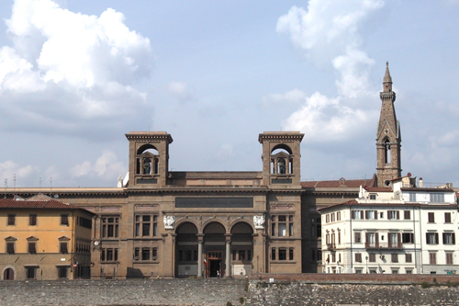

Exterior –
http://www.librari.beniculturali.it/opencms/opencms/it/biblpubbliche/istitutiuffici/istitutoufficio_31.html

- If available, please provide .jpg images of all library sites described in question 5.
- If available, please provide .jpg images of all library spaces described in question 6.
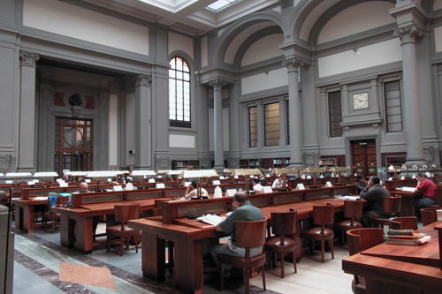
Reading Room -
http://www.librari.beniculturali.it/opencms/opencms/it/biblpubbliche/istitutiuffici/istitutoufficio_31.html
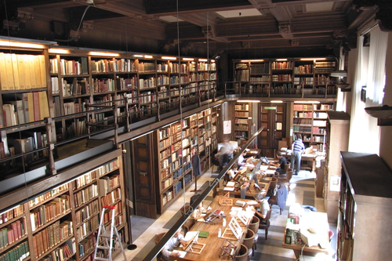
Manuscripts Room -
http://www.librari.beniculturali.it/opencms/opencms/it/biblpubbliche/istitutiuffici/istitutoufficio_31.html
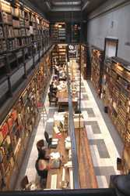
Sale di Consultazione
http://www.beniculturali.it/mibac/export/MiBAC/sito-MiBAC/Menu-Utility/Immagine/index.html_650611425.html
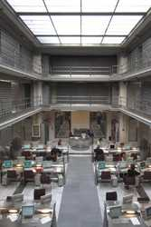
Catalogues Room
http://www.beniculturali.it/mibac/export/MiBAC/sito-MiBAC/Menu-Utility/Immagine/index.html_650611421.html
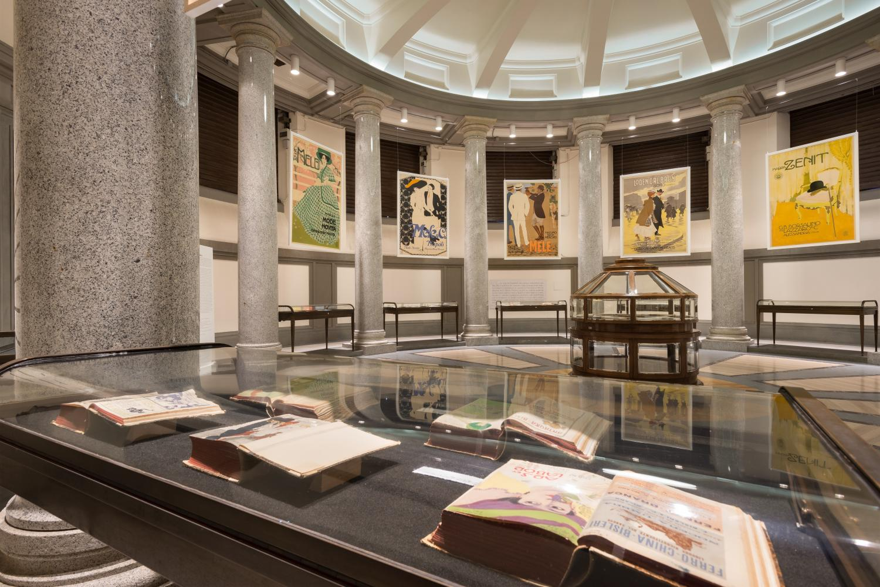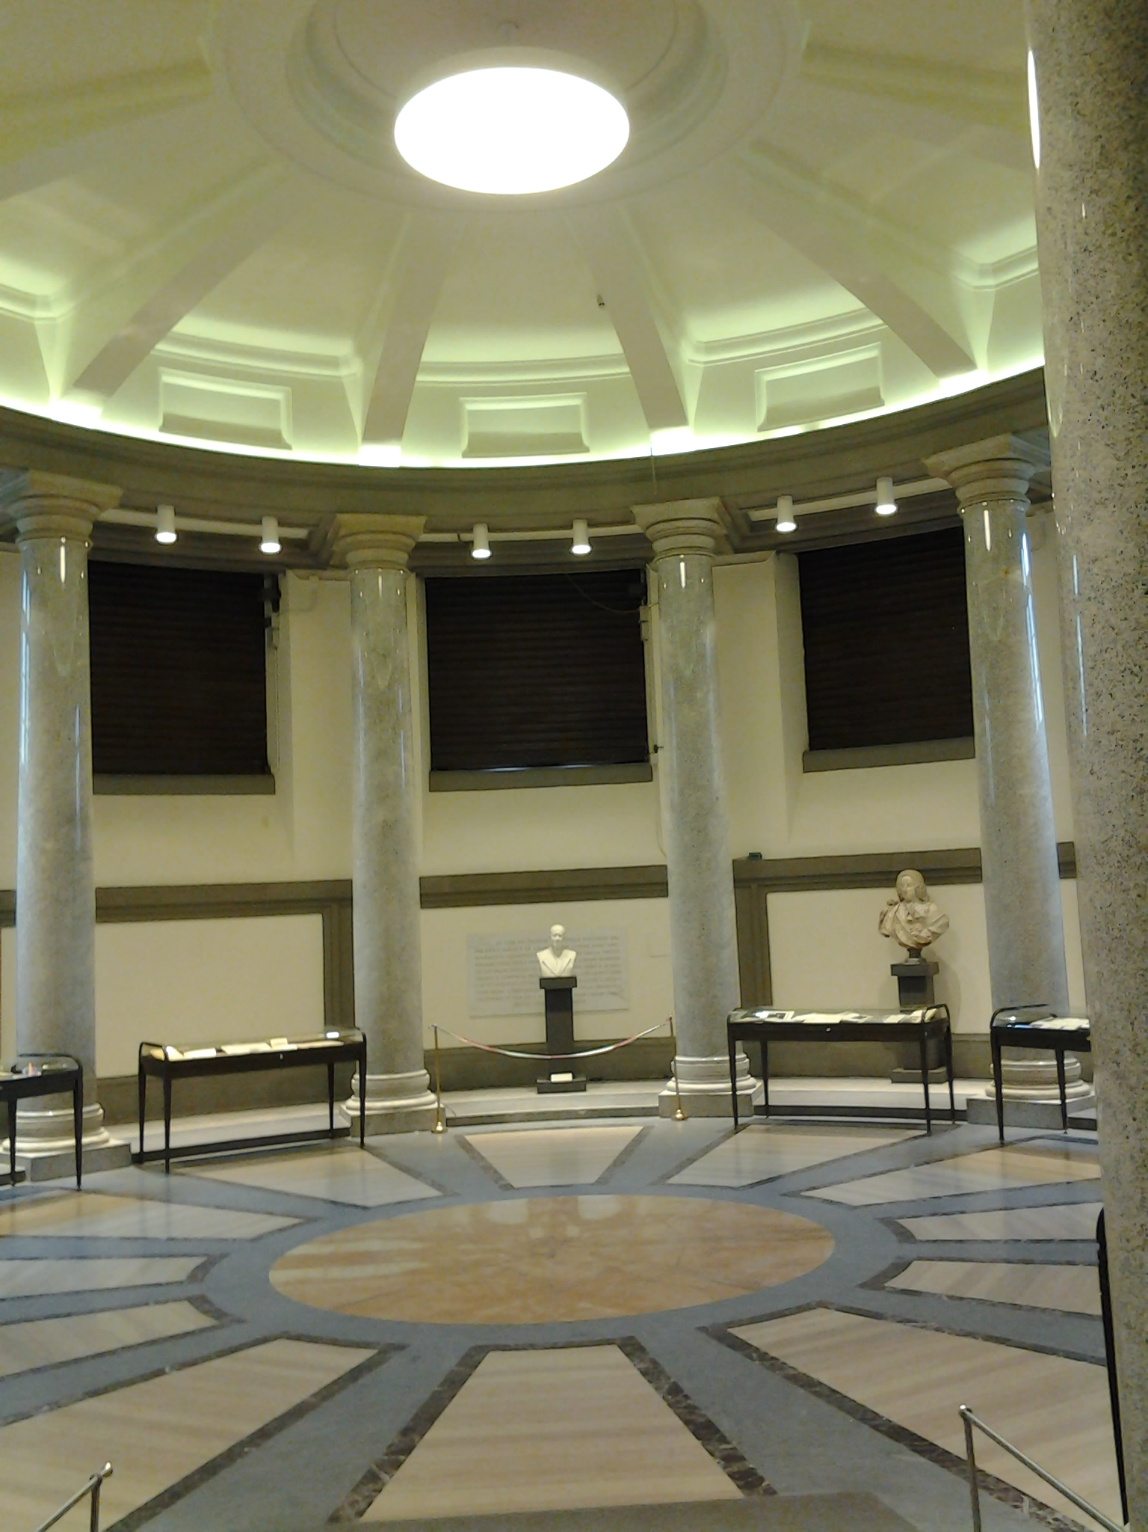
Exhibition Room

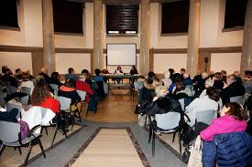
Conference Room
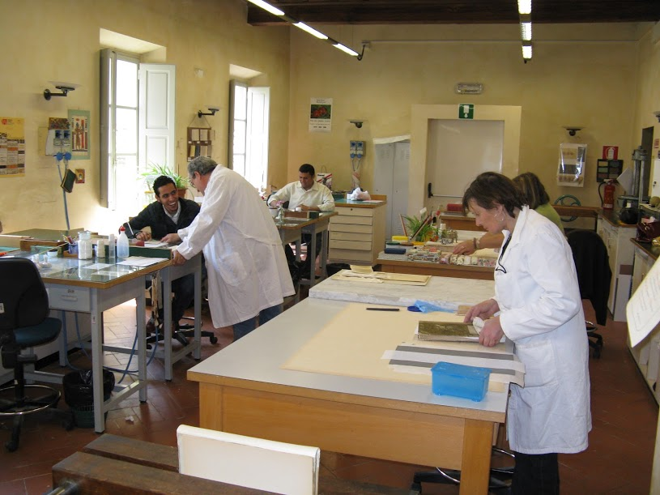
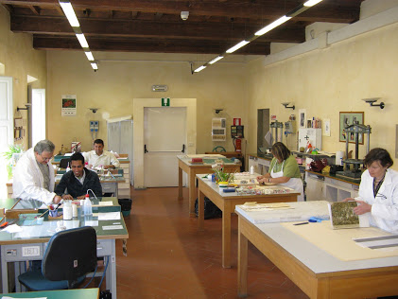
Preservation Centre
- Please provide simplified plans of your buildings, if possible in .jpg format (perhaps those used to guide visitors around your building).
Ground floor
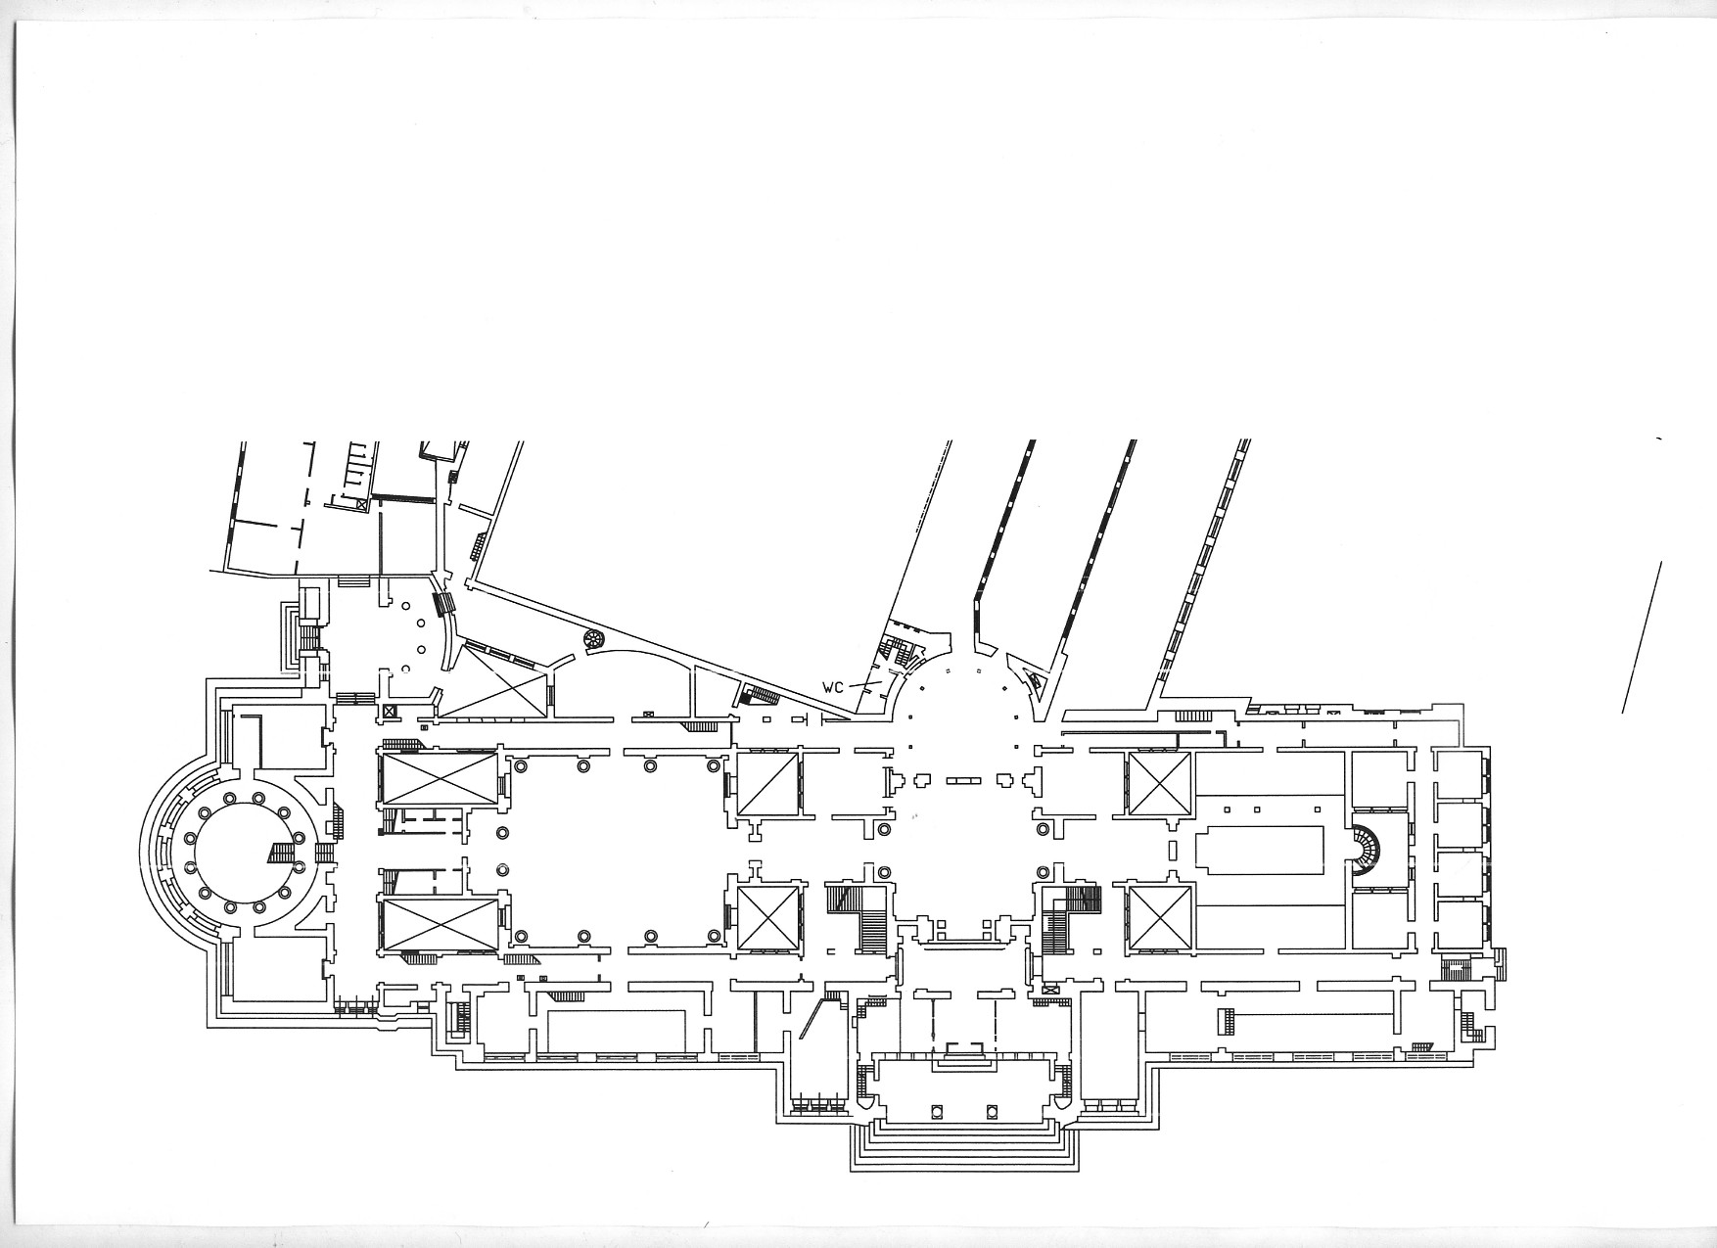

First floor
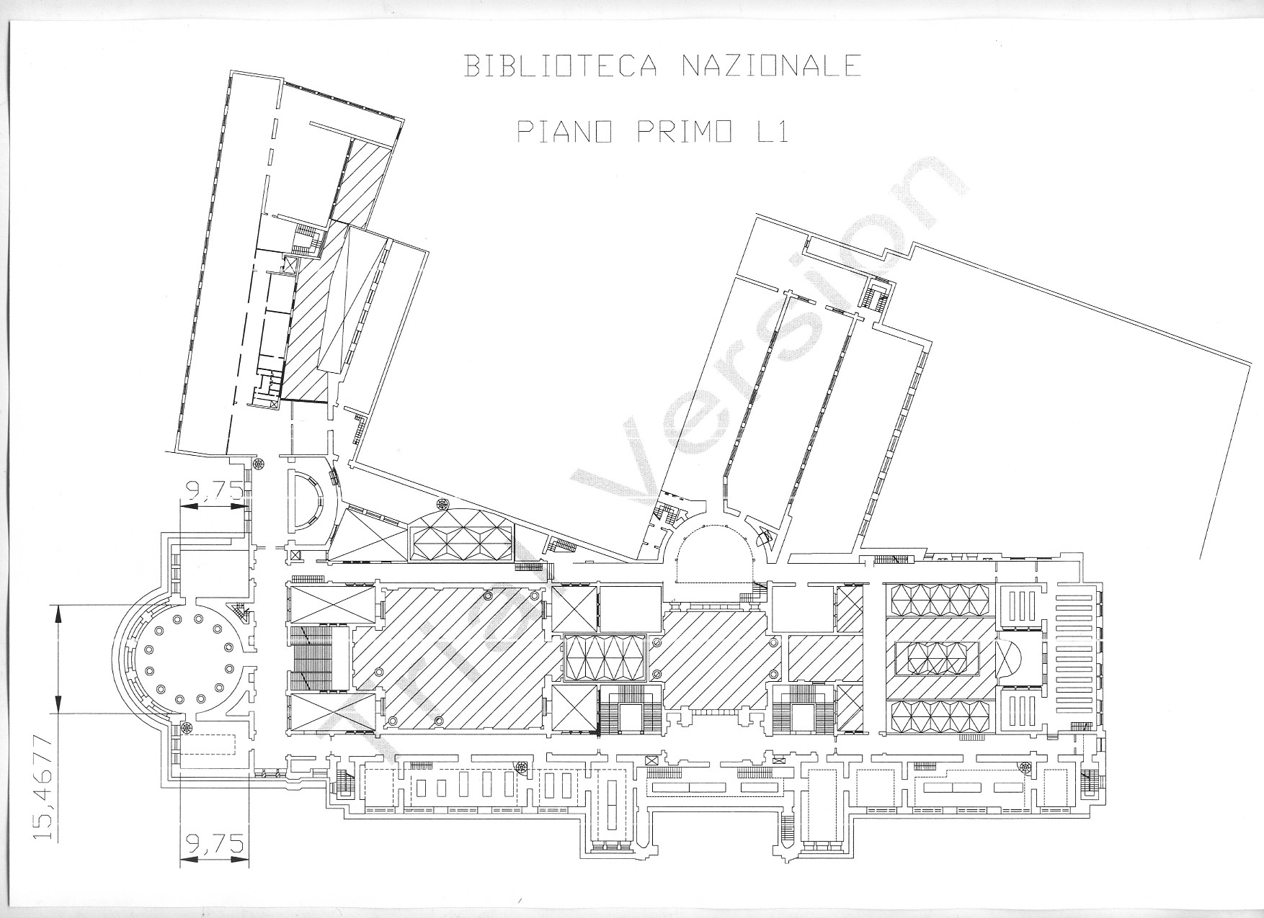

- Please provide brief details on the history of your library buildings.

 | Answer
Year (first) library building opened | 1861
Architect of (first) library building
Year (current) library building opened | 1935
Architect of (current) library building | Cesare Bazzani
Any additional information. Eg length of build/cost of build/reason for build | Later expanded by the architect Vincenzo Mazzei

- If available, please provide a short text on the milestones of the history of your library and/or provide a link to this information online. Please include any bibliographic information about publications about your library and links to these publications in your library catalogue or an aggregated catalogue.
Short history of the Library:
See :
http://www.bncf.firenze.sbn.it/pagina.php?id=50&rigamenu=Notizie%20storiche
http://storia.bncf.firenze.sbn.it/mappa-del-sito/

The current Central National Library of Florence, Institute with special autonomy with DM dated October 7, 2008, originates from the Antonio Magliabechi's private library, consisting of about 30,000 volumes,

1714: Antonio Magliabechi left his library in 1714, according to his will, "for the universal benefit of the city of Florence".
1737: it was established by decree the deposit of a copy of all the works printed in Florence and, from 1743, of those printed throughout the Grand Duchy of Tuscany.
1747: it was opened for the first time to the public with the name of Magliabechiana.
1771: the Grand Duke Pietro Leopoldo renounced the Mediceo-lotaringia Library and wanted it to be united with Magliabechiana. The Library was further enriched by many others valuable funds. Those of the former monastic libraries stand out, confiscated as a result of the policy of suppression of the monasteries implemented by Pietro Leopoldo and resumed by Napoleon.
1861: the newborn Kingdom of Italy promulgated, on December 22nd (the initiative was by Francesco De Sanctis, then Minister of Education), a decree that established the unification of the Magliabechiana Library with the great Palatina Library (founded by Ferdinando III of Lorraine and continued by his successor Leopold II). The new institute assumed the name of the National Library.
Since 1869, by the promulgation of the Royal Decree on November 25, the National Library of Florence receives a copy of all that is published in Italy.
1885: the "Organic Regulations of the Kingdom Libraries" enshrined the "Central" title for the National Libraries of Florence and Rome.
1886: From 1886 to 1957 the National Central Library of Florence (BNCF) published the "Bulletin of Italian publications received by press law", which became since 1958 "Italian National Bibliography" (BNI).
1935: Originally the Library was housed in part of the Uffizi complex; in 1935 it was moved to its current location
1966: The flood of 1966 caused serious damages, in particular to the entire newspaper library, to the precious collection of Miscellanee, to the Magliabechiano fund, to the Palatine fund and to numerous other collections, as well as to all tabbed and volume catalogs, to the bibliographic reading rooms and furnishings. Significant part of the damaged funds were recovered by the specially created Restoration Center, but a substantial part was definitively lost.
80s: the cataloging with SBN (National Library Service) procedures began. The BNCF is also a pilot seat in the creation of the National Library Service (SBN) which aims at the automation of library services and the construction of a national index of library collections held by Italian libraries.
2006: The Magazzini Digitali project, launched in 2006 by the Fondazione Rinascimento Digitale, the National Central Library of Florence and the National Central Library of Rome proposes to put into operation in 2011 a system for the permanent preservation of electronic documents published in Italy and disseminated via the network computer science, implementing the legislation on legal deposit (Law 106/2004, Presidential Decree 252/2006).
2007: The Nuovo soggettario is the instrument that can be used in the indexation by subject of resources of various kinds, created by the Central National Library of Florence. It complies with the principles established by the International Federation of Library Associations and Institutions (IFLA) and the indications of international standards. The tool is aimed at Italian libraries (general, specialized, specialist) and, in particular, those working within the National Library Service (SBN), as well as museums, media libraries, archives, documentation centers. The New Subject system is in continuous evolution and growth. The Italian National Bibliography has employed it since 2007.
2010: ProQuest and Google projects. Between the company ProQuest and BNCF an agreement was signed for the digitization of printed volumes owned by BNCF published until the year 1700. About 7000 BNCF copies have been completely digitized at high resolution. The agreement with Google has provided, and is still providing, for the digitization of volumes not subject to copyright from 1701 to the end of the nineteenth century.
2012: the Italian National Bibliography becomes totally digital, online and on DVD.
2013: Wikipedia (the free and collaborative online encyclopedia available in over 280 languages) offers in the External Links section the link to the New Subject's Thesaurus.
2017: reopening of the Music Room; resumption of the distribution service of the historical newspapers stored at the external deposit hosted at Forte Belvedere.

Short bibliography on Central National Library of Florence:
C. Rotondi, La Biblioteca nazionale di Firenze dal 1861 al 1870, Firenze, Associazione italiana biblioteche. Sezione toscana, 1967
C. Rotondi , Progetti e polemiche per la nuova sede della Biblioteca Nazionale di Firenze tra la fine dell'800 e i primi anni del '900, 1978
C. Rotondi, La Biblioteca nazionale di Firenze : dalla sua costituzione ai primi anni del '900, Firenze, Olschki, 1985
P. Pirolo e A. Giardullo, L'edificio della Biblioteca nazionale centrale di Firenze. catalogo della mostra al Forte Belvedere, ottobre-novembre 1986, Firenze, Karta, 1986
M. Mannelli Gogglioli, La Biblioteca Palatina Mediceo Lotaringia ed il suo catalogo, in “Culture del testo”, n. 3 (settembre-dicembre 1995), Firenze, Titivillus, 1995
E. di Renzo, Una biblioteca, un'alluvione. Il 4 novembre 1966 alla Nazionale di Firenze: storia di un'emergenza, introduzione di Neil Harris, Roma, Associazione Italiana Biblioteche, 2009
1861/2011: l'Italia unita e la sua Biblioteca - Catalogo della mostra tenuta a Firenze nel 2011-2012, Firenze, Polistampa, 2011 (http://storia.bncf.firenze.sbn.it/)
G. Del Bono, Storia della Biblioteca nazionale di Firenze, 1859-1885, Manziana , Vecchiarelli, 2013
G. L. Corradi, 22 dicembre 1861: un Regio Decreto costituisce il nucleo portante della Biblioteca Nazionale, su Portale Storia di Firenze, Dicembre 2015

More other results at following:
http://storia.bncf.firenze.sbn.it/bibliografia/

Chapter III: Location and Urban Spaces
- Please describe the location of your national library buildings (eg. main building in capital city with close proximity to universities, storage buildings in rural area, located two hours by train from building in capital).
All Library buildings are located in the old town of Florence, with close proximity to the main museums, universities, historical sight and administrative centers.
- CENL has provided a map of your headquarter location at the centre of a 500m radius – taken as a screenshot from Google maps. If this is not the correct location of your library building, please supply an alternative screen shot.
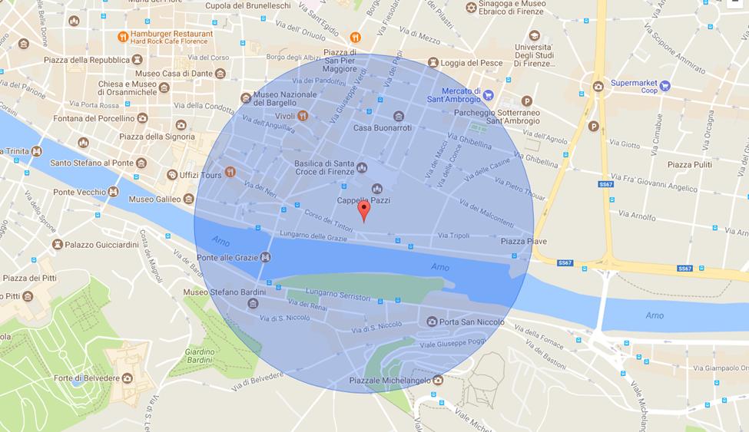
- Please provide details of major governmental, cultural or significant institutions within this vicinity (within a 500m radius).
Political and administrative buildings:
Palazzo Vecchio-Comune di Firenze: https://www.comune.fi.it/

State Archive of Florence: www.archiviodistato.firenze.it/
Museums and churches:
Gallerie degli Uffizi: https://www.uffizi.it/ https://it.wikipedia.org/wiki/Galleria_degli_Uffizi
Museo Nazionale del Bargello: http://www.bargellomusei.beniculturali.it/ https://it.wikipedia.org/wiki/Museo_nazionale_del_Bargello
Museo Galileo: https://www.museogalileo.it/ https://it.wikipedia.org/wiki/Museo_Galileo
Museo Stefano Bardini: http://museicivicifiorentini.comune.fi.it/bardini/ https://it.wikipedia.org/wiki/Museo_Bardini
Casa Buonarroti: http://www.casabuonarroti.it/it/ https://it.wikipedia.org/wiki/Casa_Buonarroti
Basilica di Santa Croce: http://www.santacroceopera.it/it/default.aspx https://it.wikipedia.org/wiki/Basilica_di_Santa_Croce
Sights:
Lungarno and Ponte Vecchio: https://it.wikipedia.org/wiki/Lungarno_delle_Grazie https://it.wikipedia.org/wiki/Ponte_Vecchio
Piazzale Michelangelo: https://it.wikipedia.org/wiki/Piazzale_Michelangelo

- Please describe all the transport options for reaching each of your library buildings open to researchers and the public.
http://www.bncf.firenze.sbn.it/pagina.php?id=65&rigamenu=Come%20arrivare

Chapter IV: Reading Rooms, collections and other interior library spaces
- What is the total number of seats in all your reading rooms across all sites?
Ca. 280
- What is the total square meterage of all your reading rooms across all sites?
Ca. 1.200
- Please list your reading rooms (type, large, by collection) and individual capacity
Reading Room Name | Collection type | Individual room seat capacity | Individual room square metres
Sala di Lettura (Reading Room) | Books | 100 | 400
Sala Periodici (Serials Room) | Serials | 30 | 100
Sala Cataloghi (Catalogues Room) | Catalogues | 30 | 250
Sala Manoscritti (Manuscripts Room) | Manuscripts, old books, rare materials | 25 | 100
Sale di Consultazione (Rare Books pre 1886) | Books, old books | 100 | 300
Sala Musica (Music Collection Room) | Music | 12 | 48
- Do users register to use your Reading Rooms? If so, how?
Reader Pass (Reading room: valid for five years; Manuscripts room: valid for one year; Sale di consultazione: valid for one year); signatures on the registers in Manuscripts room and Sale di Consultazione
- Do users pay to use your Reading Rooms? If so, how much?
No
- How are your collections accessed within the Reading Rooms? Is collection material open access or called to order? Please describe.
Access is mixed: Reference literature in Reading rooms; all other material: called to order

- What is the average number of visits per day to your Reading Rooms?
Open days 2017: 301
Total of readers 2016: 93.257
Average per day: 309

Open days 2016: 292
Total of readers 2016: 120.343
Average per day: 412,13

Open days 2007: no figures
Total of readers 2016: ca. 150.000
Average per day: no figures

- What is the average number of visits per day to your library?
Open days 2017: 301
Total of readers 2016: 93.257
Average per day: 309

Chapter V: Staffing
- What is the number of staff employed by the library in total ?

2017: Staff per 31.12.2017: 151

- What is the number of staff employed by the library in FTE ?
2017:

The keynote presentation may be accessed via http://www.cenl.org/members/cenl-annual-general-meeting-2017-15-16-may-british-library-london/nggallery/page/1

