Survey of National Library Spaces and Services

Following on from CENL’s 2017 AGM and the keynote presentations, as well as the breakout session devoted to collection management, members concluded that a survey of library spaces, and the use of digital content within, would be beneficial to all. Data gathered by the CENL Secretariat will be used for analysis and to further discussion in the coming months with all CENL members. The full results of the survey are intended to be presented at CENL’s 2018 AGM.

All over the world we have seen the creation of new libraries during recent years, including new national library buildings that have been inaugurated or redesigned in Europe. The role of libraries and national libraries is changing and is in permanent transition. This process of transformation caused by the digital revolution and by changes within the economic and political environment has impacted library spaces, staffing and library services. To understand and to meet future needs of national libraries this survey aims to collect and analyse fundamental changes within national library spaces which have occurred over the last ten years.

The survey is structured in six chapters determined by the themes that were discussed during the 2017 AGM breakout session:

• The role of national libraries in collection management is changing – this affects library spaces

• National libraries are transforming from solely heritage institutions to also being leaders in digitisation

• Previously the role of digitisation was for preservation, but now there are new uses for our collections which include the combination of digital and heritage – how is this explored within national libraries?

• Staff development is key to the transformation of libraries – staff need to be integrated in the end to end process of digitisation and using that digital content, perhaps in physical and virtual exhibitions

• Skills and standards for digital content are needed for clarity of activity for researchers

 | Answer
Name of national library in full (in your own language and in anglicised form): | National Library of Ireland  Leabharlann Náisiúnta na hEireann (Irish language)
Name of Director General with official title: | Dr. Sandra Collins, Director
Main library address: | Kildare Street  Dublin 2  Ireland
Current logo as a .jpg:
Contact name, email and telephone for this survey: | Sandra Collins  scollins@nli.ie  + 353 1 603 0231

Instructions
The CENL Secretariat has pre-completed as much information as possible within this survey. Please check the information already provided and augment or correct this as necessary. Where no information is yet provided, please supply answers in full. Do contact cenl@bl.uk with any difficulties.

Chapter I: Scope and core functions of your national library
- Please check all that apply.
X |  |  |  |  | X
National Library | University Library | Public Library | Research Library / Research Centre | National Archives | Legal deposit centre | Digital Preservation centre | Museum | Other
If other please specify:
- Are you the only library with a national remit in your country? If no (eg. there is also a National Technical Library) please specify.
Answer Yes
- What is the legal status of your library?
The National Library of Ireland was established by the Dublin Science and Art Museum Act, 1877.
The National Cultural Institutions Act, 1997, altered the statutory and administrative framework of the Library, giving it greater autonomy, with a Library Board replacing the Council of Trustees. We are classified as an autonomous semi-state body.

- Which ministry oversees your library?
Answer Department of Culture Heritage and Gaeltacht

Chapter II: Physical spaces
- Do you have multiple library sites? If so, please provide address details of all library buildings, including storage.
Answer Yes
National Library of Ireland, 2-3 Kildare Street, Dublin 2 D02 TR7
National Library of Ireland, Administration, 4 Kildare Street, Dublin 2, D02 A32
5 Kildare Street, Dublin 2 (storage)
National Library of Ireland, 7-8 Kildare Street, Dublin 2, D02 P638
National Library of Ireland – National Photographic Archive, Meeting House Square, Dublin 2, D02 WF85
3 commercial storage units

- Please provide a brief summary of all functions contained within the national library.
In 2017
X |  | X | X | X |  |  | X
Reading Rooms | Lounge | Exhibition space | Conference Centre | Conservation Studio | Gallery | Concert Hall | Café / Restaurant | Commercial space / shop | Other

By conference centre, we mean a purpose-built conference / seminar room inside our main building, in which conferences are held. It is not an independent or semi-independent conference centre.

If other please specify:
- Please provide the total square meterage for each of the following functions within your library:
M2 | M2 | M2 | M2 | M2 | M2 | M2 | M2 | M2 | M2
Reading Rooms | Lounge | Exhibition space | Conference Centre | Conservation Studio | Gallery | Concert Hall | Café / Restaurant | Commercial space / shop | Other
If other please specify:
- What is the total size of all library buildings in square metres (includes storage areas)?
2017: Approximately 7,500 m2 including NLI storage areas
- What is the size of library buildings open to the public in square metres?
2017: Approximately 1870 m2
- Please provide .jpg images of your main public building(s) exterior

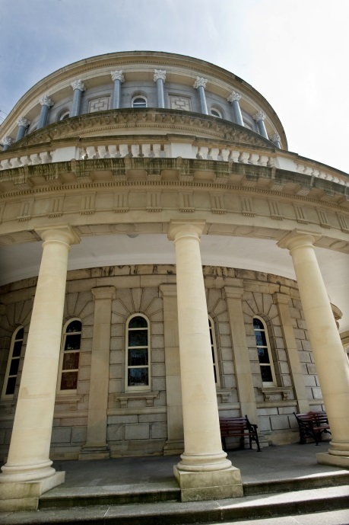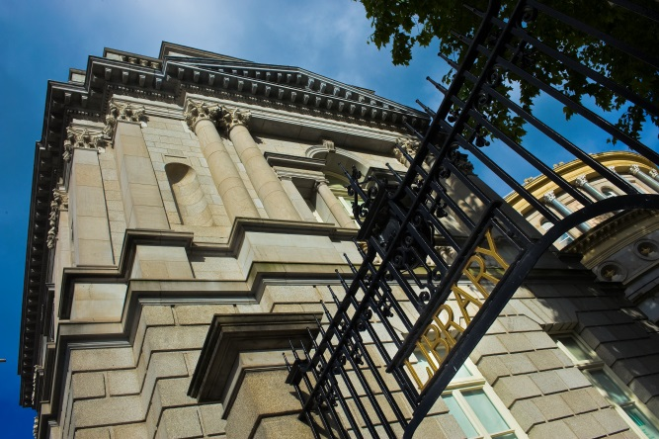

- If available, please provide .jpg images of all library sites described in question 5.

National Library of Ireland, Administration, 4 Kildare Street, Dublin 2, D02 A32:

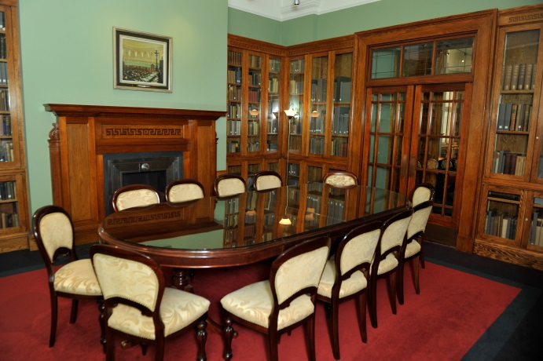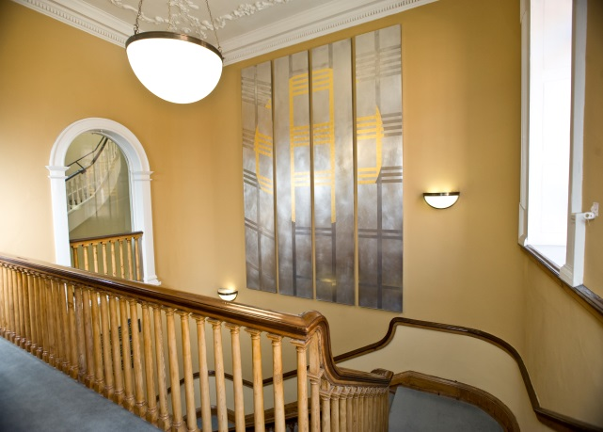

National Library of Ireland, 7-8 Kildare Street, Dublin 2, D02 P638 – see images under Q9 along with:

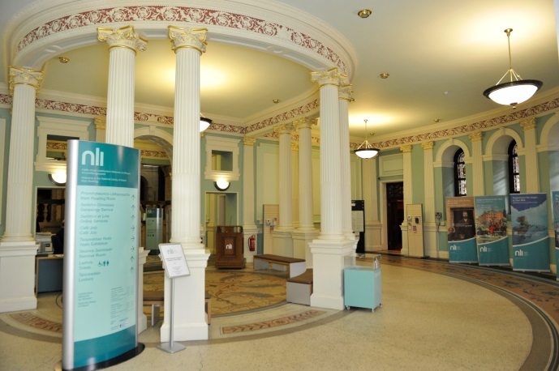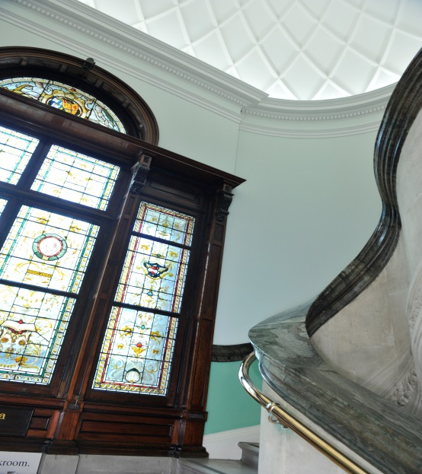

National Library of Ireland – National Photographic Archive, Meeting House Square, Dublin 2, D02 WF85:

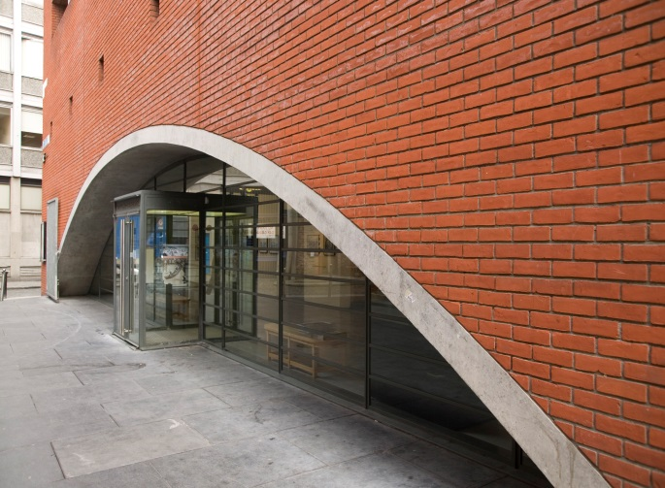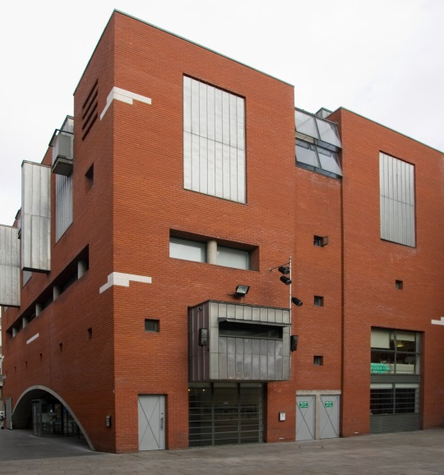

- If available, please provide .jpg images of all library spaces described in question 6.

Reading Room:
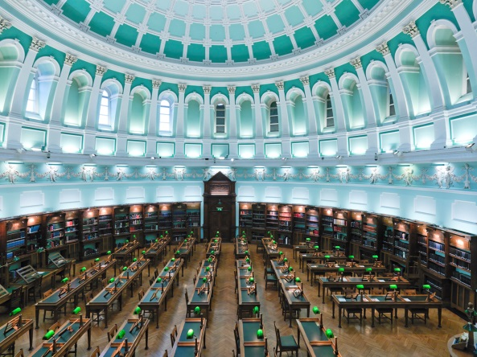

Exhibition Spaces (3 in total):
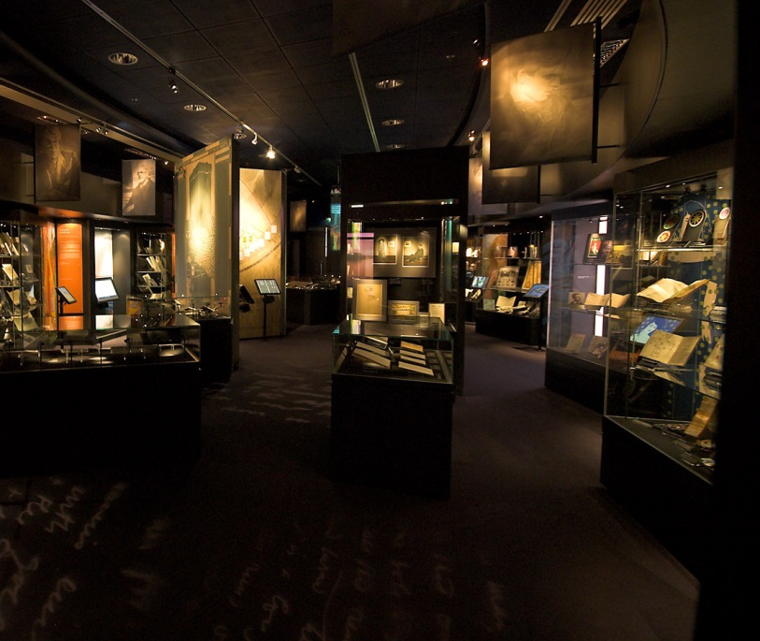

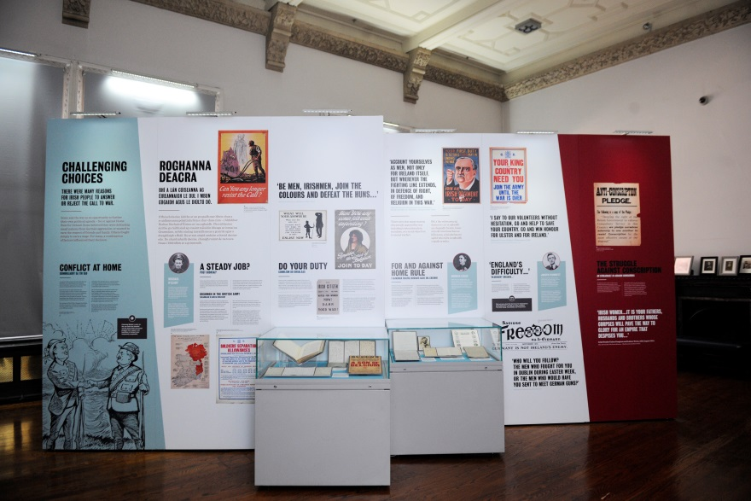
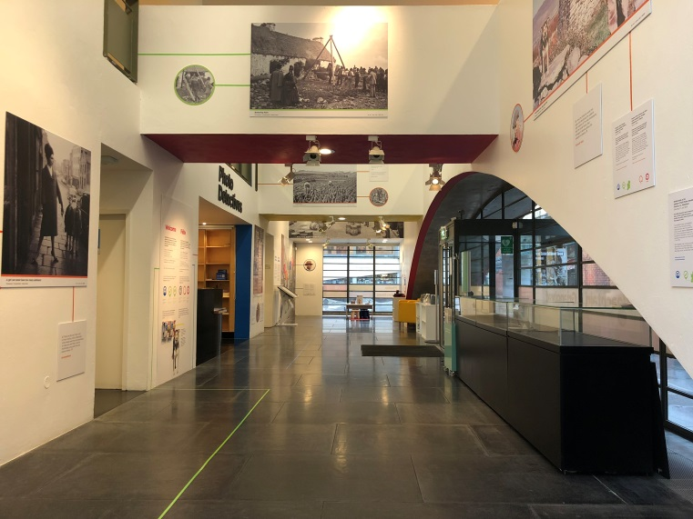

Café:
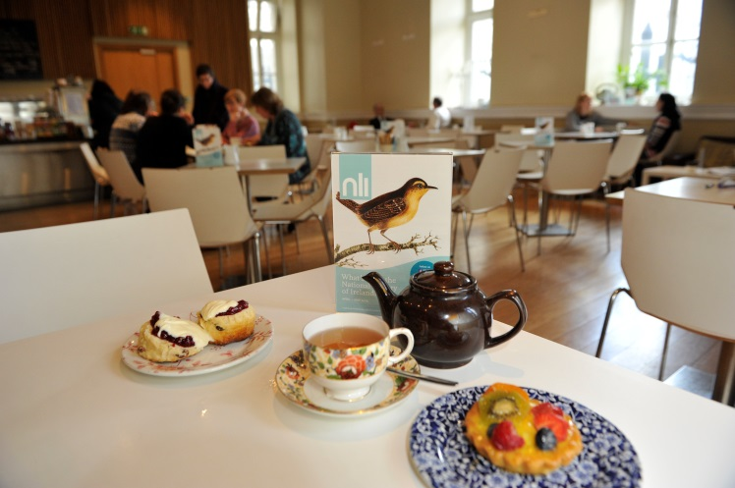

Seminar Room:
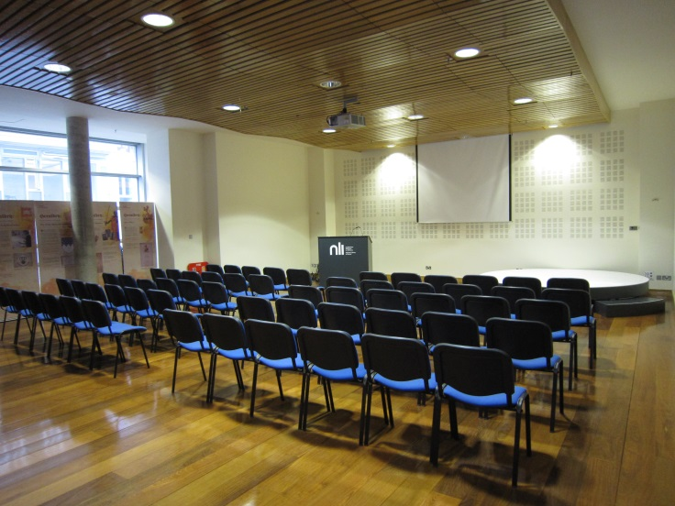

- Please provide simplified plans of your buildings, if possible in .jpg format (perhaps those used to guide visitors around your building).
Answer Simplified plans are not available
- Please provide brief details on the history of your library buildings.

 | Answer
Year (first) library building opened | 1878
Architect of (first) library building | Richard Cassels (Leinster House, the houses of the Irish Government, our original site)
Year (current) library building opened | 1890
Architect of (current) library building | Thomas Newenham Deane and Thomas Manly Deane (Father and Son)
Any additional information. Eg length of build/cost of build/reason for build | Length of build: approximately 5 years: building was constructed in tandem with the construction of the National Museum of Ireland which is also borders the former Leinster House lawn. Reason for build: purpose Library required to house collections and permit public access.

- If available, please provide a short text on the milestones of the history of your library and/or provide a link to this information online. Please include any bibliographic information about publications about your library and links to these publications in your library catalogue or an aggregated catalogue.

Short history of the National Library of Ireland online here:
https://www.nli.ie/en/history-of-the-library.aspx

1877: National Library of Ireland founded by the Dublin Science and Art Museum Act
1890: The Library’s own building opens for the first time
1926: Completion of the Library’s East Wing
1927: National Library becomes a legal deposit library, entitled to a copy of everything published in Ireland
1943: The Genealogical Office, the oldest Office of State in Ireland, becomes part of the Library
1990: Manuscripts Reading Room opens at 2/3 Kildare Street
1998: National Photographic Archive opens in Temple Bar
2004: New exhibition space opens with the exhibition James Joyce and Ulysses
2005: The Library becomes an autonomous semi-state organisation
2010: The Library celebrates 120 years in its building on Kildare Street
2017-2021: Major redevelopment of the Library’s main building

Chapter III: Location and Urban Spaces
- Please describe the location of your national library buildings (eg. main building in capital city with close proximity to universities, storage buildings in rural area, located two hours by train from building in capital).
Answer The National Library’s Main building is adjacent to the houses of the Irish Government (Dáil Éireann) and the National Museum of Ireland. All the National Library buildings accessed by the public are all sited in the city centre, within 15 walk of each other. These buildings are close to Trinity College and easily accessible from University College Dublin and Dublin City University. NLI uses offsite storage in a number of sites in Dublin outside of the city centre.
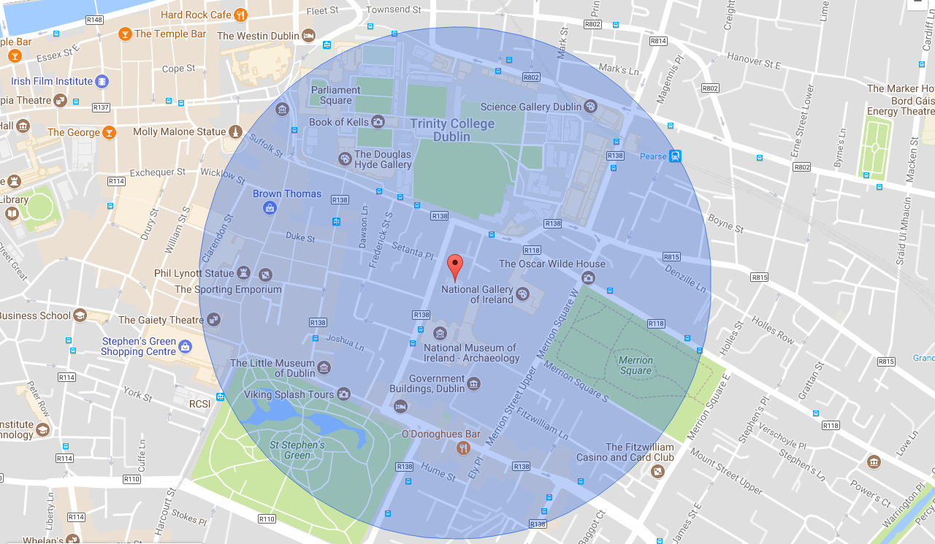
- CENL has provided a map of your headquarter location at the centre of a 500m radius – taken as a screenshot from Google maps. If this is not the correct location of your library building, please supply an alternative screen shot.

- Please provide details of major governmental, cultural or significant institutions within this vicinity (within a 500m radius).
Answer The National Museum of Ireland, The Natural History Museum, The National Gallery of Ireland, The Houses of the Oireachtas, The Little Museum of Dublin, Trinity College, The General Post Office
- Please describe all the transport options for reaching each of your library buildings open to researchers and the public.
Answer Luas (tram); DART (Local rail service); Main Line Rail (inter town and city rail services); Dublin Bus Services (local bus service) and Bus Éireann (country wide bus service). NLI is well-serviced by a wide range of regular public transport options.
Chapter IV: Reading Rooms, collections and other interior library spaces
- What is the total number of seats in all your reading rooms across all sites?
Answer 111* excludes microfiche seating
- What is the total square meterage of all your reading rooms across all sites?
Answer
- Please list your reading rooms (type, large, by collection) and individual capacity
Reading Room Name | Collection type | Individual room seat capacity | Individual room square metres
Main Reading Room | Books, newspapers | 75
Special Collections Reading Room | Manuscript material | 28
NPA Reading Room | Drawings, plans and photographic materials | 8 at communal table
- Do users register to use your Reading Rooms? If so, how?
Answer Yes, bring photographic ID and complete application form. Must be over 16 years old.
- Do users pay to use your Reading Rooms? If so, how much?
Answer No
- How are your collections accessed within the Reading Rooms? Is collection material open access or called to order? Please describe.
The National Library is a closed stack reference library which means that books and other items in our collections can’t be browsed or borrowed and must be ordered for consultation in our reading rooms. We operate fixed delivery times in our Main Reading Room and in the Manuscripts Reading Room. Other smaller reading rooms are by appointment only.
Details of delivery times etc can be found here: https://www.nli.ie/en/accessing-material.aspx

- What is the average number of visits per day to your Reading Rooms?
17,392 research visits during 2016.
- What is the average number of visits per day to your library?
Over 247,000 visits to the NLI during 2016.

Chapter V: Staffing
- What is the number of staff employed by the library in total ?
2017: 90
- What is the number of staff employed by the library in FTE ?
2017:

The keynote presentation may be accessed via http://www.cenl.org/members/cenl-annual-general-meeting-2017-15-16-may-british-library-london/nggallery/page/1

