Survey of National Library Spaces and Services

Following on from CENL’s 2017 AGM and the keynote presentations, as well as the breakout session devoted to collection management, members concluded that a survey of library spaces, and the use of digital content within, would be beneficial to all. Data gathered by the CENL Secretariat will be used for analysis and to further discussion in the coming months with all CENL members. The full results of the survey are intended to be presented at CENL’s 2018 AGM.

All over the world we have seen the creation of new libraries during recent years, including new national library buildings that have been inaugurated or redesigned in Europe. The role of libraries and national libraries is changing and is in permanent transition. This process of transformation caused by the digital revolution and by changes within the economic and political environment has impacted library spaces, staffing and library services. To understand and to meet future needs of national libraries this survey aims to collect and analyse fundamental changes within national library spaces which have occurred over the last ten years.

The survey is structured in six chapters determined by the themes that were discussed during the 2017 AGM breakout session:

• The role of national libraries in collection management is changing – this affects library spaces

• National libraries are transforming from solely heritage institutions to also being leaders in digitisation

• Previously the role of digitisation was for preservation, but now there are new uses for our collections which include the combination of digital and heritage – how is this explored within national libraries?

• Staff development is key to the transformation of libraries – staff need to be integrated in the end to end process of digitisation and using that digital content, perhaps in physical and virtual exhibitions

• Skills and standards for digital content are needed for clarity of activity for researchers

 | Answer
Name of national library in full (in your own language and in anglicised form): | Deutsche Nationalbibliothek  German National Library
Name of Director General with official title: | Director General Dr Elisabeth Niggemann
Main library address: | Adickesallee 1  60322 Frankfurt am Main  Germany
Current logo as a .jpg:
Contact name, email and telephone for this survey: | Britta Woldering  b.woldering@dnb.de  +49 – 69 – 1525 1541

Instructions
The CENL Secretariat has pre-completed as much information as possible within this survey. Please check the information already provided and augment or correct this as necessary. Where no information is yet provided, please supply answers in full. Do contact cenl@bl.uk with any difficulties.

Chapter I: Scope and core functions of your national library
- Please check all that apply.
X |  |  |  |  | X |  | X
National Library | University Library | Public Library | Research Library / Research Centre | National Archives | Legal deposit centre | Preservation centre | Museum | Other
If other please specify:
- Are you the only library with a national remit in your country? If no (eg. there is also a National Technical Library) please specify.
yes
- What is the legal status of your library?
Federal institution with legal capacity under public law (Rechtsfähige bundesunmittelbare Anstalt des öffentlichen Rechts)
- Which ministry oversees your library?
Minister of State for Culture and the Media

Chapter II: Physical spaces
- Do you have multiple library sites? If so, please provide address details of all library buildings, including storage.
Deutsche Nationalbibliothek, Deutscher Platz 1, 04103 Leipzig, Germany
Deutsche Nationalbibliothek, Adickesallee 1, 60322 Frankfurt am Main, Germany
- Please provide a brief summary of all functions contained within the national library.
In 2017
X |  | X | X |  |  |  | X
Reading Rooms | Lounge | Exhibition space | Conference Centre | Conservation Studio | Gallery | Concert Hall | Café / Restaurant | Commercial space / shop | Other

If other please specify:
- Please provide the total square meterage for each of the following functions within your library:
M2 | M2 | M2 | M2 | M2 | M2 | M2 | M2 | M2 | M2
Reading Rooms | Lounge | Exhibition space | Conference Centre | Conservation Studio | Gallery | Concert Hall | Café / Restaurant | Commercial space / shop | Other
If other please specify:
- What is the total size of all library buildings in square metres (includes storage areas)?
2017: Leipzig: 64,200 m²; Frankfurt: 47,000 m²
- What is the size of library buildings open to the public in square metres?
2017
Leipzig: 2,779.21 m² reading rooms + 1,500 m² exhibition space + 175 m² café/restaurant
Frankfurt: 3,200 m² reading rooms + 758 m² exhibition space + 571.2 m² café/restaurant

- Please provide .jpg images of your main public building(s) exterior
Exterior Frankfurt -
http://www.dnb.de/EN/Wir/fototourenFilme/fototourFrankfurt.html?cms_notFirst=true&cms_docId=212066

http://www.dnb.de/DE/Wir/fototourenFilme/fototourFrankfurt.html (the German version has more photos)

front, entrance
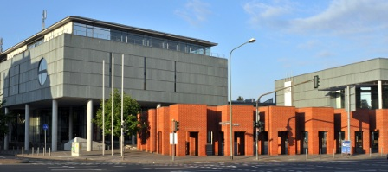

View from south west, garden, reading rooms

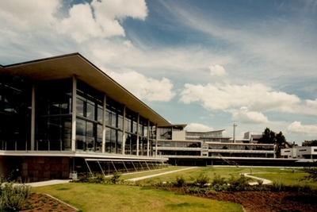

Reading rooms from the garden by night

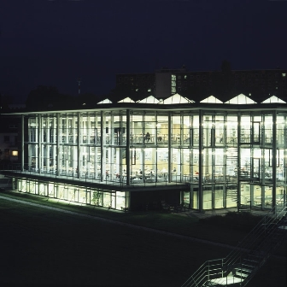

Exterior Leipzig –
http://www.dnb.de/EN/Wir/fototourenFilme/fototourLeipzig.html

main building, third (white book towers) and fourth (colourful, „flat“) extension
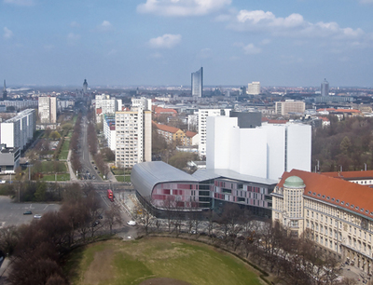

Main building
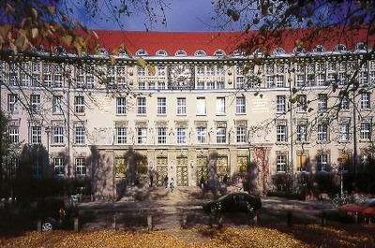
New music reading room in the inner courtyard
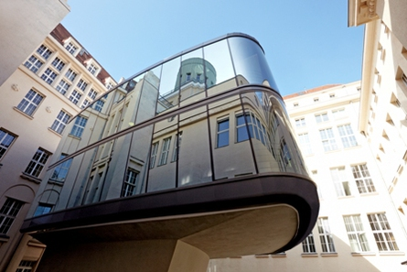
- If available, please provide .jpg images of all library sites described in question 5.
See 9)
- If available, please provide .jpg images of all library spaces described in question 6.
Leipzig: http://www.dnb.de/EN/Wir/fototourenFilme/fototourLeipzig.html

Reading rooms:
Humanities reading room
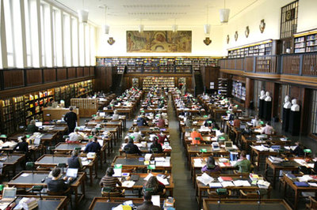
Science reading room
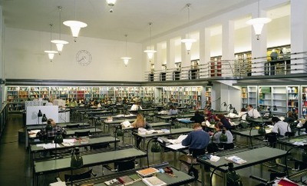
Reading room of the Anne-Frank-Shoah library
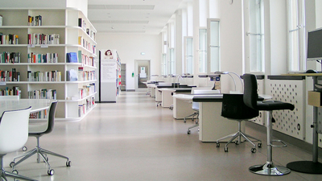
Music reading room
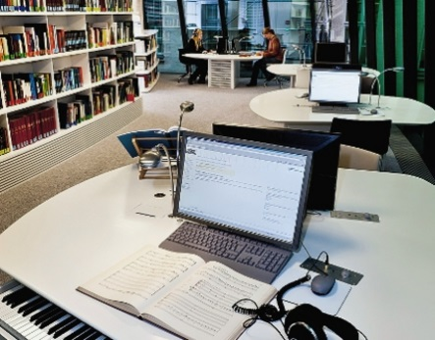
Maps reading room
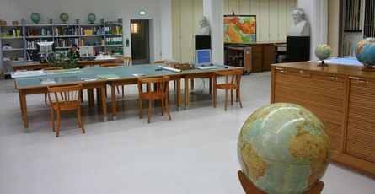
Reading room of the German Museum of Books and Writing
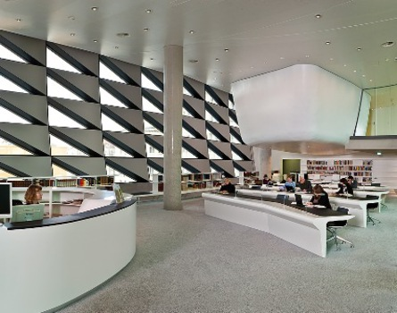
Exhibition spaces: for more photos see extra photos in separate file
Exhibition space of the German Museum of Books and Writing
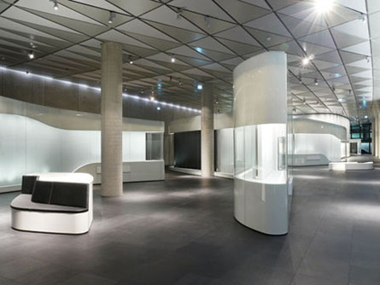

Exhibition of the German Music Archive
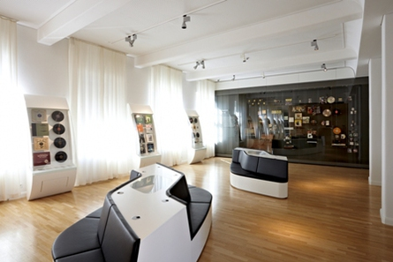
Café/Restaurant: see extra photos in separate file

Frankfurt: http://www.dnb.de/DE/Wir/fototourenFilme/fototourFrankfurt.html (the German version has more photos)
Reading rooms:
Main reading room
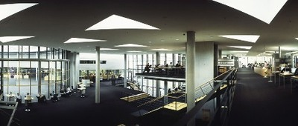
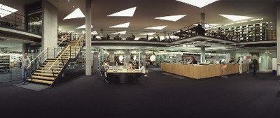

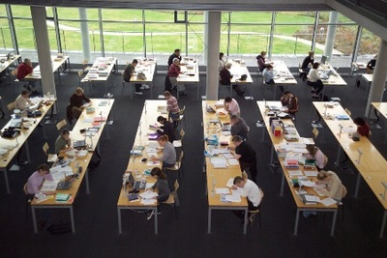

Multimedia reading room
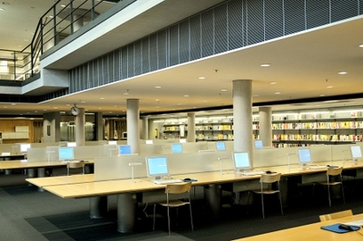
Exhibition spaces: see extra photos in separate file
Conference centre (in Frankfurt only):
Lecture hall
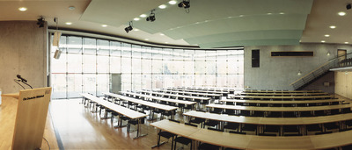

Meeting room (can be rented)
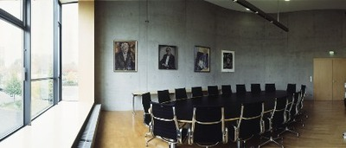
Café/Restaurant: see extra photos in separate file
- Please provide simplified plans of your buildings, if possible in .jpg format (perhaps those used to guide visitors around your building).
Leipzig:

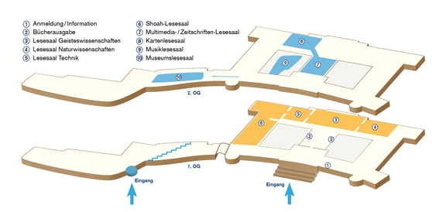

Not available for the Frankfurt site as this is less complicated than Leipzig.
- Please provide brief details on the history of your library buildings.

Year (first) library building opened | 1914–1916
Architect of (first) library building | Oskar Pusch
Any additional information. Eg length of build/cost of build/reason for build | The impressive facade is 160 m long and faces the "Deutscher Platz" (German Plaza). The building was opened on October 19, 1916, one day after the Monument to the Battle of the Nations. The site of the library had been donated by the city of Leipzig, while Friedrich August III, King of Saxony provided the funds for the building. On the facade, the portraits of Otto von Bismarck, Johann Wolfgang von Goethe and Johannes Gutenberg are displayed. Statues represent Technology, Justice, Philosophy, Medicine etc. The central reading room contains a picture by Ludwig von Hofmann, depicting Arcadia in Art Nouveau-style. The staircase displays a mural showing the founders of the German library.
First extension | 1934-1936 (east: stacks, small reading room); Oskar Pusch
Second extension | 1959-1963 (north-west: stacks for 1 mio books, reading room, office space, space for the German Museum of Books and Writing); Oskar Pusch
Third extension | 1976-1982 (book tower: stacks for 5 mio books); Dieter Seidlitz
Fourth extension | 2002-2011 (exhibition space for the German Museum of Books and Writing; two reading rooms, stacks, office space); Gabriele Glöckler; 59,125,000 Euro

- If available, please provide a short text on the milestones of the history of your library and/or provide a link to this information online. Please include any bibliographic information about publications about your library and links to these publications in your library catalogue or an aggregated catalogue.
http://www.dnb.de/EN/Wir/Geschichte/geschichte_node.html

http://www.dnb.de/EN/Wir/Geschichte/100Jahre/geschichte100Jahre_node.html (German only)

Chapter III: Location and Urban Spaces
- Please describe the location of your national library buildings (eg. main building in capital city with close proximity to universities, storage buildings in rural area, located two hours by train from building in capital).
The Leipzig location of the German National Library is located at the Deutsche Platz. It is a 10 minutes tram drive from the city centre and the Leipzig University, 15 minutes from the central station.
The Frankfurt location of the German National Library is located in the north of Frankfurt. It is a 10 minutes ride by subway from the central station and a 5 minute ride from the city centre (Konstablerwache). The Goethe University can be reached by bus: 5 minutes (Campus Westend) or 10 minutes (Campus Bockenheim).
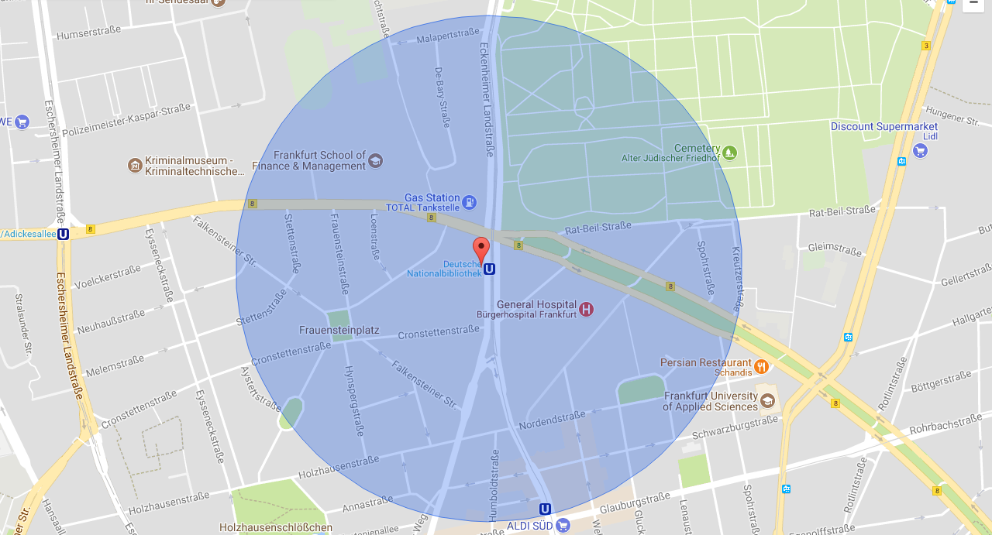
- CENL has provided a map of your headquarter location at the centre of a 500m radius – taken as a screenshot from Google maps. If this is not the correct location of your library building, please supply an alternative screen shot.
This is only the map of the Frankfurt site. Please add the map of the Leipzig site (address: Deutscher Platz 1). We do not have the tool to create a Google maps radius screenshot.

- Please provide details of major governmental, cultural or significant institutions within this vicinity (within a 500 m radius).
The Leipzig location is close to the former fair ground (Alte Messe). The Max-Planck-Institute for Evolutionary Anthropology and the German Centre for Integrative Biodiversity are opposite the library.
The Frankfurt location is in the north of the city centre and in its 500 m vicinity the Frankfurt School of Finance and Management, the Hessian Broadcasting Corporation and the Frankfurt University of Applied Sciences can be found.
- Please describe all the transport options for reaching each of your library buildings open to researchers and the public.
By tram or subway, by bus, by car (car park with costs available in Frankfurt), by bike, on foot.

Chapter IV: Reading Rooms, collections and other interior library spaces
- What is the total number of seats in all your reading rooms across all sites?
855
- What is the total square meterage of all your reading rooms across all sites?
Frankfurt site: 3,200 m2
Leipzig site: 2,779.21 m²
- Please list your reading rooms (type, large, by collection) and individual capacity
Reading Room Name | Collection type | Individual room seat capacity | Individual room square metres
Leipzig site | The reference library of the Leipzig site reading rooms contains roughly 57.600 volumes of general and specialist reference works each related to the theme of the reading room. | 550  467 reading places  67 computer workplaces  14 workplaces for microforms  2 workplaces for the blind and visually impaired | 2,779.21 m²
Humanities Reading Room (LSG) | books  reference library: 16,000 volumes | 176 | 552.98 m²
Science Reading Room (LSN) | books  reference library: 7,000 volumes | 99 | 273.37 m²
Technology Reading Room (LST) | books  reference library: 4,000 volumes | 73 | 258.35 m²
Multimedia-/periodicals' reading room  (MZLS) | periodicals, audiovisual media, microforms, electronic publications, online resources  All of these publications (CD-ROMs, audio CDs, DVDs, microfilms, e-books, e-paper etc.) can be used on specially designated computers and readers.  reference library: 1,900 periodicals from all academic fields and some national and international newspapers in printed form | 92 | 368 m²
Music Reading Room | books, periodicals, music, music files  reference library: 3,700 volumes and 30 periodicals | 18 | 421.60 m² on two levels
Museum Reading Room | books, periodicals, manuscripts, old prints, objects, archive materials  reference library:  1,200 volumes and 30 periodicals | 33 | 301.25 m²
Reading Room of the Anne-Frank-Shoah Library | contains:  Anne-Frank-Shoah-Library  Sozialistica  Library of the German National Assembly 1848/49 (Reichsbibliothek)  Poster collection  Exile collection  reference library:  23,200 volumes | 53 | 304.29 m²
Map Collection Reading Room | maps, plans, books  reference library:  600 volumes | 6 | 299.37 m²
Frankfurt site | In all reading rooms the reading room computers provide access to the catalogue (available only in German), the full texts of the online resources (such as e-books, music files and digitised content), the e-paper collection and to the Electronic Reference Library (EHB). Electronic publications (CD-ROMs, audio CDs, DVDs etc.) can be accessed on specially designated computers.
Main reading room (HLS) | The reference library of the Main Reading Room contains roughly 21,000 volumes of general and specialist reference works covering all fields of knowledge |  | 2,100 m²
Multimedia reading room (MLS) | The reference library of the Multimedia Reading Room contains a selection of printed works on topics such as the Internet, multimedia and different types of application software.  Gramophone records, audio cassettes, slides etc. from the archives of the German National Library can be used in the mediatheque. The range of services also includes a workplace for the blind and visually impaired. |  | 680 m² + 71 m² Multimedia Lab
Serials reading room (ZLS) | Issues from the 6 most recent years of roughly 900 serials from all academic fields are available for use in the open access holdings of the Serials Reading Room.  The range is supplemented by a selection of major national and international newspapers in printed form (from the current and the last month). |  | 740 m²
Reading Room of the Deutsches Exil-Archiv | Manuscripts, letters, books, objects, … |  | 45 m²
- Do users register to use your Reading Rooms? If so, how?
Daily, monthly, annual passes
- Do users pay to use your Reading Rooms? If so, how much?
Day pass: 6 EUR, monthly pass: 18 EUR, annual pass: 42 EUR
- How are your collections accessed within the Reading Rooms? Is collection material open access or called to order? Please describe.
Access is mixed: Reference Library in the reading rooms (in total: 85.000 media), all other material: called to order.
In all reading rooms the reading room computers provide access to the catalogue (available only in German), the full texts of the online resources (such as e-books, music files and digitised content), the e-paper collection and to the Electronic Reference Library (EHB). Electronic publications (CD-ROMs, audio CDs, DVDs etc.) can be accessed on specially designated computers.
- What is the average number of visits per day to your Reading Rooms?
Opening days (2017): 297
Total of readers (2017): 180,283
Average per day: 641
- What is the average number of visits per day to your library?
Opening days (2017): 297
Total of readers (180,283) + guests of guided tours (7,574) + guests of events (12,745)
Average per day: 675 persons
Chapter V: Staffing
- What is the number of staff employed by the library in total ?
2017: 634
- What is the number of staff employed by the library in FTE ?
2017:

The keynote presentation may be accessed via http://www.cenl.org/members/cenl-annual-general-meeting-2017-15-16-may-british-library-london/nggallery/page/1

