Survey of National Library Spaces and Services

Following on from CENL’s 2017 AGM and the keynote presentations, as well as the breakout session devoted to collection management, members concluded that a survey of library spaces, and the use of digital content within, would be beneficial to all. Data gathered by the CENL Secretariat will be used for analysis and to further discussion in the coming months with all CENL members. The full results of the survey are intended to be presented at CENL’s 2018 AGM.

All over the world we have seen the creation of new libraries during recent years, including new national library buildings that have been inaugurated or redesigned in Europe. The role of libraries and national libraries is changing and is in permanent transition. This process of transformation caused by the digital revolution and by changes within the economic and political environment has impacted library spaces, staffing and library services. To understand and to meet future needs of national libraries this survey aims to collect and analyse fundamental changes within national library spaces which have occurred over the last ten years.

The survey is structured in six chapters determined by the themes that were discussed during the 2017 AGM breakout session:

• The role of national libraries in collection management is changing – this affects library spaces

• National libraries are transforming from solely heritage institutions to also being leaders in digitisation

• Previously the role of digitisation was for preservation, but now there are new uses for our collections which include the combination of digital and heritage – how is this explored within national libraries?

• Staff development is key to the transformation of libraries – staff need to be integrated in the end to end process of digitisation and using that digital content, perhaps in physical and virtual exhibitions

• Skills and standards for digital content are needed for clarity of activity for researchers

 | Answer
Name of national library in full (in your own language and in anglicised form): | Bibliothèque nationale de France  National Library of France
Name of Director General with official title: | Laurence Engel
Main library address: | quai François Mauriac  75707 Paris cedex 13  France
Current logo as a .jpg:
Contact name, email and telephone for this survey: | Laurence Engel  Laurence.engel@bnf.fr  +33 (1) 53 79 48 48

Instructions
The CENL Secretariat has pre-completed as much information as possible within this survey. Please check the information already provided and augment or correct this as necessary. Where no information is yet provided, please supply answers in full. Do contact cenl@bl.uk with any difficulties.

Chapter I: Scope and core functions of your national library
- Please check all that apply.
National Library | University Library | Public Library | Research Library / Research Centre | National Archives | Legal deposit centre | Preservation centre | Museum | Other
If other please specify:
- Are you the only library with a national remit in your country? If no (eg. there is also a National Technical Library) please specify.
Strasbourg National and University Library (http://www.bnu.fr/)
- What is the legal status of your library?
Publicly-owned administrative establishment
- Which ministry oversees your library?
Ministry of Culture (http://www.culturecommunication.gouv.fr/)

Chapter II: Physical spaces
- Do you have multiple library sites? If so, please provide address details of all library buildings, including storage.
7 sites, 5 of which are open to the public (http://www.bnf.fr/fr/la_bnf/sites.html): presentation pages describing the sites (including access and photos)
- Please provide a brief summary of all functions contained within the national library.
In 2017
Reading Rooms | Lounge | Exhibition space | Conference Centre | Conservation Studio | Gallery | Concert Hall | Café / Restaurant | Commercial space / shop | Other

If other please specify:

- Please provide the total square meterage for each of the following functions within your library:
29,400 M² | 15,960 M² | 1,280 M² | 1,120 M² | M2 | M2 | M2 | 800 M² |  | M2
Reading Rooms | Lounge | Exhibition space | Conference Centre | Conservation Studio | Gallery | Concert Hall | Café / Restaurant | Commercial space / shop | Other
If other please specify:
- What is the total size of all library buildings in square metres (includes storage areas)?
2017:
François Mitterrand site: usable area 159,855 m²
Richelieu-Louvois sites: usable area 47,000 m²
Arsenal site: usable area 7,484 m²
Opera Library site: 2,673 m²
Maison Jean Vilar: 722 m²
Bussy-Saint-Georges Technical Centre: 30,202 m²
Sablé-sur-Sarthe Joël-Le-Theule Preservation Centre: 3,131 m²
2007:
- What is the size of library buildings open to the public in square metres?
2017:
François Mitterrand site: usable area 159,855 m²
Richelieu-Louvois sites: usable area 47,000 m²
Arsenal site: usable area 7,484 m²
Opera Library site: 2,673 m²
Maison Jean Vilar: 722 m²
2007:
- Please provide .jpg images of your main public building(s) exterior

Exterior -

https://www.google.co.uk/maps/place/The+Fran%C3%A7ois-Mitterrand+Library/

- If available, please provide .jpg images of all library sites described in question 5.
Answer
- If available, please provide .jpg images of all library spaces described in question 6.
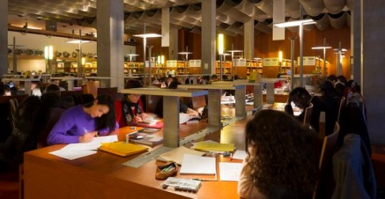
Reading room 1
http://www.bnf.fr/fr/la_bnf/bibliotheque_haut-de-jardin.html

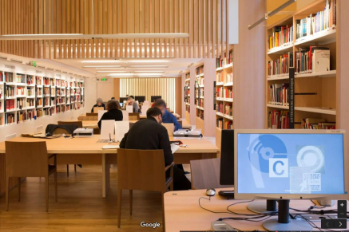
Reading room 2
https://www.google.co.uk/maps/place/The+Fran%C3%A7ois-Mitterrand+Library/

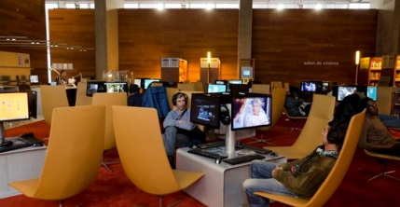
Digital Media space -
http://www.bnf.fr/fr/la_bnf/bibliotheque_haut-de-jardin.html

Exhibition Space -
https://www.google.co.uk/maps/place/The+Fran%C3%A7ois-Mitterrand+Library/
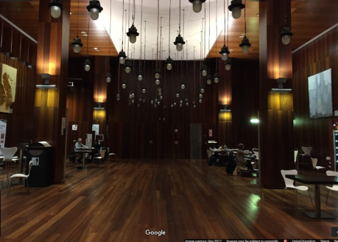

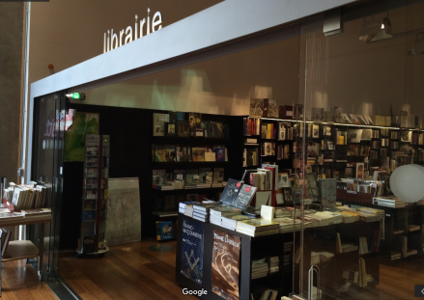
Book shop -
https://www.google.co.uk/maps/place/The+Fran%C3%A7ois-Mitterrand+Library/

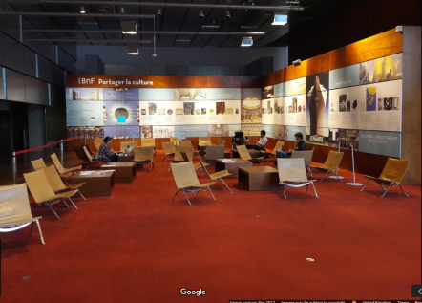
Seating Area
https://www.google.co.uk/maps/place/The+Fran%C3%A7ois-Mitterrand+Library/

- Please provide simplified plans of your buildings, if possible in .jpg format (perhaps those used to guide visitors around your building).
http://www.bnf.fr/fr/la_bnf/plans_et_salles_lecture/s.plan_haut_jardin.html?first_Art=oui
http://www.bnf.fr/fr/la_bnf/plans_et_salles_lecture/s.plan_rez_jardin.html?first_Art=non
http://www.bnf.fr/fr/la_bnf/plans_et_salles_lecture/s.plan_richelieu.html?first_Art=non

- Please provide brief details on the history of your library buildings.

 | Answer
Year (first) library building opened | 1692 (1st opened to the public); installed in 1721 on the Richelieu site
Architect of (first) library building | Jean Thiriot (Richelieu site)
Year (current) library building opened | 1996 (François-Mitterrand site)
Architect of (current) library building | Dominique Perrault
Any additional information. Eg length of build/cost of build/reason for build | Upon Labrouste's death in 1875 the library was further expanded, including the grand staircase and the Oval Room, by academic architect Jean-Louis Pascal.  In 1988, President François Mitterrand announced the construction and the expansion of one of the largest and most modern libraries in the world, intended to cover all fields of knowledge, and designed to be accessible to all. The services of the architectural firm of Dominique Perrault were retained. The National Library of France opened on 20 December 1996.

- If available, please provide a short text on the milestones of the history of your library and/or provide a link to this information online. Please include any bibliographic information about publications about your library and links to these publications in your library catalogue or an aggregated catalogue.
http://www.bnf.fr/fr/la_bnf/histoire_de_la_bnf.html

Chapter III: Location and Urban Spaces
- Please describe the location of your national library buildings (eg. main building in capital city with close proximity to universities, storage buildings in rural area, located two hours by train from building in capital).
http://www.bnf.fr/fr/la_bnf/sites/a.site_francois-mitterrand.html: The François-Mitterrand site is located in the new Paris Rive Gauche district in the 13th arrondissement, sometimes called the "new Latin Quarter", owing to the large number of university and cultural institutions which can be found there today. These include Paris-Diderot University, the Inalco, the École nationale supérieure d'architecture Paris-Val de Seine and the École des hautes études en sciences sociales.
+ http://www.nql13.fr/
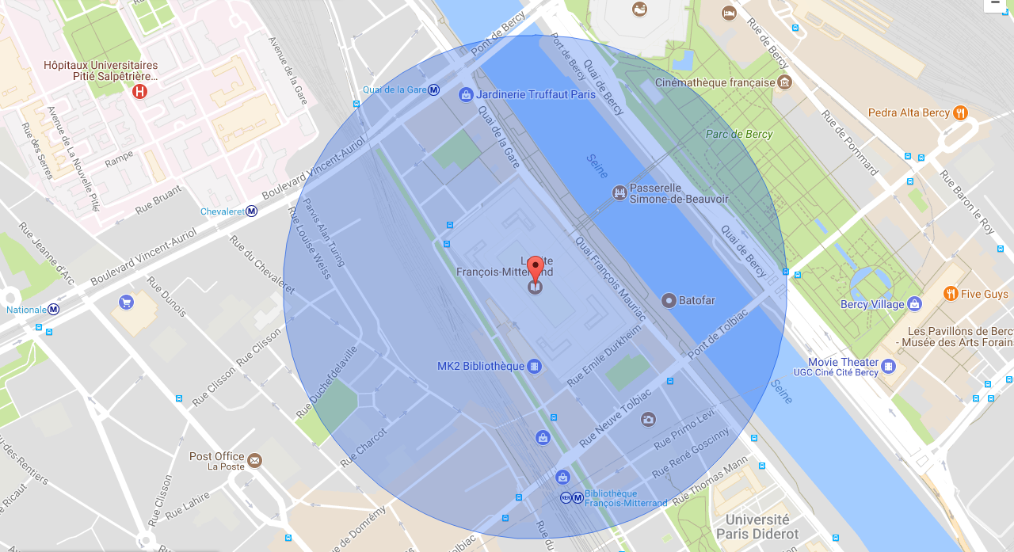
- CENL has provided a map of your headquarter location at the centre of a 500m radius – taken as a screenshot from Google maps. If this is not the correct location of your library building, please supply an alternative screen shot.
See: http://www.bnf.fr/fr/la_bnf/adresses_transports/s.adresses_transports_fm.html

- Please provide details of major governmental, cultural or significant institutions within this vicinity (within a 500m radius).
Paris-Diderot University, the Inalco, the École nationale supérieure d’architecture Paris-Val de Seine, the École des hautes études en sciences sociales
- Please describe all the transport options for reaching each of your library buildings open to researchers and the public.
See: http://www.bnf.fr/fr/la_bnf/adresses_transports/s.adresses_transports_fm.html

Chapter IV: Reading Rooms, collections and other interior library spaces
- What is the total number of seats in all your reading rooms across all sites?
3,228
- What is the total square meterage of all your reading rooms across all sites?
Answer
- Please list your reading rooms (type, large, by collection) and individual capacity
Reading Room Name | Collection type | Individual room seat capacity | Individual room square metres
FM Haut-de-jardin Room A | Audiovisual (open access collections) | 54 | unknown
FM Haut-de-jardin Room B | Press (open access collections) | 127 | unknown
FM Haut-de-jardin Room C | Science and technology (open access collections) | 227 | unknown
FM Haut-de-jardin Room D | Law, economics and politics (open access collections) | 236 | unknown
FM Haut-de-jardin Room E | General (open access collections) | 40 | unknown
FM Haut-de-jardin Room F | Art (open access collections) | 130 | unknown
FM Haut-de-jardin Room GH | Literature (open access collections) | 348 | unknown
FM Haut-de-jardin Room I | Children’s literature (open access collections) | 43 | unknown
FM Haut-de-jardin Room J | Philosophy, history and humanities (open access collections) | 274 | unknown
FM Haut-de-jardin open access | None | 185 | unknown
FM Rez-de-jardin | All | 1246 | unknown
Arsenal | Literature | 46 | unknown
Opera Library | Music | 18 | unknown
Louvois | Music | 70 | unknown
Richelieu | Manuscripts, performing arts, coins and medals, prints | 166 | unknown
Maison Jean Vilar | Performing arts | 40 | unknown
- Do users register to use your Reading Rooms? If so, how?
Access to the Reading Rooms requires a subscription card or a day ticket, according to 3 price categories: full, concession and exempt
- Do users pay to use your Reading Rooms? If so, how much?
3 price categories: full, concession and exempt; in the evening, the Reading Rooms in the Haut-de-jardin are free to access
- How are your collections accessed within the Reading Rooms? Is collection material open access or called to order? Please describe.
All rooms have open access collections. The "research" Reading Rooms (Rez-de-jardin, Richelieu, Music, BMO, Arsenal) provide access to documents kept in storage.
- What is the average number of visits per day to your Reading Rooms?
3,137
- What is the average number of visits per day to your library?
4,000

Chapter V: Staffing
- What is the number of staff employed by the library in total ?
2017: 2,182 full-year FTE
- What is the number of staff employed by the library in FTE ?
2017:
900 people employed in the Collections management department work in the Reading Rooms and in the communication of documents in storage; distribution of schedules over 80 Reading Room stations

The keynote presentation may be accessed via http://www.cenl.org/members/cenl-annual-general-meeting-2017-15-16-may-british-library-london/nggallery/page/1

