Survey of National Library Spaces and Services

Following on from CENL’s 2017 AGM and the keynote presentations, as well as the breakout session devoted to collection management, members concluded that a survey of library spaces, and the use of digital content within, would be beneficial to all. Data gathered by the CENL Secretariat will be used for analysis and to further discussion in the coming months with all CENL members. The full results of the survey are intended to be uploaded on CENL website / member area and presented at CENL’s 2019 AGM.

All over the world we have seen the creation of new libraries during recent years, including new national library buildings that have been inaugurated or redesigned in Europe. The role of libraries and national libraries is changing and is in permanent transition. This process of transformation caused by the digital revolution and by changes within the economic and political environment has impacted library spaces, staffing and library services. To understand and to meet future needs of national libraries this survey aims to collect and analyse fundamental changes within national library spaces which have occurred over the last ten years.

The survey is structured in five chapters

• Scope and core functions of National Libraries

• Physical Spaces

• Location and Urban Spaces

• Reading Rooms

• Staffing

 | Answer
Name of national library in full (in your own language and in anglicised form): | Kansalliskirjasto  The National Library of Finland
Name of Director General with official title: | Cecilia af Forselles, DPhil  +358504487459  cecilia.afforselles@helsinki.fi
Main library address: | PO Box 15 (Unioninkatu 36)  00014 Helsinki  Finland
Current logo as a .jpg:
Contact name, email and telephone for this survey: | liisa.savolainen@helsinki.fi  Tel. +358 2941 22745

Instructions
The CENL Secretariat has pre-completed as much information as possible within this survey. Please check the information already provided and augment or correct this as necessary. Where no information is yet provided, please supply answers in full. Do contact cenl@bl.uk with any difficulties.

Chapter I: Scope and core functions of your national library
- Please check all that apply.
National Library | University Library | Public Library | Research Library / Research Centre | National Archives | Legal deposit centre | Digital  Preservation centre | Museum | Other
If other please specify:
Definitions: Public Library: defined by national law (community library, not research library)
- Are you the only library with a national remit in your country? If no (eg. there is also a National Technical Library) please specify.
Answer
- What is the legal status of your library?
Answer
- Which ministry oversees your library?
Answer

Chapter II: Physical spaces
- Do you have multiple library sites? If so, please provide address details of all library buildings, including storage.
Answer
- Please provide a brief summary of all functions contained within the national library.
In 2017
Reading Rooms | Lounge | Exhibition space | Conference Centre | Conservation Studio | Gallery | Concert Hall | Café / Restaurant | Commercial space / shop | Other

If other please specify:

- Please provide the total square meterage for each of the following functions within your library:
M2 | M2 | M2 | M2 | M2 | M2 | M2 | M2 | M2 | M2
Reading Rooms | Lounge | Exhibition space | Conference Centre | Conservation Studio | Gallery | Concert Hall | Café / Restaurant | Commercial space / shop | Other
If other please specify:
- What is the total size of all library buildings in square metres (includes closed storage areas and staff areas)?
2017:
- What is the size of library buildings open to the public in square metres? (total size minus closed storage areas and staff areas)?
Answer:
- Please provide .jpg images of your main public building(s) exterior

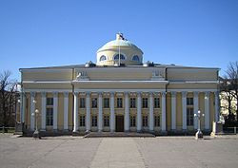

Exterior –
https://en.wikipedia.org/wiki/National_Library_of_Finland

- If available, please provide .jpg images of all library sites described in question 5.
Answer
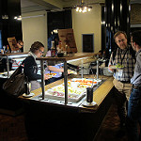
- If available, please provide .jpg images of all library spaces described in question 6.

Restaurant-
https://www.flickr.com/photos/natlibfi/page1
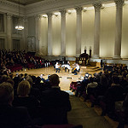

Concert Hall -
https://www.flickr.com/photos/natlibfi/page1

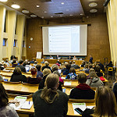

Lecture Hall 1 -
https://www.flickr.com/photos/natlibfi/page1
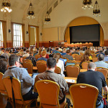

Lecture Hall 2 -
https://www.flickr.com/photos/natlibfi/page1

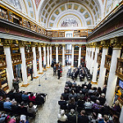
Event Hall -
https://www.flickr.com/photos/natlibfi/page1

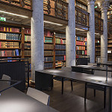

Reading Room 1 -
https://www.flickr.com/photos/natlibfi/page1
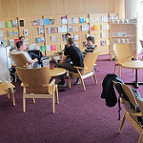

Reading Room 2 -
https://www.flickr.com/photos/natlibfi/page1

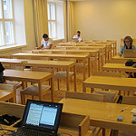
Reading Room 3 -
https://www.flickr.com/photos/natlibfi/page1

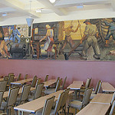
Reading Room 4 -
https://www.flickr.com/photos/natlibfi/page1

- Please provide simplified plans of your buildings, if possible in .jpg format (perhaps those used to guide visitors around your building).
Answer
- Please provide brief details on the history of your library buildings.

 | Answer
Year (first) library building opened
Architect of (first) library building
Year (current) library building opened | 1836
Architect of (current) library building | C.L. Engel
Any additional information. Eg length of build/cost of build/reason for build | The library is divided into two principal buildings. The Library's main building was designed by architect C.L. Engel 1836 and was built in 1840-45. The annex is called the Rotunda and was built in 1902-06 by architect Gustaf Nyström.

- If available, please provide a short text on the milestones of the history of your library and/or provide a link to this information online. Please include any bibliographic information about publications about your library and links to these publications in your library catalogue or an aggregated catalogue.
Answer

Chapter III: Location and Urban Spaces
- Please describe the location of your national library buildings (eg. main building in capital city with close proximity to universities, storage buildings in rural area, located two hours by train from building in capital).
Answer
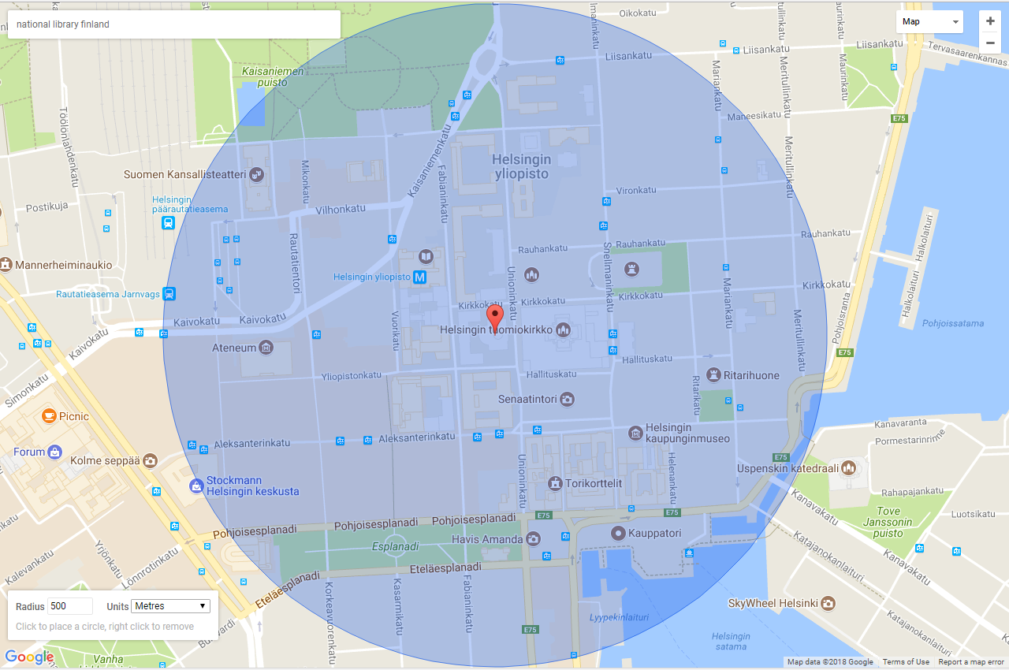
- CENL has provided a map of your headquarter location at the centre of a 500m radius – taken as a screenshot from Google maps. If this is not the correct location of your library building, please supply an alternative screen shot.
- Please provide details of major governmental, cultural or significant institutions within this vicinity (within a 500m radius).
Answer
- Please describe all the transport options for reaching each of your library buildings open to researchers and the public.
Answer

Chapter IV: Reading Rooms, collections and other interior library spaces
- What is the total number of seats in all your reading rooms across all sites?
Answer
- What is the total square meterage of all your reading rooms across all sites?
Answer
- Please list your reading rooms (type, large, by collection) and individual capacity
Reading Room Name | Collection type | Individual room seat capacity | Individual room square metres
- Do users register to use your Reading Rooms? If so, how?
Answer
- Do users pay to use your Reading Rooms? If so, how much?
Answer
- What is the average number of visits per day to your Reading Rooms?
Answer
- What is the average number of visits per day to your library?
Answer

Chapter V: Staffing
- What is the number of staff employed by the library in total ?
2017:
- What is the number of staff employed by the library in FTE?
2017:

The keynote presentation may be accessed via http://www.cenl.org/members/cenl-annual-general-meeting-2017-15-16-may-british-library-london/nggallery/page/1

