Survey of National Library Spaces and Services

Following on from CENL’s 2017 AGM and the keynote presentations, as well as the breakout session devoted to collection management, members concluded that a survey of library spaces, and the use of digital content within, would be beneficial to all. Data gathered by the CENL Secretariat will be used for analysis and to further discussion in the coming months with all CENL members. The full results of the survey are intended to be presented at CENL’s 2018 AGM.

All over the world we have seen the creation of new libraries during recent years, including new national library buildings that have been inaugurated or redesigned in Europe. The role of libraries and national libraries is changing and is in permanent transition. This process of transformation caused by the digital revolution and by changes within the economic and political environment has impacted library spaces, staffing and library services. To understand and to meet future needs of national libraries this survey aims to collect and analyse fundamental changes within national library spaces which have occurred over the last ten years.

The survey is structured in six chapters determined by the themes that were discussed during the 2017 AGM breakout session:

• The role of national libraries in collection management is changing – this affects library spaces

• National libraries are transforming from solely heritage institutions to also being leaders in digitisation

• Previously the role of digitisation was for preservation, but now there are new uses for our collections which include the combination of digital and heritage – how is this explored within national libraries?

• Staff development is key to the transformation of libraries – staff need to be integrated in the end to end process of digitisation and using that digital content, perhaps in physical and virtual exhibitions

• Skills and standards for digital content are needed for clarity of activity for researchers

 | Answer
Name of national library in full (in your own language and in anglicised form): | Eesti Rahvusraamatukogu  National Library of Estonia
Name of Director General with official title: | Janne Andresoo, Director General
Main library address: | Tõnismägi 2  15189 Tallinn  Estonia
Current logo as a .jpg:
Contact name, email and telephone for this survey: | Mari Kannusaar  mari.kannusaar@nlib.ee  +372 630 7503

Instructions
The CENL Secretariat has pre-completed as much information as possible within this survey. Please check the information already provided and augment or correct this as necessary. Where no information is yet provided, please supply answers in full. Do contact cenl@bl.uk with any difficulties.

Chapter I: Scope and core functions of your national library
- Please check all that apply.
x |  |  | x |  | x | x |  | x
National Library | University Library | Public Library | Research Library / Research Centre | National Archives | Legal deposit centre | Digital  Preservation centre | Museum | Other
If other please specify: parliamentary library; we are officially not a public library but we serve the wide public.
- Are you the only library with a national remit in your country? If no (eg. there is also a National Technical Library) please specify.
We are the only national library in Estonia.
- What is the legal status of your library?
A legal person in public law operating on the basis of the National Library of Estonia Act, other legislation and the library’s articles of association.
- Which ministry oversees your library?
Officially the National Library of Estonia is not subordinated to any ministry (our supervisory body is the National Library Board), but we closely cooperate with the Ministy of Culture and the Ministry of Economic Affairs and Communications (with the latter in IT-projects).

Chapter II: Physical spaces
- Do you have multiple library sites? If so, please provide address details of all library buildings, including storage.
No
- Please provide a brief summary of all functions contained within the national library.
In 2017
x | x | x | x | x |  |  | x | x | x
Reading Rooms | Lounge | Exhibition space | Conference Centre | Conservation Studio | Gallery | Concert Hall | Café / Restaurant | Commercial space / shop | Other

If other please specify: meeting rooms, private study carrels, a children’s area and a piano room in the reading area, theatre hall accessible from the foyer.
- Please provide the total square meterage for each of the following functions within your library:
M2 | M2 | M2 | M2 | M2 | M2 | M2 | M2 | M2 | M2
Reading Rooms  4808 | Lounge  993 (incl cloakroom) | Exhibition space  788 | Conference Centre  716 | Conservation Studio  791,5 | Gallery | Concert Hall | Café / Restaurant  518 (without the caterer’s office and kitchen facilities) | Commercial space / shop  53 (bookstore) | Other  theatre hall 280
If other please specify: Theatre hall 280m2
- What is the total size of all library buildings in square metres (includes storage areas)?

2017: | 43 451 m2
- What is the size of library buildings open to the public in square metres?
2017: 10 378,88 m2

- Please provide .jpg images of your main public building(s) exterior
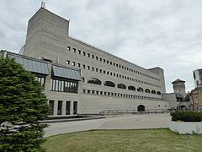
Exterior -
https://en.wikipedia.org/wiki/National_Library_of_Estonia

- If available, please provide .jpg images of all library sites described in question 5.
Answer
- If available, please provide .jpg images of all library spaces described in question 6.
Coming later

- Please provide simplified plans of your buildings, if possible in .jpg format (perhaps those used to guide visitors around your building).
Please find attached.
- Please provide brief details on the history of your library buildings.

 | Answer
Year (first) library building opened | The library’s first rooms were in the Toompea Castle which was built in1773. The castle was one part of the complex that has served as the the site of the Riigikogu (Parliament) during our first and second independence period.
Architect of (first) library building | Johann Schultz
Year (current) library building opened | 1993
Architect of (current) library building | Raine Karp
Any additional information. Eg length of build/cost of build/reason for build | The present building was constructed during 1985-1993

- If available, please provide a short text on the milestones of the history of your library and/or provide a link to this information online. Please include any bibliographic information about publications about your library and links to these publications in your library catalogue or an aggregated catalogue.
21 December 1918 – the Provisional Government of the Republic of Estonia passed the resolution to establish the State Library (presently the National Library of Estonia).

1919 - the library began to receive a legal deposit copy of all printed matter published in Estonia.

1935 – the library was assigned the task to acquire and preserve all Estonian publications. The Mandatory Deposit Collection was established.

1938 – the Government of the Republic of Estonia passed the State Library Act

1944 – According to the Resolution of the People’s Commissars Council of the Estonian Soviet Socialist Republic (ESSR), the library was renamed the Republican Library of the ESSR. According to the new Statutes of the library it was an open access central library and a research institution on librarianship and bibliography.

1947 – the library started to move to its second location, the building of the former Knight’s Guild and several surrounding buildings, close to its previous site in the Toompea Castle.

1985 – construction works of the new library building began at its present location Tõnismägi 2

1988 – the library was named the National Library of Estonia

1989 – the library re-acquired the status of a parliamentary library

1991 – the library stopped providing services in its previous location and started to move the holdings to the new building

1993 – the new building at Tõnismägi 2 opened for the public. The same year the library started generating and using electronic databases.

1997 – the library opened its Public Internet Access Point, the first of its kind in Estonia.

1997 – the Estonian Libraries Network Consortium and Innovative Interfaces, Inc. signed a contract to implement the INNOPAC integrated library system in Estonia. In 1999, gradual transfer to the electronic environment began.
The national library was a founding member of the consortium which today uses the latest version of this system and manages the shared online catalogue of major research libraries and 2 largest public libraries of Estonia

2012 – the air-conditioning and climate system in stackrooms and reading rooms was renovated, the 696 windows and 45 exterior doors of the building were replaced.

http://www.nlib.ee/en/history/

Publications:

National Library of Estonia 100 / koostaja Piret Lotman
Tallinn : Eesti Rahvusraamatukogu, 2017
lk. ; cm
ISBN/ISSN: 9789949413584

National Library of Estonia Act
[Tallinn] : [Eesti Rahvusraamatukogu], 1998 ([Tallinn] : Riigi Teataja Kirjastuse trükikoda)
8 lk. ; 22 cm

National Library of Estonia = Eesti Rahvusraamatukogu / compiled by Triin Soone ; translated by Ursula Roosmaa ; photos by Teet Malsroos
Tallinn, 1996
[12] lk. : ill

National Library of Estonia : [guide = Eesti Rahvusraamatukogu / compiled by Triin Soone ; translated by Ursula Roosmaa ; foreword: Ivi Eenmaa]
[Tallinn] : National Library of Estonia, 1996 (Tallinn : Tallinna Raamatutrükikoda)
[15] lk. koos kaanega : ill., portr. ; 30 cm.
ISBN/ISSN: 9789949798636 (pdf)

Arhiivkogu Rahvusraamatukogus : Eesti kultuuripärandi hoidja = Archival collection in the National Library of Estonia : cherishing Estonian cultural heritage / [koostanud Helle Remmelt, Kaire Lass ; toimetanud Anne Ainz ; keeleliselt toimetanud Inna
Tallinn : Eesti Rahvusraamatukogu, 2013 ([Tallinn] : Pakett)
128 lk. : ill., kaart., portr., noot. ; 22 cm
ISBN/ISSN: 9789949413430

Eesti Rahvusraamatukogu 80 : artiklite kogumik = National Library of Estonia 80 : collection of articles / koostanud Anu Nuut ; [toimetaja Aili Norberg ; resümeed tõlkinud Kirsti Ora ja Tiina Vilberg]
Tallinn : Eesti Rahvusraamatukogu, 1998 ([Tallinn : Reva Print])
133 lk. : ill., portr. ; 23 cm
ISBN/ISSN: 998592178X 9985600010 (vale)

Rahvus ja raamatukogu : Eesti Rahvusraamatukogu 80. aastapäeva teaduskonverents, 18. detsember 1998, [Tallinn] : ettekannete teesid = A nation and a national library : the scientific conference dedicated to the 80th anniversary of the National Libra
Tallinn : Eesti Rahvusraamatukogu, 1998 ([Tallinn : Riigi Teataja Kirjastuse trükikoda])
72 lk. ; 30 cm
ISBN/ISSN: 9985926501 9985600037 (vale)

National Library, Tallinn, Estonia : rehabilitation of facades and roofs : final report, January 1995 / COWIconsult
[Lyngby], 1995
6 lk.

Bibliothèque nationale d'Estonie
Paris : Electre-Editions du Cercle de la Libraire, 1996
399, 15 lk. : ill. ; 31 cm
ISBN/ISSN: 2765406197

Elu paralleelmaailmades : meenutusi Eesti Rahvusraamatukogu saamisloost 1982-1997 / Ivi Eenmaa ; [toimetanud Sirje Nilbe ; kujundanud ja fotod töödelnud Eve Pärnaste ; fotograafid Teet Malsroos, K. Liiv, Verner Puhm ... jt.]
Tallinn : Eesti Rahvusraamatukogu, 2013 ([Viljandi] : Print Best)
271 lk. : ill., portr. ; 25 cm
ISBN/ISSN: 9789949413454 (köites)

New building of the National Library of Estonia
Graz : Akad. Druck u. Verl.-Anst., [1997]
302 lk. : ill. ; 24 cm
ISBN/ISSN: 3201016764
1 |  | Parlamendiraamatukogust rahvusraamatukoguks. 1. osa, Eesti Vabariigi Riigiraamatukogu 1918-1940 / Piret Lotman ; [eessõna: R. Ruutsoo] ; Eesti Rahvusraamatukogu : Lotman, Piret, | 1988 | 1
2 |  | Parlamendiraamatukogust Rahvusraamatukoguks : Eesti Vabariigi Riigiraamatukogu areng aastail 1918-1940 ja Eesti NSV Riikliku Raamatukogu stalinismi periood : magistritöö autoreferaat = From the State Library to the National Library : development of / Piret Lotman ; Tallinna Pedagoogikaülikool, infoteaduste osakond : Lotman, Piret, | 1997 | 1
3 |  | Parlamendiraamatukogust rahvusraamatukoguks. II, ENSV Riiklik Avalik Raamatukogu 1940-1953 / Piret Lotman ; Eesti Rahvusraamatukogu : Lotman, Piret, | 1993 | 1
4 |  | Parlamendiraamatukogust rahvusraamatukoguks. III, F. R. Kreutzwaldi nimeline Eesti NSV Riiklik Raamatukogu 1954-1988 / Piret Lotman ; Eesti Rahvusraamatukogu : Lotman, Piret, | 2000 | 1

Chapter III: Location and Urban Spaces
- Please describe the location of your national library buildings (eg. main building in capital city with close proximity to universities, storage buildings in rural area, located two hours by train from building in capital).
The library building is conveniently in the city centre, on the verge of the old town area. Distance to the campus of the Tallinn University is ca 4 km from the library (4 stops by tram), the Tallinn Technical University campus is ca 7 km from the centre (ca 30 minutes by bus). The new site of the Estonian Academy of Arts (to be opened in autumn 2018) is ca 3 km from the library, accessible by tram and bus. The Estonian Music Academy is within walking distance (ca 15 min).
- 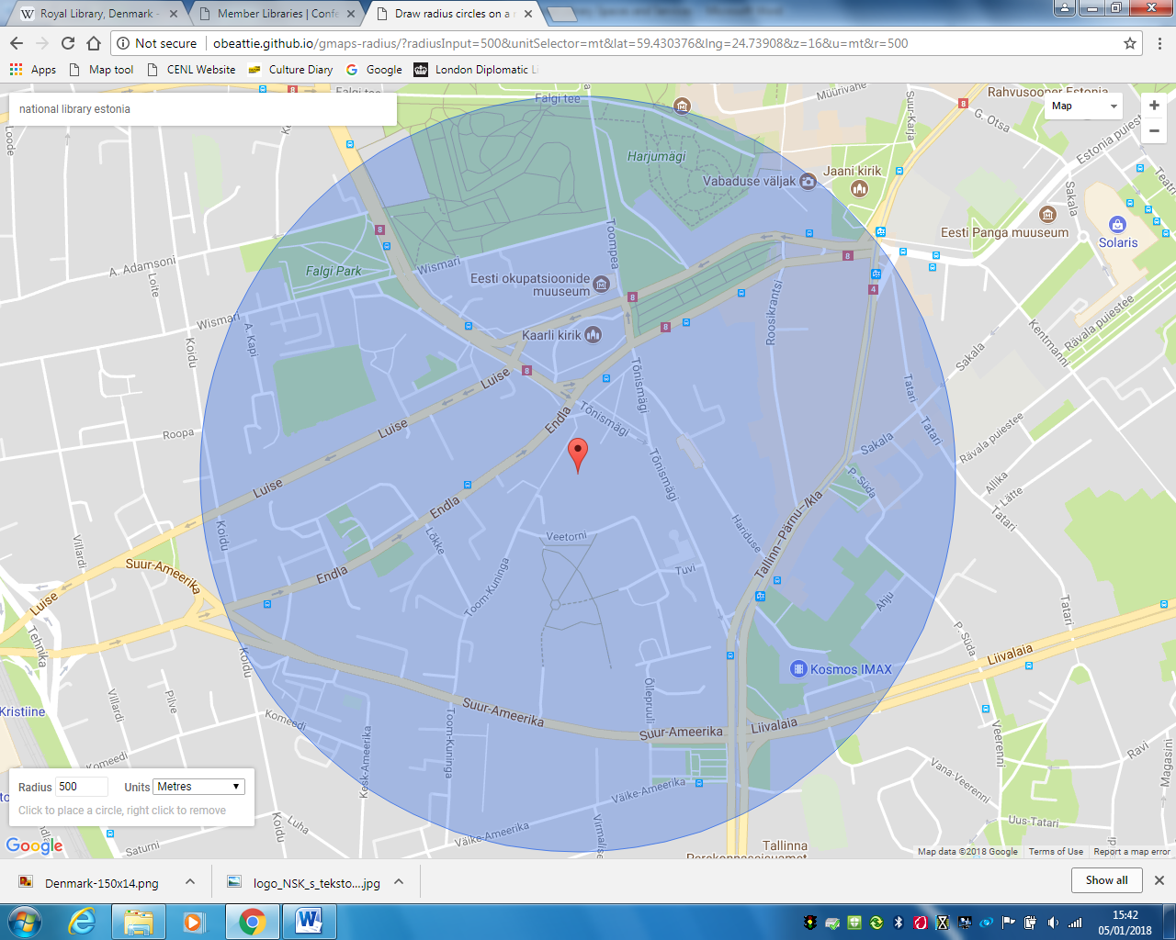CENL has provided a map of your headquarter location at the centre of a 500m radius – taken as a screenshot from Google maps. If this is not the correct location of your library building, please supply an alternative screen shot.

- Please provide details of major governmental, cultural or significant institutions within this vicinity (within a 500m radius).
500m from the library - a building complex that accommodates the Ministry of Finance, the Ministry of Economic Affairs and Communications, the Ministry of Social Affairs, the Ministry of Justice and the Ministry of Education and Research. Ca 300 m – Tallinn City Government building and the central Liberty Square. Ca 500 m – Tallinn Central Library. Ca 600 m – Toompea Castle, seat of the Riigikogu (Parliament).
- Please describe all the transport options for reaching each of your library buildings open to researchers and the public.
By tram No 3 and 4 (ca 5-minute walk from the stop “Kosmos” to the library), buses No 16, 17, 22, 23, 24, 24A, 40, 42 (ca 3-5 min from the stop “Tõnismägi”); trolleybus No 1 and 3 (ca 3-5 min from the stop “Tõnismägi”); buses No 5, 14, 18, 20, 20A, 36 (ca 5-minute walk from the stop “Kosmos”).

Chapter IV: Reading Rooms, collections and other interior library spaces
- What is the total number of seats in all your reading rooms across all sites?
409
- What is the total square meterage of all your reading rooms across all sites?
4794,5m2
- Please list your reading rooms (type, large, by collection) and individual capacity
Reading Room Name | Collection type | Individual room seat capacity | Individual room square metres
Music Reading Room | Music books, magazines sound recordings, printed music, video collection, databases | 48 | 266,5m2
Arts Reading Room | Books, magazines, exilibrises, original and printed graphics, databases | 33 | 271m2
Cartography and Geography Reading Room | Magazines, atlases, maps, plans, databases | 8 | 24,5m2
Theatre and Film Reference Room | Books, magazines, DVDs | 2 | 21,5m2
Humanities Reading Room | Books, periodicals, databases | 114 | 2110m2
Reference Reading Room | Books, periodicals, databases | 63 | 824m2
European Union Information Centre Reading Room | Books, periodicals, databases on EU politics and law | 14 | 104m2
Law and International Organisations Reading Room | Books, periodicals, databases | 48 | 458m2
Social Sciences Reading Room and open repository | Books, serials, journals | 62 in reading room, 2 in open repository | Reading room 418m2, open repository 233m2
Rare Books and Archives Reading Room | Rare books and archival collections | 15 | 64m2
- Do users register to use your Reading Rooms? If so, how?
Visitors do not have to register to use reading rooms and open shelves collections; however, only registered users can order items from the stacks.
- Do users pay to use your Reading Rooms? If so, how much?
Use of the library is free.
- How are your collections accessed within the Reading Rooms? Is collection material open access or called to order? Please describe.
Each reading room has open access collection of items used more frequently. Items stored in the stacks have to be ordered, the waiting time is ca 15 minutes. Archival collection and rare book collection are preservation collections and the items may be used only if the requested items are not found in other collections of the Library, including the digital collection.

- What is the average number of visits per day to your Reading Rooms?
We do not collect official statistics on visits to reading rooms, we only register the number of visits to the entire reading area – provided under cl 27.
There are a number of reading rooms whose architectural solution and/or number of visitors allows the librarian on duty to keep unofficial record of the visits. These numbers are below but we do not include them in our official annual statistics.
Law and International Organisations Reading Room: 119 visits
Social Sciences Reading Room: 82 visits
Rare Books and Archives Reading Room: 2,5 visits
- What is the average number of visits per day to your library?
Ca 425 per day

Chapter V: Staffing
- What is the number of staff employed by the library in total ?
2017: 282
- What is the number of staff employed by the library in FTE ?
2017: 86

The keynote presentation may be accessed via http://www.cenl.org/members/cenl-annual-general-meeting-2017-15-16-may-british-library-london/nggallery/page/1

