Survey of National Library Spaces and Services

Following on from CENL’s 2017 AGM and the keynote presentations, as well as the breakout session devoted to collection management, members concluded that a survey of library spaces, and the use of digital content within, would be beneficial to all. Data gathered by the CENL Secretariat will be used for analysis and to further discussion in the coming months with all CENL members. The full results of the survey are intended to be uploaded on CENL website / member area and presented at CENL’s 2019 AGM.

All over the world we have seen the creation of new libraries during recent years, including new national library buildings that have been inaugurated or redesigned in Europe. The role of libraries and national libraries is changing and is in permanent transition. This process of transformation caused by the digital revolution and by changes within the economic and political environment has impacted library spaces, staffing and library services. To understand and to meet future needs of national libraries this survey aims to collect and analyse fundamental changes within national library spaces which have occurred over the last ten years.

The survey is structured in five chapters

• Scope and core functions of National Libraries

• Physical Spaces

• Location and Urban Spaces

• Reading Rooms

• Staffing

 | Answer
Name of national library in full (in your own language and in anglicised form): | Národní knihovna České republiky  National Library of the Czech Republic
Name of Director General with official title: | PhDr. Martin Kocanda
Main library address: | Klementinum 190  110 00  Prague
Current logo as a .jpg:
Contact name, email and telephone for this survey: | Mr. Martin Kocanda  martin.kocanda@nkp.cz  +420 221 663 260

Instructions
The CENL Secretariat has pre-completed as much information as possible within this survey. Please check the information already provided and augment or correct this as necessary. Where no information is yet provided, please supply answers in full. Do contact cenl@bl.uk with any difficulties.

Chapter I: Scope and core functions of your national library
- Please check all that apply.
National Library | University Library | Public Library | Research Library / Research Centre | National Archives | Legal deposit centre | Digital  Preservation centre | Museum | Other
If other please specify:
Definitions: Public Library: defined by law (community library, not research library)
- Are you the only library with a national remit in your country? If no (eg. there is also a National Technical Library) please specify.
No.
Other: National Technical Library, National Library of Medicine, National Pedagogical Museum and Library, Antonín Švehla Agricultural Library
- What is the legal status of your library?
Act No 257/2001, about libraries and conditions for providing public librarian and informational services.
The National Library has a universal book collection, specialised collections, and it is responsible for long-term preservation of national document production and its historical collections. It harvests also the Czech web (since 2001) and ensures its long-term storage. It provides the equal access to all public and informational services and other offered services. The National Library is the centre of the national public library system; it administrates and coordinates specialised, informational, educational, analytical, research, methodical, and advisory activities. It is also a research organization: the main areas of research are: history of book culture, musicology, Slavonic studies, digital codicology and bibliology, web archiving for scientific research, archival storage of digital data, and conservation and preservation of library collections.
The National Library is co-financed from the state budget (ca. 90 of income from the state budget)

- Which ministry oversees your library?
Ministry of Culture

Chapter II: Physical spaces
- Do you have multiple library sites? If so, please provide address details of all library buildings, including storage.
- Klementinum 190, 110 00 Prague – Headquarters, specialized departments, historical library, main study hall
- Central Depository Hostivař, Sodomkova 2/1146, 102 00 Prague 15 (2 interconnected buildings)
- Small depository in Neratovice town, 30 km north of Prague
- Please provide a brief summary of all functions contained within the national library.
In 2017
Reading Rooms | Lounge | Exhibition space | Conference Centre | Conservation Studio | Gallery | Concert Hall | Café / Restaurant | Commercial space / shop | Other

If other please specify: educational rooms

- Please provide the total square meterage for each of the following functions within your library:
2450 m² | m² | 510 m² | m² | m² | 160 m² | 290 m² | 210 m² | 120 m² | 56 760 m²
Reading Rooms | Lounge | Exhibition space | Conference Centre | Conservation Studio | Gallery | Concert Hall | Café / Restaurant | Commercial space / shop | Other

- What is the total size of all library buildings in square metres (includes closed storage areas and staff areas)?
2017: 60 500 m²
Main historical building: 32 400 m²
Central Depository 1: 18 200 m²
Central Depository 2: 9 900 m²

2007: 50 600 m²
Main historical building: 32 400 m²
Central Depository 1: 18 200 m²
- What is the size of library buildings open to the public in square metres? (total size minus closed storage areas and staff areas) ?
2017: 15 200 m²
Main historical building: 14 900 m²
Central Depository 2: 300 m²

2007: 10 030 m²
Main historical building: 9 900 m²
Central Depository 1: 130 m²

- Please provide .jpg images of your main public building(s) exterior

Klementinum, main building and HQ

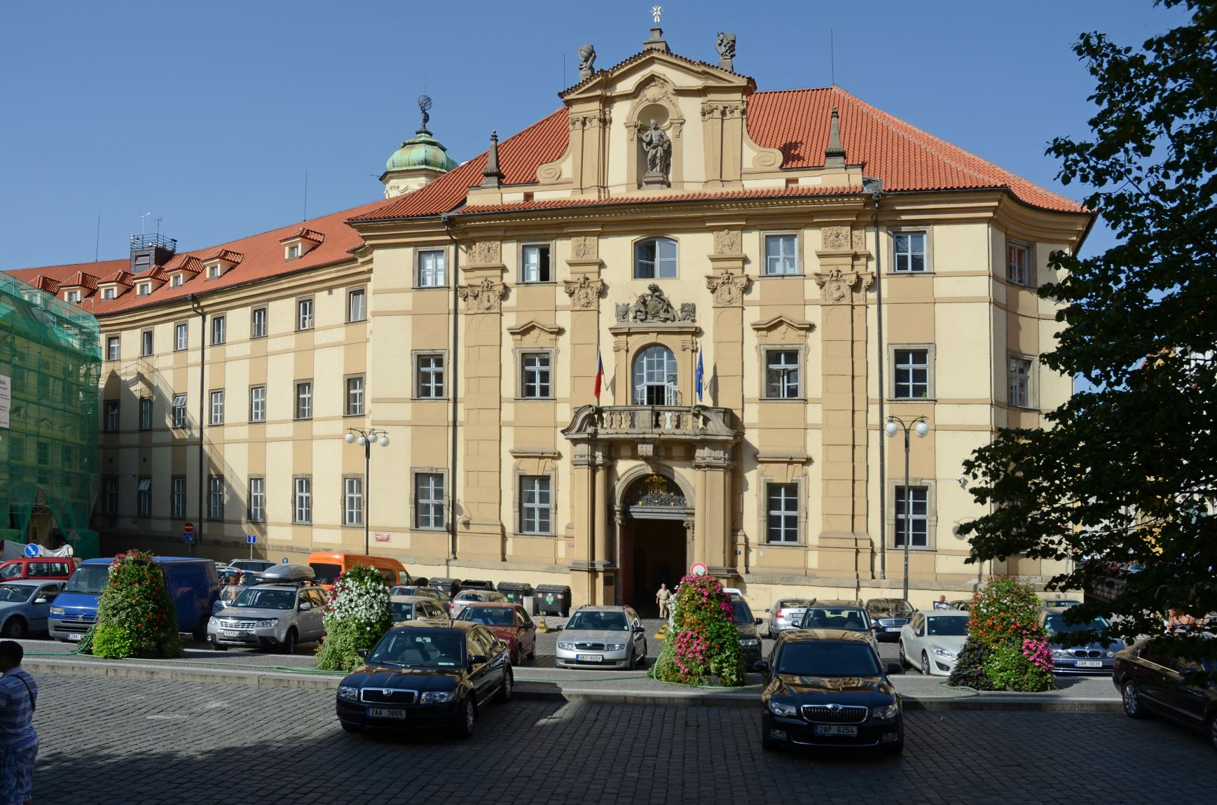

- If available, please provide .jpg images of all library sites described in question 5.

Central Depository Hostivař

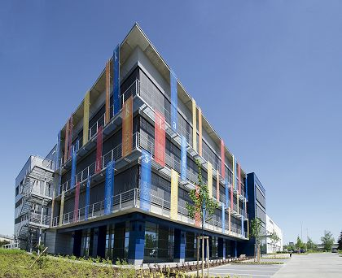

- If available, please provide .jpg images of all library spaces described in question 6.
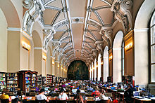
Main Reading Room

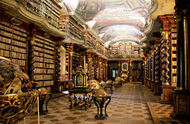
Baroque Library

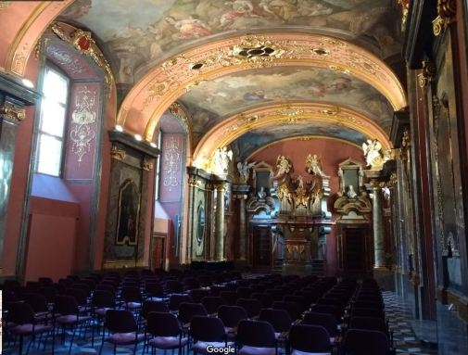
Mirror Chapel

- Please provide simplified plans of your buildings, if possible in .jpg format (perhaps those used to guide visitors around your building).
Klementinum
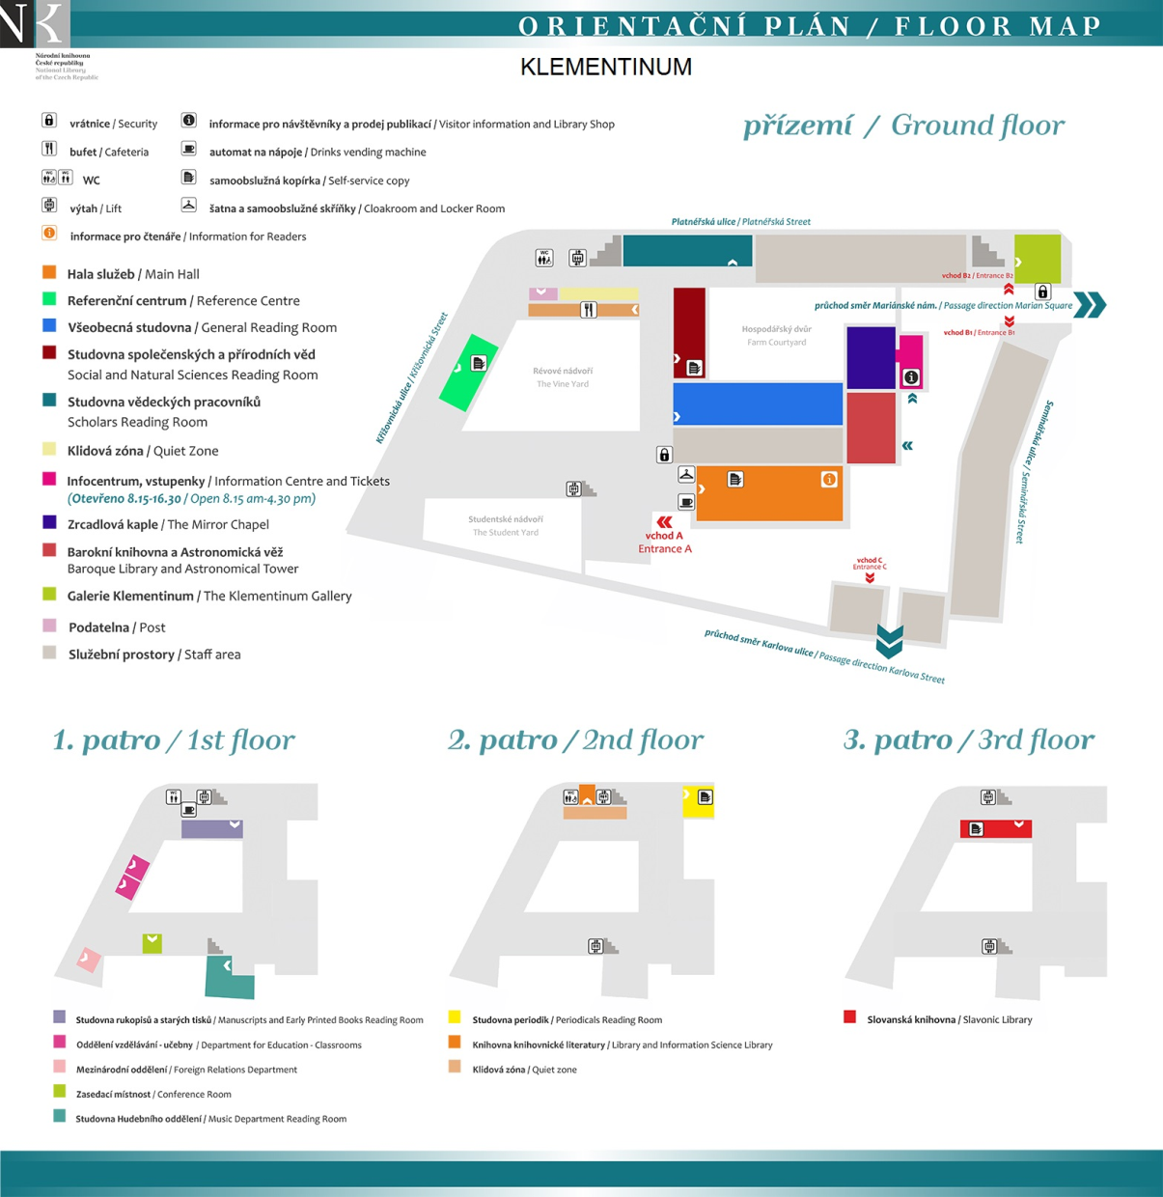

Central Depository Hostivař
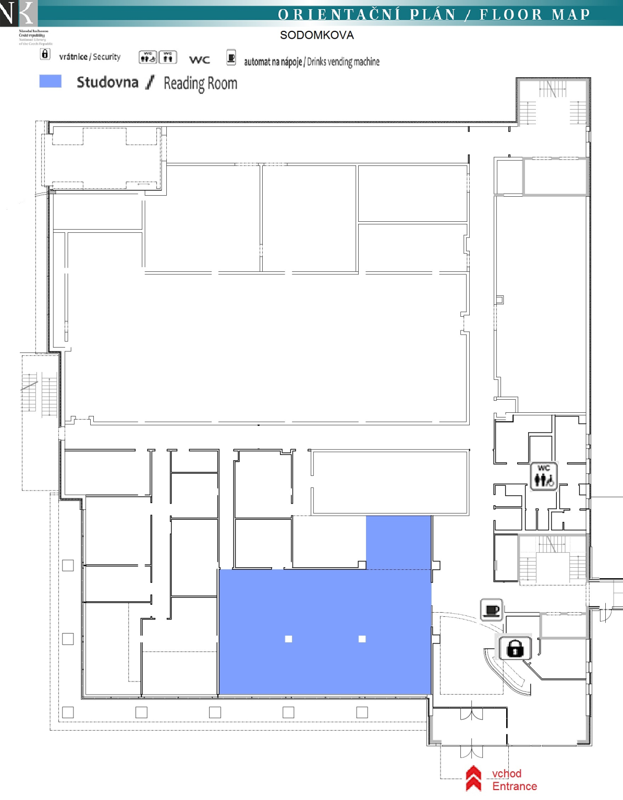

- Please provide brief details on the history of your library buildings.

 | Answer
Year (first) library building opened | 1556
Architect of (first) library building | Most important baroque architects: Carlo Lurago, František Maxmilián Kaňka, Kilián Ignác Dientzenhofer.
Year (current) library building opened | As above, but in 1777 opened for public after merge with several other Prague college libraries.
Architect of (current) library building | As above
Any additional information. Eg length of build/cost of build/reason for build | The main building is a former Jesuit college and monastery. The area is on UNESCO list. Total size of the area is 2 hectares, which is second biggest historical conservation area in Prague.

- If available, please provide a short text on the milestones of the history of your library and/or provide a link to this information online. Please include any bibliographic information about publications about your library and links to these publications in your library catalogue or an aggregated catalogue.
http://www.en.nkp.cz/about-us/about-nl

11thcentury first records attesting the existence of St. Clement's Chapel (Sv. Kliment)
13th - 14thcentury there is a Studium generale - a latin school at a Dominican monastery - it eventually merges with the Prague university
1366 Charles IV donates a set of codices to the university
1556 the Jesuits build a college upon the ruins of the Dominican monastery - and its name is Klementinum
1622 from now the Charles University is administered by Jesuits who transfer the Charles University libraries to Klementinum
17th - 18thcentury an important Jesuit press, an astronomical observatory, and the university, then called Charles-Ferdinand's University (Karlo-Ferdinandova Universita) all are housed in Klementinum
1773 - 1777 Jesuits leave Klementinum, the university and library stay and, thanks to the efforts of Francis the Count Kinsky, they receive from the empress Mary Theresa the title of Imperial-Royal Public and University Library (Cisarsko-kralovska verejna a univerzitni biblioteka)
1781 since now the Prague printers hand in a legal deposit copy to the library
1807 the duty of legal deposit copy is extended to cover all Czech printers
1837 the Mozart Memorial (now a part of Music Department) is founded - it contains both manuscript and printed documents
1848 Klementinum is converted into students' fortress against the armies of general Windischgrätz
1918 the Public and University Library is taken over by the newly founded Czechoslovakia
1919 the Czechoslovak Institute Bibliography is incorporated into the library (Ceskoslovensky ustav bibliograficky)
1924 Slavonic Library is founded
1929 Slavonic Library is transferred to Klementinum
1935 the library is renamed to National and University Library, a law is passed stipulating the legal deposit copy duty
1939 after the closure of Czech universities and colleges, it continues under the name of Municipal and University Library (Zemská a univerzitní knihovna)
1958 all large Prague libraries are merged into a single centralized one with the name of State Library of the Czech Republic (Státní knihovna CSR)
1990 the library is renamed and its new name - the National Library (Národní knihovna) - does justice to the library's tradition and objectives
1992 first digitization projects
1996 Central Depository is inaugurated in Hostivař
Routine digitization of manuscripts and old printed books started
1999 Routine digitization of periodicals and modern books started
2003 Opening of two digital libraries: Manuscriptorium and Kramerius
2005 The UNESCO Memory of the World Jikji Prize Awarded for contribution to safeguarding of and access to documentary heritage
Since 2010 ongoing reconstruction and revitalization of the downtown main Klementinum building (still not completed)
2012 opened the second building in the remote Hostivař area

Chapter III: Location and Urban Spaces
- Please describe the location of your national library buildings (eg. main building in capital city with close proximity to universities, storage buildings in rural area, located two hours by train from building in capital).
Headquarters (Klementinum) – historical downtown, urban conservation area, building is on UNESCO list, Old Town district.
Central depository Hostivař – suburb, industrial area, complicated public transport access.
- CENL has provided a map of your headquarter location at the centre of a 500m radius – taken as a screenshot from Google maps. If this is not the correct location of your library building, please supply an alternative screen shot.
Map is correct.
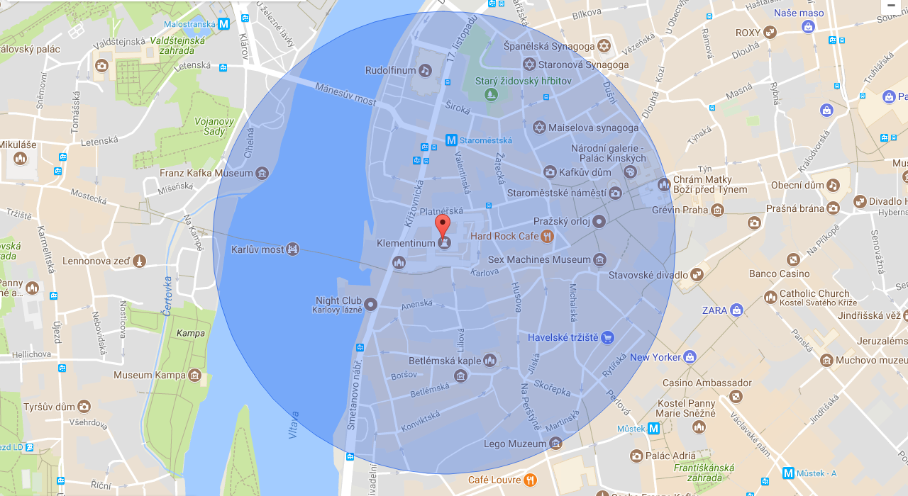

- Please provide details of major governmental, cultural or significant institutions within this vicinity (within a 500m radius).
Parliament and Government buildings are within 700 m; in close proximity: Charles University main building and several faculty buildings (e.g. Philosophical Faculty, Faculty of Legal Studies, Faculty of Social Studies…); Faculty of Nuclear Physics and Physical Engineering (part of the Czech University of Technology), Academy of Performing Arts in Prague (Theatre Faculty is across the street, while the other two faculties are within 700 m – Film and TV Faculty and Faculty, Music and Dance Faculty), Academy of Arts, Architecture and Design in Prague, Czech Philharmonic Orchestra (Rudolfinum Building), Náprstek Museum of Oriental Cultures (part of the National Museum), Museum of Applied Arts, The Prague Conservatoire of Music, Kinsky Palace (one of the buildings of the National Gallery), Jewish Museum, Old Town Square and related historical monuments, important Catholic and Protestant churches, synagogues, Prague Municipal Library, Franz Kafka birthplace house, and a lot of other monuments
- Please describe all the transport options for reaching each of your library buildings open to researchers and the public.
Klementinum – Metro station Staroměstská, tram stop, bus stop
Central Depository in Hostivař – Bus stop only

Chapter IV: Reading Rooms, collections and other interior library spaces
- What is the total number of seats in all your reading rooms across all sites?
499
- What is the total square meterage of all your reading rooms across all sites?
Ca. 2200
- Please list your reading rooms (type, large, by collection) and individual capacity
Reading Room Name | Collection type | Individual room seat capacity | Individual room square metres
General reading room | general | 207 | 570
Social and Natural Sciences Reading Room | humanities, social and natural sciences | 49 | 230
Scholars´ Reading Room | literary history and theory, linguistics and the arts, general encyclopaedias and language and subject dictionaries | 39 | 179
Reference centre&  Interlibrary loans reading room | reference collection - encyclopaedias, bibliographies, language and subject dictionaries, biographies, atlases and other reference publications, licenced databases accessible on-line and CD-ROMs, online research journals, Czech bibliography of articles | 29 | 125
Periodicals Reading Room | Czech and foreign periodicals in the field of natural and social sciences, arts and culture, foreign newspaper, basic reference collection,  full text online research journals | 48 | 204
Main Hall | x | 58 | 556
Hostivař Central Depository Reading Room&Archive | basic reference literature (language dictionaries, collection of general encyclopaedias) | 27 | 234
LIS Library | Czech and foreign periodicals and books (both electronic and traditional), licensed databases and electronic sources created in the library | 15 | 50
Slavonic Library, circulation desk and reading room | collection specialized in Slavic Studies | 20 | 115

- Do users register to use your Reading Rooms? If so, how?
One day ticket is needed for studying materials on open stacks. Users register for studying materials stored in depositories and using other services. For more information see survey of services http://www.en.nkp.cz/services/links/survey-of-services
- Do users pay to use your Reading Rooms? If so, how much?
Registration fee is 100 CZK (4 EUR) per year
- How are your collections accessed within the Reading Rooms? Is collection material open access or called to order? Please describe.
Generally, collections in the reading rooms are accessible within open access. Specific materials are available on request without requiring ordering. Documents from depositories are called to order. Some parts of our collections can be lent home.
- What is the average number of visits per day to your Reading Rooms?
ca. 1 000 per day
- What is the average number of visits per day to your library?
1 695 per day

Chapter V: Staffing
What is the number of staff employed by the library in total
2019: 520
What is the total number of staff employed by the library in FTE
2019: 467 (summed including part time jobs)

The keynote presentation may be accessed via http://www.cenl.org/members/cenl-annual-general-meeting-2017-15-16-may-british-library-london/nggallery/page/1

