Survey of National Library Spaces and Services

Following on from CENL’s 2017 AGM and the keynote presentations, as well as the breakout session devoted to collection management, members concluded that a survey of library spaces, and the use of digital content within, would be beneficial to all. Data gathered by the CENL Secretariat will be used for analysis and to further discussion in the coming months with all CENL members. The full results of the survey are intended to be presented at CENL’s 2018 AGM.

All over the world we have seen the creation of new libraries during recent years, including new national library buildings that have been inaugurated or redesigned in Europe. The role of libraries and national libraries is changing and is in permanent transition. This process of transformation caused by the digital revolution and by changes within the economic and political environment has impacted library spaces, staffing and library services. To understand and to meet future needs of national libraries this survey aims to collect and analyse fundamental changes within national library spaces which have occurred over the last ten years.

The survey is structured in six chapters determined by the themes that were discussed during the 2017 AGM breakout session:

• The role of national libraries in collection management is changing – this affects library spaces

• National libraries are transforming from solely heritage institutions to also being leaders in digitisation

• Previously the role of digitisation was for preservation, but now there are new uses for our collections which include the combination of digital and heritage – how is this explored within national libraries?

• Staff development is key to the transformation of libraries – staff need to be integrated in the end to end process of digitisation and using that digital content, perhaps in physical and virtual exhibitions

• Skills and standards for digital content are needed for clarity of activity for researchers

 | Answer
Name of national library in full (in your own language and in anglicised form): | Cyprus Library
Name of Director General with official title: | Demetris Nicolaou  Tel +357 22410064  Fax +357 22 663028  Email: demnicolaou@cytanet.com.cy
Main library address: | Eleftherias Square  1011 Nicosia  Cyprus
Current logo as a .jpg:
Contact name, email and telephone for this survey: | Demetris Nicolaou  demnicolaou@cytanet.com.cy  +357 22 410064

Instructions
The CENL Secretariat has pre-completed as much information as possible within this survey. Please check the information already provided and augment or correct this as necessary. Where no information is yet provided, please supply answers in full. Do contact cenl@bl.uk with any difficulties.

Chapter I: Scope and core functions of your national library
- Please check all that apply.
√
National Library | University Library | Public Library | Research Library / Research Centre | National Archives | Legal deposit centre | Preservation centre | Museum | Other
If other please specify:
Are you the only library with a national remit in your country? If no (eg. there is also a National Technical Library) please specify.
Yes
- What is the legal status of your library?
Governmental Organization
- Which ministry oversees your library?
Ministry of Education and Culture

Chapter II: Physical spaces
- Do you have multiple library sites? If so, please provide address details of all library buildings, including storage.
Yes
Building 1: (Central Building – Loaning Department) Eleftherias Square 1011 Nicosia
Building 2: (Reference Department) Faneromenis 46 1011 Nicosia
Building 3: (Research Collections – Administration Offices) Faneromenis 60-68 1011 Nicosia
Building 4: (Bookstore – Book preservation Department) D. Vikela & G. Kranidioti Ave. 1300 Nicosia
- Please provide a brief summary of all functions contained within the national library.
In 2017
X |  | X
Reading Rooms | Lounge | Exhibition space | Conference Centre | Conservation Studio | Gallery | Concert Hall | Café / Restaurant | Commercial space / shop | Other

If other please specify : Events place
- What is the total size of all library buildings in square metres (includes storage areas)?
2017: 3042
- Please provide the total square meterage for each of the following functions within your library:
560 | 30 | 70 | 0 | 40 | 20 | 0 | 0 | 0 | M2
Reading Rooms | Lounge | Exhibition space | Conference Centre | Conservation Studio | Gallery | Concert Hall | Café / Restaurant | Commercial space / shop | Other
If other please specify: Loaning Department 30 , Cataloguing rooms 40 , Periodicals 60

- What is the size of library buildings open to the public in square metres?
2017: 2286
- Please provide .jpg images of your main public building(s) exterior

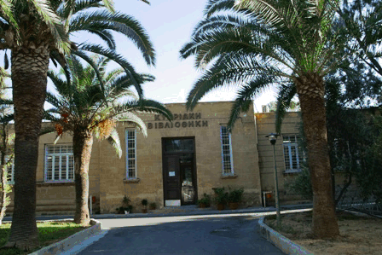
Cyprus Library (Site 1)-
http://www.cypruslibrary.gov.cy/moec/cl/cl.nsf/DMLindex_en/DMLindex_en?opendocument

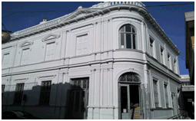
Cyprus Library Reference Department (Site 2) -http://www.cypruslibrary.gov.cy/moec/cl/cl.nsf/DMLindex_en/DMLindex_en?opendocument

- If available, please provide .jpg images of all library sites described in question 5.
N/A
- If available, please provide .jpg images of all library spaces described in question 6.
N/A
- Please provide simplified plans of your buildings, if possible in .jpg format (perhaps those used to guide visitors around your building).
N/A
- Please provide brief details on the history of your library buildings.

 | Answer
Year (first) library building opened | 1927
Architect of (first) library building | British Colonial Governor Sir Ronald Storrs.
Year (current) library building opened | N/A
Architect of (current) library building | N/A
Any additional information. Eg length of build/cost of build/reason for build

- If available, please provide a short text on the milestones of the history of your library and/or provide a link to this information online. Please include any bibliographic information about publications about your library and links to these publications in your library catalogue or an aggregated catalogue.
The Cyprus Library's actual origin dates back to 1927 with the establishment of the Cyprus Public Library on the initiative of the British Colonial Governor Sir Ronald Storrs. It operated under municipal control until 1954. Under the Cyprus Public Library Law of 1968 the Library came under the control of the Ministry of Education and Culture and its collections were merged with those of the Ministry's Library. In 1974 the Library was relocated back to its original premises on the D'Avila Bastion of the Venetian walls of Nicosia. The Cyprus Library was established by law in 1987.
The Cyprus Library was founded with the following objectives in mind:
- To secure, process, and make available publications that are produced in Cyprus or have to do with Cyprus.
- To promote and encourage the use of the Library services by the public.
- To compile and publish the Cyprus Bibliography, both current and retrospective.
- To catalogue the resources of the Library and other government libraries.
- To provide guidance and assistance to the planning, organization and development of the other libraries in Cyprus.
- To administer the Cyprus Registration Centres for books, periodicals and other materials. [The National Centre for ISMN began in 2000].
- To operate an interlibrary loan system with other Cypriot libraries and other institutions abroad.
- To work for the creation of a union catalogue of the material found in Cypriot libraries.
Even though designed to play the role of a national library, its historical legacy and the absence of strong public libraries in Nicosia have influenced the orientation of the Cyprus Library which functions also as a public library with lending services to its members. For the same reason, the core of collection development has been in the humanities, especially literature, and the social sciences. The Library is an agency under the Ministry of Education and Culture with a Consultative Committee appointed by the Government to provide advice and assistance in the operation and development of the Library.

Chapter III: Location and Urban Spaces
- Please describe the location of your national library buildings (eg. main building in capital city with close proximity to universities, storage buildings in rural area, located two hours by train from building in capital).
The Cyprus Library is located in the center of Nicosia close to the old town of Nicosia. It is surrounded by traditional buildings which are mostly used for business purposes. It is also located 5 minutes walk from the commercial center of Nicosia and 15 minutes drive from other University Libraries.
- CENL has provided a map of your headquarter location at the centre of a 500m radius – taken as a screenshot from Google maps. If this is not the correct location of your library building, please supply an alternative screen shot.

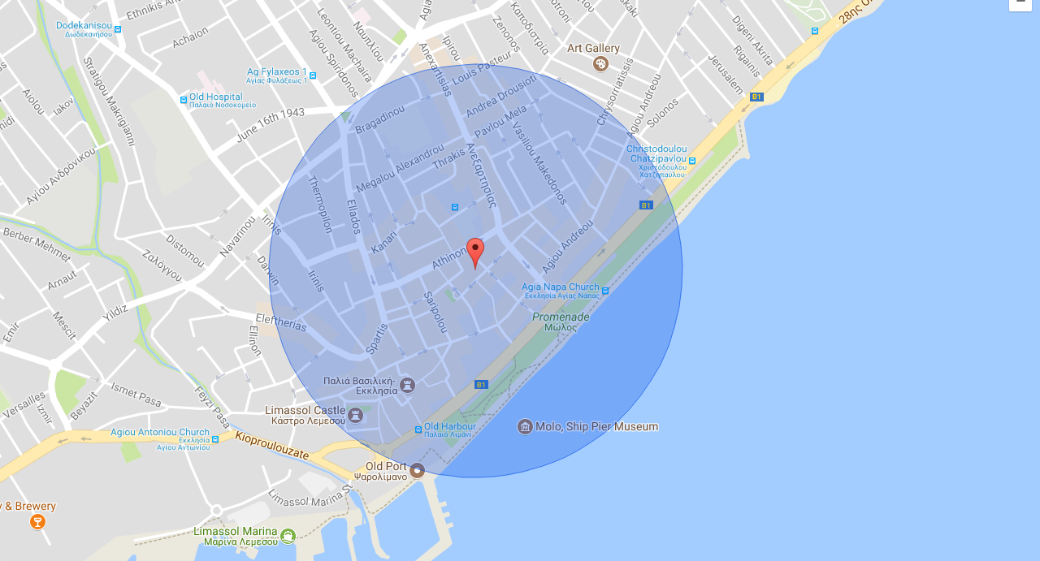

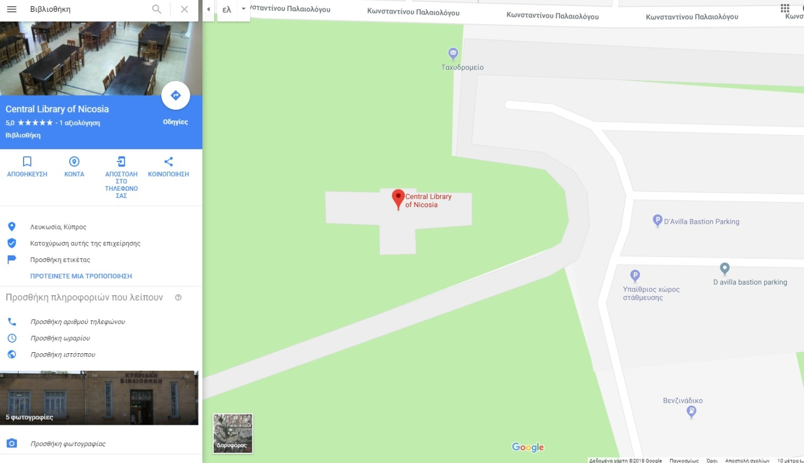

- Please provide details of major governmental, cultural or significant institutions within this vicinity (within a 500m radius).
Iacovos Patatsos monument
Leventis Municipal Museum
Shacolas Tower Museum and Observatory
Art Project Place
Post Office Museum

- Please describe all the transport options for reaching each of your library buildings open to researchers and the public.
Bus, Car

Chapter IV: Reading Rooms, collections and other interior library spaces
- What is the total number of seats in all your reading rooms across all sites?
60
- What is the total square meterage of all your reading rooms across all sites?
560
- Please list your reading rooms (type, large, by collection) and individual capacity
Reading Room Name | Collection type | Individual room seat capacity | Individual room square metres
Faneromenis Reading Room | Reference | 290 | 360
Central Building | Main Collections | 80 | 110
Research Collections | Research | 50 | 90
- Do users register to use your Reading Rooms? If so, how?
No
- Do users pay to use your Reading Rooms? If so, how much?
No
- How are your collections accessed within the Reading Rooms? Is collection material open access or called to order? Please describe.
Main Collections are Open, Collection of Rare and Old Books requires call
- What is the average number of visits per day to your Reading Rooms?
20
- What is the average number of visits per day to your library?
35

Chapter V: Staffing
- What is the number of staff employed by the library in total ?
2017: 19
- What is the number of staff employed by the library in FTE ?
2017:

The keynote presentation may be accessed via http://www.cenl.org/members/cenl-annual-general-meeting-2017-15-16-may-british-library-london/nggallery/page/1

