Survey of National Library Spaces and Services

Following on from CENL’s 2017 AGM and the keynote presentations, as well as the breakout session devoted to collection management, members concluded that a survey of library spaces, and the use of digital content within, would be beneficial to all. Data gathered by the CENL Secretariat will be used for analysis and to further discussion in the coming months with all CENL members. The full results of the survey are intended to be presented at CENL’s 2018 AGM.

All over the world we have seen the creation of new libraries during recent years, including new national library buildings that have been inaugurated or redesigned in Europe. The role of libraries and national libraries is changing and is in permanent transition. This process of transformation caused by the digital revolution and by changes within the economic and political environment has impacted library spaces, staffing and library services. To understand and to meet future needs of national libraries this survey aims to collect and analyse fundamental changes within national library spaces which have occurred over the last ten years.

The survey is structured in six chapters determined by the themes that were discussed during the 2017 AGM breakout session:

• The role of national libraries in collection management is changing – this affects library spaces

• National libraries are transforming from solely heritage institutions to also being leaders in digitisation

• Previously the role of digitisation was for preservation, but now there are new uses for our collections which include the combination of digital and heritage – how is this explored within national libraries?

• Staff development is key to the transformation of libraries – staff need to be integrated in the end to end process of digitisation and using that digital content, perhaps in physical and virtual exhibitions

• Skills and standards for digital content are needed for clarity of activity for researchers

 | Answer
Name of national library in full (in your own language and in anglicised form): | Nacionalna i sveučilišna knjižnica u Zagrebu  National and University Library in Zagreb, Croatia
Name of Director General with official title: | Tatijana Petrić, PhD
Main library address: | Hrvatske bratske zajednice 4, PO Box 550, 10 000 Zagreb, Croatia
Current logo as a .jpg:
Contact name, email and telephone for this survey: | Jasenka Zajec  jzajec@nsk.hr  +385 1 616 4081

Instructions
The CENL Secretariat has pre-completed as much information as possible within this survey. Please check the information already provided and augment or correct this as necessary. Where no information is yet provided, please supply answers in full. Do contact cenl@bl.uk with any difficulties.

Chapter I: Scope and core functions of your national library
- Please check all that apply.
National Library | University Library | Public Library | Research Library / Research Centre | National Archives | Legal deposit centre | Preservation centre | Museum | Other
If other please specify:
- Are you the only library with a national remit in your country? If no (eg. there is also a National Technical Library) please specify.
YES
- What is the legal status of your library?
PUBLIC BODY
- Which ministry oversees your library?
MINISTRY OF SCIENCE AND EDUCATION

Chapter II: Physical spaces
- Do you have multiple library sites? If so, please provide address details of all library buildings, including storage.
NO
- Please provide a brief summary of all functions contained within the national library.
In 2017
Reading Rooms | Lounge | Exhibition space | Conference Centre | Conservation Studio | Gallery | Concert Hall | Café / Restaurant | Commercial space / shop | Other

If other please specify:
COMMENT: NOTE PLEASE THAT WE DO NOT HAVE A PROPER CONFERENCE CENTRE OR EXHIBITION SPACE THAT WOULD CONFORM TO THE STANDARDS FOR SPACES USED FOR SUCH PURPOSES. THERE ARE 2 SMALL MEETING ROOMS (10-15 SEATS), A MEETING/CONFERENCE ROOM WITH 100 SEATS AND AN ELECTRONIC CLASSROOM WITH 20 SEATS. WE USE OUR LOBBIES AS BOTH CONFERENCE AND EXHIBITION SPACE.
- Please provide the total square meterage for each of the following functions within your library:
8,734 M2 | 87 M2 | 692 M2 | 263 M2 | 476 M2 | M2 | M2 | 795 M2 | M2 | M2
Reading Rooms | Lounge | Exhibition space | Conference Centre | Conservation Studio | Gallery | Concert Hall | Café / Restaurant | Commercial space / shop | Other
If other please specify:
- What is the total size of all library buildings in square metres (includes storage areas)?
2017: 51,022 m² (unfinished part cca 7,000 m²)
- What is the size of library buildings open to the public in square metres?
2017: 12,137 m²
- Please provide .jpg images of your main public building(s) exterior

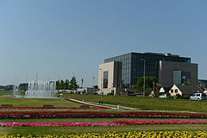
Exterior 1 https://en.wikipedia.org/wiki/National_and_University_Library_in_Zagreb

Entrance
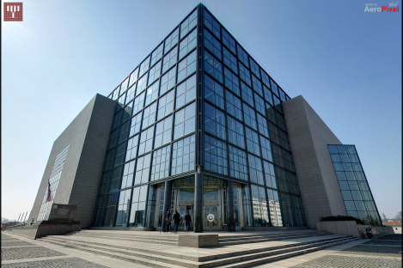
http://www.nsk.hr/wp-content/themes/nk/vs/index.htm

More photos in the file: Photos_question 11
- If available, please provide .jpg images of all library sites described in question 5.
Answer
- If available, please provide .jpg images of all library spaces described in question 6.
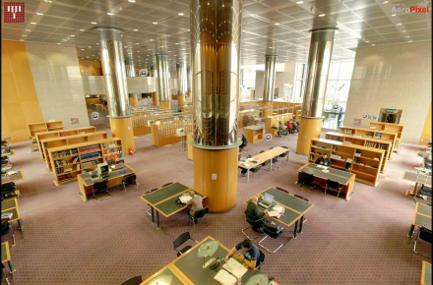
Ground floor reading room
http://www.nsk.hr/wp-content/themes/nk/vs/index.htm

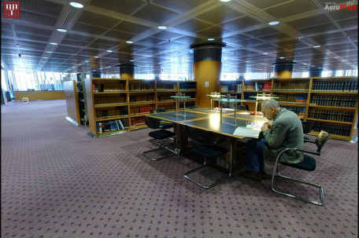
Ground floor reading room
http://www.nsk.hr/wp-content/themes/nk/vs/index.htm

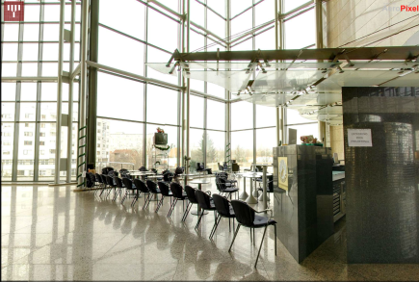
Small lobby
http://www.nsk.hr/wp-content/themes/nk/vs/index.htm

- Please provide simplified plans of your buildings, if possible in .jpg format (perhaps those used to guide visitors around your building).
Link to virtual walk with a plan: http://www.nsk.hr/wp-content/themes/nk/vs/index.htm
Link to a plan for users: http://www.nsk.hr/en/where-are-user-areas-in-the-library/
- Please provide brief details on the history of your library buildings.

 | Answer
Year (first) library building opened | 1913 (ALTHOUGH THE LIBRARY DATES FROM 1607, THIS WAS THE FIRST BUILDING BUILT ESPECIALLY FOR THIS PURPOSE)
Architect of (first) library building | RUDOLF LUBYNSKI
Year (current) library building opened | 1995
Architect of (current) library building | VELIMIR NEIDHARDT, MARIJAN HRŽIĆ, ZVONIMIR KRZNARIĆ AND DAVOR MANCE
Any additional information. Eg length of build/cost of build/reason for build | IT TOOK 7 YEARS TO BUILD (1988-1995). THE 1913 BUILDING COULD HOUSE UP TO 500,000 ITEMS. THE COLLECTION GREW OVER THE YEARS AND BEFORE 1995 USED TO ON SEVERAL LOCATIONS IN ZAGREB AND ITS SURROUNDINGS.

- If available, please provide a short text on the milestones of the history of your library and/or provide a link to this information online. Please include any bibliographic information about publications about your library and links to these publications in your library catalogue or an aggregated catalogue.
HISTORICAL OVERVIEW: http://www.nsk.hr/en/historical-overview/
BIBLIOGRAPHY ATTACHED (Literature about NSK)

Chapter III: Location and Urban Spaces
- Please describe the location of your national library buildings (eg. main building in capital city with close proximity to universities, storage buildings in rural area, located two hours by train from building in capital).
NATIONAL AND UNIVERSITY LIBRARY IN ZAGREB IS LOCATED IN THE PART OF THE CITY CALLED TRNJE WHICH IS SOME 15 MINUTES WALK FROM THE CITY CENTRE. THERE ARE SEVERAL FACULTIES OF THE ZAGREB UNIVERSITIY IN CLOSE PROXIMITY OF THE BUILDING: FACULTY OF HUMANITIES AND SOCIAL SCIENCES, FACULTY OF MECHANICAL ENGINEERING AND NAVAL ARCHITECTURE AND FACULTY OF ELECTRICAL ENGINEERING AND COMPUTING.
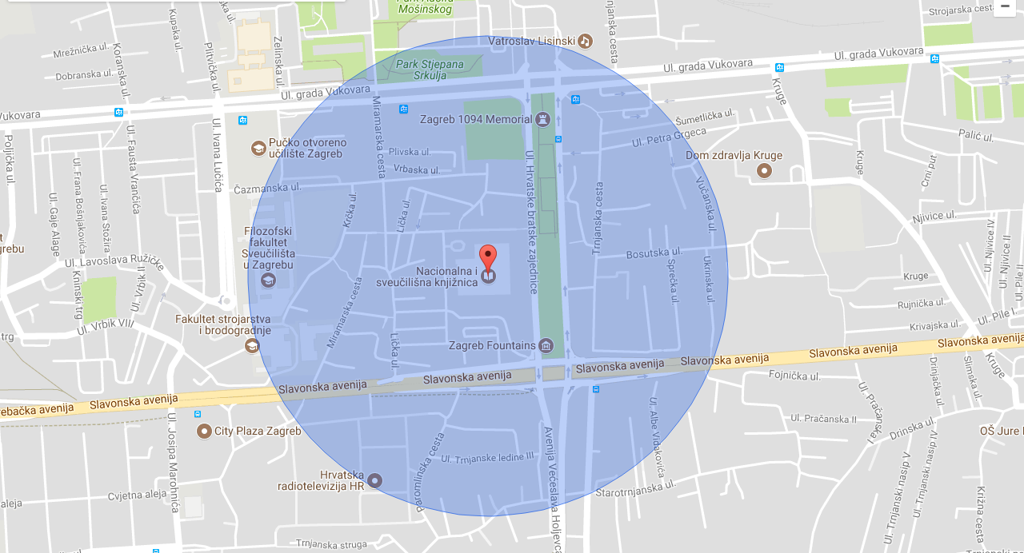
- CENL has provided a map of your headquarter location at the centre of a 500m radius – taken as a screenshot from Google maps. If this is not the correct location of your library building, please supply an alternative screen shot.

- Please provide details of major governmental, cultural or significant institutions within this vicinity (within a 500m radius).
IN ADDITION TO FACULTIES LISTED IN 15 OTHER SIGNIFICANT INSTITUTIONS IN CLOSE PROXIMITY ARE: ADULT EDUCATION UNIVERSITY CENTRE, CROATIAN RADIOTELEVISION, MINISTRY OF THE SEA, TRANSPORT AND INFRASTRUCTURE, MINISTRY OF ECONOMY, ENTREPRENEURSHIP AND CRAFTS, MINISTRY OF JUSTICE, MINISTRY OF REGIONAL DEVELOPMENT AND EU FUNDS, MINISTRY OF LABOUR AND PENSION SYSTEM, MINISTRY OF AGRICULTURE, STATE INTELLECTUAL PROPERTY OFFICE, CROATIAN STANDARDS INSTITUTE, ZAGREB CITY ADMINISTRATION, VATROSLAV LISINSKI CONCERT HALL, MUNICIPAL COURT OF ZAGREB, CROATIAN FINANCIAL AGENCY.
- Please describe all the transport options for reaching each of your library buildings open to researchers and the public.
ON FOOT, BY CAR (PUBLIC CAR PARK AVAILABLE), PUBLIC TRANSPORT: TRAM AND BUS.

Chapter IV: Reading Rooms, collections and other interior library spaces
- What is the total number of seats in all your reading rooms across all sites?
1,179
- What is the total square meterage of all your reading rooms across all sites?
8,734 m²
- Please list your reading rooms (type, large, by collection) and individual capacity
Reading Room Name | Collection type | Individual room seat capacity | Individual room square metres
Social Sciences and Humanities Reading Room | Books | 610 seats  (both Social Sciences and Humanities Reading Room and Natural and Applied Sciences Reading Room) | Both reading rooms: 4,103 m²
Natural and Applied Sciences Reading Room | Books, Journals
Faculty Reading Room | Books | 16 seats | 68 m2
Current Croatian and International Periodicals Reading Room | Periodicals | (part of Natural and Applied Sciences Reading Room) | 280 m2
Periodicals reading room | Periodicals | 60 seats | 202 m2
Reference Collection | Books | 150 seats | 840 m2
LIS Collection | Books, Journals | 40 seats | 230 m2
Doctoral and Master’s Theses Collection | Theses | 20 seats | 1,615 m2
Homeland War Book Collection | Books, Journals | 6 seats | 140 m2
Official Publications Collection | Books, Journals | 20 seats | 280 m2
Manuscripts and Old Books Collection | Manuscripts, Old Books | 14 | 412 m2
Print Collection | Drawings, Prints, Books | 12 | 154 m2
Map Collection | Maps, Atlases, Books | 6 | 169 m2
Music Collection | Sheet music, Sound recordings, Books | 56 | 241 m2

- Do users register to use your Reading Rooms? If so, how?
ANNUAL REGISTRATION– LIBRARY MEMBERSHIP CARD
WEEKLY REGISTRATION – LIBRARY MEMBERSHIP CARD
MONTHLY REGISTRATION – LIBRARY MEMBERSHIP CARD
DAILY REGISTRATION – LIBRARY MEMBERSHIP CARD
- Do users pay to use your Reading Rooms? If so, how much?
ANNUAL REGISTRATION – HRK 100.00 STUDENTS, HRK 200.00 OTHERS
MONTHLY REGISTRATION – HRK 50.00
WEEKLY REGISTRATION – HRK 40.00
DAILY REGISTRATION – HRK 30.00
- How are your collections accessed within the Reading Rooms? Is collection material open access or called to order? Please describe.
COLLECTIONS ARE BOTH IN OPEN ACCESS AND CALLED TO ORDER.

- What is the average number of visits per day to your Reading Rooms?
600 (2017)
- What is the average number of visits per day to your library?
700 (2017)

Chapter V: Staffing
- What is the total number of staff employed by the library in total ?
2017: 306
- What is the total number of staff employed by the library in FTE ?
2017:

The keynote presentation may be accessed via http://www.cenl.org/members/cenl-annual-general-meeting-2017-15-16-may-british-library-london/nggallery/page/1

