Survey of National Library Spaces and Services

Following on from CENL’s 2017 AGM and the keynote presentations, as well as the breakout session devoted to collection management, members concluded that a survey of library spaces, and the use of digital content within, would be beneficial to all. Data gathered by the CENL Secretariat will be used for analysis and to further discussion in the coming months with all CENL members. The full results of the survey are intended to be presented at CENL’s 2018 AGM.

All over the world we have seen the creation of new libraries during recent years, including new national library buildings that have been inaugurated or redesigned in Europe. The role of libraries and national libraries is changing and is in permanent transition. This process of transformation caused by the digital revolution and by changes within the economic and political environment has impacted library spaces, staffing and library services. To understand and to meet future needs of national libraries this survey aims to collect and analyse fundamental changes within national library spaces which have occurred over the last ten years.

The survey is structured in six chapters determined by the themes that were discussed during the 2017 AGM breakout session:

• The role of national libraries in collection management is changing – this affects library spaces

• National libraries are transforming from solely heritage institutions to also being leaders in digitisation

• Previously the role of digitisation was for preservation, but now there are new uses for our collections which include the combination of digital and heritage – how is this explored within national libraries?

• Staff development is key to the transformation of libraries – staff need to be integrated in the end to end process of digitisation and using that digital content, perhaps in physical and virtual exhibitions

• Skills and standards for digital content are needed for clarity of activity for researchers

 | Answer
Name of national library in full (in your own language and in anglicised form): | Nacionalna i univerzitetska biblioteka Bosne i Hercegovine  National and University Library of Bosnia and Herzegovina
Name of Director General with official title: | Dr. Ismet Ovcina
Main library address: | Zmaja od Bosne 8b, 71000 Sarajevo, Bosnia and Herzegovina
Current logo as a .jpg:
Contact name, email and telephone for this survey: | Dr. Ismet Ovcina  ismet@nub.ba  +387 33 275 312

Instructions
The CENL Secretariat has pre-completed as much information as possible within this survey. Please check the information already provided and augment or correct this as necessary. Where no information is yet provided, please supply answers in full. Do contact cenl@bl.uk with any difficulties.

Chapter I: Scope and core functions of your national library
- Please check all that apply.
National Library | University Library | Public Library | Research Library / Research Centre | National Archives | Legal deposit centre | Preservation centre | Museum | Other
If other please specify:
- Are you the only library with a national remit in your country? If no (eg. there is also a National Technical Library) please specify.
Yes.
- What is the legal status of your library?
State library
- Which ministry oversees your library?
Ministry of Civil Affairs of B&H

Chapter II: Physical spaces
- Do you have multiple library sites? If so, please provide address details of all library buildings, including storage.
The building (Vijecnica, Obala Kulina Bana) that belongs to the Library by law was bombarded and destroyed 1992., but it has been restored and the city administration is located there without legal basis. The Library is temporary accommodated at the University Campus (Zmaja od bosne 8B) in three small buildings: main building; storage building and Laboratory for preservation and restauration.
- Please provide a brief summary of all functions contained within the national library.
In 2017
Reading Rooms | Lounge | Exhibition space | Conference Centre | Conservation Studio | Gallery | Concert Hall | Café / Restaurant | Commercial space / shop | Other

If other please specify:

- Please provide the total square meterage for each of the following functions within your library:
M2 | M2 | M2 | M2 | M2 | M2 | M2 | M2 | M2 | M2
Reading Rooms | Lounge | Exhibition space | Conference Centre | Conservation Studio | Gallery | Concert Hall | Café / Restaurant | Commercial space / shop | Other
If other please specify:

- What is the total size of all library buildings in square metres (includes storage areas)?
2017: 3.471,75 m2
- What is the size of library buildings open to the public in square metres?
2017: 494,85 m2
- Please provide .jpg images of your main public building(s) exterior

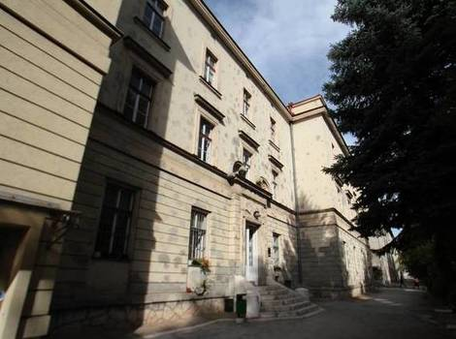
- If available, please provide .jpg images of all library sites described in question 5.

- If available, please provide .jpg images of all library spaces described in question 6.
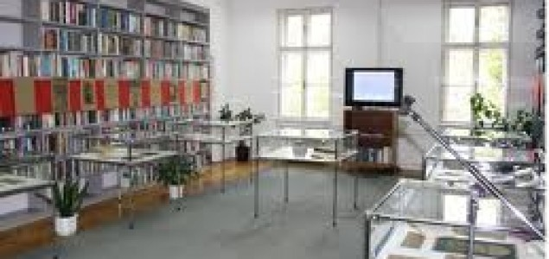
Exhibition space
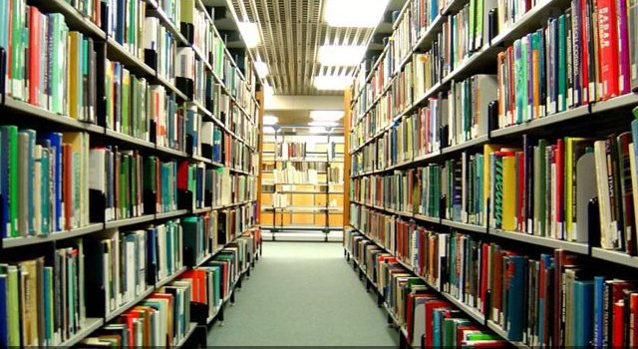
Storage space

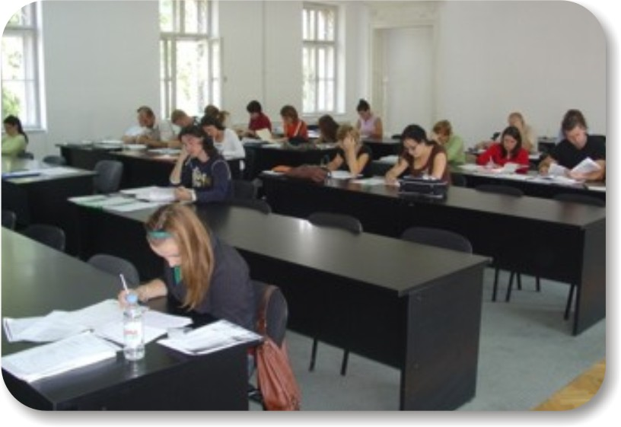
One of the reading rooms
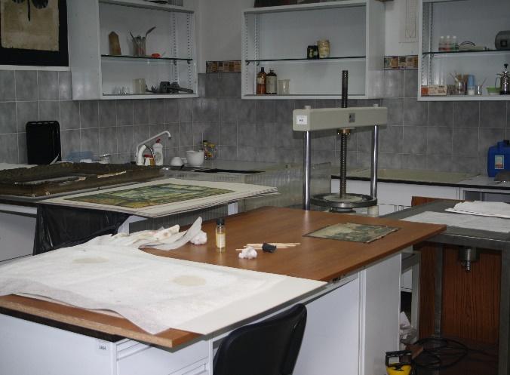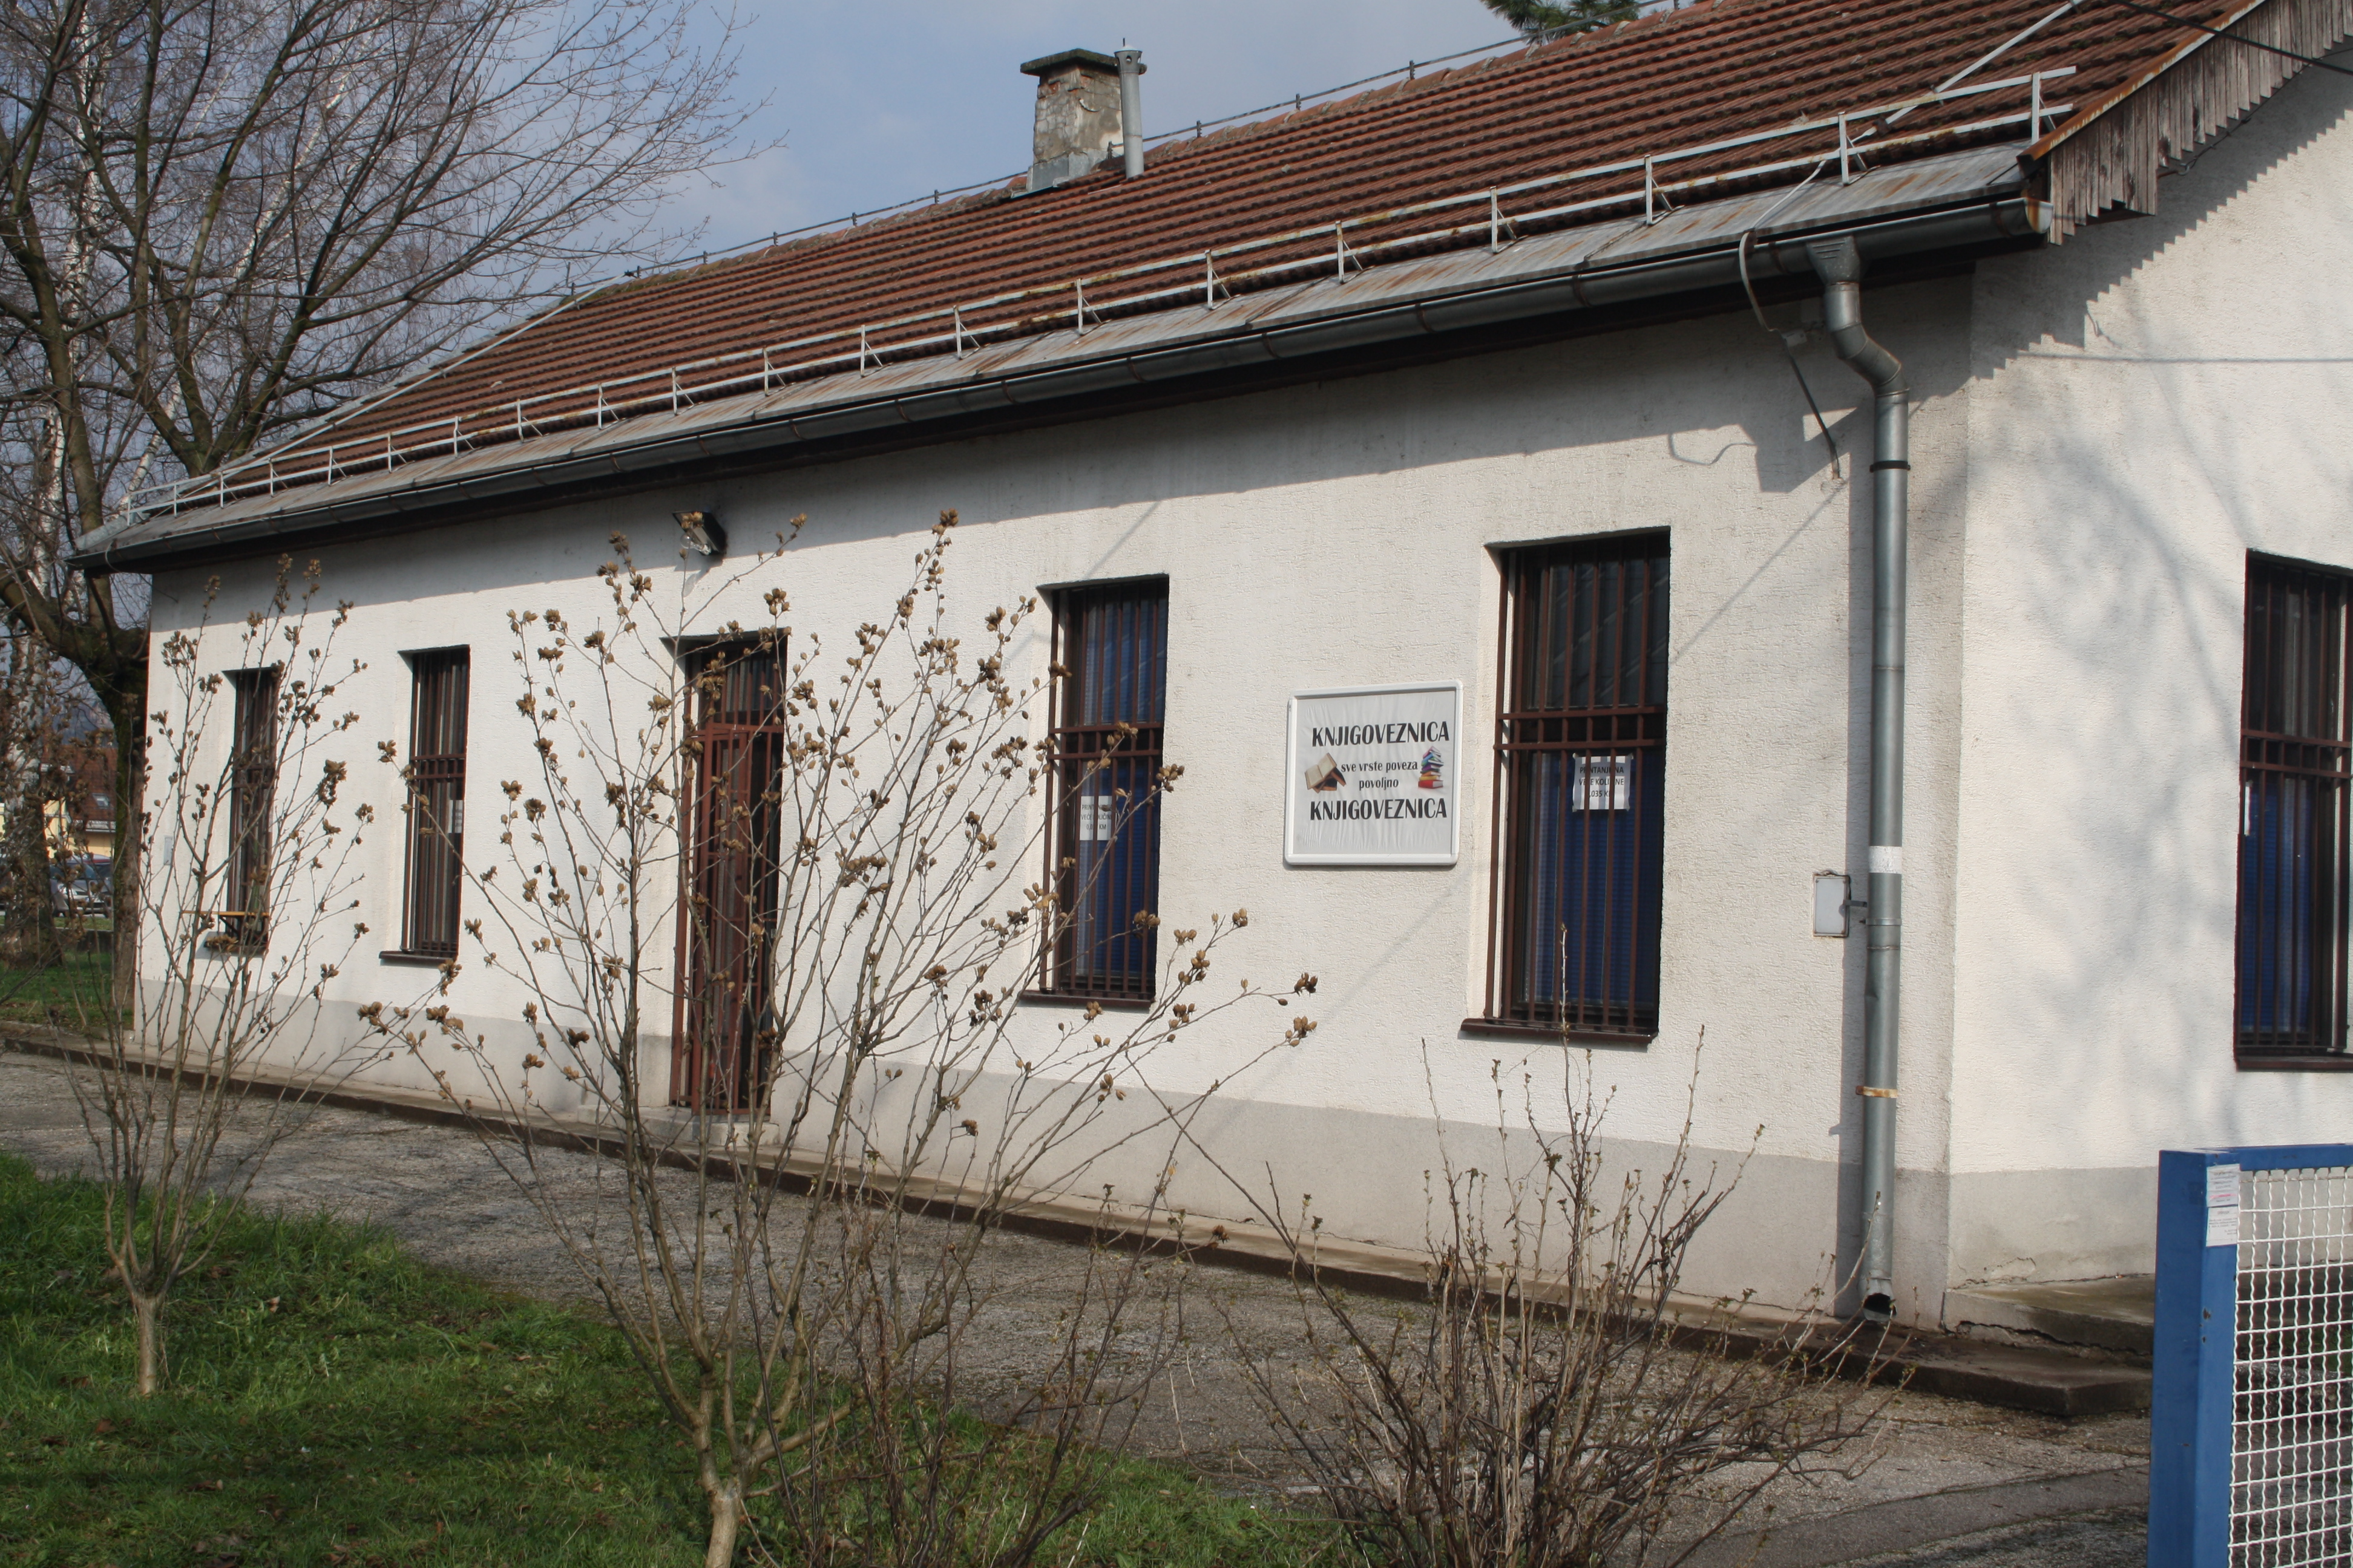
Preservation and Conservation Center
- Please provide simplified plans of your buildings, if possible in .jpg format (perhaps those used to guide visitors around your building).
n/a
- Please provide brief details on the history of your library buildings.

 | Answer
Year (first) library building opened | 1945
Architect of (first) library building | Karel Pařík, Alexander Wittek, Ćiril Iveković
Year (current) library building opened | 1998
Architect of (current) library building | No data.
Any additional information. Eg length of build/cost of build/reason for build | The building was built and used as a military barracks and is not adequate space for the accommodation and purpose of the Library.

- If available, please provide a short text on the milestones of the history of your library and/or provide a link to this information online. Please include any bibliographic information about publications about your library and links to these publications in your library catalogue or an aggregated catalogue.
The National and University Library of Bosnia and Herzegovina was established on 1945, and is one of seven institutions of culture established by the Parliamentary Assembly of B&H.
In spite of the fact that the Library building (Vijecnica) and its valuable documentary content (about 90%) was destroyed in the Summer of 1992., the Library has succeeded in the revival of most of its services, and it works according to the Law of Librarianship („Official Gazette of B&H“, 37/95).
This Institution represents Bosnia and Herzegovina in the international library associations, such as IFLA, CENL, LIBER, eIfl, WDL, etc., and it is home for the ISSN, ISBN, ISMN agencies, as same as the Virtual Library of B&H – on line catalogue www.cobiss.bh.
It also provides permanent education for librarians in B&H.

Chapter III: Location and Urban Spaces
- Please describe the location of your national library buildings (eg. main building in capital city with close proximity to universities, storage buildings in rural area, located two hours by train from building in capital).
Main building and all storage spaces are located in the Campus of University of Sarajevo.
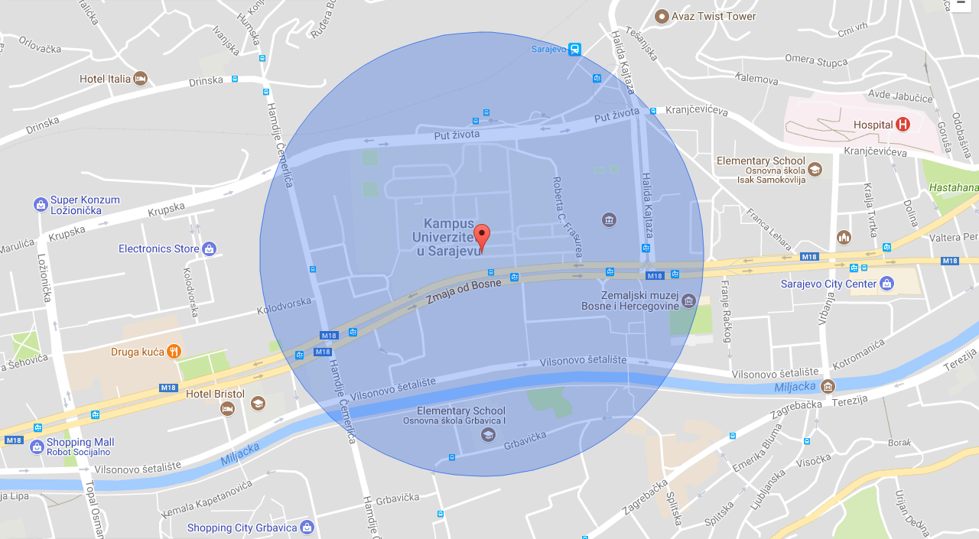
- CENL has provided a map of your headquarter location at the centre of a 500m radius – taken as a screenshot from Google maps. If this is not the correct location of your library building, please supply an alternative screen shot.

- Please provide details of major governmental, cultural or significant institutions within this vicinity (within a 500m radius).
State Museum of B&H; Historical Museum of B&H; Government, State Assembly and State ministries of B&H; Embassy of USA; Several faculties of University of Sarajevo.
- Please describe all the transport options for reaching each of your library buildings open to researchers and the public.
Public transport (tram, bus, trolleybus), private transport (car, motorcycle, bicycle etc.) or on foot.

Chapter IV: Reading Rooms, collections and other interior library spaces
- What is the total number of seats in all your reading rooms across all sites?
136
- What is the total square meterage of all your reading rooms across all sites?
n/a
- Please list your reading rooms (type, large, by collection) and individual capacity
Reading Room Name | Collection type | Individual room seat capacity | Individual room square metres
II floor Reading room | all | 50 | n/a
I floor (three reading rooms) | all | 20 + 20 + 6 | “
Austrian reading room | German language literature | 10 | “
Research reading room | Scientific literature | 10 | “
Egyptian reading room | Arab language literature | 8 | “
Special reading room | Special collections – old and rare books, manuscripts etc | 8 | “
Reading room for serial publications | Old periodicals | 4 | “
- Do users register to use your Reading Rooms? If so, how?
Yes. Membership card
- Do users pay to use your Reading Rooms? If so, how much?
Yes – membership fee: 20 KM (10 EUR) per year for students; 30 KM (15 EUR) for employed citizens and 10 KM (5 EUR) unemployed and retired citizens; 60 KM (30 EUR) for foreign users and collective fee (faculties, institutions etc…)
- How are your collections accessed within the Reading Rooms? Is collection material open access or called to order? Please describe.
NO. Called to order.
- What is the average number of visits per day to your Reading Rooms?
50
- What is the average number of visits per day to your library?
150

Chapter V: Staffing
- What is the number of staff employed by the library in total ?
2017: 47
- What is the number of staff employed by the library in FTE ?
2017:

The keynote presentation may be accessed via http://www.cenl.org/members/cenl-annual-general-meeting-2017-15-16-may-british-library-london/nggallery/page/1

