Survey of National Library Spaces and Services

Following on from CENL’s 2017 AGM and the keynote presentations, as well as the breakout session devoted to collection management, members concluded that a survey of library spaces, and the use of digital content within, would be beneficial to all. Data gathered by the CENL Secretariat will be used for analysis and to further discussion in the coming months with all CENL members. The full results of the survey are intended to be presented at CENL’s 2018 AGM.

All over the world we have seen the creation of new libraries during recent years, including new national library buildings that have been inaugurated or redesigned in Europe. The role of libraries and national libraries is changing and is in permanent transition. This process of transformation caused by the digital revolution and by changes within the economic and political environment has impacted library spaces, staffing and library services. To understand and to meet future needs of national libraries this survey aims to collect and analyse fundamental changes within national library spaces which have occurred over the last ten years.

The survey is structured in six chapters determined by the themes that were discussed during the 2017 AGM breakout session:

• The role of national libraries in collection management is changing – this affects library spaces

• National libraries are transforming from solely heritage institutions to also being leaders in digitisation

• Previously the role of digitisation was for preservation, but now there are new uses for our collections which include the combination of digital and heritage – how is this explored within national libraries?

• Staff development is key to the transformation of libraries – staff need to be integrated in the end to end process of digitisation and using that digital content, perhaps in physical and virtual exhibitions

• Skills and standards for digital content are needed for clarity of activity for researchers

 | Answer
Name of national library in full (in your own language and in anglicised form): | Azərbaycan Milli Kitabxanası  Azerbaijan National Library
Name of Director General with official title: | Prof. Dr. Karim Tahirov
Main library address: | Khagani str. 29, Baku, Azerbaijan 1000
Current logo as a .jpg:
Contact name, email and telephone for this survey: | Prof. Dr. Karim Tahirov  ktahirov@gmail.com  (+99412) 4934003

Instructions
The CENL Secretariat has pre-completed as much information as possible within this survey. Please check the information already provided and augment or correct this as necessary. Where no information is yet provided, please supply answers in full. Do contact cenl@bl.uk with any difficulties.

Chapter I: Scope and core functions of your national library
- Please check all that apply.
x |  | x |  |  | x | x | x | x
National Library | University Library | Public Library | Research Library / Research Centre | National Archives | Legal deposit centre | Digital  Preservation centre | Museum | Other
If other please specify:
Scientific methodical center
- Are you the only library with a national remit in your country? If no (eg. there is also a National Technical Library) please specify.
Yes
- What is the legal status of your library?
National Library
- Which ministry oversees your library?
Ministry of Culture and Tourism of the Republic of Azerbaijan

Chapter II: Physical spaces
- Do you have multiple library sites? If so, please provide address details of all library buildings, including storage.
No
- Please provide a brief summary of all functions contained within the national library.
In 2017
x | x | x | x |  |  |  |  |  | x
Reading Rooms | Lounge | Exhibition space | Conference Centre | Conservation Studio | Gallery | Concert Hall | Café / Restaurant | Commercial space / shop | Other

If other please specify:

Open Library
- Please provide the total square meterage for each of the following functions within your library:
M2 | M2 | M2 | M2 | M2 | M2 | M2 | M2 | M2 | M2
Reading Rooms | Lounge | Exhibition space | Conference Centre | Conservation Studio | Gallery | Concert Hall | Café / Restaurant | Commercial space / shop | Other
If other please specify:
Reading rooms: 1562 m²
Lounge: 210 m²
Exhibition hall: 195 m²
Conference hall: 90 m²
- What is the total size of all library buildings in square metres (includes storage areas)?
2017: 13187, 9 m²
- What is the size of library buildings open to the public in square metres?
2017: 13187, 9 m²

- Please provide .jpg images of your main public building(s) exterior
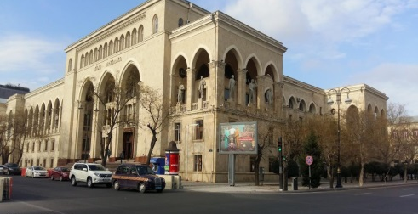
Main Building https://www.google.co.uk/maps/place/Akhundov+National+Library

- If available, please provide .jpg images of all library sites described in question 5.
Answer
- If available, please provide .jpg images of all library spaces described in question 6.
http://anl.az/new/en/hall/6
- Please provide simplified plans of your buildings, if possible in .jpg format (perhaps those used to guide visitors around your building).
http://anl.az/new/en/contact/22
- Please provide brief details on the history of your library buildings.

 | Answer
Year (first) library building opened | 1923
Architect of (first) library building
Year (current) library building opened | 1960
Architect of (current) library building | Mikayil Useynov
Any additional information. Eg length of build/cost of build/reason for build

- If available, please provide a short text on the milestones of the history of your library and/or provide a link to this information online. Please include any bibliographic information about publications about your library and links to these publications in your library catalogue or an aggregated catalogue.
http://anl.az/down/Kitabxana.pdf
http://anl.az/new/en/publication/14

Chapter III: Location and Urban Spaces
- Please describe the location of your national library buildings (eg. main building in capital city with close proximity to universities, storage buildings in rural area, located two hours by train from building in capital).
http://anl.az/new/en/contact/22
The library building is situated in the capital city Baku. It is the only building.
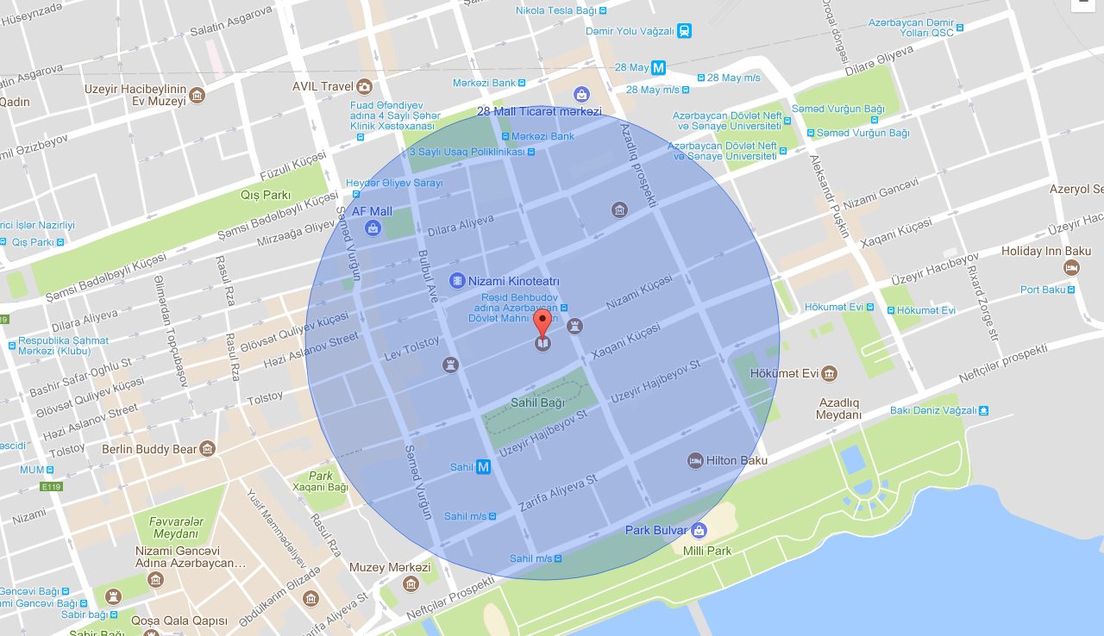
- CENL has provided a map of your headquarter location at the centre of a 500m radius – taken as a screenshot from Google maps. If this is not the correct location of your library building, please supply an alternative screen shot.

- Please provide details of major governmental, cultural or significant institutions within this vicinity (within a 500m radius).

State Song Theatre named after Rashid Behbudov:
https://en.wikipedia.org/wiki/Rashid_Behbudov_State_Song_Theatre

Azerbaijan Writers Union:
https://en.wikipedia.org/wiki/Union_of_Azerbaijani_Writers

Azerbaijan State Academic Opera and Ballet Theatre:
https://en.wikipedia.org/wiki/Azerbaijan_State_Academic_Opera_and_Ballet_Theater

Azerbaijan State Theatre of Young Spectators:
https://en.wikipedia.org/wiki/Azerbaijan_State_Theatre_of_Young_Spectators

Union of Azerbaijan Artists:
https://en.wikipedia.org/wiki/Union_of_Artists_of_Azerbaijan

Union of Azerbaijan Composers:
https://www.google.com/maps/place/Az%C9%99rbaycan+B%C9%99st%C9%99karlar+%C4%B0ttifaq%C4%B1/@40.373546,49.8455095,15z/data=!4m2!3m1!1s0x0:0xe33d3dbaadb08802?sa=X&ved=0ahUKEwiMstCI94vaAhWPhqYKHQcLBA4Q_BIIggEwCg

- Please describe all the transport options for reaching each of your library buildings open to researchers and the public.
https://www.google.com/maps/dir/Sahil,+Bak%C4%B1,+Az%C9%99rbaycan/Axundov+Milli+Kitabxanas%C4%B1,+Xaqani+K%C3%BC%C3%A7%C9%99si,+Bak%C4%B1/@40.37316,49.843048,17z/data=!3m1!4b1!4m13!4m12!1m5!1m1!1s0x40307dae1c3304f5:0x2d58273b4d9f7c0f!2m2!1d49.8444004!2d40.3719869!1m5!1m1!1s0x40307daee2cda66f:0x99f05ae9b4d92154!2m2!1d49.845875!2d40.3743331

Chapter IV: Reading Rooms, collections and other interior library spaces
- What is the total number of seats in all your reading rooms across all sites?
500
- What is the total square meterage of all your reading rooms across all sites?
Answer
- Please list your reading rooms (type, large, by collection) and individual capacity
Reading Room Name | Collection type | Individual room seat capacity | Individual room square metres
Reading Room for Humanitarian sciences | Books
Reading Room for Technical sciences | Books
Reading room for students | Books
Periodical press room | Newspapers and magazines
Reading room for local network use | e-resources
Internet reading room
Exhibition hall | All types of literature
Foreign literature reading room | Books and periodicals
Note publications room | Music literature and note publications, note manuscripts
Country study and bibliography
Rare books and library museum | Rare and old books
Depositary literature room | books and magazines
Information service | Books and magazines
Archive of Azerbaijan literature | Books and periodicals
Conference hall
E-information service
- Do users register to use your Reading Rooms? If so, how?
Day Pass, Annual pass
- Do users pay to use your Reading Rooms? If so, how much?
No
- How are your collections accessed within the Reading Rooms? Is collection material open access or called to order? Please describe.
Mixed
- What is the average number of visits per day to your Reading Rooms?
800
- What is the average number of visits per day to your library?
1000

Chapter V: Staffing
- What is the number of staff employed by the library in total ?
2017: 355
- What is the total number of staff employed by the library in FTE ?
2017: 85

The keynote presentation may be accessed via http://www.cenl.org/members/cenl-annual-general-meeting-2017-15-16-may-british-library-london/nggallery/page/1

