Survey of National Library Spaces and Services

Following on from CENL’s 2017 AGM[1] and the keynote presentations, as well as the breakout session devoted to collection management, members concluded that a survey of library spaces, and the use of digital content within, would be beneficial to all. Data gathered by the CENL Secretariat will be used for analysis and to further discussion in the coming months with all CENL members. The full results of the survey are intended to be uploaded on CENL website / member area and presented at CENL’s 2019 AGM.

All over the world we have seen the creation of new libraries during recent years, including new national library buildings that have been inaugurated or redesigned in Europe. The role of libraries and national libraries is changing and is in permanent transition. This process of transformation caused by the digital revolution and by changes within the economic and political environment has impacted library spaces, staffing and library services. To understand and to meet future needs of national libraries this survey aims to collect and analyse fundamental changes within national library spaces which have occurred over the last ten years.

The survey is structured in five chapters

• Scope and core functions of National Libraries

• Physical Spaces

• Location and Urban Spaces

• Reading Rooms

• Staffing

|  |  |
| --- | --- |
|  | Answer |
| **Name of national library in full (in your own language and in anglicised form):** | Österreichische Nationalbibliothek  Austrian National Library |
| **Name of Director General with official title:** | Dr. Johanna Rachinger  Generaldirektorin |
| **Main library address:** | Josefsplatz 1  A 1015 WIen |
| **Current logo as a .jpg:** | Bitte Kommunikation und marketing alle bilder und logos (9-12) |
| **Contact name, email and telephone for this survey:** | Dr. Hans Petschar  Hans.petschar@onb.ac.at |

# Instructions

The CENL Secretariat has pre-completed as much information as possible within this survey. Please check the information already provided and augment or correct this as necessary. Where no information is yet provided, please supply answers in full. Do contact [cenl@bl.uk](mailto:cenl@bl.uk) with any difficulties.

# Chapter I: Scope and core functions of your national library

1. Please check all that apply.

|  |  |  |  |  |  |  |  |  |
| --- | --- | --- | --- | --- | --- | --- | --- | --- |
| x | ⭘ | ⭘ | x | ⭘ | x | x | x | ⭘ |
| National Library | University Library | Public Library | Research Library / Research Centre | National Archives | Legal deposit centre | Digital Preservation centre | Museum | Other |

If other please specify:

1. Are you the only library with a national remit in your country? If no (eg. there is also a National Technical Library) please specify.

yes

1. What is the legal status of your library?

Wissenschaftliche Anstalt öffentlichen Rechts

Scientific Institute under Public Law

1. **Which ministry oversees your library?**

Bundeskanzleramt

Federal Chancellery

# Chapter II: Physical spaces

1. Do you have multiple library sites? If so, please provide address details of all library buildings, including storage.

Modern Library:  
Heldenplatz: <https://www.onb.ac.at/ueber-uns/presse/pressematerial/#lg=1&slide=36>  
Heldenplatz 1  
1010 Wien

Head Quarters:  
Josefsplatz <https://www.onb.ac.at/ueber-uns/presse/pressematerial/#lg=1&slide=35>  
Josefsplatz 1  
1010 Wien

Museums and Collections:  
Palais Mollard: <https://www.onb.ac.at/ueber-uns/presse/pressematerial/#lg=1&slide=39>  
Johannesgasse 6  
1010 Wien

Literaturmuseum: <https://www.onb.ac.at/ueber-uns/presse/pressematerial/#lg=1&slide=38>  
Grillparzerhaus  
Johannesgasse 6  
1010 Wien

1. Please provide a brief summary of all functions contained within the national library.

In 2017

|  |  |  |  |  |  |  |  |  |  |
| --- | --- | --- | --- | --- | --- | --- | --- | --- | --- |
| x | x | x | x | x | ⭘ | ⭘ | x | x | ⭘ |
| Reading Rooms | Lounge | Exhibition space | Conference Centre | Conservation Studio | Gallery | Concert Hall | Café / Restaurant | Commercial space / shop | Other |

If other please specify:

1. Please provide the total square meterage for each of the following functions within your library:

|  |  |  |  |  |  |  |  |  |  |
| --- | --- | --- | --- | --- | --- | --- | --- | --- | --- |
| M2 | M2 | M2 | M2 | M2 | M2 | M2 | M2 | M2 | M2 |
| Reading Rooms  3156 | Lounge  520 | Exhibition space  3045 | Conference Centre  792 | Conservation Studio | Gallery  0 | Concert Hall  0 | Café / Restaurant  138 | Commercial space / shop  1983 | Other |

If other please specify:

1. What is the total size of all library buildings in square metres (includes closed storage areas and staff areas)?

2017: ca 60.000 m2

1. What is the size of library buildings open to the public in square metres (minus closed storage areas and staff areas) ?

2017: ca 10.000 m2

Please provide .jpg images of your main public building(s) exterior  
(For all fotos and documents: please provide links to publically available fotos and docs and a zipfile with fotos and docs for CENL)

Heldenplatz: <https://www.onb.ac.at/ueber-uns/presse/pressematerial/#lg=1&slide=36>

Josefsplatz <https://www.onb.ac.at/ueber-uns/presse/pressematerial/#lg=1&slide=35>

Palais Mollard: <https://www.onb.ac.at/ueber-uns/presse/pressematerial/#lg=1&slide=39>

Literaturmuseum: <https://www.onb.ac.at/ueber-uns/presse/pressematerial/#lg=1&slide=38>

1. If available, please provide .jpg images of all library sites described in question 5.

<https://www.onb.ac.at/ueber-uns/presse/pressematerial/>

Modern Library:  
Heldenplatz: <https://www.onb.ac.at/ueber-uns/presse/pressematerial/#lg=1&slide=36>  
bitte wenn vorhanden ein aktuelles Bild (mit 650 Jahre Transparent)

Heldenplatz 1  
1010 Wien

Head Quarters:  
Josefsplatz <https://www.onb.ac.at/ueber-uns/presse/pressematerial/#lg=1&slide=35>  
bitte wenn vorhanden ein aktuelles Bild (mit 650 Jahre Transparent)

Josefsplatz 1  
1010 Wien

Museums and Collections:  
Palais Mollard: <https://www.onb.ac.at/ueber-uns/presse/pressematerial/#lg=1&slide=39>  
Johannesgasse 6  
1010 Wien

Literaturmuseum: <https://www.onb.ac.at/ueber-uns/presse/pressematerial/#lg=1&slide=38>  
Grillparzerhaus  
Johannesgasse 6  
1010 Wien

1. If available, please provide .jpg images of all library spaces described in question 6.

<https://www.onb.ac.at/ueber-uns/presse/pressematerial/>

Reading Room:

Modern Library at Heldenplatz   
<https://www.onb.ac.at/ueber-uns/presse/pressematerial/#lg=1&slide=27>  
<https://www.onb.ac.at/ueber-uns/presse/pressematerial/#lg=1&slide=27>  
<https://www.onb.ac.at/ueber-uns/presse/pressematerial/#lg=1&slide=30>

Collections / Departments:

Old and Rare Books, Manuscripts: Augustinerlesesaal:   
<https://www.onb.ac.at/ueber-uns/presse/pressematerial/#lg=1&slide=7>

Public Spaces

German <https://www.onb.ac.at/mieten-foerdern/raumvermietungen/>

English <https://www.onb.ac.at/en/rent-support/renting-premises/>

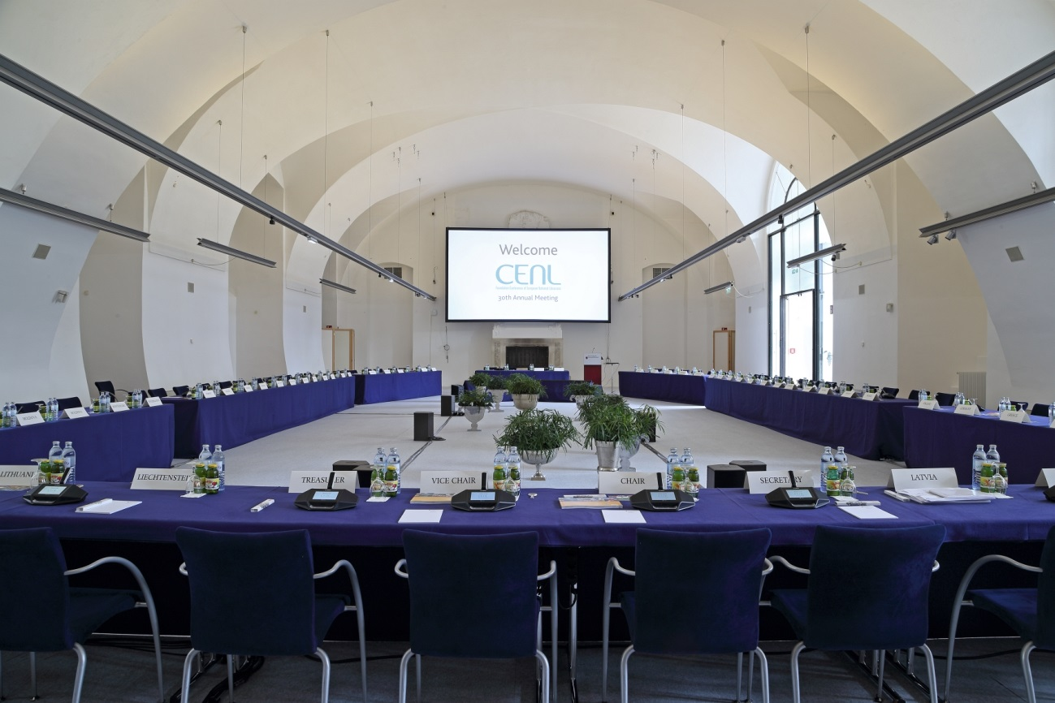

Lounge Literature Museum:  
<https://www.onb.ac.at/ueber-uns/presse/pressematerial/#lg=1&slide=10>

1. Please provide simplified plans of your buildings, if possible in .jpg format (perhaps those used to guide visitors around your building).

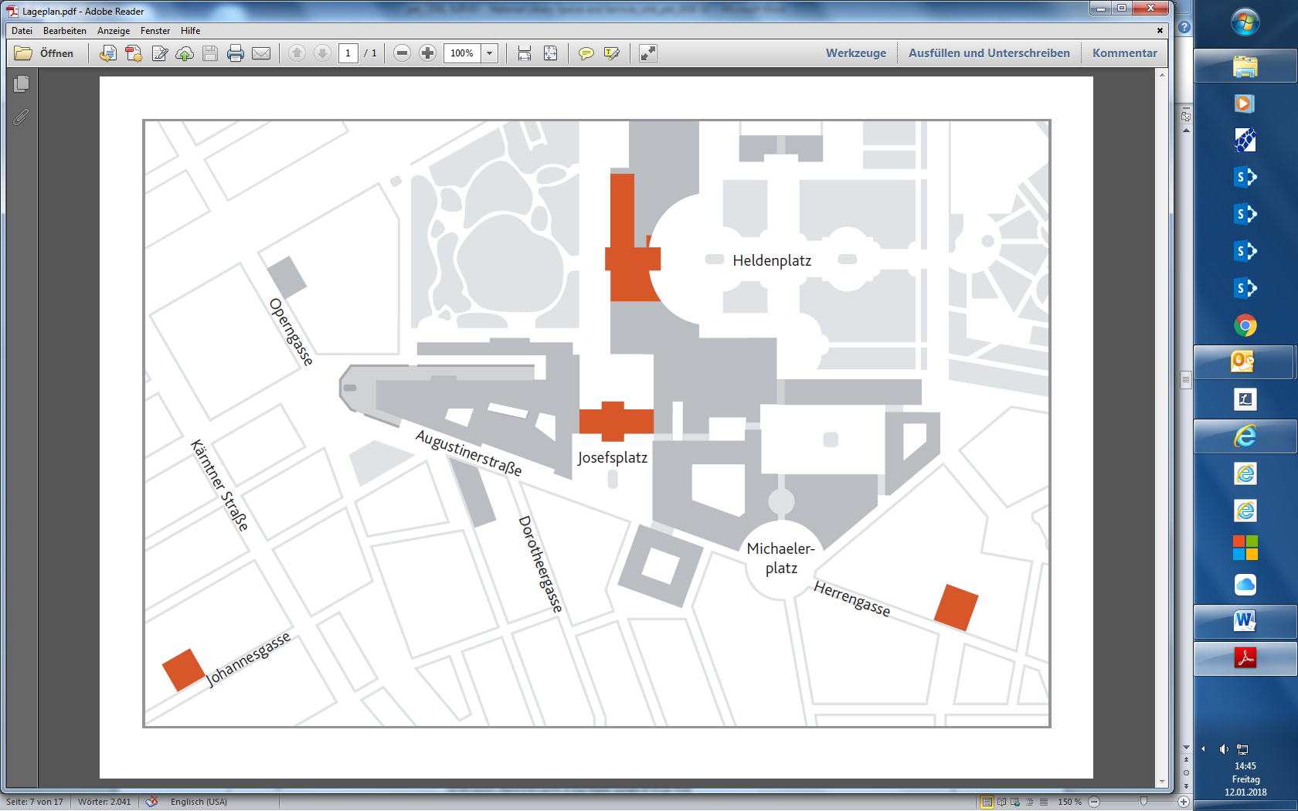

* Collections/ Departments: <https://www.onb.ac.at/besucherinfo/lageplaene/sammlungen/>   
  Museums: <https://www.onb.ac.at/de/besucherinfo/lageplaene/museen/>   
  Modern Library: <https://www.onb.ac.at/besucherinfo/lageplaene/moderne-bibliothek/>

1. Please provide brief details on the milestones of history of your library buildings.

|  |  |
| --- | --- |
|  | Answer |
| **Year (first) library building opened** | 1726 |
| **Architect of (first) library building** | Joseph Emanuel Fischer von Erlach  Johann Bernhard Fischer von Erlach |
| **Year (current) library building opened** | 1726 |
| **Architect of (current) library building** | Joseph Emanuel Fischer von Erlach  Johann Bernhard Fischer von Erlach |
| **Any additional information. Eg length of build/cost of build/reason for build** | 1723 – 1726  Financed with new created State Tax, The Baroque library became immediately a land mark in the city of Vienna and a status symbol of the Habsburg dynasty |
| **Milestones** | 1368: Foundation Codex and Medieval Treasure  1440: Emperor Frederick’s Book collection formed the core holdings of the imperial court library  1500: Emperor Maximilian I: Origins of the "Bibliotheca Regia"  [1575: Hugo Blotius: First Imperial Librarian](https://www.onb.ac.at/en/about-us/650th-anniversary/timeline/1575-hugo-blotius-first-imperial-librarian/)  1624: Origins of Legal Deposit  1665: Ambras Court Library transferred to Vienna  1723-1726: Baroque Library at Josefsplatz  1780/ 1781: The First Card Catalogue 1806: Imperial court library is redefined as National Library of the Austrian Empire 1906: Opening of the Augustinian Reading Room for the Court Library  1920: The Court Library becomes the National Library  1945: Renaming: National Library becomes "Austrian National Library”  1966: Opening of Main Reading Room at Heldenplatz  1992: Opening of a new storage depot underneath the Burggarten  1999: Opening of an entrance hall and event lounge at Josefsplatz  1999: Opening of Papyrus Museum at Heldenplatz  2000: Digitization of card catalogues, First Homepage, First digitization campaigns  2002: New legislation: ANL becomes Scientific Institute under Public Law  2004: Renovation of Public Spaces and Reading Rooms at Heldenplatz  2005: Opening of Globes Museum and Esperanto Museum at Palais Mollard  2005 Moving of Music Department and Department of Maps to Palais Mollard  2012: Opening of Ludwig Wittgenstein Reading Room at Heldenplatz  2015: Opening of Literary Museum at Grillparzerhaus  2018: November: Opening of the new Museum: House of History Austria |
|  |  |
|  |  |
| **.** |  |

1. If available, please provide a short text on the milestones of the history of your library and/or provide a link to this information online. Please include any bibliographic information about publications about your library and links to these publications in your library catalogue or an aggregated catalogue.

Timeline:

Time travel through 650 years of Austrian National Library:

<https://www.onb.ac.at/en/about-us/650th-anniversary/timeline/>

**Bibliography: History of the Austrian National Library (Selection)**

**Monographs:**

**Festschrift 1926:** Festschrift der Nationalbibliothek in Wien. Herausgegeben zur Feier des 200jährigen Bestehens des Gebäudes (Vienna 1926).

**Hall/Köstner 2006:** Hall, Murray G. / Köstner, Christina: … Allerlei für die Nationalbibliothek zu ergattern … Eine österreichische Institution in der NS-Zeit (Vienna/Cologne/Weimar 2006).

**Hall/Köstner/Werner 2004:** Hall, Murray G. / Köstner, Christina / Werner, Margot (ed.): Geraubte Bücher. Die österreichische Nationalbibliothek stellt sich ihrer NS-Vergangenheit (Vienna 2004).

**Handlirsch/Smital/Zimmermann 1920:** Handlirsch, Hans / Smital, Otto / Zimmermann, Heinrich: Die beiden Hofmuseen und die Hofbibliothek. Der Werdegang der Sammlungen, ihre Eigenart und Bedeutung (Vienna 1920).

**Huber-Frischeis/Knieling/Valenta 2015:** Huber-Frischeis, Thomas / Knieling, Nina / Valenta, Rainer: [Die Privatbibliothek Kaiser Franz' I. von Österreich](http://www.boehlau-verlag.com/download/164294/978-3-205-79672-5_OpenAccess.pdf). Bibliotheks- und Kulturgeschichte einer fürstlichen Sammlung zwischen Aufklärung und Vormärz (Veröffentlichungen der Kommission für Neuere Geschichte Österreichs 111, Vienna/Cologne/Weimar 2015).

**Mazal 1987**: Mazal, Otto (ed.): Ein Weltgebäude der Gedanken. Die Österreichische Nationalbibliothek. Graz 1987.

**Petschar/Strouhal/Zobernig**: Petschar, Hans, Strouhal, Ernst, Zobernig, Heimo: Der Katalog. Ein historisches System geistiger Ordnung (Vienna/New York 1999).

**Rachinger 2017:** Rachinger, Johanna (ed.): Schatzkammer des Wissens. 650 Jahre Österreichische Nationalbibliothek (Vienna 2017).

**Stummvoll 1968:** Stummvoll, Josef (ed.): Die Geschichte der Österreichischen Nationalbibliothek, Bd. 1 Die Hofbibliothek 1368–1922 (Vienna 1968).

**Stummvoll 1973:** Stummvoll, Josef (ed.): Die Geschichte der Österreichischen Nationalbibliothek, Bd. 2 Die Nationalbibliothek 1923–1967 (Vienna 1973).

**Essais:**

**Bick 1947:** Bick, Josef: Die österreichische Zentralbibliothek in Wien. Das Projekt ihres Baues und ihrer Organisation. In: Phaidros (1947, 1) 6–16.

**Doublier 1926:** Doublier, Othmar: Ein Vierteljahrhundert aus der Geschichte der Nationalbibliothek 1891–1916. In: Festschrift der Nationalbibliothek in Wien (Vienna 1926) 163–210.

**Huber-Frischeis/Knieling/Valenta 2014:** Huber-Frischeis, Thomas / Knieling, Nina / Valenta, Rainer: Die Geschichte der Privatbibliothek Kaiser Franz’ I. von Österreich 1784–1835. In: Bibliothek, Forschung und Praxis 38 (2014) 461–467.

**Kisser 1948:** Kisser, Alois: Die Druckschriftensammlung. In: Josef Stummvoll (ed.): Die Österreichische Nationalbibliothek. Festschrift hrsg. zum 25jährigen Dienstjubiläum des Generaldirektors Univ.-Prof. Dr. Josef Bick (Vienna 1948) 73–104.

**Ortner 2017:** Ortner, Michaela: Die Katalogisierung der Bücher der ehemaligen Fideikommissbibliothek des Hauses Habsburg-Lothringen an der Österreichischen Nationalbibliothek. In: Bibliothek, Forschung und Praxis 41,2 (2017) 156–162.

**Payer von Thurn 1927:** Payer von Thurn, Rudolf: Ein kaiserlicher Bibliophile. In: Von Büchern und Menschen. Festschrift Fedor von Zobeltitz zum 5. Oktober 1927 überreicht von der Gesellschaft der Bibliophilen (Weimar 1927) 64–97.

**Petschar 2001:** Petschar, Kataloggeschichte: Hans Petschar, Kataloggeschichte – Bibliotheksgeschichte. Skizzen zum Funktionswandel der kaiserlichen Bibliothek in Wien vom 16. bis zum 18. Jahrhundert. In: Moritz Csáky, Peter Stachel (ed.), Speicher des Gedächtnisses. Bibliotheken, Museen Archive. Bd. 2: Die Erfindung des Ursprungs. Die Systematisierung der Zeit (Vienna 2001) 43–56.

**Petschar 2016:** Petschar, Hans: Der Prunksaal der Österreichischen Nationalbibliothek. Zur Semiotik eines barocken Denkraumes. In: Barbier, Frédéric / Monok, Istvan / De Pasquale, Andrea*:* Bibliotheken, Dekor (17.-19. Jahrhundert) (Paris 2016) 69 – 79.

**Strebl 1970:** Strebl, Magda: Die Wiener Hofbibliothek und die Pflichtexemplare. In: Festschrift Josef Stummvoll, Vol. 1 (Vienna 1970) 348–356.

# Chapter III: Location and Urban Spaces

1. Please describe the location of your national library buildings (eg. main building in capital city with close proximity to universities, storage buildings in rural area, located two hours by train from building in capital).

All Library buildings are located in the capital city Vienna. Head Quarters, Department of Manuscripts, old and Rare Books, Modern Library, Picture Archives and Graphics Department and Literary Archives and Papyrus Museum and Papyrus Collection are located at the Hofburg (Imperial Palace complex). The Music Department, the Department of Maps and Cartography and the Esperanto Museum are located at Palais Mollard, Herrengasse, the Literature Museum is located at the Grillparzerhaus in Johannesgasse 6, Archives of Popular Music is located next the State Opera House.  
All buildings are located in the first district of Vienna, with close proximity to universities, cultural centers, museums, historical sights and political and administrative centers.

Hofburg:   
 <https://de.wikipedia.org/wiki/Hofburg>  
<https://en.wikipedia.org/wiki/Hofburg>

Palais Mollard:   
<https://de.wikipedia.org/wiki/Palais_Mollard-Clary>  
<https://en.wikipedia.org/wiki/Palais_Mollard-Clary>

Grillparzerhaus: <https://de.wikipedia.org/wiki/Literaturmuseum_der_%C3%96sterreichischen_Nationalbibliothek>

1. CENL has provided a map of your headquarter location at the centre of a 500m radius – taken as a screenshot from Google maps. If this is not the correct location of your library building, please supply an alternative screen shot.  
     
   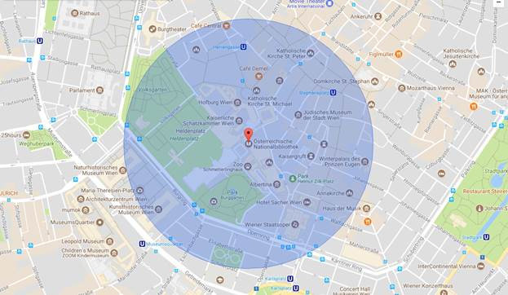
2. Please provide details of major governmental, cultural or significant institutions within this vicinity (within a 500m radius).

Political and administrative buildings:   
Bundespräsident: <https://de.wikipedia.org/wiki/Pr%C3%A4sidentschaftskanzlei>   
Bundeskanzleramt: <https://de.wikipedia.org/wiki/Bundeskanzleramt_(%C3%96sterreich)>   
Parliament: <https://de.wikipedia.org/wiki/%C3%96sterreichisches_Parlament#Parlamentsgebäude>   
  
Culture  
Weltmuseum Wien: <https://de.wikipedia.org/wiki/Weltmuseum_Wien>   
Schatzkammer: <https://de.wikipedia.org/wiki/Schatzkammer_(Wien)>   
Kunsthistorisches Museum: <https://de.wikipedia.org/wiki/Kunsthistorisches_Museum>   
Naturhistorisches Museum: <https://de.wikipedia.org/wiki/Naturhistorisches_Museum_Wien>   
Albertina: <https://de.wikipedia.org/wiki/Albertina_(Wien)>   
Staatsoper: <https://de.wikipedia.org/wiki/Wiener_Staatsoper>   
Burgtheater: <https://de.wikipedia.org/wiki/Burgtheater>   
MuseumsQuartier: <https://de.wikipedia.org/wiki/MuseumsQuartier>   
  
sights:  
Stephansdom: <https://de.wikipedia.org/wiki/Stephansdom_(Wien)>   
Augustinerkirche: <https://de.wikipedia.org/wiki/Augustinerkirche_(Wien)>   
Michaelerkirche: <https://de.wikipedia.org/wiki/Michaelerkirche_(Wien)>   
Looshaus: <https://de.wikipedia.org/wiki/Looshaus>   
Spanische Hofreitschule: <https://de.wikipedia.org/wiki/Spanische_Hofreitschule>

1. Please describe all the transport options for reaching each of your library buildings open to researchers and the public.

<https://www.onb.ac.at/besucherinfo/lageplaene/verkehrsanbindung/>

<https://www.onb.ac.at/en/visitors-information/site-maps/transport-connections/>

# Chapter IV: Reading Rooms, collections and other interior library spaces

1. What is the total number of seats in all your reading rooms across all sites?

608 (+ 107 computer research seats in lounges & public spaces)

1. What is the total square meterage of all your reading rooms across all sites?

**3156**

1. Please list your reading rooms (type, large, by collection) and individual capacity  
   complete:

|  |  |  |  |
| --- | --- | --- | --- |
| Reading Room Name | Collection type | Individual room seat capacity | Individual room square metres |
| Main Reading Room | Books | 149 | 693 |
| Austriaca | Books | 67 | 282 |
| Researchers RR | Books | 64 | 392 |
| Newspaper RR I | Newspapers | 48 | 294 |
| Newspaper RR II - IV | Books / Newspapers | 97 | 230 |
| Picture Archives RR | Pictorial Sources, Books; Archival Material | 24 | 437 |
| Map Department RR | Maps | 23 | 151 |
| Music Department RR | Music | 37 | 225 |
| Manuscript Dep. RR | Manuscripts, Rare Books | 65 | 251 |
| Literary Archives | Books, Archival Material | 16 | 58 |
| Papyrus Department | Papyri, Books | 6 | 50 |
| Esperanto RR | Books, Archival Material | 6 | 23 |
| Folklore Music RR | Books, Archival Material | 6 | 70 |
|  |  |  |  |
| Total | Modern Library | 425 | 1891 |
|  | Special Collections | 183 | 1265 |
| Total Reading Rooms |  | 608 | 3156 |

1. Do users register to use your Reading Rooms? If so, how?

**Day Passes, Reader Pass (Annual)**

1. Do users pay to use your Reading Rooms? If so, how much?

**Day Pass: 3 Euro**

**Annual Reader Pass: 30 Euro (since 2018)**

1. How are your collections accessed within the Reading Rooms? Is collection material open access or called to order? Please describe.

**Acces is mixed: Reference Literature in Reading Rooms, all other materials: called to order:**

1. What is the average number of visits per day to your Reading Rooms?

Open days 2017: (Main Library at Heldenplatz): 334

Total of Readers 2017: 233.648

Average of Readers per day 2017: 700

1. What is the average number of visits per day to your library?

Library visitors, including museums visitors, open days based on max. open days at Modern Library, Heldenplatz

2017

Open days 2017 (Heldenplatz) : 334

Total of visitors 2017: 672.611

Average of visitors per day 2017: 2014

# Chapter V: Staffing

1. What is the number of staff employed by the library in total ?

2017: total number of staff 31.12. 2017 381

1. What is the number of staff employed in FTE ?  
     
   2017: (31.12.17) 314

1. The keynote presentation may be accessed via <http://www.cenl.org/members/cenl-annual-general-meeting-2017-15-16-may-british-library-london/nggallery/page/1>