Survey of National Library Spaces and Services

Following on from CENL’s 2017 AGM and the keynote presentations, as well as the breakout session devoted to collection management, members concluded that a survey of library spaces, and the use of digital content within, would be beneficial to all. Data gathered by the CENL Secretariat will be used for analysis and to further discussion in the coming months with all CENL members. The full results of the survey are intended to be presented at CENL’s 2018 AGM.

All over the world we have seen the creation of new libraries during recent years, including new national library buildings that have been inaugurated or redesigned in Europe. The role of libraries and national libraries is changing and is in permanent transition. This process of transformation caused by the digital revolution and by changes within the economic and political environment has impacted library spaces, staffing and library services. To understand and to meet future needs of national libraries this survey aims to collect and analyse fundamental changes within national library spaces which have occurred over the last ten years.

The survey is structured in six chapters determined by the themes that were discussed during the 2017 AGM breakout session:

• The role of national libraries in collection management is changing – this affects library spaces

• National libraries are transforming from solely heritage institutions to also being leaders in digitisation

• Previously the role of digitisation was for preservation, but now there are new uses for our collections which include the combination of digital and heritage – how is this explored within national libraries?

• Staff development is key to the transformation of libraries – staff need to be integrated in the end to end process of digitisation and using that digital content, perhaps in physical and virtual exhibitions

• Skills and standards for digital content are needed for clarity of activity for researchers

 | Answer
Name of national library in full (in your own language and in anglicised form): | Росси́йскаянациона́льнаябиблиоте́ка  National Library of Russia
Name of Director General with official title: | Alexander Vershinin
Main library address: | Sadovaya Street 18  191069 St Petersburg  Russia
Current logo as a .jpg:
Contact name, email and telephone for this survey: | Alexander Vershinin  vibe@nlr.ru  (812) 718-85-06

Instructions
The CENL Secretariat has pre-completed as much information as possible within this survey. Please check the information already provided and augment or correct this as necessary. Where no information is yet provided, please supply answers in full. Do contact cenl@bl.uk with any difficulties.

Chapter I: Scope and core functions of your national library
- Please check all that apply.
National Library | University Library | Public Library | Research Library / Research Centre | National Archives | Legal deposit centre | Preservation centre | Museum | Other
If other please specify:
- Are you the only library with a national remit in your country? If no (eg. there is also a National Technical Library) please specify.
No
- What is the legal status of your library?
State budgetary institution of federal importance
- Which ministry oversees your library?
Ministry of Culture

Chapter II: Physical spaces
- Do you have multiple library sites? If so, please provide address details of all library buildings, including storage.
Main Building - 1/3, Ostrovsky Square, St.Petersburg
New Building - 165/2, Moskovsky Prospekt, St.Petersburg
Building on the Fontanka Embankment - 36, the Fontanka Embankment, St.Petersburg
Building in Liteyny Prospect - 49, Liteyny Prospect, St.Petersburg
Plekhanov House - 1/33, 4th Krasnoarmeyskaya St, St.Petersburg
- Please provide a brief summary of all functions contained within the national library.
In 2017
Reading  Rooms | Lounge | Exhibition space | Conference Centre | Conservation Studio | Gallery | Concert Hall | Café / Restaurant | Commercial space / shop | Other

If other please specify:
- Please provide the total square meterage for each of the following functions within your library:
M2 | M2 | M2 | M2 | M2 | M2 | M2 | M2 | M2 | M2
Reading Rooms | Lounge | Exhibition space | Conference Centre | Conservation Studio | Gallery | Concert Hall | Café / Restaurant | Commercial space / shop | Other
If other please specify:
- What is the total size of all library buildings in square metres (includes storage areas)?
2017: 157 000 square meters
- What is the size of library buildings open to the public in square metres?
2017: 10 000 square meters
- Please provide .jpg images of your main public building(s) exterior

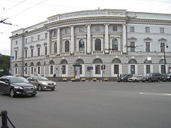
Exterior –
https://en.wikipedia.org/wiki/National_Library_of_Russia
http://nlr.ru/media/RA233/rnb-photos

- If available, please provide .jpg images of all library sites described in question 5.
http://nlr.ru/media/RA233/rnb-photos
- If available, please provide .jpg images of all library spaces described in question 6.
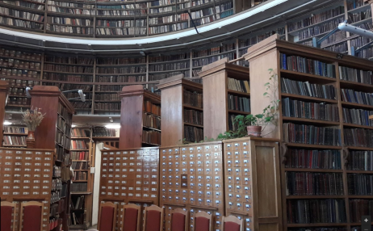
Reading room –
https://www.google.co.uk/maps/place/National+Library+of+Russia/

- Please provide simplified plans of your buildings, if possible in .jpg format (perhaps those used to guide visitors around your building).
Answer
- Please provide brief details on the history of your library buildings.

 | Answer
Year (first) library building opened | In 1801 it was built, in 1814 – opened to readers
Architect of (first) library building | Yegor Sokolov
Year (current) library building opened | 1801
Architect of (current) library building | YegorSokolov
Any additional information. Eg length of build/cost of build/reason for build | There are two more major library buildinds, one of them was built in 1804 and has been allocating the library since 1949, another one was build specially for the library and officially opened in 2002.

- If available, please provide a short text on the milestones of the history of your library and/or provide a link to this information online. Please include any bibliographic information about publications about your library and links to these publications in your library catalogue or an aggregated catalogue.
http://nlr.ru/eng/nlr/history/

Chapter III: Location and Urban Spaces
- Please describe the location of your national library buildings (eg. main building in capital city with close proximity to universities, storage buildings in rural area, located two hours by train from building in capital).
Two of the main library buildings are located in the city center surrounded by higher education institutions, museums and other cultural institutions. Another building is located 8 km away from the central one; it takes about 30 minutes to get there by public transport. It is located near the student campus.
- CENL has provided a map of your headquarter location at the centre of a 500m radius – taken as a screenshot from Google maps. If this is not the correct location of your library building, please supply an alternative screen shot.
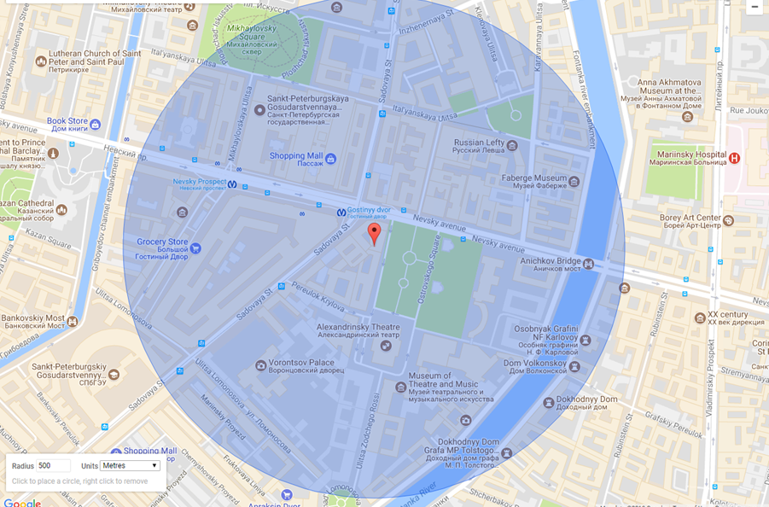
- Please provide details of major governmental, cultural or significant institutions within this vicinity (within a 500m radius).
As the main building is located in the very centre of the city, many theatres, outstanding museums and other cultural institutions are located nearby.
- Please describe all the transport options for reaching each of your library buildings open to researchers and the public.
http://nlr.ru/eng/nlr/location.htm

Chapter IV: Reading Rooms, collections and other interior library spaces
- What is the total number of seats in all your reading rooms across all sites?
1970
- What is the total square meterage of all your reading rooms across all sites?
-
- Please list your reading rooms (type, large, by collection) and individual capacity
Reading Room Name | Collection (items) | Individual room seat capacity (seats) | Individual room square metres
Universal Reading Room | 75 122 | 276
Lenin reading Room | - | 72
Reading room of the main Russian collection | 10 275 012 | 16
Russian magazines collection | 4 395 630 | 75
Library collection | 113 481 | 27
Library information centre (mail building) | 884 848 | 16
Library information centre (new building) |  | 28
Collection of group cataloguing | 5 146 000 | 18
Collection of normative-technical and technical documents | 3 971 261 | 65
Collection of microfilm | 517 305 | 28
Foreign magazines collection | 3 486 313 | 36
Confidential (for official use only) | 416 003 | 8
Reading room for personal work | - | 22
Literature on humanities | 61 310 | 542
Literature on medicine and technology | 52 202 | 20
Please note that the list of the reading rooms is not complete. Many department of our library have their own reading rooms (e.g. prints department, rare books department, manuscript department and so on)
- Do users register to use your Reading Rooms? If so, how?
It is necessary to get a library card (it is free and it takes just about 5 minutes)
- Do users pay to use your Reading Rooms? If so, how much?
No, library card is free of charge
- How are your collections accessed within the Reading Rooms? Is collection material open access or called to order? Please describe.
There are different kinds of access to the collections in the library including some open collections.
- What is the average number of visits per day to your Reading Rooms?
800
- What is the average number of visits per day to your library?
960

Chapter V: Staffing
- What is the total number of staff employed by the library in total ?
2017:1300
- What is the total number of staff employed by the library in FTE ?
2017: 320

The keynote presentation may be accessed via http://www.cenl.org/members/cenl-annual-general-meeting-2017-15-16-may-british-library-london/nggallery/page/1

